**Lab Week 1**



Session: 2022 – 2026

**Submitted by:**

Muhammad Saad Akmal 2022-CS-148

**Submitted To:**

Sir Nauman Shafi

Department of Computer Science

**University of Engineering and Technology**

**Lahore Pakistan**

**Problem 1:**

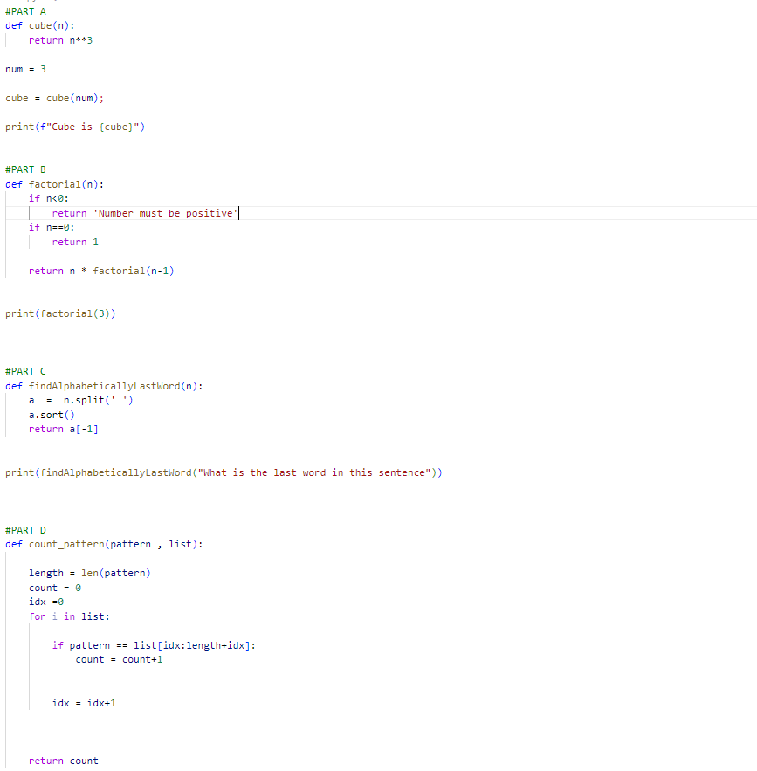

**Output:**



**Problem2:**

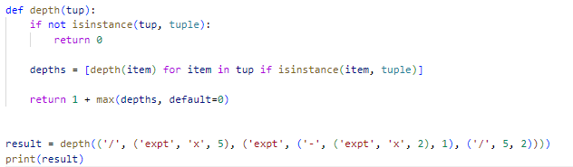

**Output:**



**Problem 3:**

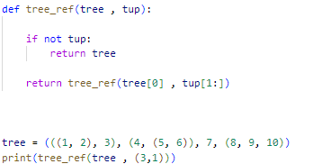

**Output:**

