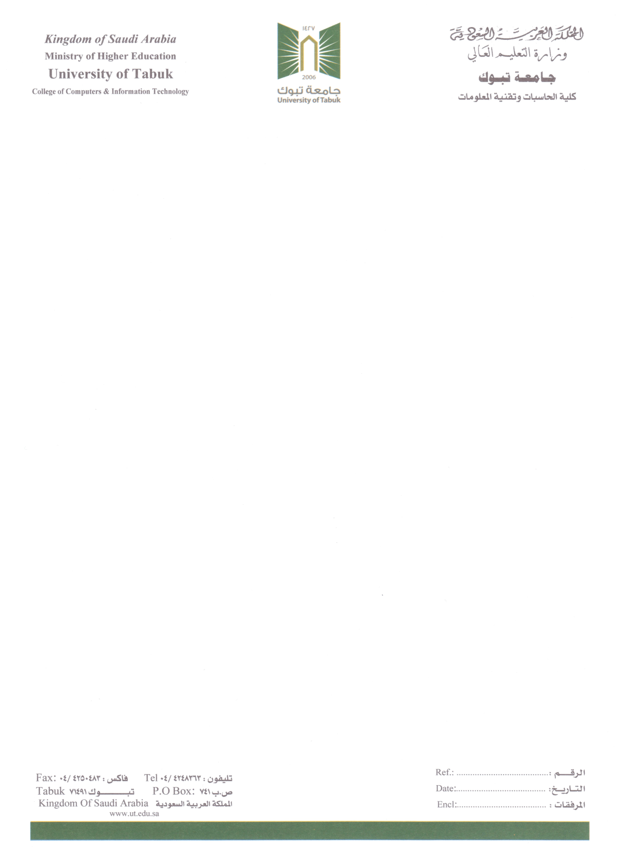

The design and development of a robot navigation system for unknown terrains using search algorithms
Project Report submitting this report as part of my requirements for earning my Bachelor's degree in Computer Science.

This project has been submitted before
By
Saad Safar Al-Baqmi
Youssef Musaad Al-Rashidi
Wael Mansour Alanazi
Abdullah Isam Arbab
Supervised By
DR. TAREQ ALHMIEDAT
Department of Computer Science
Faculty of Computers and Information Technology
University of Tabuk

The design and development of a robot navigation system for unknown terrains using search algorithms

ABSTRACT

Robot navigation is a significant task for mobile robots, where the mobile robot needs to travel independently from one location to another in a safe manner. This project aims to build a robot navigation system for unknown indoor terrains using one of the well-known search algorithms (Breadth-first, A*, Dijkstra, … etc). The designed system will be validated using Lego Ev3 robot platform and Python programming language to assess its efficiency and accuracy.

TABLE OF CONTENTS

CHAPTER1: INTRODUCTION
1.1 Background 8
1.2 Problem overview 8
1.3 Project Aims and Objectives 8
1.4 Project Concept 8
1.5 Report’s Layout 9
CHAPTER 2: RELATED WORKS
2.1 INTRODUCTION 10
2.2 ROBOT 10
2.3 Search Algorithm 10
2.3.1 A* Algorithm 10
2.3.2 Dijkstra Algorithm 10
2.3.3 Random Mouse Algorithm 11
2.3.4 Hill climbing algorithm 11
2.4 Robot Navigation using Search Algorithm 11
2.4.1 Autonomous Navigation with Lego EV3 11
2.4.2 Neural Network-Based Navigation for Lego NXT Robots 12
2.4.3 Exploring Autonomous Navigation Principles in Robotics 12
2.4.4 Navigation with LEGO EV3 Robot 12
2.4.5 Navigation Using EV3 Lego Robot 12
2.4.6 Maze Bot Autonomous Navigation System 13
2.4.7 Autonomous Maze Solving with LEGO EV3 13
2.4.8 Navigation with Wall Follower Robot 13
CHAPTER 3: DESIGN
3.1 Software development model 15
3.1.1 Waterflow 15
3.2 Requirement 16
3.2.1 Function Requirements 16
3.2.2 Non-Function Requirements 16
3.3 Use-case Design 17
3.4 Class Design 19
3.5 Activity Design 21
3.6 Sequence Design 22

LIST OF TABLES
TABLE TITLE PAGE
Table 2.3: Algorithm Comparison 11
Table 2.4: Navigation System Using Comparison 13
Table 3.3.1: Use Case Scenario 18
Table 3.3.2: Use Case Scenario 18
Table 3.3.3: Use Case Scenario 19
Table 3.3.4: Use Case Scenario 19
Table 3.3.5: Use Case Scenario 20
Table 3.3.6: Use Case Scenario 20
Table 3.4: Class Diagram 22

LIST OF FIGURES
FIGURE TITLE PAGE
Figure 3.1.1: Waterflow Model 15
Figure 3.3: Use Case Diagram 17
Figure 3.4: Class Diagram 21
Figure 3.5: Activity Diagram. 23
Figure 3.6.1: Sequence Diagram. 24
Figure 3.6.2: Sequence Diagram. 24
Figure 3.6.3: Sequence Diagram. 25
Figure 3.6.4: Sequence Diagram. 25
Figure 3.6.5: Sequence Diagram. 25
Figure 3.6.6: Sequence Diagram. 26
Figure 3.6.7: Sequence Diagram. 26

CHAPTER1: INTRODUCTION
1.1 Background
A robot is an advanced machine used to perform complex tasks that may be difficult or impossible for humans due to their inability to reach the place. The field of robotics deals with the design, programming, and operation of these machines, and also requires the use of computer systems to control them and process information, to ensure that they perform their function as required. The robot Navigation feature enables the robot to navigate through various environments using sensors such as the ultrasonic sensors, allowing it to move accurately and avoid obstacles [1].
1.2 Problem Overview
Indoor robot systems require the construction of pathways of the indoor environment in order to allow the robot to travel independently in a safe manner. The absence of robot navigation and orientation will mislead the robot to achieve its desired function, as the robot does not information about the area of interest and hence loses its location and direction.
1.3 Project Aims and Objectives
This project aims to design and implement an efficient robot navigation system using one of the existing search algorithms. The main objectives associated with the project aim are as follows
1- Research the recent developed robot navigation systems.
2-Discuss and analyze the efficiency of the recent developed robot navigation systems.
3-Analyze the requirement of the design and development of a robot navigation system.
4-Implement several search algorithms in the area of robot navigation
5-validat the efficiency of the implemented search algorithms through experimental studia.
1.4 Project Concept
The project aims to develop a robotic navigation system that enables robots to autonomously navigate indoor environments using an obstacle avoidance sensor. The system will utilize the Lego EV3 robot platform and be programmed in Python, focusing on real-time obstacle detection and avoidance to ensure safe navigation. By implementing search algorithms like A* and Dijkstra, the robot will efficiently plan its path while dynamically adjusting to obstacles in its surroundings. The project's effectiveness will be validated through practical experiments, enhancing the capabilities of robotic navigation in confined spaces.

1.5 Report’s Layout
This report consists of 3 chapters. Chapter 2 presents the relevant robot navigation systems and discusses the existing searching algorithms. In Chapter 3, the analysis and design of the robot navigation system are considered.
CHAPTER 2: RELATED WORKS

2.1 INTRODUCTION
This Chapter discusses the searching algorithms that can be used in robot navigation systems for the purpose of finding out the existing paths between reference points in the area of interest. In addition, we discuss the existing robot navigation systems that have been employed using Lego EV3 platform.
2.2 ROBOT
A robot is an intelligent device designed to perform tasks with precision and speed, either to assist humans or handle tasks that are difficult for them. In general, robot uses modern technologies like artificial intelligence to work efficiently in various fields such as industry, medicine, and even space exploration. The area of robot has received significant attention with developing diverse robot systems and methods. In this report, we focus on the area of robot navigation, where the search algorithms play significant role in finding the optimal paths in the navigation environment. Several search algorithms are discussed in the next subsection.

2.3 Search Algorithm
An algorithm is a set of organized and logical steps used to solve a problem or perform a specific task. It acts as a guide for processes in software or devices, making it the foundation of modern technology. Therefore, in this report, we discuss four searching algorithms as presented below.
2.3.1 A* Algorithm
The A* algorithm (pronounced "A-star") is one of the most popular and powerful search algorithms used in AI (in artificial intelligence) and applications that require finding an optimal path, such as robotics and games, The algorithm generally searches for the fastest and shortest path between two points (start and end) taking into account obstacles or distances.Maze solving is the process of figuring out how to move from one place to another through a maze, AI (Artificial intelligence) can be used to navigate mazes, A robot learns how to navigate through a maze by receiving feedback based on its behavior, After receiving the feedback, when the robot is asked to navigate through the maze a second time, it will use the previous feedback that will help reduce unnecessary paths and lead the robot to the shortest path, This will help it navigate through the maze in the shortest possible time. The A* algorithm, the path is found by searching among all possible paths to the target the one that has smallest cost. The cost function of the shortest finder [2].
2.3.2 Dijkstra Algorithm
Dijkstra's algorithm finds the shortest path from a given source node to every other node. It can also be used to find the shortest path to a specific destination node, by terminating the algorithm once the shortest path to the destination node is known. The algorithm uses a min-priority queue data structure for selecting the shortest paths, Dijkstra's algorithm is commonly used on graphs where the edge weights are positive integers or real numbers. It can be generalized to any graph where the edge weights are partially ordered, provided the subsequent labels (a subsequent label is produced when traversing an edge) are monotonically non-decreasing [3].

2.3.3 Random Mouse Algorithm
This algorithm is simply based on the idea that the mouse (or cursor) moves randomly in the environment without prior planning. Every move he takes is completely randomly selected, whether forward, backward, right, or left, until he finds the solution or reaches the goal. The Random Mouse Algorithm does not rely on searching for the closest distance or making intelligent decisions to reach the goal. The basic idea is absolute randomness. That is, the mouse moves randomly without any consideration of distance or direction towards the target (in other words, the mouse is not evaluating which path is closest or best to reaching the goal) [4].
2.3.4 Hill climbing algorithm
The Hill climbing algorithm is a local search algorithm used to find the optimal solution by gradually improving solutions from a specific starting point until reaching the goal. It works by starting with a random solution and then moving to a better neighboring solution based on an evaluation function. The process continues until no further improvement is possible, which could be a local or global optimum [5].
The presented searching algorithms are analyzed according to the following evaluation metrics: speed, accuracy, efficiency, and the best use case for each search algorithm. Table 2.1 presents the comparison among the existing searching algorithms.
Table 2.1: Algorithm Comparison
Algorithm | Speed | Accuracy | Efficiency | Best Use Case
A* | High | High | Excellent | Accurate Pathfinding
Dijkstra | Medium | High | Good | Multiple Paths
Random Mouse | Slow | Low | Weak | Initial Experiments
Hill Climbing | High | Medium | Moderate | Local Optimization Problems

2.4 Robot Navigation system using Search Algorithm
In this section, we discuss the recent developed robot navigation systems that employed the Lego EV3 robot in their implementation. For this purpose, we discussed 8 recent research works.
The research work presented in [6] includes the employment of the Lego Mindstorms EV3 robot to develop a real-time autonomous navigation system by integrating the Shortest Path Finder algorithm for efficient path planning, a PID controller for precise motion control, and an ultrasonic sensor for accurate obstacle detection. The system successfully enabled the robot to navigate unknown environments autonomously, avoiding obstacles with high accuracy and demonstrating superior performance compared to traditional methods. This highlights the robot's effectiveness as a reliable platform for exploring advanced robotics concepts and applications.
The autonomous navigation model for the Lego NXT robot was developed using neural networks to process ultrasonic sensor data and make effective movement decisions. The model was trained in a MATLAB simulator, utilizing algorithms such as Backpropagation Neural Network (BPNN) and Counter-Propagation Neural Network (CPNN) to evaluate their effectiveness in guiding the robot. The results showed that the BPNN algorithm was more effective in improving the robot's performance and reducing errors compared to CPNN, especially in complex scenarios requiring "victim rescue." The simulator facilitated testing the robot in various environments, and the experiments confirmed that BPNN enhances decision-making accuracy and increases efficiency [7].
The work presented in [8] focuses on the core principles of navigation, including location determination, obstacle avoidance, and pathfinding algorithms. By analyzing the incoming data, the robot can make informed decisions about suitable movement directions, enhancing its efficiency and effectiveness in navigating. The objective of this project is to develop a theoretical model of autonomous navigation, contributing to a deeper scientific understanding of movement and interaction mechanisms. Participants will explore pathfinding algorithms, such as Dijkstra's and A*, and learn how to apply them in various scenarios. Ultimately, this navigation project serves as a valuable educational experience, helping students develop analytical and critical thinking skills while deepening their understanding of robotics and autonomous navigation principles [8].
In [9], authors employed the LEGO Mindstorm EV3 robot, programmed in Java via leJOS, to improve autonomous navigation in labyrinths using the Flood Fill algorithm. The system incorporates a camera for real-time environmental monitoring, with image processing handled by a server using OpenCV and data transmitted to the robot via Wi-Fi. Results show that integrating camera-based processing enhances the robot's decision-making speed, significantly reducing maze-solving time compared to prior implementations.
The work presented in [10] involves an experiment on one of important fields of AI – Searching Algorithms, to find shortest possible solution by searching the produced tree, where authors focused on the on the Hill climbing algorithm, which is one of simplest searching algorithms in AI. This algorithm is one of the most suitable searching methods to help expert system to make decision at every state, at every node. The experimental robot constructed and programmed. The Lego EV3 robot has been adopted as this robot can interact quickly with sensors and can be reconstructed in many ways. Hill climbing algorithm is a local search algorithm that seeks to find optimal path from a starting position to a goal, it starts with a stochastic solution and climbs the hill by accepting better connecting solution than the one at hand the algorithm stops when it gets to either global maximum in the case of maximization or global minimum for Minimization [10].
Maze Bot is an autonomous aimed at navigating complex environments. It employs decision-making algorithms like the Wall Follower Algorithm (WFA) and the Pledge Algorithm (PA) to adeptly maneuver through obstacles and dead ends. To enhance its obstacle-clearing capability, it utilizes SHARP GP2D120 and SHARP GP2Y0A21YK0F infrared sensors, achieving a detection precision exceeding 92%. Key findings reveal successful maze navigation and efficient obstacle handling, positioning Maze Bot as a promising tool for applications in disaster response and automated warehouse operations. Future directions include the integration of a visual system to enhance environmental awareness and robustness, enabling scalability for more complex scenarios [11].
The research utilizes a customized LEGO EV3 robot to solve mazes using Dijkstra's algorithm and a Right-Left-Front search strategy. Equipped with ultrasonic, gyro, color, and inertial sensors, the robot navigates, determines its position, and builds a 2D map to identify the shortest path. Results demonstrate enhanced adaptability and efficiency in solving complex mazes while addressing infinite loop issues [12].
The shortest path traversal in a maze with wall following robot. This research focuses on developing a robot named "Wall Follower Robot" that can navigate a maze by following the walls, using the shortest-path algorithm. The aim is to create a robot that can find the quickest way through a maze while avoiding obstacles along the way. The robot was simulated with sensors that help it detect and follow walls. It uses simple rules to move it always tries to turn left, goes straight if it can’t turn left, and only turns right when necessary. The sensors on the robot help it figure out what’s around it and adjust its direction accordingly. The simulation showed that the robot could successfully navigate the maze using the shortest path. The sensors allowed it to efficiently avoid obstacles and find their way to the goal more quickly than some of the other techniques used in similar studies [13].
Table 2.2 presents a comparison among the existing robot navigation systems, where the existing systems have been analyzed according to main purpose of each robot navigation system, the potential application for the navigation system, and the obtained results that have been accomplished.

Table 2.2: Navigation System Using Comparison
Navigation System | Description | Application | Results
[6] | Utilized Lego Mindstorms EV3 with Shortest Path Finder algorithm, PID controller, and ultrasonic sensor for real-time navigation. | Implemented to navigate unknown environments and avoid obstacles. | Achieved high accuracy and superior performance compared to traditional methods.
[7] | Developed navigation using neural networks processing ultrasonic sensor data with BPNN and CPNN algorithms. | Trained in MATLAB simulator for effective movement decision-making. | BPNN reduced errors and enhanced performance in complex scenarios.
[8] | Focused on location determination, obstacle avoidance, and pathfinding algorithms using various sensors. | Educational project exploring Dijkstra’s and A* algorithms. | Improved analytical and critical thinking skills in robotics.
[9] | Integrated Flood Fill algorithm and camera-based processing with OpenCV for labyrinth navigation. | Improved real-time environmental monitoring and data transmission. | Reduced maze-solving time significantly with enhanced decision-making.
[10] | Implemented Hill Climbing algorithm for optimal pathfinding. | Designed an experimental robot with interactive sensors for maze traversal. | Demonstrated efficient decision-making and adaptable reconstruction.
[11] | Employed Wall Follower and Pledge Algorithms with infrared sensors for precision. | Navigated complex environments like disaster sites and warehouses. | Achieved >92% obstacle detection precision and effective maze navigation.
[12] | Used Dijkstra's algorithm and multi-sensor setup for maze solving. | Built 2D maps and determined shortest paths in complex mazes. | Improved adaptability and efficiency, avoiding infinite loops.
[13] | Developed a wall-following robot using a shortest-path algorithm. | Simulated with sensors for efficient obstacle detection and movement. | Successfully navigated mazes faster than alternative techniques.

CHAPTER 3: DESIGN

3.1 Software development model
is the process that includes designing, building, and testing the software necessary to guide a robot and achieve its goals of navigating effectively and safely, Software development here depends on creating a system or program that can determine the location of the robot, calculate the most appropriate paths, avoid obstacles, and interact with the surrounding environment. Simply put, the goal of software development in a robot mobility project is to provide intelligent software that allows the robot to move in a safe manner and achieve the required task without collisions or errors [14].
3.1.1 Waterflow
It is a linear, sequential approach to software development consisting of several phases, where each phase (such as analysis, design, implementation, and testing) is performed one after the other and must be completed in a specific order. The classic waterfall model is simple and perfect, Rollback is not allowed, which means that any changes in requirements will require starting over[15].
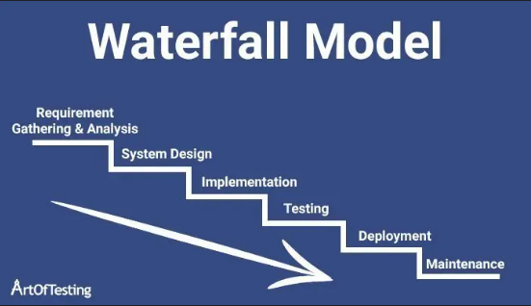
Figure 3.1.1: Waterflow Modul
The reason waterfall model is suitable for projects with clear and fixed requirements from the beginning, where the stages are carefully organized and classified, and progress is carefully monitored. It is ideal for environments that require clear documentation and standards such as national or financial projects, where synchronization and serialization are core to ensuring business success.
3.2 Requirement
Requirements are usually classified into types that are produced at different stages of development progress. The classification is based on the general model used and is an essential part of software development and describes what the system should do and how it will perform these tasks, forming the basis for software design and development [16].
3.2.1 Function Requirements
For a robot navigation project, functional requirements include tasks such as:
- Optimal Path Calculation: The robot must determine the most efficient path to its destination.
- Real-Time Obstacle Avoidance: The robot must detect and avoid obstacles immediately.
- Dynamic Path Adjustment: The robot must change its route if unexpected obstacles are detected.
- Autonomous Navigation: The robot must navigate without human intervention.
- Environmental Mapping: The robot must create and update a map of its surroundings.
3.2.2 Non-Function Requirements:
- Decision Speed: The robot must make navigation decisions within 1 second.
- Path Accuracy: Path calculations must have an accuracy of 95% or higher.
- Adaptability to Environment: The robot must operate in varied lighting and terrain conditions.
- System Reliability: Must maintain 99% uptime for continuous availability.
3.3 Use-case Design
The use case describes how the user (operator) interacts with the robot to achieve a navigation goal, such as moving from a starting point to a specified destination. It includes the necessary steps for navigation and handling obstacles. It also encompasses functional requirements, such as the robot's ability to calculate the optimal path and avoid obstacles, and non-functional requirements, such as the required speed during navigation and the accuracy of position determination.
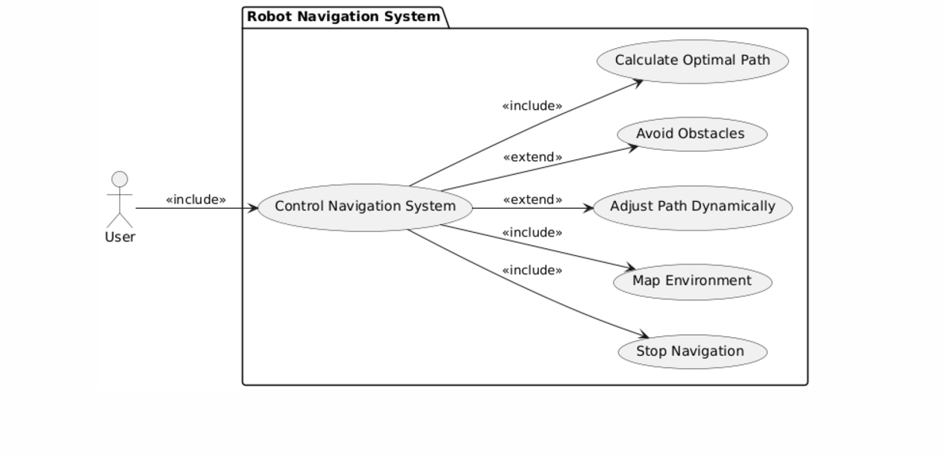
Figure 3.3: Use Case Diagram

Use Case Scenario

Control Navigation System
Table 3.1: Use Case Scenario
Aspect | Description
Actors | 1. User: Controls the navigation system.  2. Control System: Manages navigation processes.
Main Function | Allows the user to manage and operate the navigation system.
Preconditions | 1. User is available to operate the system.  2. Navigation system is functional and powered on.
Steps | 1. User initiates the system.  2. System starts navigation processes.  3. User oversees operations and makes adjustments.
Postconditions | 1. System operates successfully.  2. User retains full control.
Real-Time Adjustments | Real-time updates are provided to ensure smooth navigation.

Calculate Optimal Path
Table 3.2: Use Case Scenario
Aspect | Description
Actors | 1. System: Calculates the path.  2. Sensors: Provide environmental data.
Main Function | Calculate the most efficient route for the robot to follow.
Preconditions | 1. System has valid start and end points.  2. Sensors provide accurate data.
Steps | 1. System receives start and end points.  2. Sensors collect data about obstacles.  3. System computes the optimal path.
Postconditions | 1. Optimal path is determined.  2. The path avoids obstacles.
Real-Time Adjustments | The path is recalculated dynamically based on real-time sensor input.

Avoid Obstacles
Table 3.3: Use Case Scenario
Aspect | Description
Actors | 1. System: Implements obstacle avoidance.  2. Sensors: Detect obstacles in real-time.
Main Function | Ensure the robot avoids obstacles while navigating.
Preconditions | 1. Sensors are functional.  2. Obstacles are detectable within sensor range.
Steps | 1. Sensors detect an obstacle.  2. System calculates an avoidance maneuver.  3. Robot follows the adjusted path.
Postconditions | 1. Robot successfully avoids obstacles.  2. Navigation continues without interruptions.
Real-Time Adjustments | Obstacle detection and avoidance are handled dynamically.

Adjust Path Dynamically
Table 3.4: Use Case Scenario
Aspect | Description
Actors | 1. System: Adjusts the path.  2. Sensors: Continuously provide environmental data.
Main Function | Dynamically adapt the path during navigation.
Preconditions | 1. Real-time data is available.  2. System is operational.
Steps | 1. System monitors environmental changes.  2. Adjustments are calculated and applied in real-time.  3. Robot follows the updated path.
Postconditions | 1. Path adjustments are applied successfully.  2. Navigation adapts to environmental changes.
Real-Time Adjustments | Continuous path updates ensure safe navigation.

Map Environment
Table 3.5: Use Case Scenario
Aspect | Description
Actors | 1. Sensors: Collect environmental data.  2. System: Processes and maps the data.
Main Function | Create a detailed map of the environment.
Preconditions | 1. Sensors are functional.  2. System is active.
Steps | 1. Sensors gather data.  2. System processes the data.  3. Map is generated and stored.
Postconditions | 1. A detailed map is created.  2. Data is stored for future use.
Real-Time Adjustments | Mapping updates occur dynamically as the environment changes.

Stop Navigation
Table 3.6: Use Case Scenario
Aspect | Description
Actors | 1. User: Issues stop commands.  2. System: Executes stop actions.
Main Function | Safely stop the robot's navigation.
Preconditions | 1. User is monitoring navigation.  2. System is active and responsive.
Steps | 1. User sends a stop command.  2. System halts navigation processes.  3. Robot comes to a complete stop.
Postconditions | 1. Navigation is stopped safely.  2. Robot remains stationary.
Real-Time Adjustments | Emergency stops can be executed if needed.

3.4 Class Design
The Robotic Navigation Class Diagram is a design that illustrates how a robot interacts with the essential components that assist in navigation. This includes Sensors for gathering environmental data, and the Navigation System, which determines the optimal path to reach a target. The Robot entity uses sensors to analyze its surroundings and relies on the navigation system for route planning. The Environment contains information such as maps and obstacles, which help the navigation system adapt and plan, enabling the robot to move safely and avoid obstacles on its way to the target.
Example: -
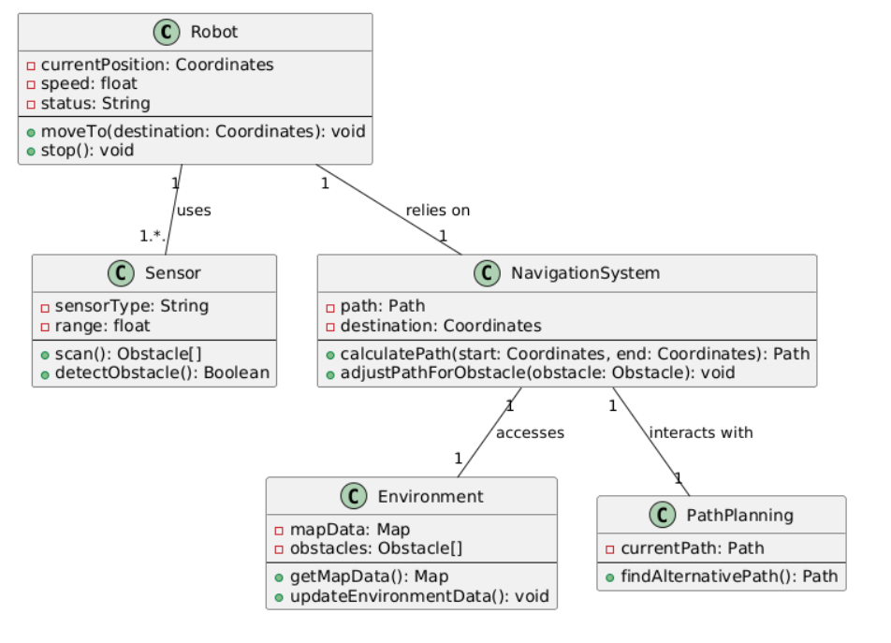
Figure 3.4: Class Diagram
Relationships between Classes:

- Robot ↔ Sensor: The robot relies on sensors to detect the location of obstacles.
- Robot ↔ Navigation System The robot uses the navigation system to determine the best path to reach its target.
- Navigation System ↔ Environment The navigation system depends on environmental data for planning and updating the route.
Here’s the information organized in a table in English:

Table 3.6: Class Digram
Class | Attributes | Methods
Robot | - currentPosition: Stores the robot's current coordinates.  - speed: Represents the robot's movement speed.  - status: Indicates the robot's current state (e.g., 'moving' or 'stopped'). | - moveTo(destination): Moves the robot to a specific destination.  - stop(): Stops the robot.
Sensor | - sensorType: Type of sensor (e.g., camera or laser).  - range: The sensor's detection range. | - scan(): Scans the environment for obstacles.  - detectObstacle(): Checks for nearby obstacles.
Navigation System | - path: The current path the robot needs to follow.  - destination: The target location the robot is heading to. | - calculatePath(start, end): Calculates the path from start to destination.  - adjustPathForObstacle(obstacle): Modifies the path to avoid obstacles.
Environment | - mapData: Represents the environment's map or layout.  - obstacles: A list of obstacles in the environment. | - getMapData(): Retrieves map information.  - updateEnvironmentData(): Updates map and obstacle data.
Path Planning | - currentPath: The current route the robot is following. | - findAlternativePath(): Finds a new path if the current one is blocked.

3.5 Activity Design
An Activity Diagram is a visual representation that illustrates the flow of activities and steps the robot performs during its navigation tasks in a defined environment. It focuses on depicting the logical sequence of events and decisions, from initialization to reaching the target or returning to the charging station. This diagram is used to explain the robot's behavior, including how it responds to challenges such as encountering obstacles or low battery conditions while emphasizing the decision points throughout the process.
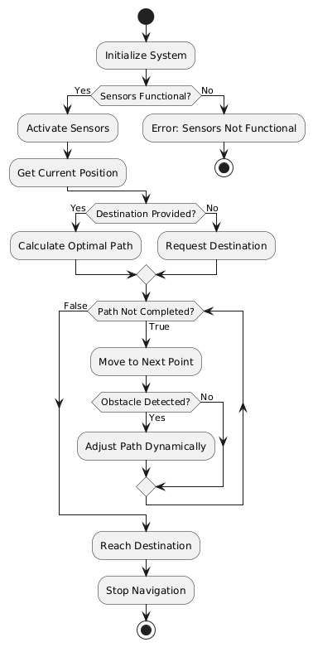

Figure 3.5: Activity Diagram.

3.6 Sequence Design
Interaction Overview in the Maze-Solving Robot Sequence Diagram
In the context of developing a maze-solving robot, the sequence diagram demonstrates how key components interact, including the user, the robot controller, various sensors (such as ultrasonic, gyro, color, and inertial sensors), the mapping module, and the pathfinding algorithm.
The diagram begins with the user interacting with the robot controller to start the maze-solving process. The robot controller communicates with the sensors to gather environmental data, such as distance and orientation measurements. The robot's position on a 2D map is updated based on the collected data. While navigating, the robot continuously collects information to update the map periodically. After sufficient data is gathered, the robot uses Dijkstra's algorithm to calculate the shortest path to the goal. The robot then executes the movement based on the calculated path and notifies the user upon completion of the maze-solving task.

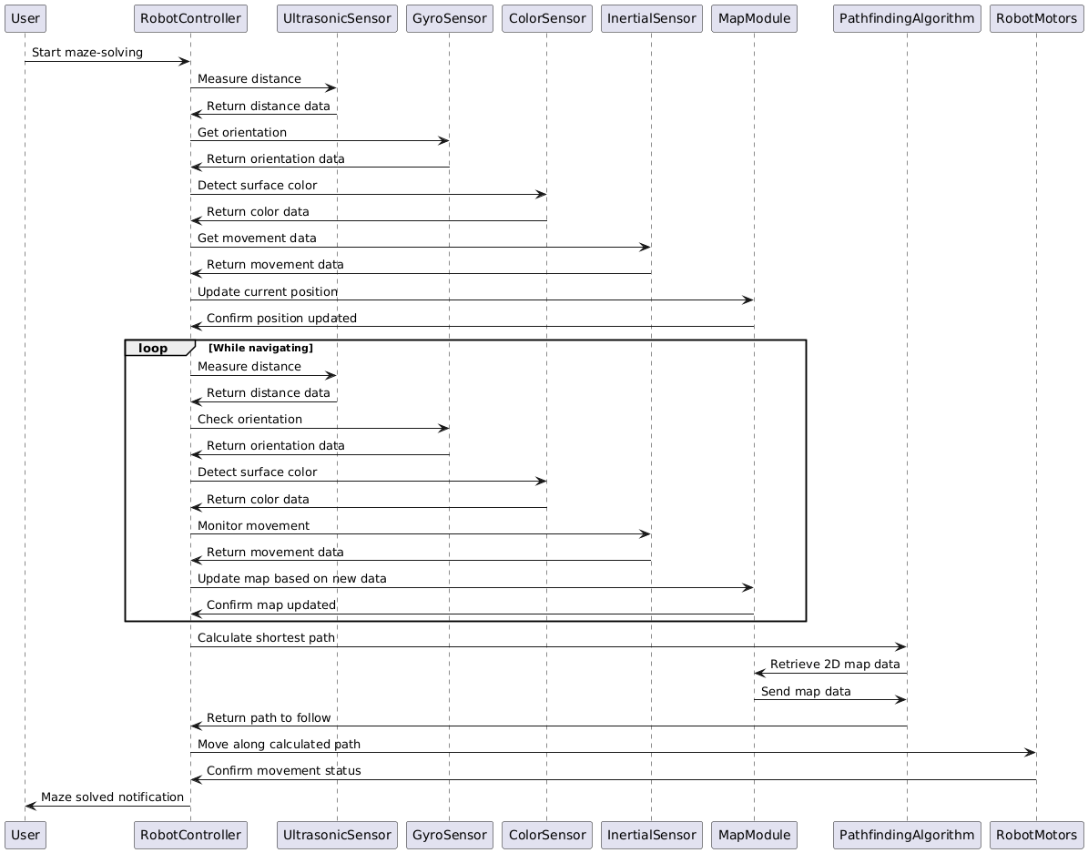
Figure 3.7: Sequence Diagram.
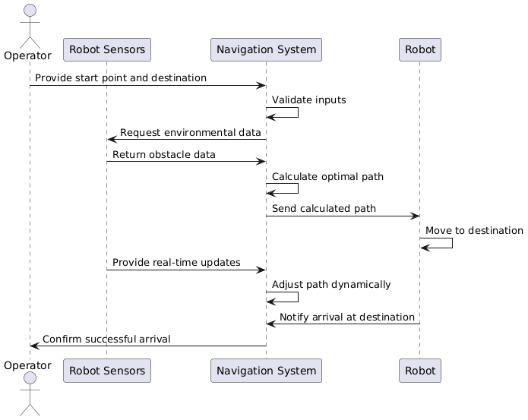
Figure 3.8: Sequence Diagram.
Actors 1. Operator: Defines start and destination points, monitors the system.
2. Robot Sensors: Provide real-time updates and detect obstacles.

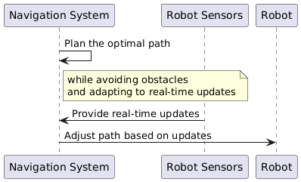
Figure 3.9: Sequence Diagram.
Main Function Plan the optimal path for the robot while avoiding obstacles and adapting to real-time updates.
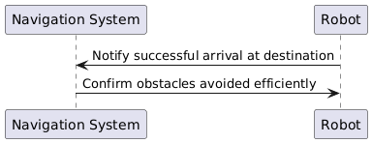
Figure 3.10: Sequence Diagram.
Postconditions 1. Robot successfully reaches the destination.
2.Obstacles are avoided efficiently.

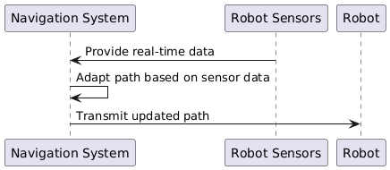
Figure 3.11: Sequence Diagram.
Real-Time Adjustments
The system continuously adapts the path using real-time data from sensors to ensure safe and efficient navigation.
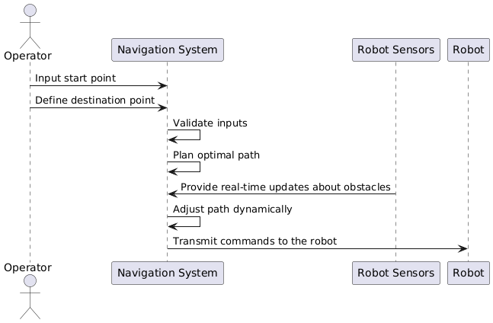
Figure 3.12: Sequence Diagram.
Steps
1. The Operator inputs the start point into the system.
2. The Operator defines the destination point.
3. The System validates inputs and plans the optimal path.
4. Robot Sensors provide real-time updates about obstacles.
5. The System adjusts the path dynamically to avoid obstacles.
6. The System transmits commands to the robot.
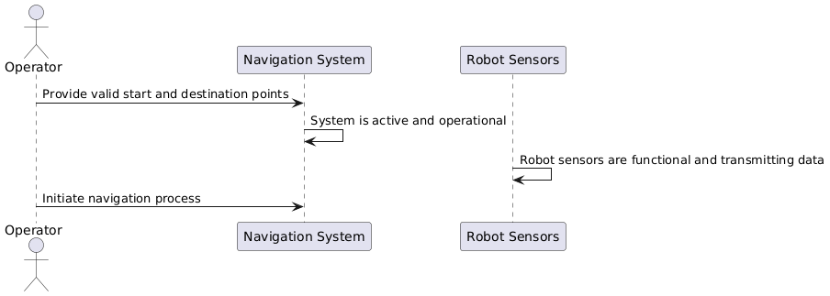 Figure 3.13: Sequence Diagram.
Preconditions
1. System is active and operational.
2. Robot sensors are functional and transmitting data.
3. Valid start and destination points are provided by the Operator.

REFERENCES
[1] Experimentation on the motion of an obstacle avoiding robot
[2] Design and Implementation of a Real-Time Autonomous Navigation System Applied to Lego Robots
[3] https://en.m.wikipedia.org/wiki/Dijkstra%27s_algorithm
[4] https://en.wikipedia.org/wiki/Maze-solving_algorithm
[5] https://ocw.mit.edu/courses/6-034-artificial-intelligence-fall-2010/resources/lecture-4-search-depth-first-hill-climbing-beam/
[6] Design and Implementation of a Real-Time Autonomous Navigation System Applied to Lego Robots
[7] Autonomous Navigation of a Lego Robot with Neural Networks
[8] A Comparative Study of Bug Algorithms for Robot Navigation
[9] Autonomous Navigation of Mobile Robot Based on Flood Fill Algorithm
[10] Experimentation on the motion of an obstacle avoiding robot
[11] Maze solving robot with automated obstacle avoidance
[12] AnAutonomousMaze-Solving Robotic System Based on an Enhanced Wall-Follower Approach
[13] Shortest path traversal in a maze with wall following robot
[14] https://github.com/resources/articles/software-development/what-is-sdlc
[15] https://artoftesting.com/waterfall-model
[16] https://deeprojectmanager.com/functional-vs-non-functional-requirements/

