Project
  - Deadline: Day 02.12.2026 @ 23:59
[Total Mark is 14]

Natural Language Processing
DS483

Instructions:
- You must submit two separate copies (one Word file and one PDF file) using the Assignment Template on Blackboard via the allocated folder. These files must not be in compressed format.
- It is your responsibility to check and make sure that you have uploaded both the correct files.
- Zero mark will be given if you try to bypass the SafeAssign (e.g. misspell words, remove spaces between words, hide characters, use different character sets, convert text into image or languages other than English or any kind of manipulation).
- Email submission will not be accepted.
- You are advised to make your work clear and well-presented. This includes filling your information on the cover page.
- You must use this template, failing which will result in zero mark.
- You MUST show all your work, and text must not be converted into an image, unless specified otherwise by the question.
- Late submission will result in ZERO mark.
- The work should be your own, copying from students or other resources will result in ZERO mark.
- Use Times New Roman font for all your answers.
Student Details: CRN:
Name:  Name:  Name:  Name: |  | ID:  ID:  ID:  ID:

Deliverables
- Your project report that should contain your answers to the five project tasks, including the required results, analysis, and discussion.
- A Jupyter Notebook containing the complete implementation and outputs. All models must use the same test data to ensure a fair comparison.
- One shared GitHub repository per group documenting the project history and development timeline. The repository must be publicly accessible to allow verification and must show incremental progress and contributions from each group member through the commit history. Each group member must commit regularly (at least once per week) using clear and descriptive commit messages. A separate PDF file must also be submitted containing the public GitHub repository link and screenshots of the commit history, clearly showing the contributions and timestamps of all group members.

Important Notes
- AI use: Students may use AI tools (ChatGPT, Claude, Copilot, Gemini, etc.) only for brainstorming approaches or debugging small errors. AI must not be used to generate analysis, write code logic, or produce substantial portions of report or codebase. AI use beyond this scope will result in a zero grade for the entire project.
- Any submission lacking a valid, inspectable version/commit history, or showing evidence of AI generation or plagiarism, will receive a zero grade for the entire project.

Scenario

A telecommunications company receives a large volume of SMS messages through its network. While most messages are legitimate communications, some contain unsolicited advertisements, fraudulent offers, prize notifications, phishing attempts, or other forms of spam. The company would like to develop an intelligent Natural Language Processing (NLP) system capable of automatically distinguishing between:
- Ham: legitimate SMS messages
- Spam: unwanted or unsolicited SMS messages
Your task is to develop and evaluate an NLP-based spam detection system by applying techniques studied throughout the course. You will investigate the text, transform it into appropriate representations, develop different generations of NLP classification models, and determine which approach is most appropriate for deployment.
Use the SMS Spam Collection dataset available from the UCI Machine Learning Repository. The dataset contains 5,574 labeled SMS messages classified as either ham or spam.
Dataset source: https://archive.ics.uci.edu/dataset/228/sms+spam+collection

DS483 – Natural Language Processing
Project Report
SMS Spam Detection: From TF-IDF Classifiers to
Transformers

Dataset and Experimental Setup
The project uses the SMS Spam Collection from the UCI Machine Learning Repository (Almeida et al., 2011), which contains 5,574 labelled messages. The raw file contains 403 exact duplicate messages. If a duplicate falls in both the training and the test split, the test score is inflated because the model has already seen the message, so all duplicates were removed before splitting. This leaves 5,171 unique messages (4,518 ham, 653 spam).
The data were split once with stratification (random seed 42) into 3,619 training, 776 validation and 776 test messages; every split contains 12.6% spam. All four models were trained on the same training split, tuned using either 5-fold cross-validation inside the training split (Naive Bayes, Logistic Regression) or the validation split (BiLSTM, DistilBERT), and evaluated once on the same test split, which contains 98 spam and 678 ham messages. Because only about one message in eight is spam, accuracy alone is misleading (a model that always predicts ham would score 87.4%). Results are therefore reported mainly with spam-class precision, recall and F1, together with ROC-AUC. A decision threshold of 0.5 is used for every model.
Table 1. Dataset after duplicate removal and the three splits.
Split | Messages | Spam | Ham
All (unique) | 5,171 | 653 | 4,518
Training | 3,619 | 457 | 3,162
Validation | 776 | ≈ 98 | ≈ 678
Test | 776 | 98 | 678

Task 1: Text Preprocessing
Explore the SMS dataset and prepare the messages for subsequent NLP analysis. Your analysis should examine the distribution of ham and spam messages and identify textual characteristics that may help distinguish between the two classes. Design and implement an appropriate text preprocessing pipeline using techniques covered in the course, such as regular expressions, tokenization, case normalization, punctuation handling, stopword removal, and stemming where appropriate. Clearly present the preprocessing steps, provide examples of messages before and after preprocessing, and justify your choices. [2.5 marks]

Learning Outcome(s):
CLO1 Explain the fundamental concepts, models and algorithms of natural language processing.

1.1 Class distribution and textual characteristics
The dataset is imbalanced: 87.4% of the messages are ham and 12.6% are spam (Figure 1, left). This is why the later tasks use class-sensitive metrics and, for the Logistic Regression, BiLSTM and DistilBERT models, class weighting.
Spam and ham differ clearly in surface form (Table 2). Spam messages are about twice as long (138 versus 71 characters on average, Figure 1 right) and contain far more digits (15.5 versus 0.3 per message). 73.7% of spam messages contain a number of five or more digits, typically a phone number or a short code, compared with 0.1% of ham messages. Currency symbols appear in 33.2% of spam against 0.4% of ham, and URLs in 17.8% against 0.3%. Spam also uses more capital letters (11.0% of characters against 5.7%) and more exclamation marks.
Table 2. Mean value of simple text features per class (unique messages).
Feature | Ham | Spam
Characters | 70.9 | 137.7
Words | 14.2 | 23.7
Digits | 0.30 | 15.49
Upper-case ratio | 0.057 | 0.110
Contains URL | 0.003 | 0.178
Contains £ / $ / € | 0.004 | 0.332
Contains number of 5+ digits | 0.001 | 0.737
Exclamation marks | 0.18 | 0.70
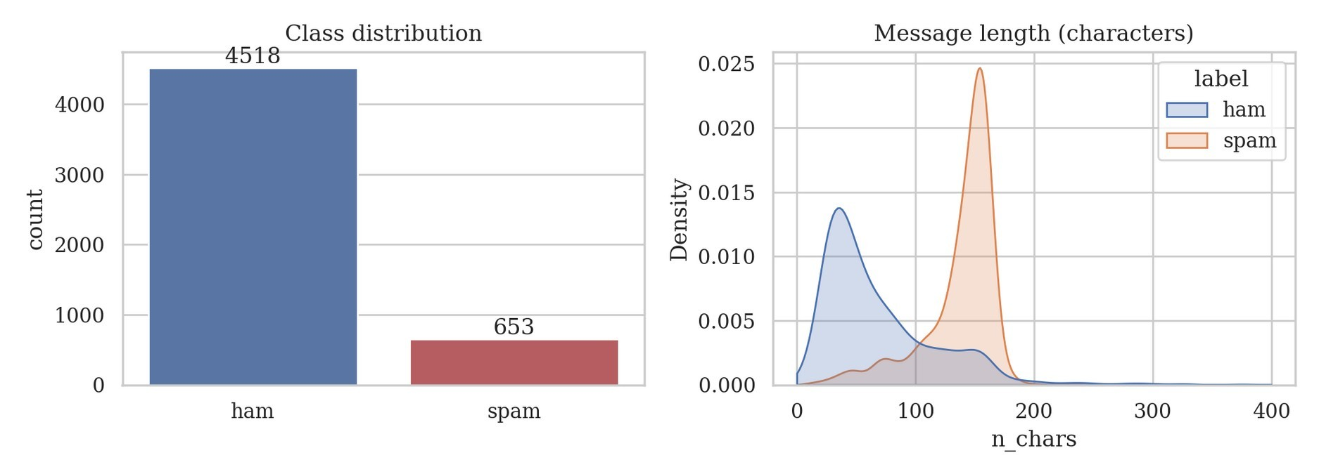
Figure 1. Class distribution (left) and message length in characters per class (right).
The most frequent content words also separate the classes (Figure 2). Spam is dominated by action words such as “call”, “free”, “txt”, “stop”, “mobile” and “claim”, while ham consists of everyday conversational words (“get”, “ok”, “go”, “know”, “good”). The tokens “gt” and “lt” are frequent in ham; they are most likely remnants of HTML-escaped placeholders in the corpus and not real vocabulary, a point that matters later when the model weights are interpreted.
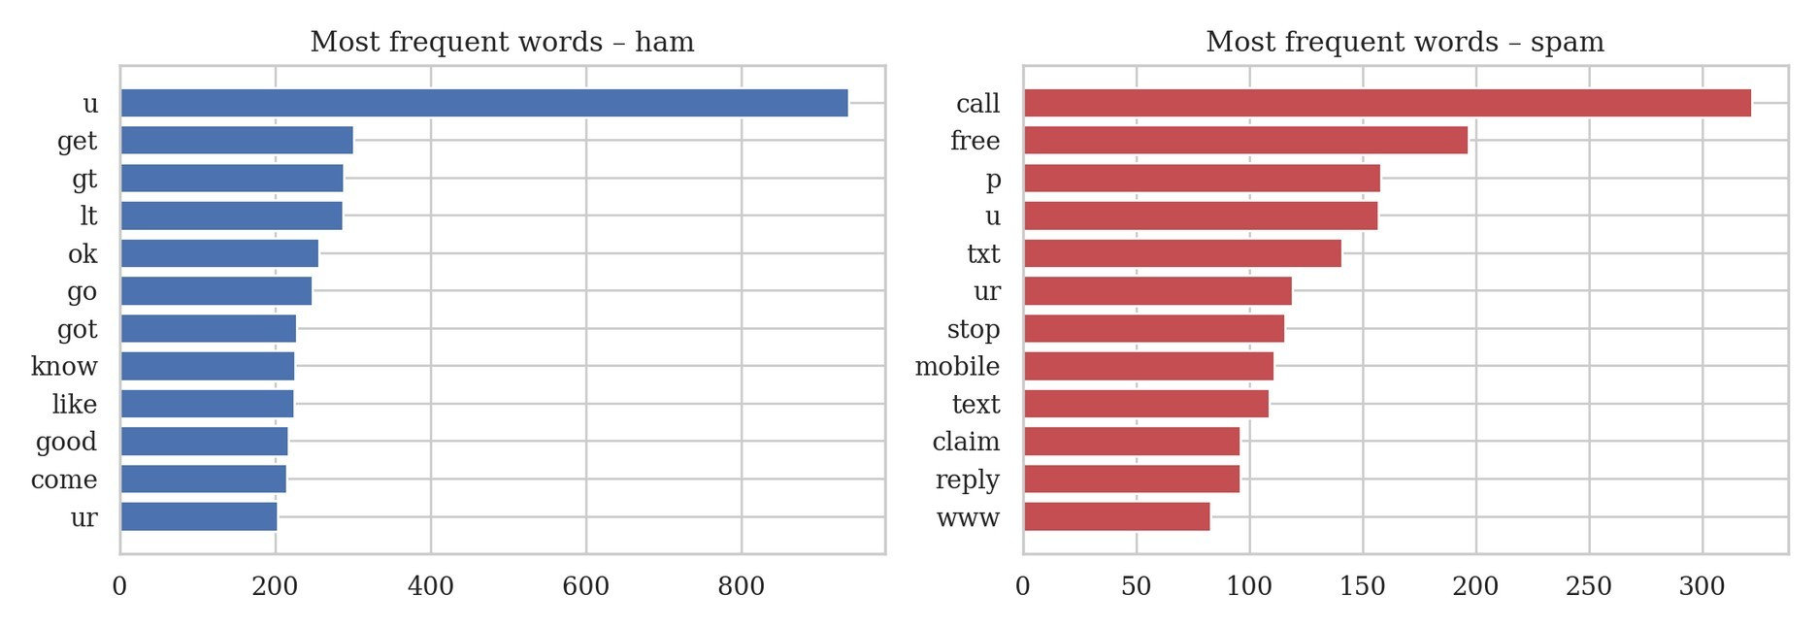
Figure 2. Most frequent words per class after removing English stop-words.
1.2 Preprocessing pipeline and justification The pipeline applies the following steps in order:
- Regular-expression normalisation. E-mail addresses, URLs, currency amounts, long digit strings (five or more digits) and other numbers are replaced by the placeholder tokens emailtok, urltok, moneytok, phonetok and numtok. The exact phone number or price is almost never repeated across messages, but the presence of a phone number, a price or a link is a strong spam signal, so the placeholder keeps the signal and removes the sparsity.
- Case normalisation. All text is lower-cased so that “FREE”, “Free” and “free” share one feature.
- Punctuation removal and tokenisation. A regular expression keeps alphabetic tokens only. A simple regular-expression tokenizer was preferred to a trained one because SMS text contains abbreviations (“u”, “ur”, “txt”) and irregular punctuation.
- Stop-word removal and stemming (optional). The NLTK English stop-word list and the Porter stemmer were evaluated rather than assumed, as explained below.
Stop-word removal and stemming are standard steps, but they do not help every task. Many stop-words (“you”, “your”, “to”) are typical of the second-person, imperative style of spam. The two steps were therefore compared with an ablation: a TF-IDF plus Logistic Regression classifier was evaluated with 5-fold stratified cross-validation on the training split only, with the vectorizer refitted inside each fold to avoid leakage (Table 3).
Table 3. Preprocessing ablation (5-fold CV on the training split, spam-class F1).
Variant | Vocabulary | CV F1 (mean) | CV F1 (std)
lower + punctuation only | 6,276 | 0.9442 | 0.0094
+ stop-word removal | 6,134 | 0.9228 | 0.0079
+ stemming | 5,206 | 0.9461 | 0.0114
+ stop-words + stemming | 5,096 | 0.9250 | 0.0064
The selected variant is highlighted.
Removing stop-words reduced the F1 score by about two points (0.9442 to 0.9228), which confirms that function words carry useful information in this task. Stemming gave a marginally higher F1 (0.9461 against 0.9442); this difference is smaller than one standard deviation and should not be called a real improvement, but stemming shrinks the vocabulary by 17% (6,276 to 5,206 terms) by merging inflected forms such as “claims” and “claimed”, which is useful with a training set of only about 3,600 messages. The final pipeline for the classical models is therefore normalisation, lower-casing, tokenisation and stemming, without stop-word removal.
Table 4 shows examples before and after preprocessing.
Table 4. Examples of messages before and after preprocessing.
Class | Original message | After preprocessing
spam | 1000's of girls many local 2 u who r virgins 2 this & r ready 2 4fil ur every sexual need. Can u 4fil theirs?  text CUTE to 69911(£1.50p. m) | numtok s of girl mani local numtok u who r virgin numtok thi r readi numtok fil ur everi sexual need can u fil their text cute to phonetok moneytok p m
spam | PRIVATE! Your 2003 Account Statement for shows  800 un-redeemed S.I.M. points. Call 08718738001  Identifier Code: 49557 Expires 26/11/04 | privat your numtok account statement for show numtok un redeem s i m point call phonetok identifi code phonetok expir numtok numtok numtok
spam | http//tms. widelive.com/index. wml?  id=820554ad0a1705572711&first=true¡C C Ringtone¡ | http tm urltok wml id ad a first true c c rington
ham | Ah you see. You have to be in the lingo. I will let you know wot on earth it is when has finished making it! | ah you see you have to be in the lingo i will let you know wot on earth it is when ha finish make it
Class | Original message | After preprocessing
ham | We spend our days waiting for the ideal path to appear in front of us.. But what we forget is.. "paths are made by walking.. not by waiting.." Goodnight! | we spend our day wait for the ideal path to appear in front of us but what we forget is path are made by  walk not by wait goodnight
ham | Package all your programs well | packag all your program well
The examples show the intended effects: the phone number 69911 and the price £1.50p become phonetok and moneytok, “girls” and “virgins” are reduced to “girl” and “virgin”, and punctuation disappears. They also show limitations. The malformed URL in the third message is only partly recognised (“http tm urltok wml …”), “1000’s” becomes “numtok s”, and the Porter stemmer produces non-words such as “mani” and “ha” (from “has”). These errors are tolerated because the downstream models only need consistent features, not readable text.

Task 2: Vector Representation and Similarity
Represent the SMS messages using TF-IDF and use cosine similarity to identify similar messages. Present representative results and explain how TF-IDF and cosine similarity capture important relationships between SMS messages. [2.5 marks]

Learning Outcome(s):
CLO1 Explain the fundamental concepts, models and algorithms of natural language processing.

2.1 TF-IDF representation
Each preprocessed message is represented as a TF-IDF vector. The term frequency is damped with a logarithm (sublinear tf, 1 + log tf), the inverse document frequency downweights terms that occur in many messages, and every vector is length-normalised. The vectorizer was fitted on the training split only. The weight of term t in message d is therefore high when t is frequent in d but rare in the collection, which is exactly the property of words such as “claim” or “voda” that identify a spam template, and low for words such as “the” or “you” that occur everywhere.
The terms with the highest average TF-IDF weight confirm the observations from Task 1 (Table 5). For spam they are led by the placeholders phonetok, numtok and moneytok, followed by “call”, “free” and urltok. For ham the top terms are common function words such as “you”, “the”, “it”, “me” and “my”, which reflect personal conversation and not any single topic.
Table 5. Terms with the highest mean TF-IDF weight in each class (training split).
Rank | Spam (mean weight) | Ham (mean weight)
1 | phonetok (0.116) | you (0.045)
2 | numtok (0.110) | to (0.033)
3 | moneytok (0.087) | the (0.027)
4 | call (0.070) | it (0.026)
5 | to (0.068) | me (0.025)
6 | your (0.048) | in (0.024)
7 | free (0.047) | and (0.022)
8 | urltok (0.037) | my (0.022)
9 | for (0.037) | numtok (0.021)
10 | you (0.036) | that (0.020)

2.2 Cosine similarity
The cosine similarity of two messages is the dot product of their TF-IDF vectors divided by the product of their lengths, so it measures the angle between them and ignores message length. A value of 1 means the two messages use the same weighted terms; 0 means they share no terms.
Three test messages were used as queries against the training messages (Table 6).
Table 6. Query messages and their most similar training message.
Query (test message, truncated) | Most similar training message (truncated) | Cosine | Label
Todays Voda numbers ending 5226 are selected to receive a £350 award. If you have a match please call 08712300220… | Todays Voda numbers ending 7548 are selected to receive a $350 award. If you hav… | 0.981 | spam
Dear Voucher Holder, 2 claim this weeks offer, at your PC go to http://www.etlp.co.uk/expressoffer… | Dear Voucher Holder, To claim this weeks offer, at your PC please go to http://w… | 0.866 | spam
Awesome question with a cute answer:  Someone asked a boy “how is ur life?” … Gudnite (ham) | Ur balance is now £500. Ur next question is: Who sang 'Uptown Girl' in the 80's … | 0.316 | spam
The first query is a prize notification. Its two nearest neighbours both have a cosine of 0.981 and differ from it only in the number and the currency symbol, which shows that spam is largely produced from templates. The terms contributing most to the similarity are template words (“voda”, “standard”, “quot”, “app”), not the digits. The second query matches a near-identical voucher message (0.866), and the next-best matches drop sharply to about 0.38, showing that cosine similarity separates a true template match from a merely topical one.
The third query is an innocent ham message and is a useful counter-example. Its closest training message is a spam quiz message (cosine 0.316), because both contain the words “question” and “answer”, while the true ham neighbours score lower (about 0.20). TF-IDF similarity is purely lexical: it has no notion of meaning, synonymy or word order, so overlapping vocabulary can be mistaken for similar content. The score of 0.32 is, however, low in absolute terms, which is a useful warning that the match is weak.
The same pattern appears at class level. For 300 randomly chosen messages per class, the mean pairwise cosine similarity is 0.083 within spam, but only 0.020 within ham and 0.019 between ham and spam (Figure 3). Spam messages are therefore about four times more similar to each other than ham messages are, because they share templates, while ham messages are so diverse that they are no more similar to each other than to spam. As a quantitative check, a 1-nearestneighbour classifier based on cosine similarity reaches an accuracy of 97.2% on the test set but a spam recall of only 83.7% (precision 93.2%, F1 0.882); it catches template spam well but misses a spam message whose nearest training neighbour happens to be ham.
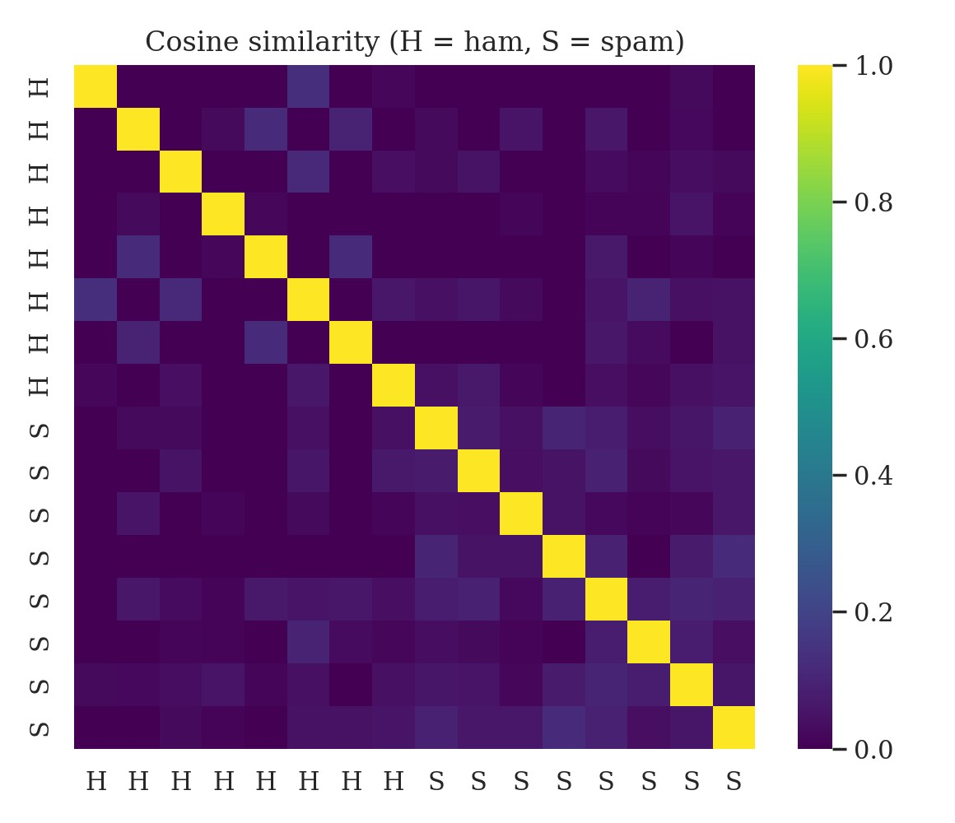
Figure 3. Cosine similarity between 8 ham (H) and 8 spam (S) training messages.

Task 3: Text Classification
Develop Naive Bayes and Logistic Regression models to classify SMS messages as ham or spam. Evaluate and compare the models using appropriate classification metrics and analyze examples of incorrectly classified messages. [3 marks]

Learning Outcome(s):
CLO4 Evaluate natural language processing models for their performance, fairness, explainability, and robustness.

3.1 Models and tuning
Two classical classifiers were built on top of a TF-IDF vectorizer inside a single scikit-learn pipeline, so that the vectorizer is refitted within every cross-validation fold. Hyper-parameters were chosen by grid search with 5-fold stratified cross-validation on the training split, using the F1 score of the spam class as the criterion. The selected Multinomial Naive Bayes uses unigrams and bigrams, no minimum document frequency and a smoothing parameter α = 0.05 (cross-validated F1 0.9512). The selected Logistic Regression uses unigrams and bigrams with a minimum document frequency of 2, C = 100 and balanced class weights (cross-validated F1 0.9588).

3.2 Test results
Table 7. Test-set results of the two classical models (spam is the positive class).
Model | Accuracy | Precision | Recall | F1 | ROC-AUC | FP | FN
Naive Bayes | 0.9910 | 0.9892 | 0.9388 | 0.9634 | 0.9955 | 1 | 6
Logistic Regression | 0.9936 | 1.0000 | 0.9490 | 0.9738 | 0.9969 | 0 | 5
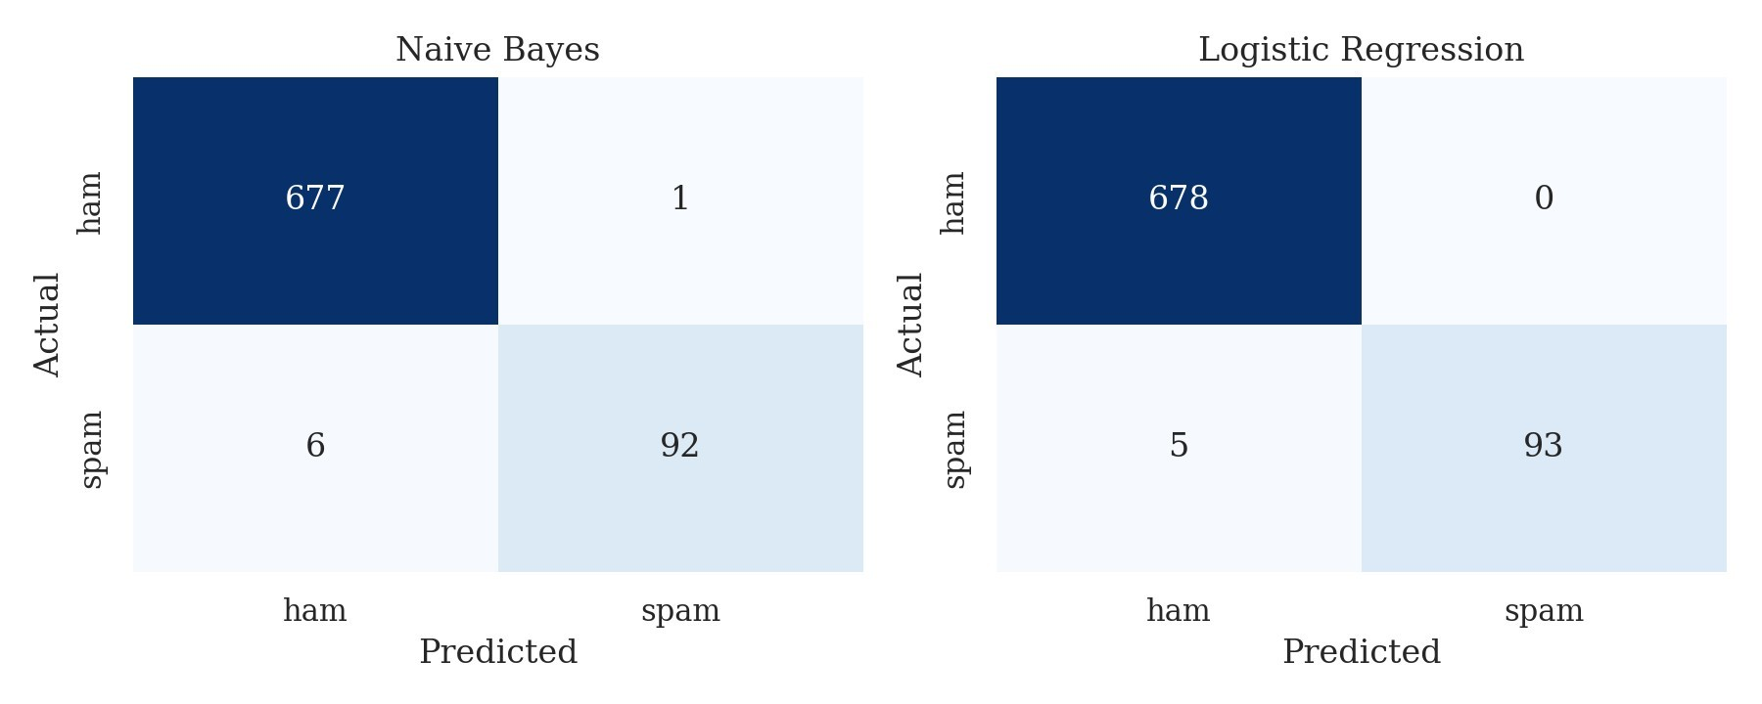
Figure 4. Confusion matrices on the test set for Naive Bayes (left) and Logistic Regression (right).
Both models perform very well. Logistic Regression is better on every metric: it makes no false positives (precision 1.000) and misses 5 of 98 spam messages (recall 0.949), giving an F1 of 0.974. Naive Bayes has one false positive and 6 false negatives (F1 0.963). The ordering matches the cross-validation scores (0.959 against 0.951), which makes it more credible. The gap is nevertheless small: one message is about one point of recall on a test set with only 98 spam messages, so the two models should be regarded as close. The Logistic Regression is a discriminative model that learns how strongly each feature separates the classes, whereas Naive Bayes assumes the features are conditionally independent; this assumption is violated by overlapping unigrams and bigrams, which is a plausible reason for the small difference.

3.3 Error analysis
The only false positive of Naive Bayes is “Unlimited texts. Limited minutes.” (spam probability 0.774). It is a legitimate message but its wording resembles a mobile-tariff advertisement, which is very common in the spam class. The false negatives of the two models overlap strongly. All 5 messages missed by Logistic Regression are also missed by Naive Bayes, and they share two features: none contains a phone number or a link, and all are written in conversational or ordinary promotional language (Table 8).
Table 8. Spam messages missed by Logistic Regression (spam probability of the model in brackets).
Message | P(spam)
Would you like to see my XXX pics they are so hot they were nearly banned in the uk! | 0.014
Burger King - Wanna play footy at a top stadium? Get 2 Burger King before 1st Sept and go Large or Super with Coca-Cola and wal… | 0.051
Latest News! Police station toilet stolen, cops have nothing to go on! | 0.009
Babe: U want me dont u baby! Im nasty and have a thing 4 filthyguys. Fancy a rude time with a sexy bitch. How about we go slo n… | 0.091
Oh my god! I've found your number again! I'm so glad, text me back xafter this msgs cst std ntwk chg £1.50 | 0.117
These messages are conversational (“Oh my god! I’ve found your number again!”), promotional without an explicit call to action (“Burger King …”, “Latest News! Police station toilet stolen …”) or adult content phrased in ordinary words. A bag-of-words model has only individual terms to work with, and the terms in these messages are the same as in ham. Some of them are probably also hard for a human annotator without knowing the sender.
The coefficients of the Logistic Regression make the model explainable. The strongest spam indicators are the placeholders phonetok (24.67), moneytok (17) and urltok (15.69), followed by the stems “repli”, “txt” and “free” and the bigram “call phonetok”. The strongest ham indicators are personal words (“my”, “me”, “can”, “that”). This agrees with the exploratory analysis and shows that the regular-expression placeholders of Task 1 became the most important features. It also exposes a weakness: “gt” and “lt” are among the strongest ham indicators, although they are artefacts of the corpus and not real words, so the model partly relies on a dataset quirk that would not transfer to new data.

Task 4: Sequence-Based Classification
Develop an LSTM-based model for SMS spam classification and evaluate its performance on unseen data. Compare its results with the classical classifiers and discuss whether modeling the sequential nature of text improves classification performance. [3 marks]

Learning Outcome(s):
CLO3 Apply natural language processing algorithms to realistic problems including machine translation, chatbots and other applications.

4.1 Model and training
The sequence model is a bidirectional LSTM implemented in PyTorch. Messages are lowercased and normalised with the same placeholders as before, but stop-words are kept and no stemming is applied, because a sequence model needs the original word order and function words; “!” and “?” are kept as tokens. The vocabulary contains the 2,923 words that occur at least twice in the training split, and messages are truncated or padded to 41 tokens (the 98th percentile of the length distribution). The network has a 100-dimensional embedding layer trained from scratch, a bidirectional LSTM with 64 units per direction, dropout of 0.4 and a single output unit, with 377,421 trainable parameters. It was trained with Adam (learning rate 0.002), a binary cross-entropy loss weighted by the ham-to-spam ratio, and early stopping on the validation F1 score with a patience of four epochs; the best epoch was restored.
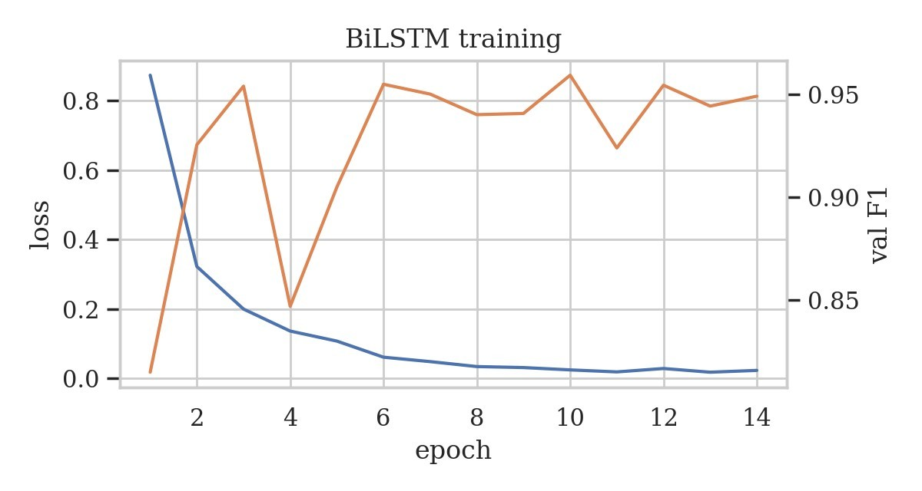
Figure 5. Training loss and validation F1 of the BiLSTM per epoch.
The training loss falls steadily, but the validation F1 is unstable: after epoch 2 it fluctuates between 0.847 and 0.959, and the best value (0.959) was reached at epoch 10, so the selection of the best epoch is itself somewhat noisy. This is typical for a recurrent network trained on about 3,600 messages with only about 460 spam examples.

4.2 Test results and comparison with the classical models
Table 9. Test-set results of the BiLSTM compared with the classical models.
Model | Accuracy | Precision | Recall | F1 | ROC-AUC | FP | FN
Naive Bayes | 0.9910 | 0.9892 | 0.9388 | 0.9634 | 0.9955 | 1 | 6
Logistic Regression | 0.9936 | 1.0000 | 0.9490 | 0.9738 | 0.9969 | 0 | 5
BiLSTM | 0.9845 | 0.9388 | 0.9388 | 0.9388 | 0.9937 | 6 | 6
The BiLSTM reaches an F1 of 0.939, below both Naive Bayes (0.963) and Logistic Regression (0.974). Its recall equals that of Naive Bayes, but it makes 6 false positives against 1 and 0, so its precision is lower. Most of its false positives are legitimate messages that read like service or commercial messages (“Have you laid your airtel line to rest?”, a bank security warning, a survey asking the user to “Reply Toll Free”), and the network is very confident about them (probabilities between 0.83 and 1.00), which suggests that it overfits to surface patterns. In total it misclassifies 12 test messages, against 5 for Logistic Regression.
4.3 Does modelling word order help?
To test directly whether the models use word order, the words of every test message were randomly shuffled and the models were evaluated again, without retraining (Table 10). A bagof-words model is almost unaffected by shuffling by construction; a model that exploits sequence information should lose performance.
Table 10. Test F1 before and after shuffling the word order of each test message.
Model | F1 original | F1 shuffled | Drop
Naive Bayes | 0.9634 | 0.9574 | 0.0059
Logistic Regression | 0.9738 | 0.9688 | 0.0051
BiLSTM | 0.9388 | 0.9381 | 0.0006
The BiLSTM loses almost nothing (0.0006), no more than the bag-of-words models (0.0059 and 0.0051). Although the BiLSTM is a sequence model, it has effectively learned a bag-ofwords classifier, so modelling the sequential nature of the text did not improve classification here. Three reasons are plausible. SMS messages are very short, so there is little structure to model. Spam is identified mainly by vocabulary (“free”, “claim”, phone numbers, links) and not by syntax. And a recurrent network with 377,421 parameters trained from scratch on a few hundred spam examples has far more capacity than data. This conclusion applies to this dataset and this run; tasks in which order carries meaning, such as negation in sentiment analysis, may behave differently.

Task 5: Transformer-Based Classification
Fine-tune a pretrained BERT-family model for SMS spam classification and evaluate its performance. Compare it with the previous models and recommend the most suitable approach for deployment based on performance, errors, and model complexity. [3 marks]

Learning Outcome(s):
CLO2 Recognize different machine learning methodologies suitable for natural language processing tasks.

5.1 Fine-tuning DistilBERT
A pretrained DistilBERT model (distilbert-base-uncased, a distilled version of BERT with about 67 million parameters; Sanh et al., 2019) was fine-tuned for sequence classification. The raw message text is given to the model’s own WordPiece tokenizer without any manual cleaning, since the pretrained model has been trained on natural text and handles casing, punctuation and sub-words itself. Messages were truncated to 128 tokens. Training used AdamW with a learning rate of 2e-5, a batch size of 32, 10% linear warm-up followed by linear decay, a class-weighted cross-entropy loss, mixed precision and three epochs on a GPU. The epoch with the best validation F1 was kept: validation F1 was 0.914, 0.969, 0.939 in epochs 1 to 3, so the model after epoch 2 (0.969) was used, because the validation F1 dropped again in epoch 3.

5.2 Comparison of all models
Table 11. Test-set performance, errors, training time, inference latency and size of all models.
Model | Accuracy | Precision | Recall | F1 | ROC-AUC | FP | FN
Naive Bayes | 0.9910 | 0.9892 | 0.9388 | 0.9634 | 0.9955 | 1 | 6
Logistic Regression | 0.9936 | 1.0000 | 0.9490 | 0.9738 | 0.9969 | 0 | 5
BiLSTM | 0.9845 | 0.9388 | 0.9388 | 0.9388 | 0.9937 | 6 | 6
DistilBERT | 0.9910 | 0.9892 | 0.9388 | 0.9634 | 0.9966 | 1 | 6
Table 12. Computational cost of the models.
Model | Parameters | Training time (s) | Inference (ms per message)
Naive Bayes | 69,266 | 18.3 | 0.124
Logistic Regression | 8,644 | 26.1 | 0.105
BiLSTM | 377,421 | 8.9 | 0.077
DistilBERT | 66,955,010 | 29.2 | 1.967
Best value per column is shaded in Table 11. Training time for the two classical models includes the full grid search with cross-validation; the BiLSTM and DistilBERT times cover one training run on a GPU. Latency is the time per message on the test set including preprocessing; DistilBERT was measured with batched GPU inference, so a CPU-only deployment would very likely be slower.
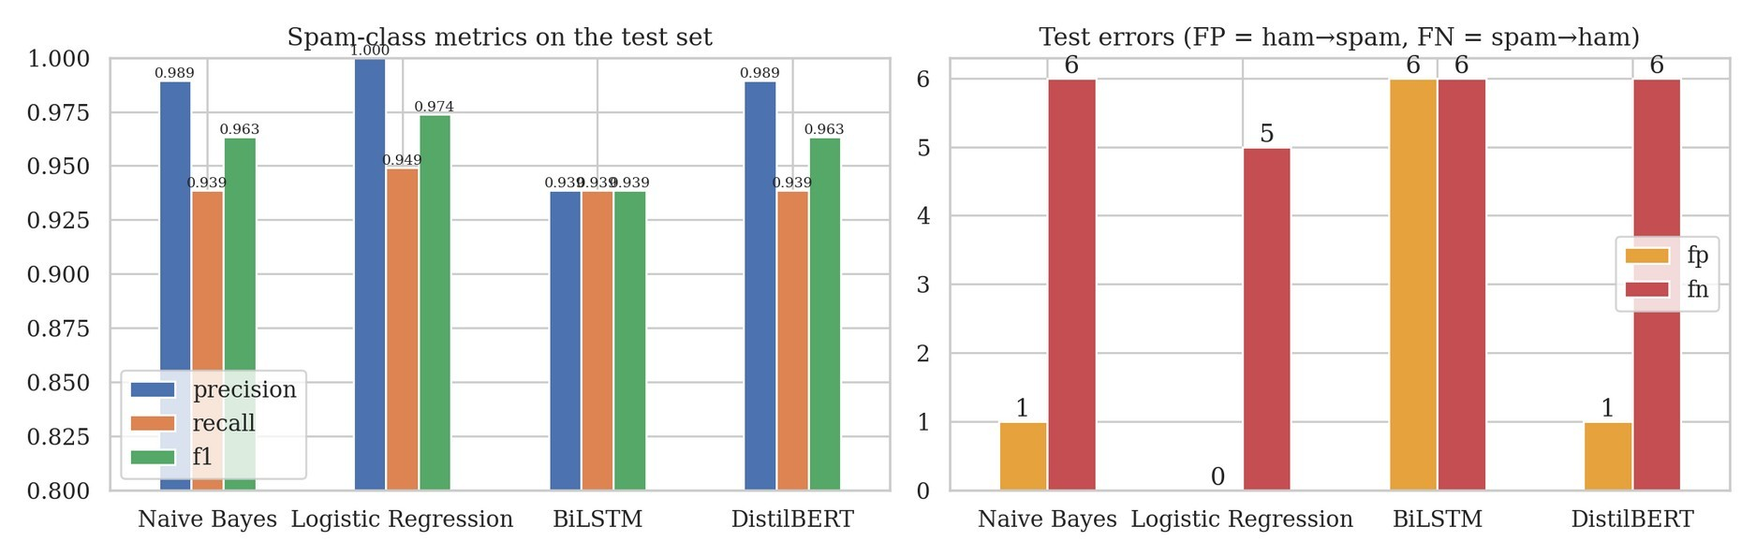
Figure 6. Spam-class precision, recall and F1 (left) and number of false positives and false negatives (right) for all models.
DistilBERT obtains an F1 of 0.963, with one false positive and 6 false negatives. This is the same count of errors as Naive Bayes and lower than Logistic Regression (0.974), even though DistilBERT has 7,746 times more parameters than the Logistic Regression and is about 19 times slower per message. Logistic Regression is also best on precision, recall and ROC-AUC (0.9969 against 0.9966). The pretrained language model therefore gave no measurable benefit on this dataset.
The errors of the models overlap strongly. Only 3 test messages are misclassified by all four models and 15 by at least one model; the number of errors per model is Naive Bayes 7, Logistic Regression 5, BiLSTM 12, DistilBERT 7. The three messages that every model gets wrong are an adult-content message (“Would you like to see my XXX pics …”), a news-style message (“Latest News! Police station toilet stolen …”) and an adult chat-line message. These are spam without strong lexical markers, and even a pretrained model, which should know more about language, does not recognise them, so the limit seems to lie in the information in the messages and possibly in the labels, not in the model. DistilBERT also has its own errors: it misses a ringtone message that Logistic Regression catches (“New Tones This week include …”) and it flags the bank security notice (“Please protect yourself from e-threats …”) as spam with probability 0.854. That message really is an institutional warning that resembles phishing texts, so this error is understandable.
These differences should be interpreted carefully. The test set has 98 spam messages, so one message changes recall by about one percentage point, and all results come from a single split and a single training run. The gaps between Logistic Regression, Naive Bayes and DistilBERT (one or two messages) are within this noise and do not prove that one is better. The weaker BiLSTM (12 errors) is a larger gap, but still rests on one run.

5.3 Deployment recommendation
Recommended approach: TF-IDF with Logistic Regression. It achieved the best F1 score (0.974), the best precision (no legitimate message blocked) and the highest ROC-AUC, and no other model was clearly better on any metric. It is very small (about 8,600 weights), the fastest to run (about 0.1 ms per message on a CPU), cheap to retrain and, as shown in Task 3, explainable: each decision can be justified by the terms that raised the spam score. Explainability and cost matter for a telecommunications operator that processes a very large message volume and must be able to explain why a customer’s message was blocked. A false positive, blocking a legitimate message, is usually more harmful than letting a single spam message through, so the zero false positives of this model are an important advantage.
The main weakness of the recommended model is recall (94.9%): about one spam message in twenty gets through, mostly messages without lexical markers. Possible improvements, none of which were tested here, are to lower the decision threshold if the operator accepts more false alarms, to retrain regularly because spammers change their wording, and to use DistilBERT as a second-stage model only for messages for which the Logistic Regression is uncertain, if future data show that spam increasingly avoids the typical vocabulary. DistilBERT alone is not recommended on this evidence, because its costs (about 67 million parameters, higher latency and the need for GPU or optimised serving) are not matched by better results. The BiLSTM is the least suitable, as it is less accurate than the classical models, unstable during training and does not use word order.

Limitations and Conclusion
The study has four main limitations. The dataset is small (5,171 unique messages, 653 spam) and old, so the results may not transfer to modern spam. Evaluation relies on one stratified split and one run per model, without confidence intervals; repeated cross-validation or bootstrapping would show whether the small differences are stable. The corpus contains artefacts (such as “gt” and “lt”) that models can exploit. Finally, the neural models received only light tuning, and a larger hyper-parameter search or pretrained word embeddings for the BiLSTM might narrow the gap.
In summary, a carefully preprocessed TF-IDF representation with a linear classifier is sufficient to detect SMS spam with an F1 score of about 0.97 on this dataset. More complex models (BiLSTM, DistilBERT) did not improve on it, the BiLSTM did not exploit word order, and the remaining errors are mostly spam messages that look like ordinary conversation. For deployment, Logistic Regression with TF-IDF is the most suitable choice among the four models.

