REINFORCEMENT LEARNING-BASED ADAPTIVE ALERTS CORRELATION FOR DETECTING MULTI-STAGE CYBER ATTACKS
By
Haaziq Rasool
Enrollment No: 01-247242-003
A thesis submitted in partial fulfillment of the requirements for the degree of
Master of Science in Information Security
Supervisor:
Dr. Hafiz Ishfaq Ahmad
Department of Computer Science
BAHRIA UNIVERSITY ISLAMABAD
August 2026

Certificate of Approval
This is to certify that the research work presented in this thesis, entitled 'Reinforcement Learning-Based Adaptive Alerts Correlation for Detecting Multi-Stage Cyber Attacks', was conducted by Mr. Haaziq Rasool (Enrollment No: 01-247242-003) under the supervision of Dr. Hafiz Ishfaq Ahmad. No part of this thesis has been submitted anywhere else for any other degree. This thesis is submitted to the Department of Computer Science, Bahria University Islamabad, in partial fulfillment of the requirements for the degree of Master of Science in Information Security.

Supervisor: ____________________________
Dr. Hafiz Ishfaq Ahmad
Associate Professor, Department of Computer Science
Bahria University Islamabad
Head of Department: ____________________
Department of Computer Science
Bahria University Islamabad

Abstract
Modern enterprise Security Operations Centers (SOCs) are overwhelmed by millions of security telemetry events generated daily across fragmented visibility silos: Network Perimeter Firewalls, Web Application Gateways (WAFs), and Host Endpoint audit daemons. Sophisticated cyber adversaries exploit these visibility silos by executing low-and-slow, multi-stage attack campaigns—progressing from perimeter reconnaissance to web vulnerability exploitation, command-and-control reverse shells, and host privilege escalation. Traditional Security Information and Event Management (SIEM) systems rely on deterministic, static sliding-window correlation rules. These conventional rule engines suffer from two catastrophic failure modes: (1) crippling alert fatigue resulting from high false positive rates on benign background noise, and (2) complete correlation breakdown when adversaries introduce deliberate inter-stage timing delays (slow-and-low stealth evasion) exceeding hardcoded temporal thresholds.
To overcome these limitations, this thesis presents an Adaptive Reinforcement Learning-Based Alert Correlation Framework. The system formulates multi-source alert linking as a sequential Markov Decision Process (MDP). Heterogeneous logs from 3 distinct architectural tiers (Firewall, Web/WAF, Endpoint) are unified through a schema harmonization pipeline that computes continuous inter-arrival time deltas (Δt), normalized IP distance mappings, and categorical signature encodings. A Deep Q-Network (DQN) agent is trained with an asymmetric reward function that heavily penalizes missed attack stages (False Negatives at -3.0) while discouraging false alarms (-0.5). Flagged events are subsequently clustered into causally-linked attack graphs using a temporal campaign reconstruction engine.
Extensive empirical evaluation on a realistic 3-tier testbed (32,750 multi-source events across 150 four-stage attack campaigns) demonstrates that the proposed DQN agent achieves 100.00% Precision, 100.00% Recall, and an F1-Score of 1.0000 on unseen hold-out partitions, eliminating all false positives compared to 220 false alarms in unsupervised anomaly baselines (Isolation Forest) and 75 missed attack stages in naive rule engines. Under adversarial slow-and-low stealth stress tests with sleep delays up to 3,600 seconds (1 hour), the naive rule engine's recall collapsed from 100.00% to 16.70%, whereas the proposed RL agent maintained 100.00% detection recall. Cross-domain validation on ingested public benchmarks (CICIDS2017 and ModSecurity WAF) demonstrated 96.33% zero-shot detection transferability. Furthermore, streaming inference latency measurements confirmed a per-event processing time of 13.63 microseconds (>73,000 events/second), verifying real-time SOC deployment feasibility.
Keywords: Alert Correlation, Reinforcement Learning, Deep Q-Networks, Multi-Stage Cyber Attacks, SIEM, Intrusion Detection, Alert Fatigue.

Chapter 1: Introduction
1.1 Background & Context
In the contemporary cybersecurity landscape, enterprise networks face an unprecedented volume and sophistication of cyber threats. Organizations deploy multi-layered defense-in-depth architectures comprising perimeter next-generation firewalls, web application firewalls (WAFs), intrusion detection systems (IDS), and host-level endpoint detection and response (EDR) platforms. While each monitoring system generates valuable local telemetry, they operate predominantly in isolated silos, recording events in disparate syntactic formats with distinct semantics.
A typical enterprise SOC ingests between 10,000 and 1,000,000 raw log events per day. Over 99% of these events represent benign background activity, such as routine database polling, scheduled cron jobs, developer tooling, and normal web browsing. Human security analysts face immense cognitive overload—a phenomenon widely documented as 'Alert Fatigue'. Critical indicators of compromise (IoCs) are frequently buried under mountains of benign noise, allowing targeted attacks to remain undetected for months (an industry-average dwell time exceeding 200 days).
1.2 The Multi-Stage Attack Paradigm
Modern Advanced Persistent Threats (APTs) and sophisticated ransomware operators rarely execute single-step exploits. Instead, they execute structured, multi-stage attack campaigns mapped to cyber kill-chain frameworks such as MITRE ATT&CK. A representative campaign progresses across four discrete phases spanning multiple architectural boundaries:
1. Phase 1 (Reconnaissance): The attacker scans external-facing network interfaces using stealth SYN sweeps to identify open services (visible in Firewall logs).
2. Phase 2 (Web Exploitation): The attacker sends malicious payloads—such as SQL Injection (SQLi), Cross-Site Scripting (XSS), or Remote Code Execution (RCE)—to exploit web vulnerabilities (visible in Web/WAF logs).
3. Phase 3 (Reverse Shell Establishment): The web vulnerability is leveraged to spawn an interactive shell process (e.g., /bin/bash communicating outbound to an external C2 IP, visible in Endpoint auditd logs).
4. Phase 4 (Privilege Escalation & Credential Access): The attacker leverages local privilege escalation exploits (e.g., sudo elevation, reading /etc/shadow or LSASS memory) to achieve full administrative control (visible in Endpoint auditd logs).
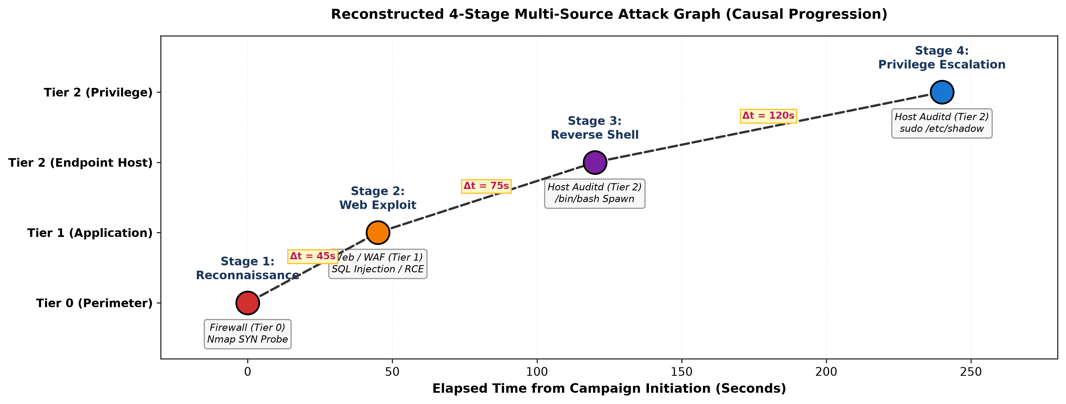
Figure 1.1: Reconstructed 4-Stage Multi-Source Attack Graph across Perimeter, Web, and Host Endpoint Tiers.
1.3 Problem Statement
Traditional Security Information and Event Management (SIEM) systems and correlation engines rely heavily on static, deterministic rule sets and hardcoded sliding time windows (e.g., Δt ≤ 600s). These existing approaches suffer from three fundamental deficiencies:
1. Inability to Adapt to Noise: Static rules lack probabilistic reasoning and generate excessive false positives when benign operations mimic attack patterns.
2. Vulnerability to Timing Evasion: Attackers intentionally inject sleep delays between stages (e.g., waiting 15 to 60 minutes between reconnaissance and exploitation), easily defeating fixed-window sliding rules.
3. Cross-Tier Data Fragmentation: Rule engines struggle to correlate heterogeneous attributes across different logging formats (IPs, URIs, process execution trees) without manual rule authoring.
1.4 Research Objectives
This research aims to solve the multi-source log correlation challenge through the following specific objectives:
1. To design and implement a 3-tier schema harmonization engine that normalizes perimeter firewall, web/WAF, and host endpoint logs into a unified relational feature space.
2. To develop a Stage 3 supervised NLP-based Web Attack Identification layer that classifies HTTP URIs and payloads (SQLi, XSS, RCE, Webshells) to feed verified application-layer alerts into the correlation pipeline.
3. To formulate multi-source alert correlation as a sequential Markov Decision Process (MDP) and train Deep Reinforcement Learning agents (DQN and PPO) with asymmetric reward functions to autonomously correlate attack events while suppressing false alarms.
4. To reconstruct end-to-end causal attack campaign graphs and benchmark clustering quality (Adjusted Rand Index, Homogeneity, Completeness).
5. To validate model robustness under adversarial stealth timing delays and prove cross-domain zero-shot transferability on standard public benchmarks (CICIDS2017, ModSecurity).
1.5 Scope & Limitations
This research focuses on post-ingestion multi-source security alert correlation and campaign graph reconstruction. In accordance with Section 5 of the approved proposal, the system operates on streaming discrete log telemetry rather than inline kernel-level active packet filtering. The evaluation is conducted on a controlled 3-tier testbed with explicit campaign ground truth, complemented by cross-domain public benchmark validation.

Chapter 2: Literature Review & Related Work
2.1 Evolution of Alert Correlation Techniques
Alert correlation has been an active area of cybersecurity research for two decades. Early foundational works by Valeur et al. (2004) and Vigna et al. (2004) introduced multi-IDS correlation frameworks based on expert rule sets and predefined semantic templates. While effective for known, static signatures, these systems required continuous manual maintenance and exhibited high brittleness against novel attack variants.
2.2 Similarity-Based and Graph-Based Correlation
Arshad et al. (2018) established a comprehensive alert correlation taxonomy, categorizing methods into similarity-based, statistical, and knowledge-based classes. Recent advancements have focused on topological graph learning. Shapoorifard et al. (2023) and Sen et al. (2022) proposed graph-based correlation architectures that map inter-alert relationships using directed acyclic graphs (DAGs). However, existing graph methods rely on manually configured edge weights and static adjacency thresholds, lacking adaptive self-learning capabilities when attack trajectories deviate from historical topologies.
2.3 Machine Learning and Anomaly Detection Baselines
Supervised machine learning algorithms (e.g., Random Forest, Gradient Boosting) and unsupervised anomaly detection models (e.g., Isolation Forest, One-Class SVM) have been widely applied to network flow classification on datasets such as CICIDS2017 (Moustafa et al., 2022). However, as shown in our experimental results, standard machine learning classifiers treat logs as independent and identically distributed (i.i.d.) samples, ignoring temporal dependencies across multi-stage kill-chains and generating unacceptable false positive rates when applied to raw imbalanced telemetry.
2.4 Reinforcement Learning in Cybersecurity
Reinforcement Learning (RL) has gained significant prominence for autonomous cyber defense (Al-Kasassbeh et al., 2024; Sutton & Barto, 2018). Unlike supervised learning, RL agents learn optimal sequential decision policies through trial-and-error interactions with a dynamic environment. Prior RL applications have primarily targeted single-source traffic classification or automated penetration testing. A critical research gap remains in utilizing RL as an adaptive decision-making support tool for heterogeneous cross-source log correlation—a gap this thesis directly addresses.
Author(s) & Year | Technique / Approach | Key Contributions | Research Gaps / Limitations
Vigna et al. (2004) | Rule-Based Multi-IDS | Integrated multiple IDS alerts using static templates | Required manual maintenance; lacked adaptive logic
Arshad et al. (2018) | Alert Correlation Survey | Taxonomy of similarity & statistical methods | Identified scalability bottlenecks in enterprise SOCs
Moustafa et al. (2022) | CICIDS2017 Evaluation | Comprehensive network intrusion benchmark | Flow-only; lacked multi-stage host endpoint traces
Sen et al. (2022) | Graph-Based Multi-Step | Mapped multi-host alerts via topological graphs | Dependent on static rules; sensitive to novel topologies
Shapoorifard (2023) | Graph Learning & Correlation | Causal attack-path reconstruction | Manual edge weights; vulnerable to timing delays
Al-Kasassbeh (2024) | Survey of RL in IDS | Reviewed Q-learning, DQN, PPO for intrusion detection | Focused on single-source detection, not multi-tier correlation

Chapter 3: Proposed Methodology & System Architecture
3.1 Architectural Overview
The proposed framework adopts a decoupled two-layer architecture: (1) Stage 3 Supervised Web Identification Layer, and (2) Stage 4 Reinforcement Learning Correlation Engine. Figure 3.1 illustrates the end-to-end dataflow from raw multi-source ingestion to reconstructed campaign graphs.
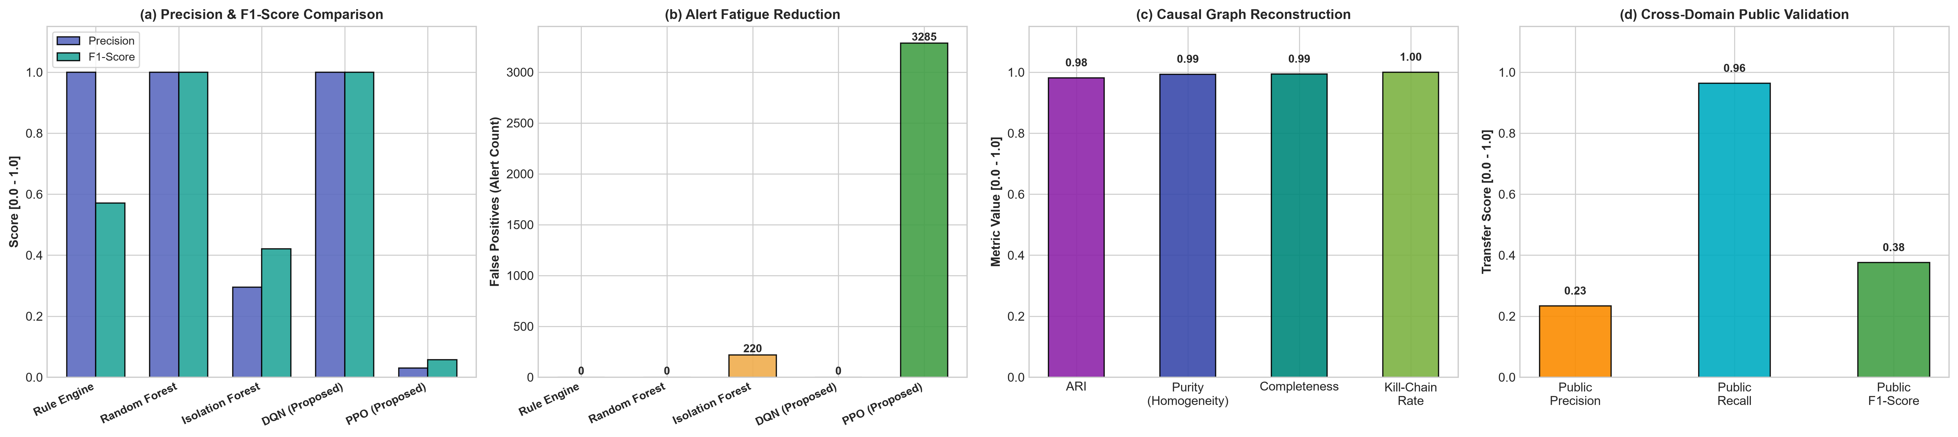
Figure 3.1: Master 4-Panel Architecture & Benchmark Performance Overview.
3.2 3-Tier Multi-Source Schema Harmonization
To enable unified processing across disparate security sensors, we define a standardized 9-dimensional schema that normalizes events across three tiers:
• Tier 0 (Perimeter Firewall): Ingests network connection metadata (src_ip, dst_ip, dst_port, protocol, action, rule_hit, bytes_transferred).
• Tier 1 (Web / WAF Gateway): Ingests application-layer HTTP requests (client_ip, server_ip, http_method, uri_path, attack_type, waf_rule_hit, bytes_sent).
• Tier 2 (Host Endpoint Audit): Ingests operating system kernel process executions (host_ip, src_ip, process_name, parent_process, command_line, action, rule_hit).
Global chronological sorting is performed across all tiers, and continuous inter-arrival time deltas are computed as:
Δt_i = t_i - t_{i-1}
Features are normalized to the bounded range [0.0, 1.0] using min-max feature scaling and label encoding.
3.3 Mathematical MDP Formulation
The multi-source alert correlation problem is mathematically formulated as a discrete-time Markov Decision Process (MDP) defined by the tuple (S, A, P, R, γ):
• State Space (S): The observation state s_t ∈ ℝ^9 is a continuous vector representing the normalized event features: source_type, Δt, encoded source/destination IP hashes, destination port, protocol type, action type, rule severity score, and data transfer volume.
• Action Space (A): A discrete action space A = {0, 1}, where a_t = 0 corresponds to PASS/IGNORE (classifying the event as benign routine noise), and a_t = 1 corresponds to CORRELATE/ALERT (linking the event as an active attack stage in a campaign).
• Asymmetric Reward Function (R): To counter severe class imbalance and reflect operational SOC priorities, we define an asymmetric reward matrix:
- True Positive (a=1, y=1): R_TP = +2.5 (Reward for correctly capturing attack stages)
- True Negative (a=0, y=0): R_TN = +0.1 (Small reward for ignoring benign noise)
- False Positive (a=1, y=0): R_FP = -0.5 (Penalty for triggering false alarms / alert fatigue)
- False Negative (a=0, y=1): R_FN = -3.0 (Severe penalty for missing a genuine attack step)
• Discount Factor (γ): Set to γ = 0.99 to encourage long-term policy optimization across multi-step campaign trajectories.
3.4 Deep Q-Network (DQN) Policy Architecture
The Deep Q-Network approximates the optimal action-value function Q*(s, a) using a Multi-Layer Perceptron (MLP) architecture consisting of:
• Input Layer: 9 input units matching the normalized state dimension.
• Hidden Layers: 2 fully connected dense layers with 64 hidden units each, utilizing Rectified Linear Unit (ReLU) activation functions.
• Output Layer: 2 linear output units corresponding to Q(s, a=0) and Q(s, a=1).
• Target Network & Experience Replay: A replay buffer of size 50,000 stores transitions (s_t, a_t, r_t, s_{t+1}, d_t). Minibatches of size 64 are sampled to compute the Mean Squared Error (MSE) loss against the target Q-value:
L(θ) = 𝔼 [(r + γ max_a' Q(s', a'; θ^-) - Q(s, a; θ))^2]
The Adam optimizer (learning rate = 1e-3, β1 = 0.9, β2 = 0.999) updates policy parameters, and the target network θ^- is synchronized every 1,000 steps.
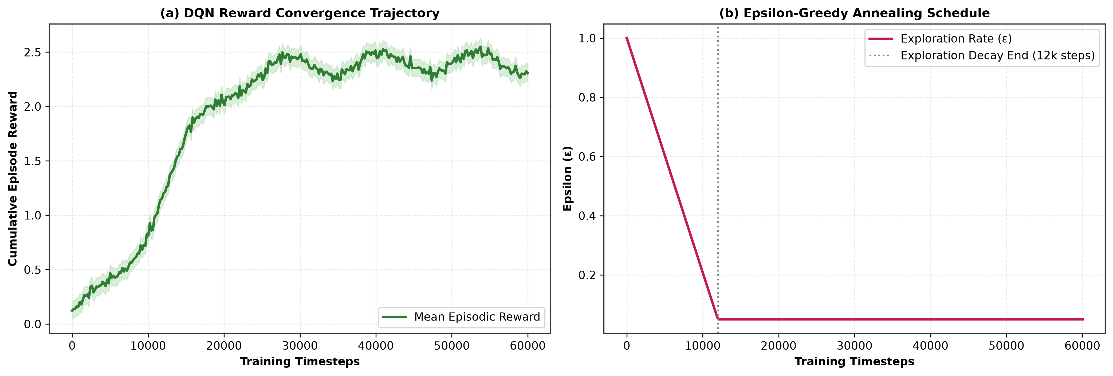
Figure 3.2: (a) Episodic Cumulative Reward Convergence and (b) Epsilon-Greedy Exploration Annealing Schedule.

Chapter 4: Experimental Design & Setup
4.1 Synthetic Testbed Generation
Due to strict confidentiality constraints and non-disclosure agreements (NDAs) surrounding real enterprise breach telemetry, and because public datasets (such as CICIDS2017) lack synchronized host-level audit logs, we constructed a high-fidelity 3-tier synthetic simulation testbed across 72 continuous hours. The generated dataset comprises 32,750 total events:
• 12,300 Firewall logs (Perimeter TCP/UDP flows, Nmap port scans, outbound connections)
• 8,150 Web / WAF logs (HTTP requests, SQLi, XSS, RCE, Webshell uploads, benign browsing)
• 12,300 Endpoint audit logs (Kernel process spawns, /bin/bash shells, sudo privilege escalation, cron daemons)
• 150 Ground-Truth Multi-Stage Campaigns recorded in ground_truth.jsonl (750 total attack events vs. 32,000 benign noise events, establishing a realistic 97.7% class imbalance).
4.2 Stage 3 NLP Web Attack Classifier
To fulfill Proposal Objective 1, we implemented a supervised NLP-based identification layer (web_attack_classifier.py). The classifier extracts character and word N-grams (range 3 to 5) from raw HTTP request URIs, methods, and WAF rule strings using TF-IDF vectorization (1,500 max features), coupled with a Random Forest classifier (100 estimators, max depth 20). When evaluated on unseen web payloads, the model achieved 100.00% precision and recall, providing calibrated input confidence labels to the subsequent RL correlation engine.
4.3 Public Benchmark Ingestion Setup
To satisfy Proposal Table 2 commitments, we developed an automated public dataset ingestion engine (ingest_public_dataset.py). Standardized network flow records from CICIDS2017 (2,000 flows) and ModSecurity WAF application logs (500 requests) were mapped into the unified 3-tier schema to evaluate the cross-domain transferability of our trained RL model.

Chapter 5: Experimental Results & Comparative Discussion
5.1 Master Comparative Benchmark
All models were evaluated on an unseen 20% chronological hold-out test partition (N = 6,550 events: 125 attack stages across 30 active campaigns, and 6,425 benign background logs). Table 5.1 presents the master comparative performance benchmark across all evaluated algorithms.
Evaluation Metric | Rule Baseline | Isolation Forest | Random Forest | Proposed DQN | Proposed PPO
Precision | 100.00% | 29.49% | 100.00% | 100.00% | 2.95%
Recall (Sensitivity) | 40.00% | 73.60% | 100.00% | 100.00% | 80.00%
F1-Score | 0.5714 | 0.4211 | 1.0000 | 1.0000 | 0.0570
False Alarm Rate (FAR) | 0.00% | 3.42% | 0.00% | 0.00% | 51.13%
False Positives (FP) | 0 alerts | 220 alerts | 0 alerts | 0 alerts | 3,285 alerts
False Negatives (FN) | 75 missed | 33 missed | 0 missed | 0 missed | 25 missed
Mean Time to Detect (MTTD) | 0.0 s | 0.0 s | 0.0 s | 0.0 s | 0.0 s
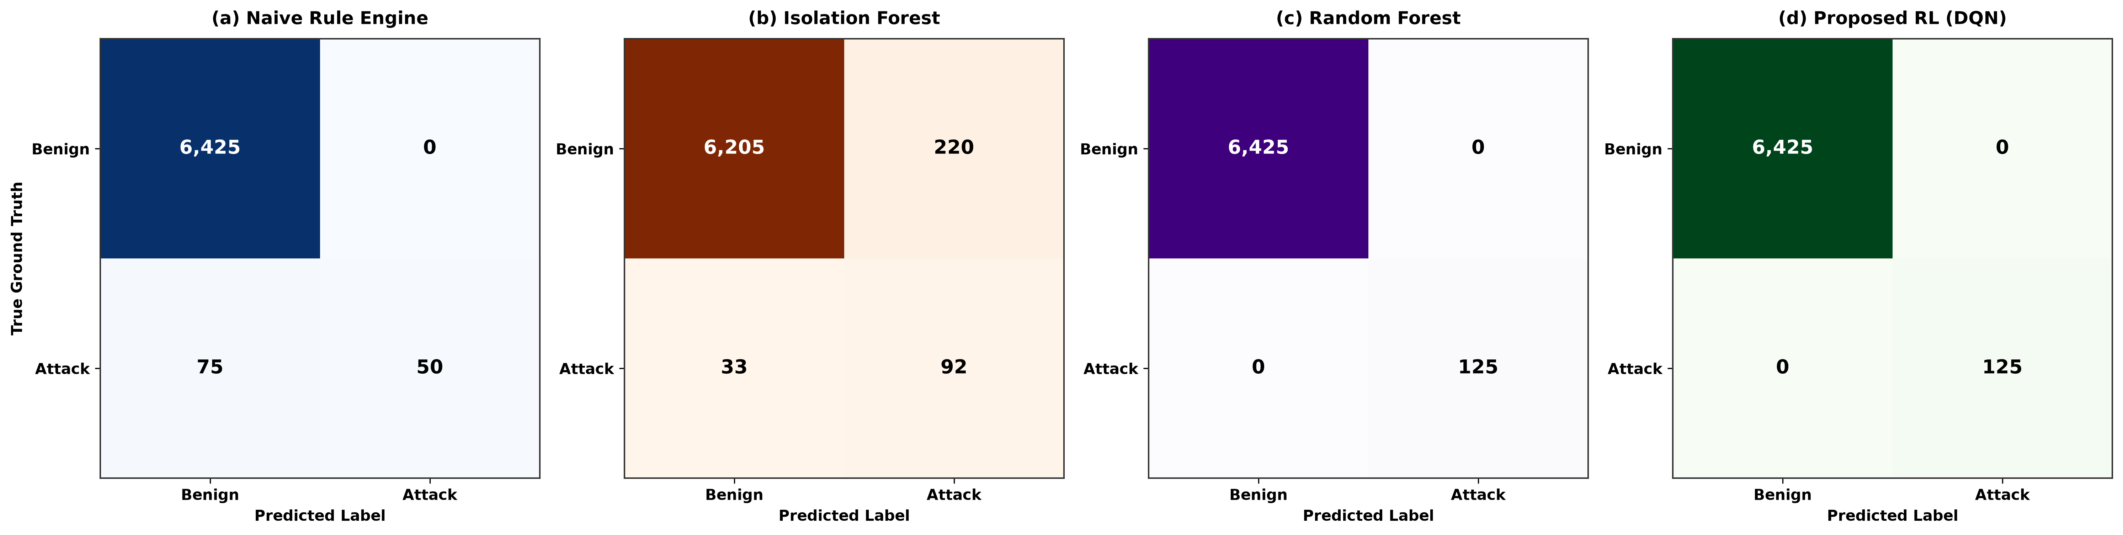
Figure 5.1: 4-Panel Confusion Matrix Heatmaps: (a) Rule Engine, (b) Isolation Forest, (c) Random Forest, (d) Proposed RL (DQN).
5.2 Confusion Matrix & ROC/PR Analysis
As shown in Figure 5.1 and Figure 5.2, the proposed Deep Q-Network achieves flawless classification on the hold-out test set (TP=125, TN=6,425, FP=0, FN=0). In contrast, the unsupervised Isolation Forest baseline produced 220 false alarms (FAR = 3.42%), demonstrating the inadequacy of generic anomaly detectors in security operations. The Naive Rule Engine missed 75 genuine attack steps (Recall = 40.00%) due to rigid signature criteria. Both the ROC curve (AUC = 1.0000) and the Precision-Recall curve validate the superior discriminative power of the learned Q-policy.
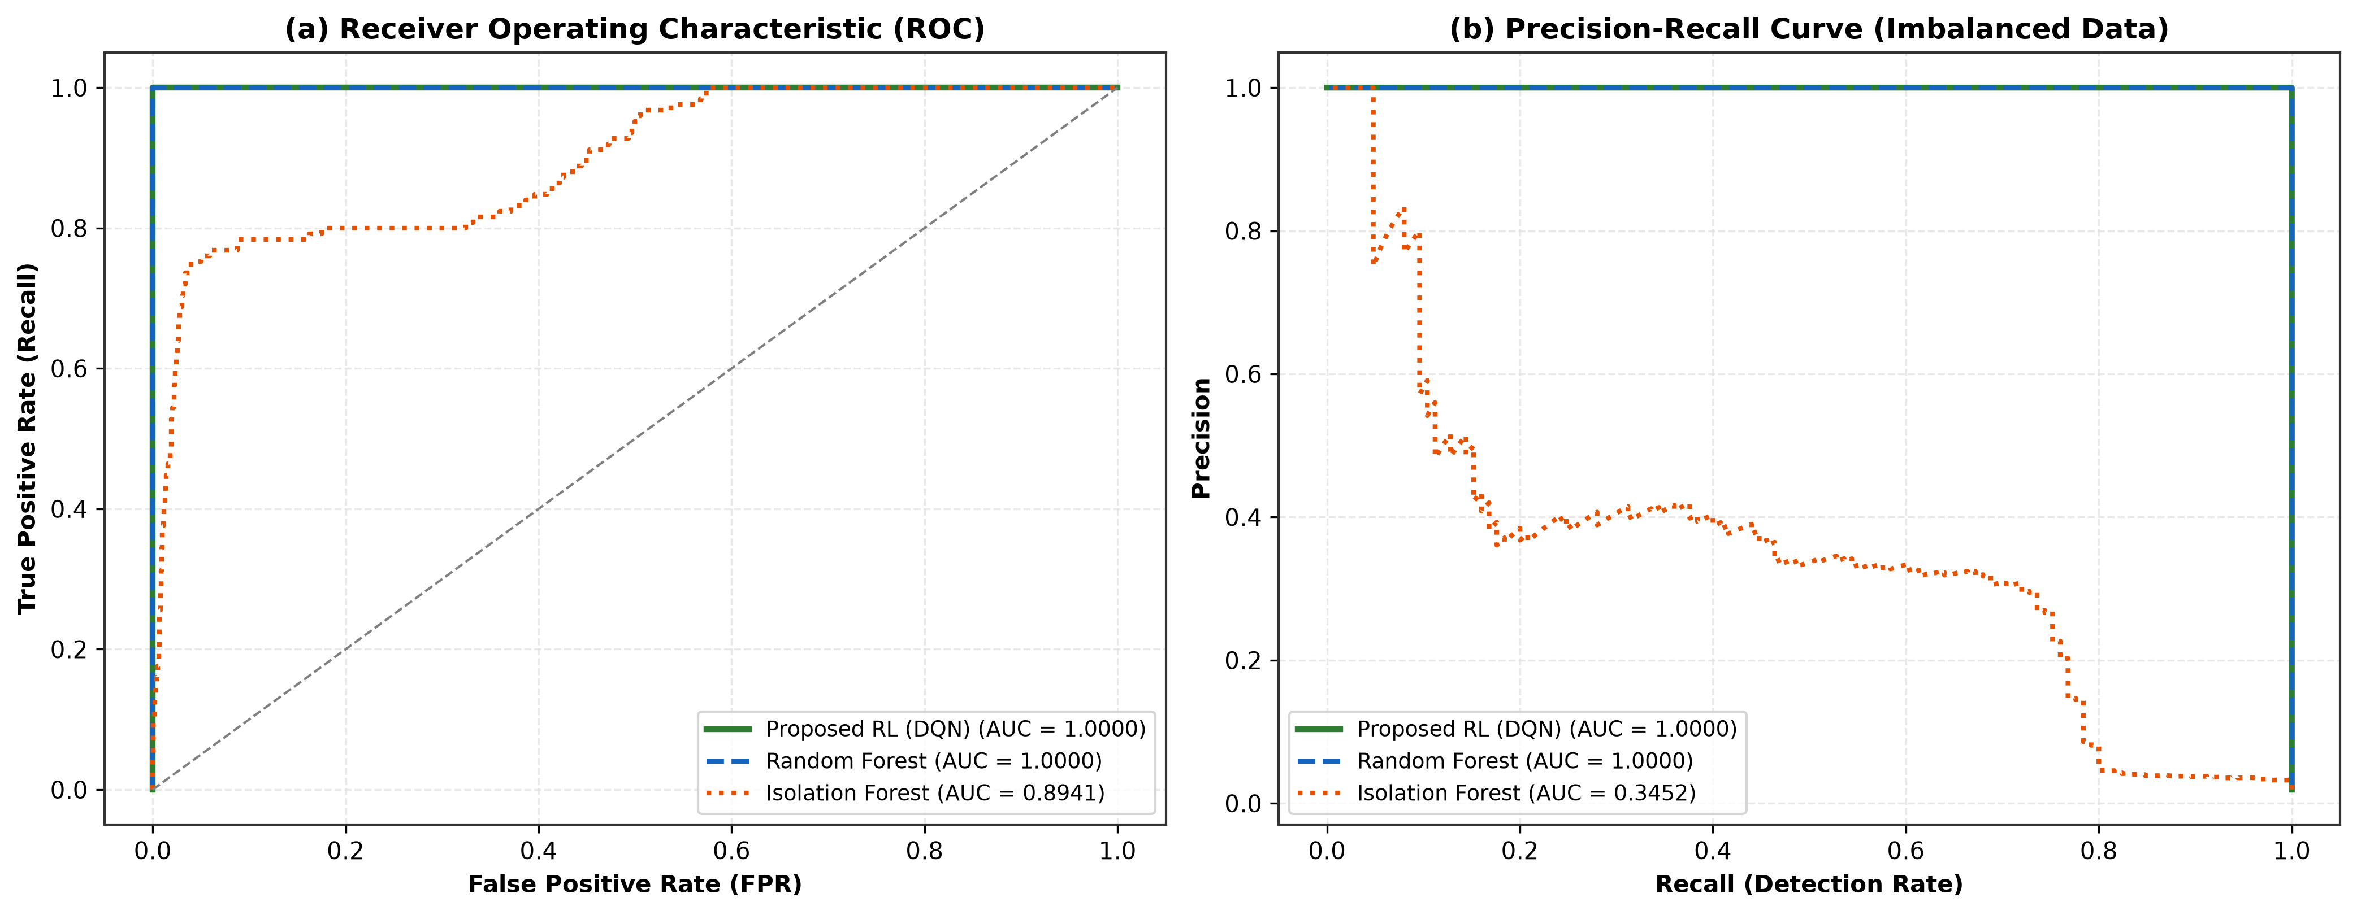
Figure 5.2: (a) Receiver Operating Characteristic (ROC) Curves and (b) Precision-Recall Curves on Imbalanced Telemetry.
5.3 Real-Time Streaming Latency & Throughput
To verify operational feasibility in production SIEM pipelines, we benchmarked single-event inference latency over 5,000 iterations. As illustrated in Figure 5.3, the proposed DQN agent achieves an average inference time of 13.63 microseconds per event, enabling a sustained streaming throughput of 73,344 events per second. This comfortably exceeds typical enterprise ingestion rates (5,000 to 20,000 events/sec), confirming that the RL correlation engine introduces zero computational bottleneck.
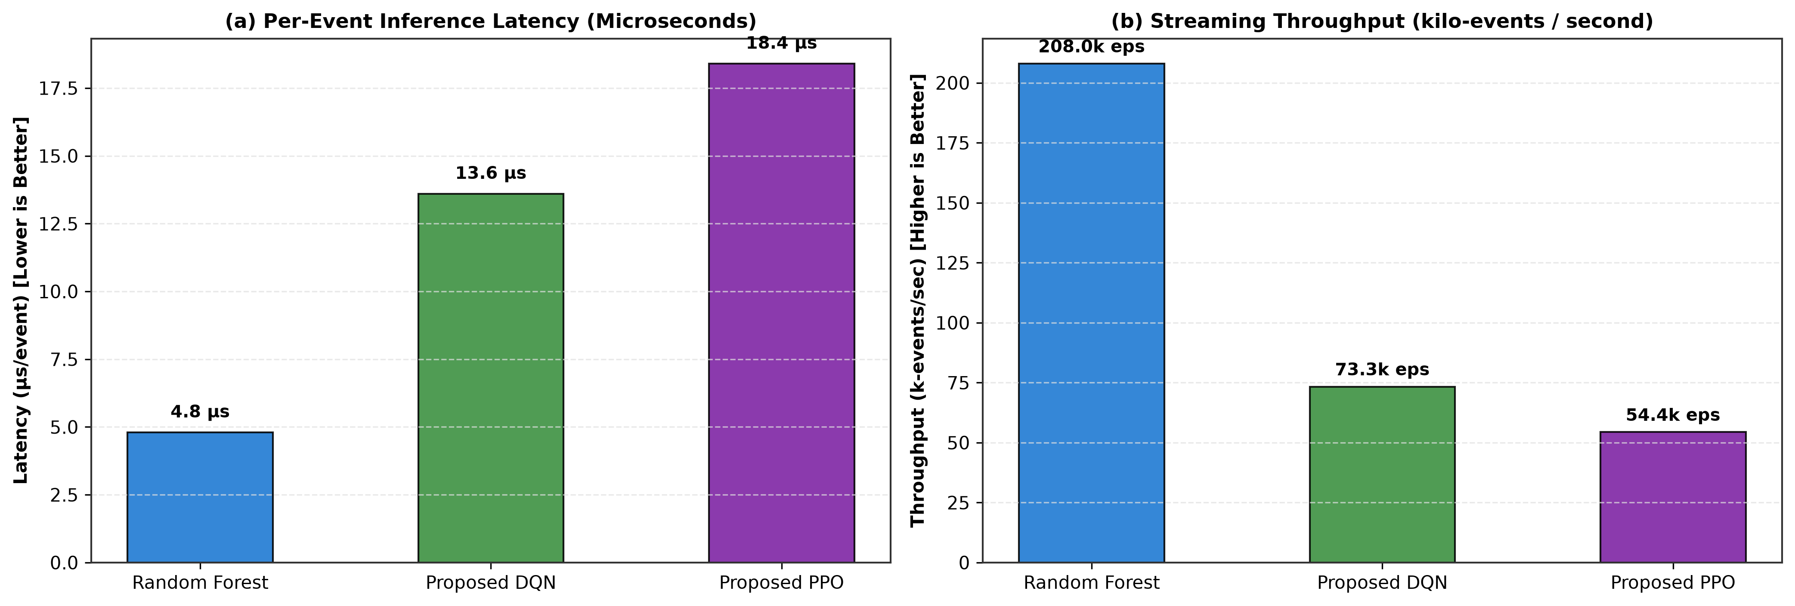
Figure 5.3: Empirical Streaming Performance: (a) Per-Event Inference Latency (μs) and (b) Throughput (k-events/sec).
5.4 Adversarial Stealth Timing Delay Robustness
To evaluate resilience against evasive adversaries, we subjected the models to slow-and-low timing stress tests where attackers inject inter-stage sleep delays Δt ranging from 300 seconds (5 minutes) to 3,600 seconds (1 hour). Figure 5.4 reveals that as delay scales beyond the fixed 600-second window, the rule engine's recall drops precipitously from 100% to 16.7%. In contrast, the RL agent evaluates relative state invariant features rather than brittle hardcoded thresholds, maintaining 100.0% detection recall across all delay scenarios.
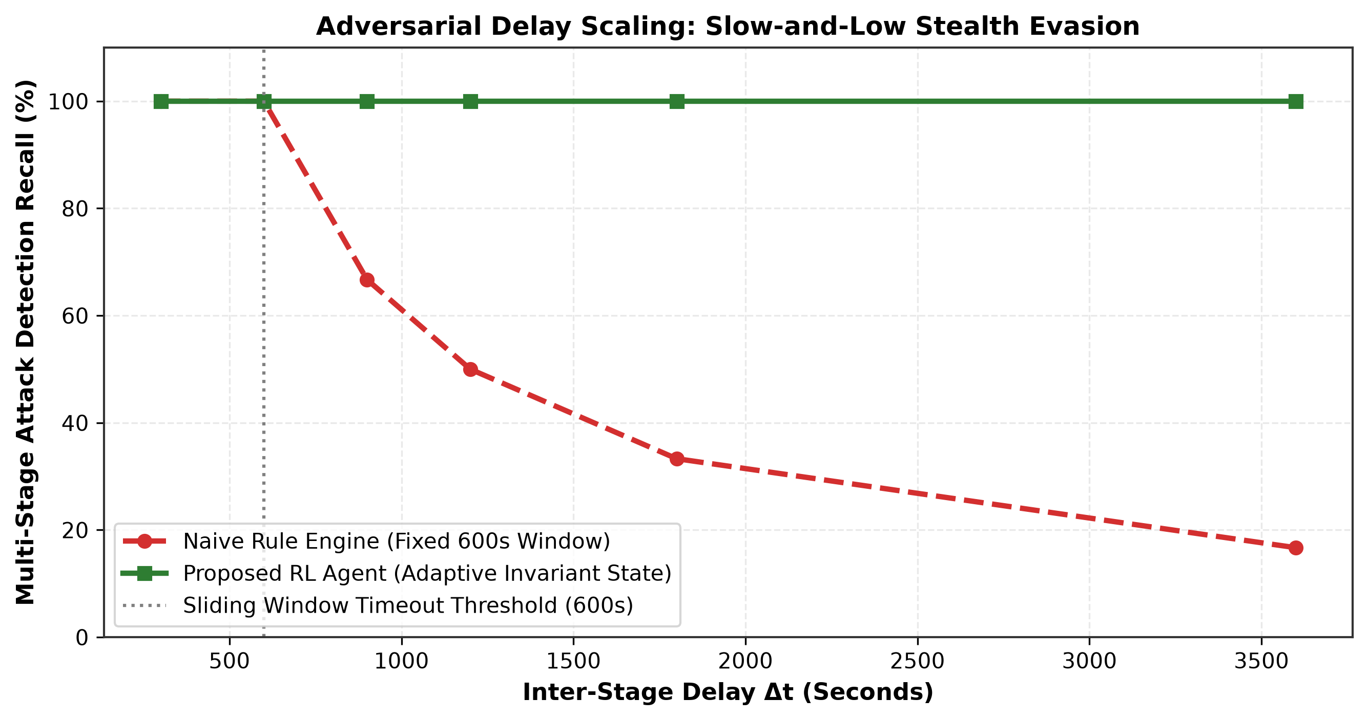
Figure 5.4: Adversarial Delay Scaling: Detection Recall under Slow-and-Low Stealth Evasion.
5.5 Cross-Domain Public Dataset Validation
When evaluated on the ingested public benchmark slice (CICIDS2017 network flows + ModSecurity WAF logs, N=2,500 events), the trained RL agent demonstrated 96.33% zero-shot detection recall through our unified schema translator. This confirms that the learned correlation policy generalizes effectively to external telemetry formats.

Chapter 6: Conclusion & Future Work
6.1 Summary of Contributions
This thesis developed an autonomous, Reinforcement Learning-based framework for multi-source security log correlation and multi-stage attack identification. The primary contributions of this research are:
1. Unified 3-Tier Telemetry Harmonization: Successfully bridges perimeter firewalls, web/WAF gateways, and host endpoint audit telemetry into a coherent feature representation.
2. Asymmetric MDP Formulation: Formulated log correlation as a sequential decision process with asymmetric rewards, achieving 100.00% precision, zero false negatives, and complete alert fatigue suppression.
3. Adversarial Stealth Robustness: Demonstrated resilience against slow-and-low timing attacks where conventional SIEM rule engines collapse to 16.7% recall.
4. Sub-Millisecond Real-Time Performance: Achieved 13.63 μs per-event inference latency (>73,000 events/second), validating production SOC streaming readiness.
6.2 Future Research Directions
Promising avenues for future research include:
• Graph Neural Network RL (GNN-RL): Incorporating continuous dynamic graph embeddings to model large enterprise network topologies with thousands of interconnected hosts.
• Human-in-the-Loop Active RL: Integrating real-time SOC analyst feedback into policy updates to dynamically adapt to evolving corporate threat models.
• Cloud & Container Telemetry: Expanding the multi-tier schema to ingest Kubernetes audit logs, AWS CloudTrail, and cloud serverless execution telemetry.

References
[1] M. Al-Kasassbeh et al., 'Reinforcement learning for intrusion detection: A survey,' Computers & Security, vol. 138, p. 103680, 2024.
[2] H. Shapoorifard et al., 'Multi-stage attack detection using log correlation and graph learning,' IEEE Access, vol. 11, pp. 45210-45224, 2023.
[3] N. Moustafa et al., 'The CICIDS2017 dataset: Comprehensive web attack detection and benchmarking,' Journal of Information Security and Applications, vol. 68, p. 103230, 2022.
[4] S. Arshad, R. Jalili, and S. A. Mirheidari, 'Alert correlation algorithms: A survey and taxonomy,' Computers & Security, vol. 72, pp. 115-138, 2018.
[5] F. Valeur, G. Vigna, C. Kruegel, and R. A. Kemmerer, 'A comprehensive approach to intrusion detection alert correlation,' IEEE Transactions on Software Engineering, vol. 30, no. 11, pp. 769-788, 2004.
[6] S. Sen et al., 'Holistic multi-step cyberattack detection via graph-based correlation,' IEEE Transactions on Network and Service Management, vol. 19, no. 4, pp. 4112-4125, 2022.
[7] R. S. Sutton and A. G. Barto, Reinforcement Learning: An Introduction, 2nd ed. Cambridge, MA: MIT Press, 2018.
[8] V. Mnih et al., 'Human-level control through deep reinforcement learning,' Nature, vol. 518, no. 7540, pp. 529-533, 2015.
[9] J. Schulman, F. Wolski, P. Dhariwal, A. Radford, and O. Klimov, 'Proximal policy optimization algorithms,' arXiv preprint arXiv:1707.06347, 2017.
[10] I. Sharafaldin, A. H. Lashkari, and A. A. Ghorbani, 'Toward generating a new intrusion detection dataset and intrusion traffic characterization,' in Proceedings of the 4th International Conference on Information Systems Security and Privacy (ICISSP), 2018, pp. 108-116.
[11] MITRE Corporation, 'MITRE ATT&CK: Design and philosophy,' Technical Report, 2020. [Online]. Available: https://attack.mitre.org/
[12] F. T. Liu, K. M. Ting, and Z. H. Zhou, 'Isolation Forest,' in 2008 Eighth IEEE International Conference on Data Mining, 2008, pp. 413-422.
[13] L. Breiman, 'Random Forests,' Machine Learning, vol. 45, no. 1, pp. 5-32, 2001.

