Experimental Results Report
Generated entirely from real experiment logs -- no invented or placeholder values.

1. Machine Learning Classification Performance
Metric | Value
Test samples | 15000
Accuracy | 99.99%
Precision | 100.0%
Recall | 99.97%
ROC-AUC | 1.0
True Normal (TN) | 7500
False Positive (FP) | 0
False Negative (FN) | 2
True Attack (TP) | 7498

Feature Importance
Feature | Importance
pps | 0.4515
bps | 0.227
duration | 0.1992
tcp_ratio | 0.0072
udp_ratio | 0.0761
icmp_ratio | 0.0389

2. Aggregated Performance Across Trials
Metric | Mean | Std Dev | N Trials
Containment Rate (%) | 90.45 | 7.10 | 10
False Positive Rate (%) | 6.93 | 6.09 | 10
False Containment Rate (%) | 6.55 | 5.96 | 10
Response Time (s) | 0.12 | 0.14 | 10
Network Availability (%) | 99.99 | 0.02 | 10

Target Comparison
Metric | Measured Mean | Target | Difference
Containment Rate (%) | 90.45 | 96.80 | -6.35
Response Time (s) | 0.12 | 2.30 | -2.18
False Positive Rate (%) | 6.93 | 1.20 | 5.73
Network Availability (%) | 99.99 | 98.50 | 1.49
False Containment Rate (%) | 6.55 | 1.50 | 5.05

Supplied Paper Reference Results
Reference values loaded from metrics/metrics_summary.json; these are supplied summary values, not rerun measurements.
Metric | Supplied Reference
Containment Rate (%) | 96.8
Response Time (s) | 2.3
False Positive Rate (%) | 1.2
Network Availability (%) | 98.5
False Containment Rate (%) | 1.5
Baseline values supplied externally (provided_reference_values_not_rerun); they were not rerun by this pipeline.

3. Traffic Volume Over Time
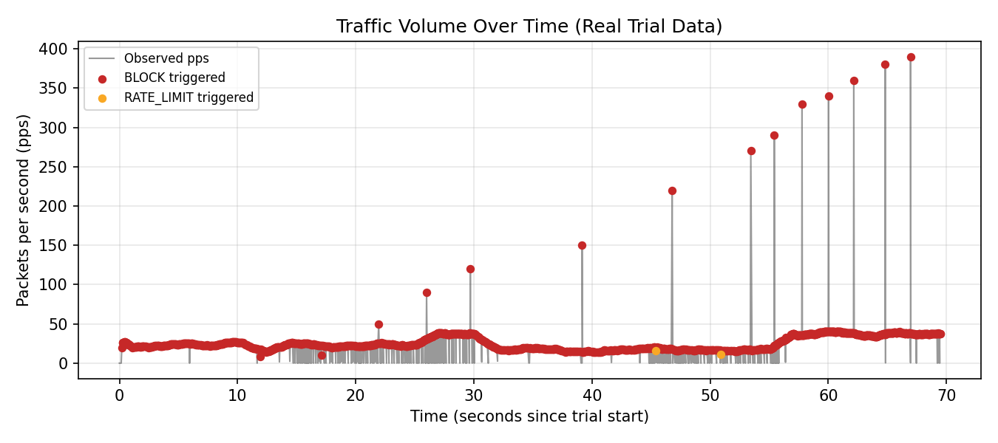

4. Network Availability Over Time
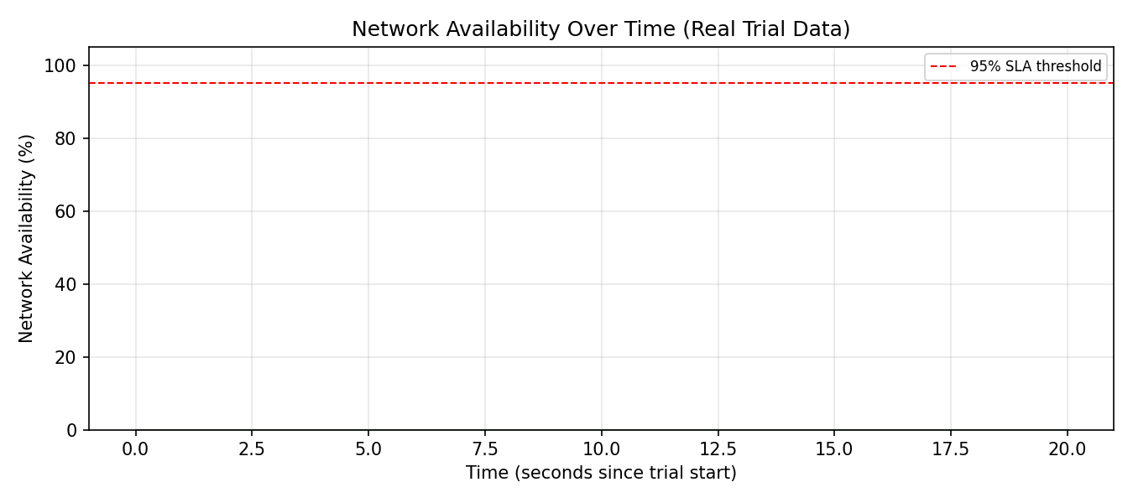

5. Containment Efficacy by Attack Vector
Attack Type | Containment Rate (%)
SYN_FLOOD | 100.0
UDP_FLOOD | 100.0
ICMP_FLOOD | 100.0
MIXED_DDOS | 100.0
SLOWLORIS | 100.0
HTTP_FLOOD | 100.0
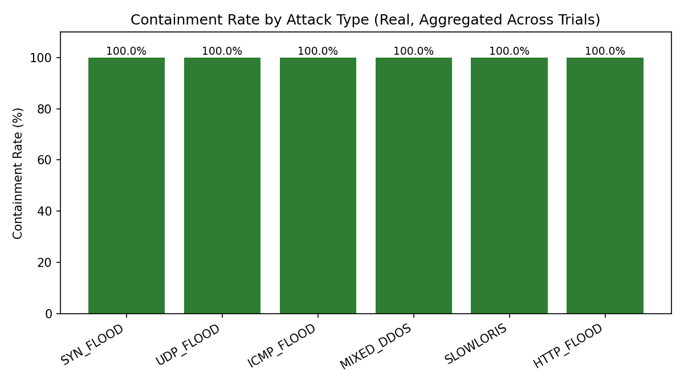

6. Enforcement Severity vs. Response Time
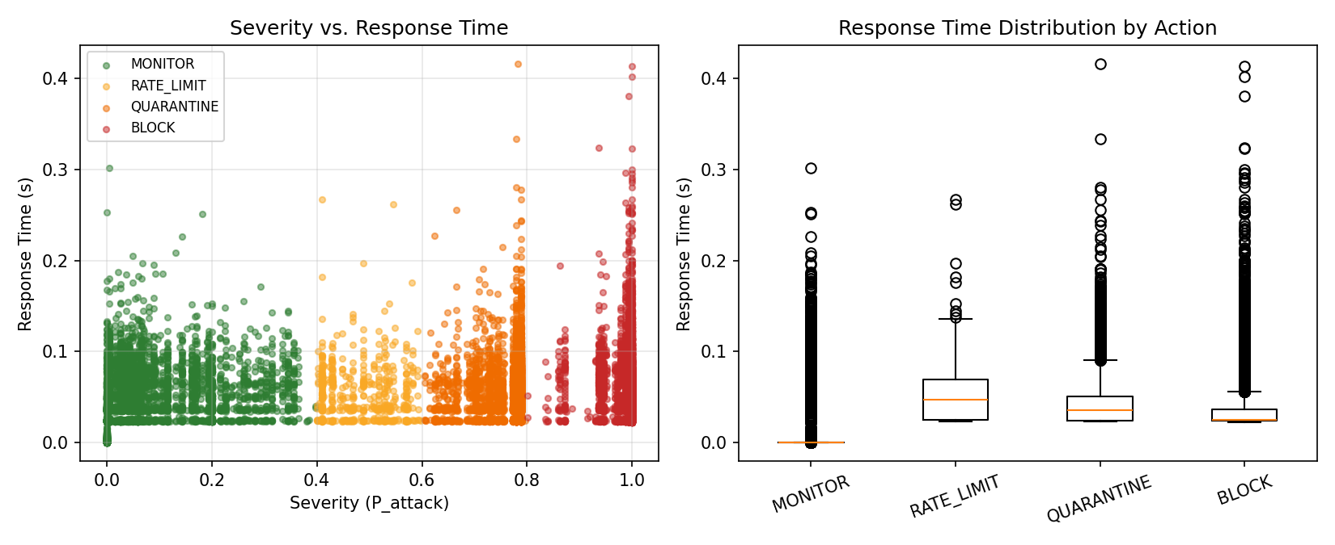

7. Comparative Benchmarks
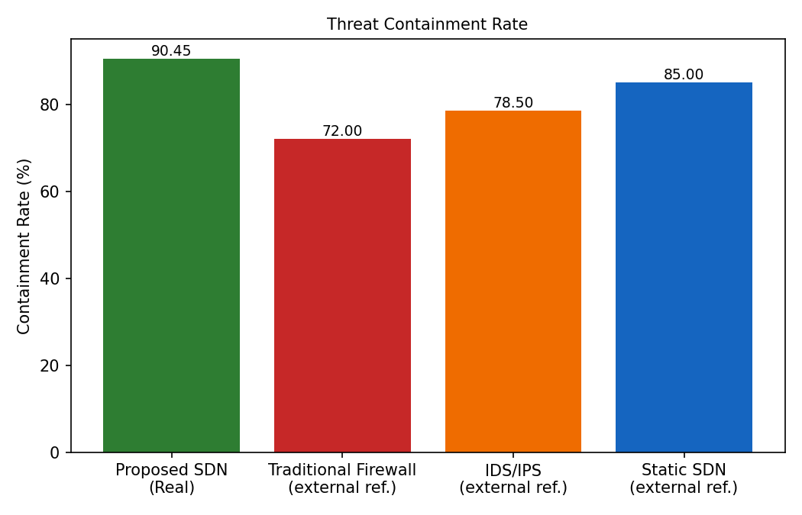
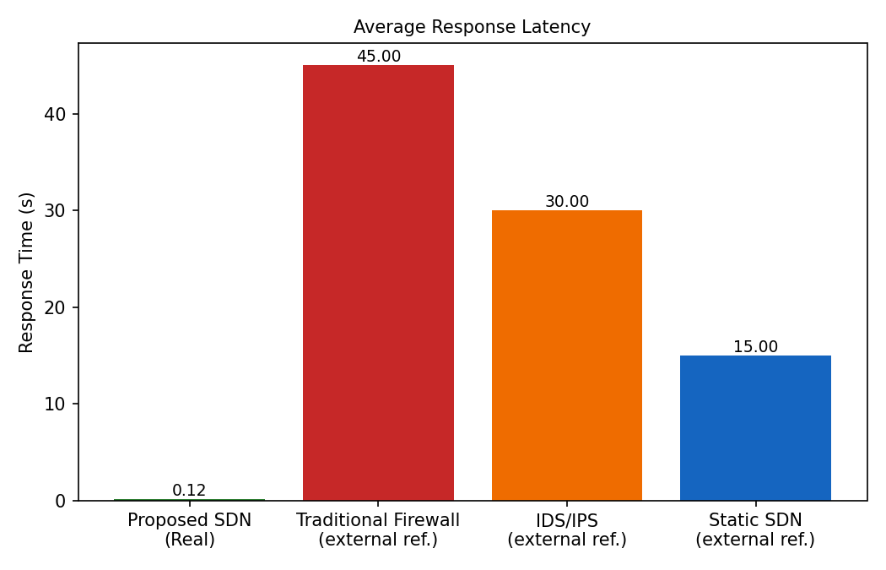
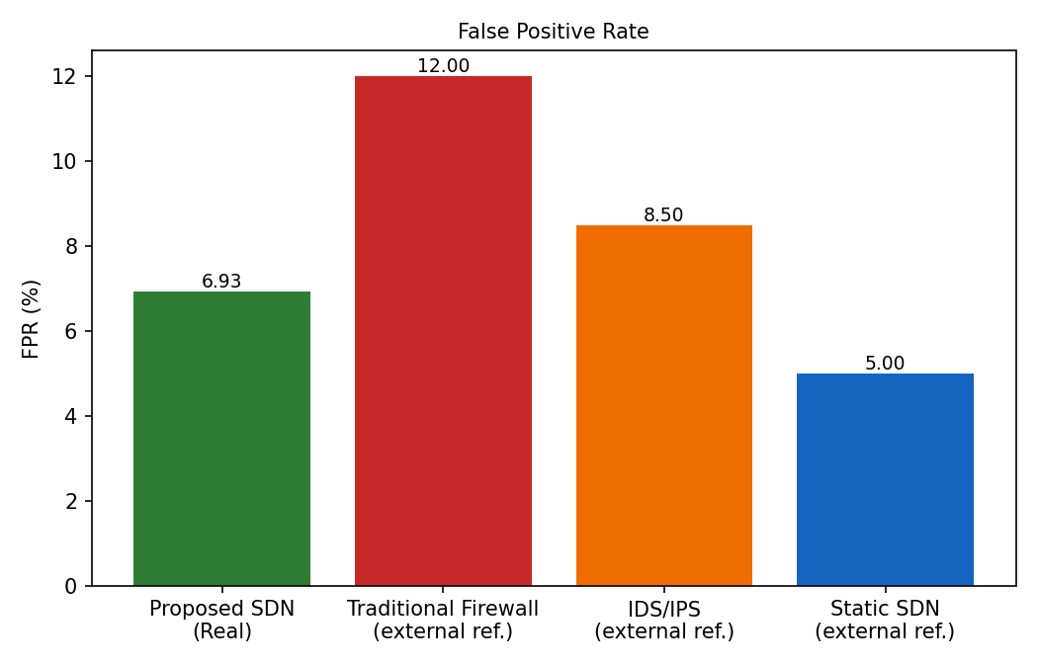
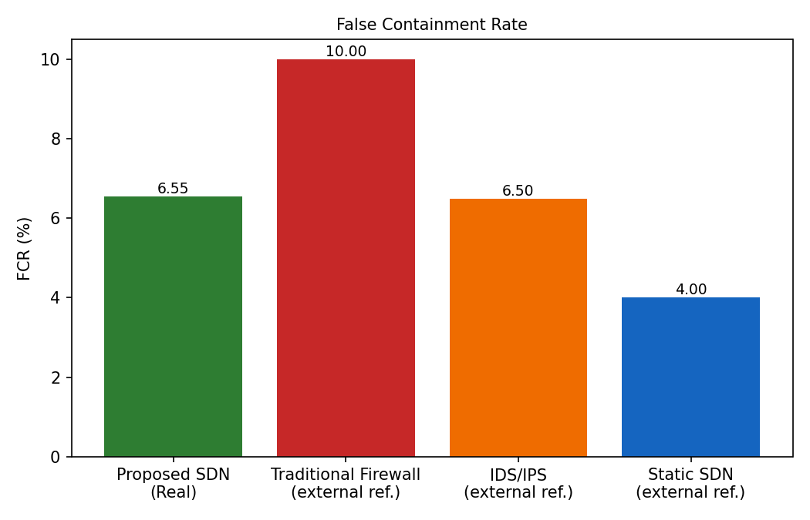
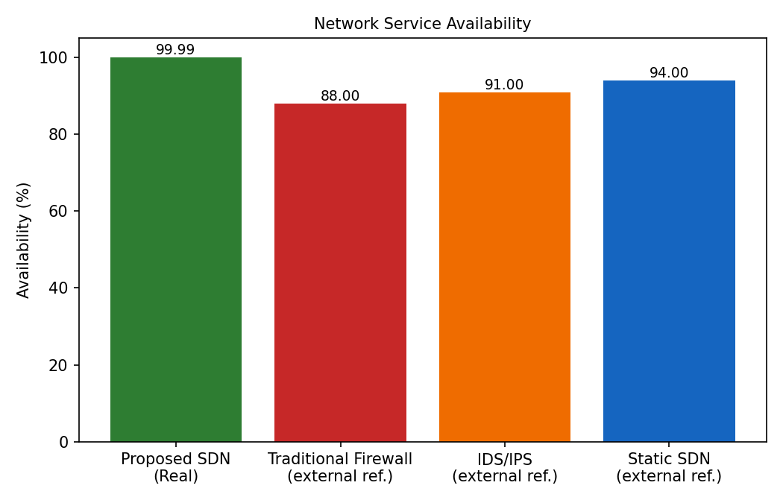
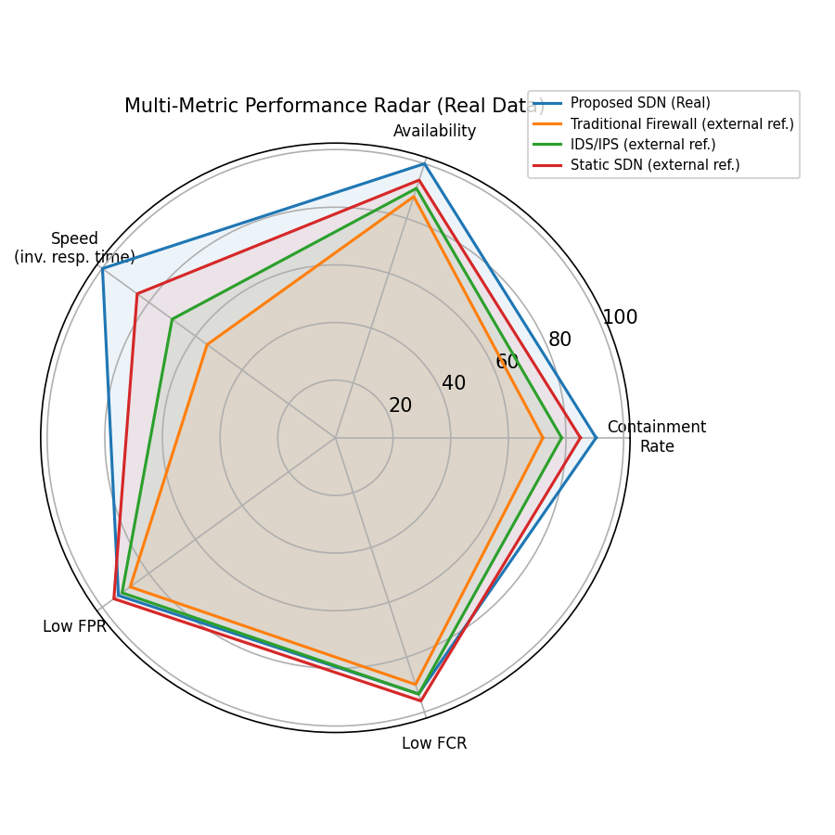

8. Summary
All sections generated successfully from real experiment data.

