**Key Milestone 1: Conceptual Schema**



**DBMS Final Project**

**Submitted By:** Muhammad Saad Amjad Khan

**Project Group #19:**

Muhammad Ehzaz Khan (22pwcse2108)

Muhammad Saad Amjad Khan (22pwcse2133)

Muhammad Kamil Khan (22pwcse2174)

**Section:** B

**Submitted to:** Engr.Sumayyea Salahuddin

“On my honor, as student of University of Engineering and Technology, I have neither given nor received unauthorized assistance on this academic work”

Department of Computer Systems Engineering

University of Engineering and Technology Peshawar

**Project: Restaurant Management System**

**Main Entities & Their Description:**

1. **users:**

|  |  |  |
| --- | --- | --- |
| **Attributes** | **Datatypes** | **Name in Database** |
| **id** (PK) | Integer | id |
| name | String | name |
| phone | String | phone |
| email | String | email |
| address | String | address |
| password | string | password |

1. **employees:**

|  |  |  |
| --- | --- | --- |
| **Attributes** | **Datatypes** | **Name in Database** |
| **id** (PK) | Integer | id |
| name | String | name |
| role | String | role |
| phone | String | phone |
| salary | Integer | salary |
| shift_timing | DateTime | shift |
| date_of_joining | Date | date_joining |

1. **foods:**

|  |  |  |
| --- | --- | --- |
| **Attributes** | **Datatypes** | **Name in Database** |
| **id** (PK) | Integer | id |
| title | String | title |
| detail | String | detail |
| price | Integer | price |
| image | String | image |

1. **orders:**

|  |  |  |
| --- | --- | --- |
| **Attributes** | **Datatypes** | **Name in Database** |
| **id** (PK) | Integer | id |
| **user_id** (FK) | Integer | user_id |
| **food_id** (FK) | Integer | food_id |
| **Employee_id** (FK) | integer | Employee_id |
| amount | Integer | amount |
| status | String | status |

1. **tables:**

|  |  |  |
| --- | --- | --- |
| **Attributes** | **Datatypes** | **Name in Database** |
| **id**(PK) | Integer | id |
| capacity | Integer | capacity |
| details | String | detail |
| status | String | status |

1. **books:**

|  |  |  |
| --- | --- | --- |
| **Attributes** | **Datatypes** | **Name in Database** |
| **id** (PK) | Integer | id |
| **table_id** (FK) | Integer | table_id |
| phone | String | phone |
| guests | Integer | guests |
| date | DateTime | date |
| time | DateTime | time |

1. **reviews:**

|  |  |  |
| --- | --- | --- |
| **Attributes** | **Datatypes** | **Name in Database** |
| **id** (PK) | Integer | id |
| **food_id** (FK) | Integer | food_id |
| review | String | review |
| rating | Integer | rating |
| date | DateTime | date |

1. **carts:**

|  |  |  |
| --- | --- | --- |
| **Attributes** | **Datatypes** | **Name in Database** |
| **id** (PK) | Integer | id |
| **user_id** (FK) | Integer | user_id |
| **food_id** (FK) | Integer | food_id |
| quantity | Integer | quantity |

1. **invoice:**

|  |  |  |
| --- | --- | --- |
| **Attributes** | **Datatypes** | **Name in Database** |
| **id** (PK) | Integer | id |
| **order_id** (FK) | Integer | order_id |
| **user_id** (FK) | Integer | user_id |
| amount | Integer | amount |
| status | String | status |
| date | DateTime | date |

**Business Rules for Restaurant Management System:**

1. users

**Business Role:**  
Stores the details of customers who use the restaurant system. Each user can browse the menu, add items to their cart, place orders, leave reviews, and book tables.

**Key Functional Rules:**

* One user can have multiple orders.
* One user can post multiple reviews.
* One user can have multiple invoices and carts.
* Each user is uniquely identified by their ID.

1. employees

**Business Role:**  
Manages records of restaurant staff such as waiters, chefs, and managers. Employees are assigned to handle orders and work shifts.

**Key Functional Rules:**

* Each employee has a designated shift.
* Employees may be linked to handling one or more orders.

1. food

**Business Role:**  
Maintains the master list of food items offered by the restaurant. This includes information like name, description, price, and image for display.

**Key Functional Rules:**

* Food items appear in the menu.
* Food items are referenced in orders, cart, and reviews.

1. orders

**Business Role:**  
Stores all placed orders made by users. Each order links a user to a food item and the employee responsible for fulfilling it. Contains the order’s current status and amount.

**Key Functional Rules:**

* Each order belongs to one user.
* Each order is assigned to one employee.
* Each order is for one food item (in flattened design).
* Order statuses include: Pending, Completed, Cancelled.

1. tables

**Business Role:**  
Stores information about the physical dining tables in the restaurant including their seating capacity and current availability status.

**Key Functional Rules:**

* Each table can be reserved (linked via books).
* Table status can be: Available, Reserved, Occupied.

1. books

**Business Role:**  
Manages customer reservations for dining tables. Tracks which user reserved which table at what date and time, for how many guests.

**Key Functional Rules:**

* A user can make multiple bookings.
* A table can have multiple bookings (on different dates/times).
* Booking includes time and number of guests.

1. reviews

**Business Role:**  
Captures feedback from users about food items. Each review includes a rating and review text, tied to a specific food item.

**Key Functional Rules:**

* A user can review multiple food items.
* A food item can have many reviews.
* Ratings help in calculating average food quality scores.

1. carts

**Business Role:**  
Temporarily stores food items that a user is planning to order. Acts like a shopping basket before converting to an order.

**Key Functional Rules:**

* A cart is user-specific.
* Items in the cart are not yet part of any official order.
* Cart is cleared when the order is placed.

1. invoice

**Business Role:**  
Keeps a financial record of each completed order. Used for billing, accounting, and payment tracking.

**Key Functional Rules:**

* Each invoice belongs to a user and an order.
* Invoices store final amount, status (e.g., Paid, Unpaid), and timestamp.
* One invoice per order.

**ERD (Entity Relationship Diagram):**

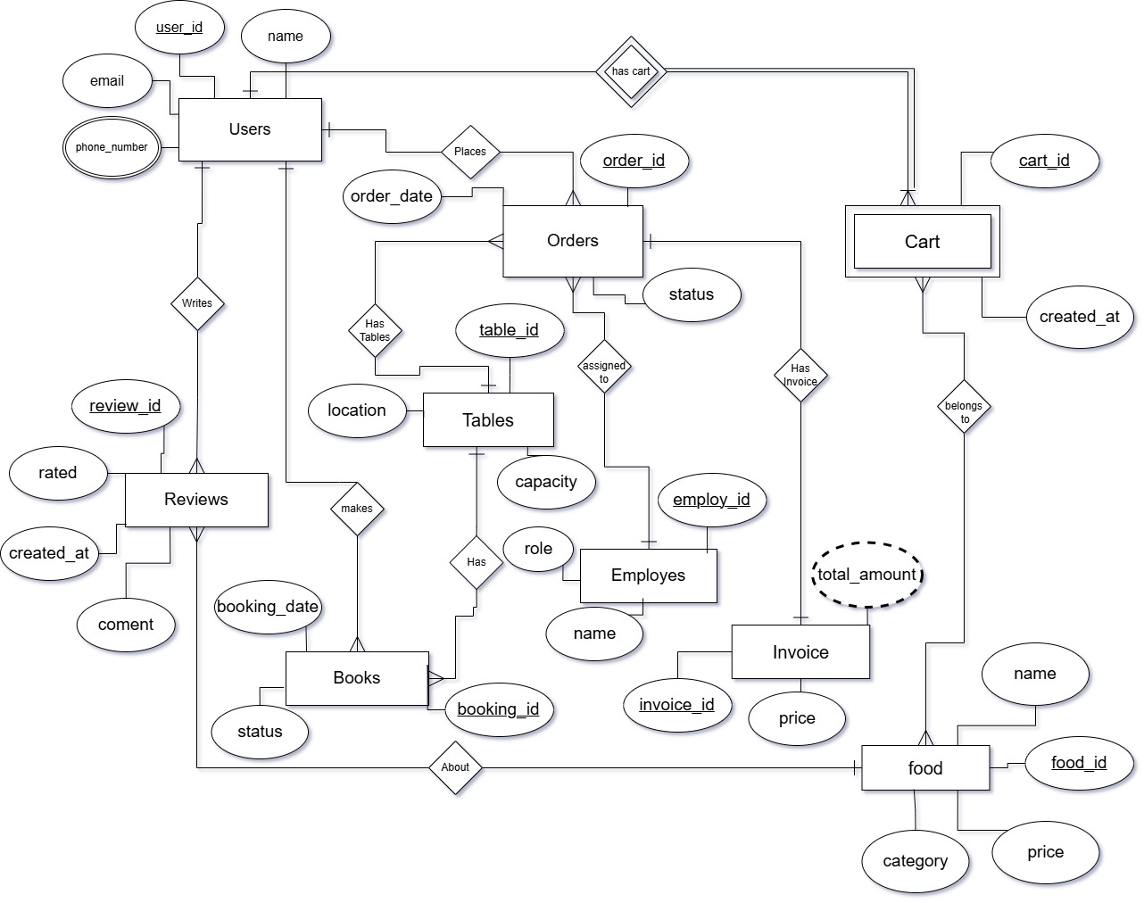

**EERD (Enhanced Entity Relationship Diagram):**

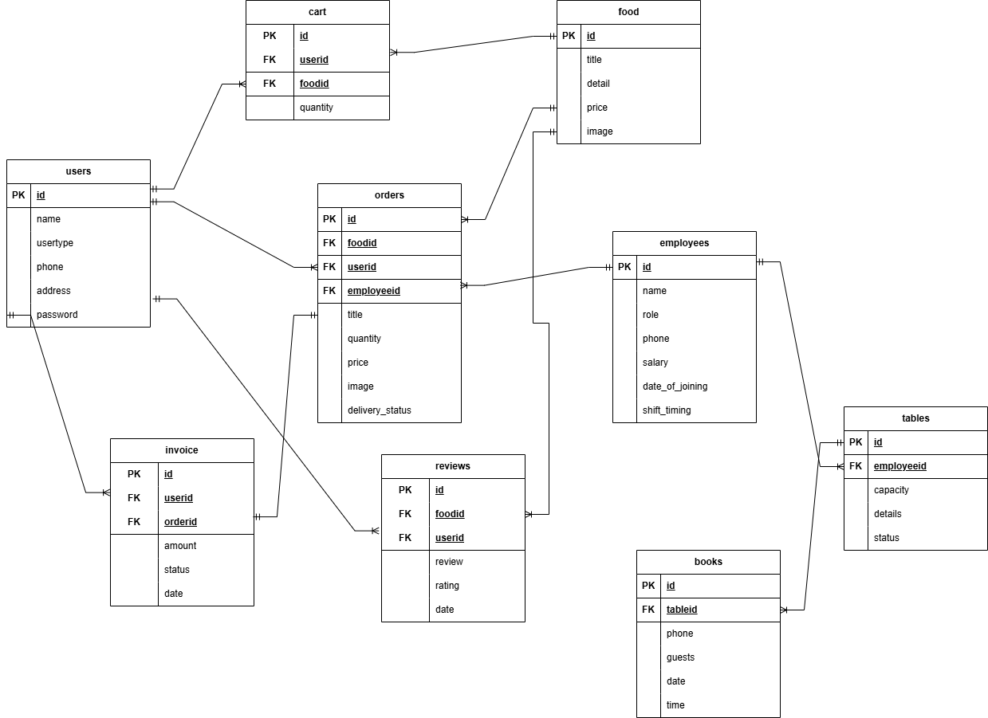

**References:**

* ChatGPT
* Youtube
* Draw.io
* Claude