**Key Milestone 3: DBMS Lab Project SQL Implementation**



**DBMS Final Project**

**Submitted By:** Muhammad Saad Amjad Khan

**Project Group #19:**

Muhammad Ehzaz Khan (22pwcse2108)

Muhammad Saad Amjad Khan (22pwcse2133)

Muhammad Kamil Khan (22pwcse2174)

**Section:** B

**Submitted to:** Engr.Sumayyea Salahuddin

“On my honor, as student of University of Engineering and Technology, I have neither given nor received unauthorized assistance on this academic work”

Department of Computer Systems Engineering

University of Engineering and Technology Peshawar

**Project: Restaurant Management System**

**Table:** users

**Metadata:**

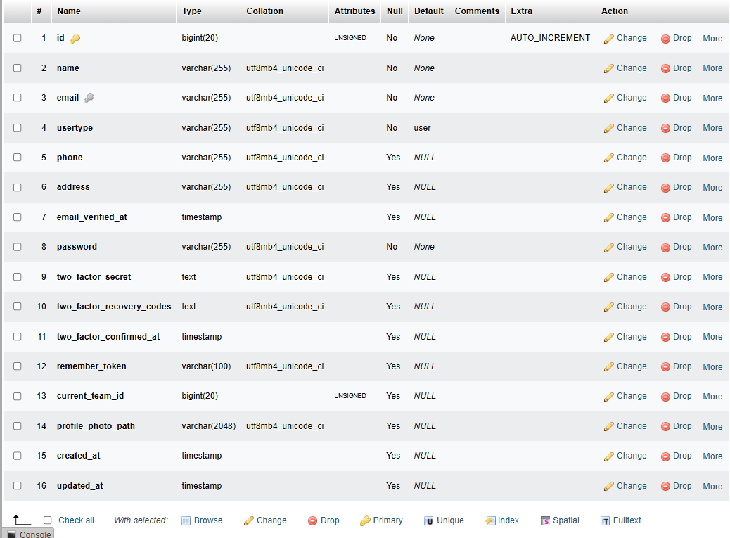

**Sample Data:**

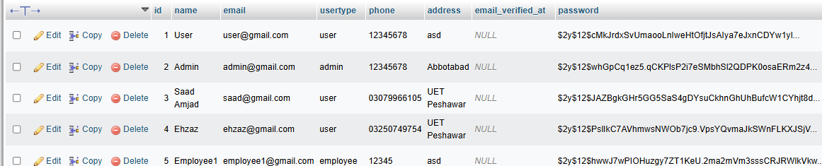

**SQL Queries:**

CREATE TABLE users (

id INT PRIMARY KEY,

name VARCHAR(100),

phone VARCHAR(15),

email VARCHAR(100),

address TEXT,

password VARCHAR(100)

);

INSERT INTO users (id, name, email, usertype, phone, address, password)

VALUES (2, 'Admin', 'admin@gmail.com', 'admin', '12345678', 'Abbotabad', '12345678');

INSERT INTO users (id, name, email, usertype, phone, address, password)

VALUES (3, 'Saad Amjad', 'saad@gmail.com', 'user', '03079966105', 'UET Peshawar', '12345678');

**Table:** employees

**Metadata:**

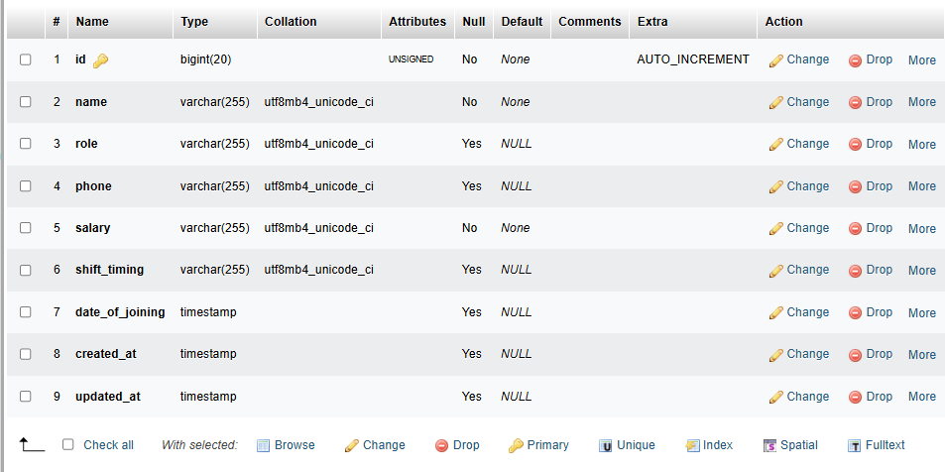

**Sample Data:**

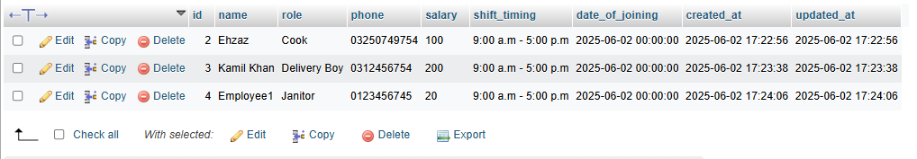

**SQL Queries:**

CREATE TABLE employees (

id INT PRIMARY KEY,

name VARCHAR(100),

role VARCHAR(50),

phone VARCHAR(15),

salary INT,

shift TIMESTAMP,

date_joining DATE

);

INSERT INTO employees (id, name, role, phone, salary, shift_timing, date_of_joining)

VALUES (2, 'Ehzaz', 'Cook', '03250749754', 100, '9:00 a.m - 5:00 p.m', '2025-06-02 00:00:00');

INSERT INTO employees (id, name, role, phone, salary, shift_timing, date_of_joining)

VALUES (3, 'Kamil Khan', 'Delivery Boy', '0312456754', 200, '9:00 a.m - 5:00 p.m', '2025-06-02 00:00:00);

INSERT INTO employees (id, name, role, phone, salary, shift_timing, date_of_joining)

VALUES (4, 'Employee1', 'Janitor', '0123456745', 20, '9:00 a.m - 5:00 p.m', '2025-06-02 00:00:00');

**Table:** food

**Metadata:**

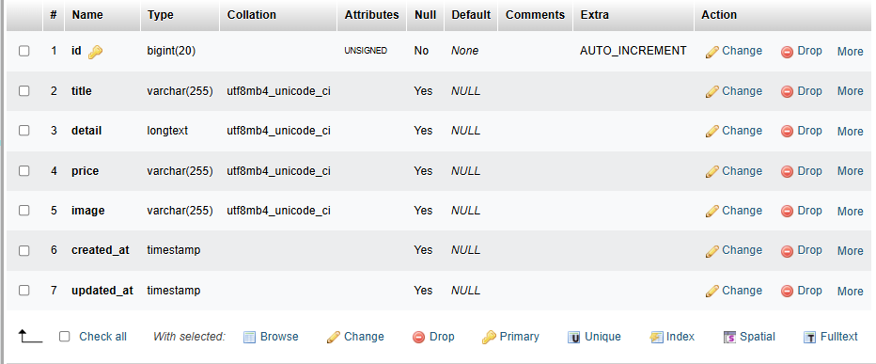

**Sample Data:**

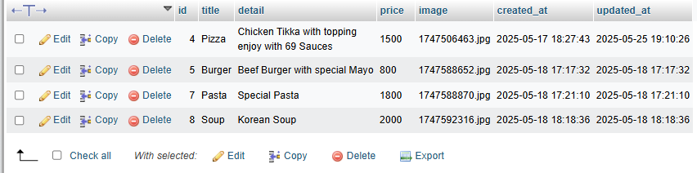

**SQL Queries:**

CREATE TABLE food_item (

id INT PRIMARY KEY,

title VARCHAR(100),

detail TEXT,

price INT,

image VARCHAR(255)

);

INSERT INTO food (id, title, detail, price, image)

VALUES (4, 'Pizza', 'Chicken Tikka with topping enjoy with 69 Sauces', 1500, ‘1747506463.jpg’);

INSERT INTO food (id, title, detail, price, image)

VALUES (5, 'Burger', 'Beef Burger with Special Mayo', 800, ‘1747588652.jpg’);

INSERT INTO food (id, title, detail, price, image)

VALUES (7, 'Pasta', 'Special Pasta', 1800, ‘1747588870.jpg’);

INSERT INTO food (id, title, detail, price, image)

VALUES (8, 'Soup', Korean Soup', 2000, ‘1747592316.jpg’);

**Table:** orders

**Metadata:**

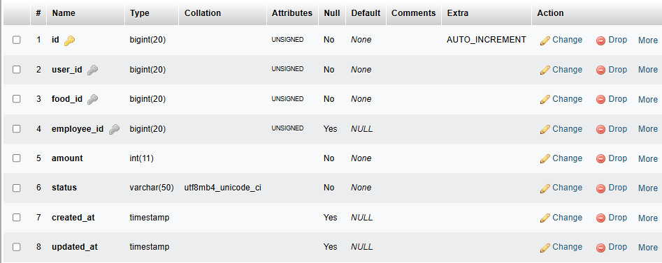

**Sample Data:**

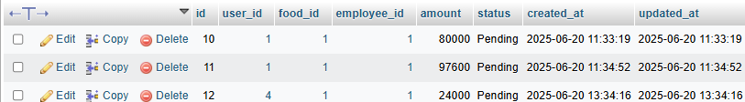

**SQL Queries:**

CREATE TABLE orders (

id INT PRIMARY KEY,

user_id INT,

food_id INT,

employee_id INT,

amount INT,

status VARCHAR(50),

FOREIGN KEY (user_id) REFERENCES users(id),

FOREIGN KEY (food_id) REFERENCES food_item(id),

FOREIGN KEY (employee_id) REFERENCES employees(id)

);

INSERT INTO orders (id, user_id, food_id, employee_id, amount, status)

VALUES (10, 1, 1, 1, 8000, Pending)

INSERT INTO orders (id, user_id, food_id, employee_id, amount, status)

VALUES (11, 1, 1, 1, 8000, Pending)

INSERT INTO orders (id, user_id, food_id, employee_id, amount, status)

VALUES (12, 1, 1, 1, 8000, Pending)

**Table:** tables

**Metadata:**

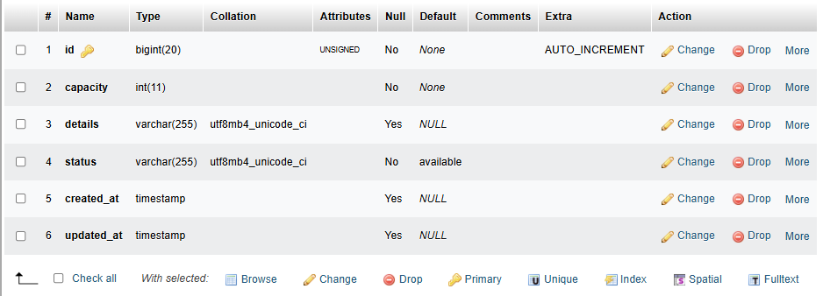

**Sample Data:**

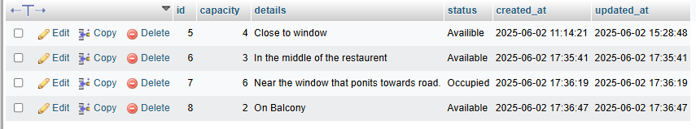

**SQL Queries:**

CREATE TABLE tables (

id INT PRIMARY KEY,

capacity INT,

detail TEXT,

status VARCHAR(50)

);

INSERT INTO tables (id, capacity, details, status)

VALUES (5, 4, ‘Close to window’, ‘Availible’)

INSERT INTO tables (id, capacity, details, status)

VALUES (6, 3, ‘In the middle of the restaurant’, ‘Available’)

INSERT INTO table (id, capacity, details, status)

VALUES (7, 6, ‘Near the window that points towards road.’, ‘Occupied’)

INSERT INTO tables (id, capacity, details, status)

VALUES (8, 2, ‘On Balcony’, ‘Available’)

**Table:** reviews

**Metadata:**

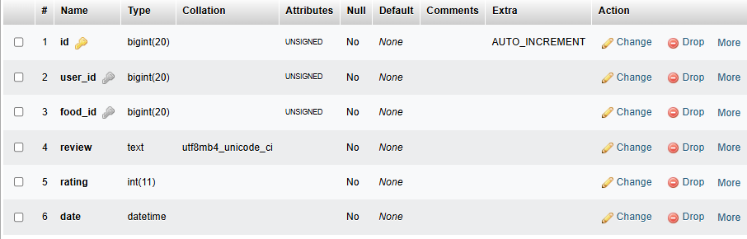

**Sample Data:**

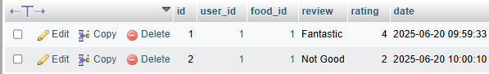

**SQL Queries:**

CREATE TABLE reviews (

id INT PRIMARY KEY,

user_id INT,

food_id INT,

review TEXT,

rating INT,

date DATETIME,

FOREIGN KEY (food_id) REFERENCES food_item(id)

);

INSERT INTO reviews (id, user_id, food_id, review, rating, date)

VALUES (1, 1, 1, ‘Fantastic’, 4, 2025-06-20)

INSERT INTO reviews (id, user_id, food_id, review, rating, date)

VALUES (2, 1, 1, ‘Not Good’, 2, 2025-06-20)

**Table:** books

**Metadata:**

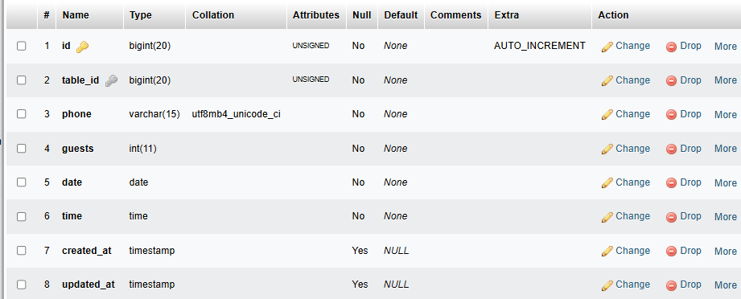

**Sample Data:**



**SQL Queries:**

CREATE TABLE books (

id INT PRIMARY KEY,

table_id INT,

phone VARCHAR(15),

guests INT,

date DATETIME,

time DATETIME,

FOREIGN KEY (table_id) REFERENCES tables(id)

);

INSERT INTO books (id, table_id, phone, guest, date, time)

VALUES (1, 1, +923429233995, 4, ‘2025-06-26’, ’22:44’)

**Table:** carts

**Metadata:**

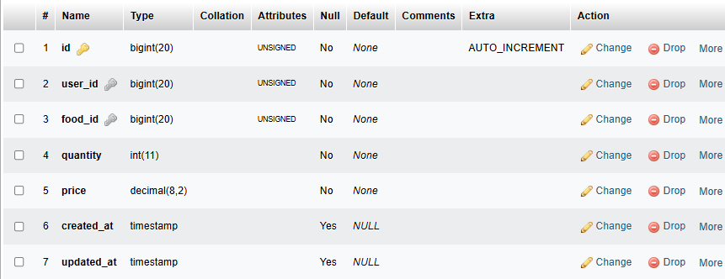

**Sample Data:**

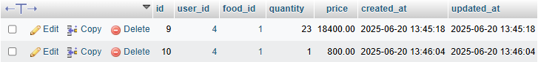

**SQL Queries:**

CREATE TABLE carts (

id INT PRIMARY KEY,

user_id INT,

food_id INT,

quantity INT,

price INT,

FOREIGN KEY (user_id) REFERENCES users(id),

FOREIGN KEY (food_id) REFERENCES food_item(id)

);

INSERT INTO carts (id, user_id, food_id, quantity, price)

VALUES (9, 4, 1, 23, 18400)

INSERT INTO carts (id, user_id, food_id, quantity, price)

VALUES (10, 4, 1, 1, 800)

**Table:** invoice

**Metadata:**

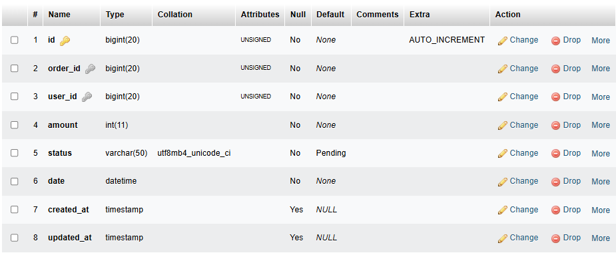

**Sample Data:**

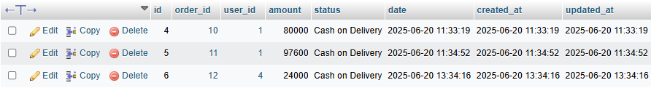

**SQL Queries:**

CREATE TABLE invoice (

id INT PRIMARY KEY,

order_id INT,

user_id INT,

amount INT,

status VARCHAR(50),

date DATETIME,

FOREIGN KEY (order_id) REFERENCES orders(id),

FOREIGN KEY (user_id) REFERENCES users(id));

INSERT INTO invoice (id, order_id, user_id, amount, status, date)

VALUES (4, 10, 1, 80000, ‘Cash on Delivery’, 2025-06-20)

INSERT INTO invoice (id, order_id, user_id, amount, status, date)

VALUES (5, 11, 1, 97600, ‘Cash on Delivery’, 2025-06-20)