**Phase 2 DBMS Lab Project**

**Sir Khizer Hayat**

**O9**

**L1F20BSSE0291**

**Muhammad Saad Arif Dhillon**

**_____________________ ____________________**

**Supermarket Grocery Store**

**ERD**

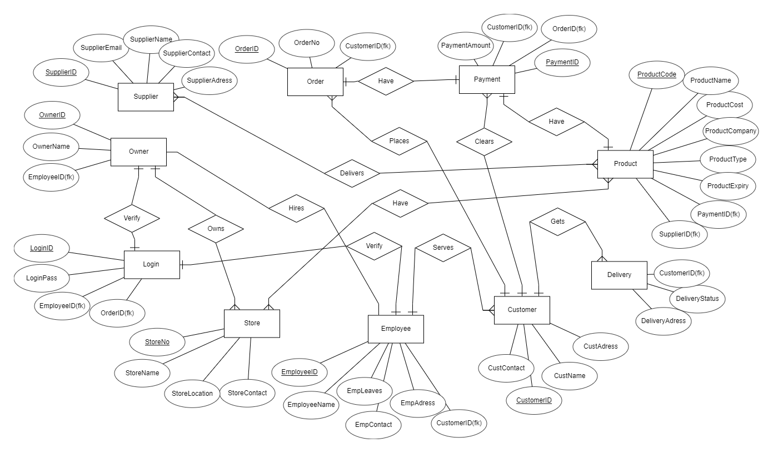

**Relational Mapping**