FX NEXUS: FOREX DATA ENGINE
Database Design Document
V 2.0
By

# | Member Name | Roll Number
1 | SAAD Nawaz | BSCS-2024-67

Department of Computer Sciences
Namal University
Mianwali, Pakistan

Submission Date: 21st June, 2026
Course: CSC-271 — Database Systems
Submitted to: Ma'am Asiya Batool

REVISION HISTORY
Date | Version | Description | Approved By
21/06/2026 | V 2.0 | Milestone 3: Added Chapter 3 (Relational Schema, FDs, Normalization) and Chapter 4 (DDL/DML, GUI, Stored Procedures, Triggers, Connectivity). Updated all sections based on Milestone 2 feedback. | Ma'am Asiya Batool
15/05/2026 | V 1.0 | Milestone 2: Initial Database Design Document — entity identification, data dictionary, business rules, ERD. | Ma'am Asiya Batool

TABLE OF CONTENTS
CHAPTER 1: PROJECT OVERVIEW 4
1.1 Introduction 4
1.2 Problem Statement 4
1.3 Project Objectives 5
1.4 GitHub Repository Link 5
CHAPTER 2: CONCEPTUAL DATABASE DESIGN 5
2.1 Entity Identification 5
2.2 Data Dictionary 6
2.3 Business Rules 7
2.4 Entity Relationship Diagram 7
CHAPTER 3: LOGICAL DATABASE DESIGN 8
3.1 Relational Schema 8
3.2 Functional Dependencies 9
3.3 Normalization to 3NF 9
CHAPTER 4: IMPLEMENTATION 10
4.1 Language / Framework 10
4.2 Database Connectivity 10
4.3 Stored Procedures, Functions & Triggers 11
4.4 Views & Indexes 11
4.5 GUI Interfaces 12
References 13
Appendix: AI Usage and Prompts 13

CHAPTER 1: PROJECT OVERVIEW

1.1. INTRODUCTION
FX Nexus is a centralized, relational database system designed for the comprehensive management, analysis, and backtesting of Forex (foreign exchange) market data. The Forex market is the world's largest financial market, reporting an average daily trading volume of approximately US$9.6 trillion as of April 2025 (BIS, 2025). This market operates 24 hours a day, five days a week, generating enormous volumes of time-stamped OHLCV (Open, High, Low, Close, Volume) price data across hundreds of currency pairs and multiple trading venues every second.
FX Nexus was developed in the context of the CSC-271 Database Systems course at Namal University, Mianwali, as a Complex Computing Problem (CCP) project. The system is designed to serve traders, quantitative analysts, and academic researchers who require structured, high-performance access to historical Forex price data, embedded computation of technical indicators (Moving Average, RSI, MACD, Bollinger Bands, ATR), and the ability to define, execute, and evaluate backtesting strategies through an integrated GUI application.
The system ingests price data from multiple external sources including Yahoo Finance, OANDA, MetaTrader 4/5 platform exports, and public datasets from Kaggle and Histdata.com. All ingested data is normalized and stored in a 3NF-compliant relational schema implemented in MySQL 8.0, with optimized composite indexes for fast time-series queries. The desktop GUI application, built with Python and Tkinter, connects to the database through mysql-connector-python and routes all write operations through stored procedures, ensuring structured and secure data access.

1.2. PROBLEM STATEMENT
Forex market analysts face four major challenges when managing, analyzing, and backtesting trading data:
- Fragmented Data Sources: Price data originates from many vendors — brokers, APIs, and platforms — each with different formats, timestamp conventions, and coverage gaps, making it nearly impossible to maintain a unified, consistent dataset for analysis without substantial manual effort.
- Error-Prone Manual Analysis: Analysts relying on spreadsheet tools or standalone scripts are prone to formula errors, version inconsistencies, and data corruption that undermine the reliability of analytical outputs and strategy conclusions.
- Performance and Scalability Constraints: Backtesting strategies over millions of M1 price records in traditional spreadsheet environments is impractical due to memory and processing limitations, making iterative strategy refinement slow and error-prone.
- Absence of Integrated Technical Analysis: Existing tools require computing indicators in external applications and manually re-importing results, creating a fragmented, multi-step workflow that introduces synchronization errors.
FX Nexus addresses all four challenges through a single, centralized, indexed relational database with a built-in data ingestion pipeline, SQL-based indicator computation via stored procedures, and a structured backtesting module — all accessible through a user-friendly GUI.

1.3. PROJECT OBJECTIVES
General Objective: To design, implement, and deploy FX Nexus — a centralized, 3NF-normalized relational database system with a full-featured GUI — enabling efficient storage, retrieval, analysis, and backtesting of high-frequency Forex market data.

Specific Objectives:
- Design a normalized relational schema (3NF) with 10 tables covering all entities, their specialization hierarchy (Trader supertype with AnalystTrader and StrategyTrader subtypes), and all foreign key relationships.
- Implement DDL scripts creating all tables, composite indexes, views, triggers, stored procedures, and functions in MySQL 8.0.
- Populate the database with at least 20 rows of meaningful, consistent sample data per table using a DML script (dbDML.sql).
- Develop 5 stored procedures and 2 functions covering all core business operations — price retrieval, trader insertion, strategy performance analysis, import job management, and MA computation.
- Build a desktop GUI application in Python/Tkinter with 7 functional pages (Dashboard, Price Bars, Traders, Currency Pairs, Strategies, Import Jobs, Indicators) — all writes routed through stored procedures.
- Achieve 3NF compliance across all 10 relations, with documented functional dependency analysis and normalization justification.

1.4. GITHUB REPOSITORY LINK
https://github.com/saadasad78692-prog/FX-Nexus-Forex-Market-Data-Engine.git

CHAPTER 2: CONCEPTUAL DATABASE DESIGN

2.1. ENTITY IDENTIFICATION
The FX Nexus system contains 10 distinct entities. The Trader entity serves as a supertype with two exclusive subtypes — AnalystTrader and StrategyTrader — modeled using an EERD specialization with a disjoint (d) constraint.
Sr.No | Entity | Description
01 | CurrencyPair | Represents a traded currency pair (e.g. EUR/USD). Central instrument around which all price data is organized.
02 | DataSource | External data provider (Yahoo Finance, OANDA, MetaTrader). Tracks origin of each price record.
03 | PriceBar | Stores OHLCV candlestick data per currency pair, timeframe, and timestamp. Core time-series entity.
04 | Trader (Supertype) | Any system user. Contains shared identity and authentication attributes. Discriminator: TraderType.
05 | AnalystTrader (Subtype) | Specialization of Trader for read-only analytical queries and indicator computation.
06 | StrategyTrader (Subtype) | Specialization of Trader for creating and running backtesting strategies.
07 | TechnicalIndicator | Computed indicator values (MA, RSI, MACD, etc.) linked to a specific PriceBar.
08 | Strategy | Backtesting strategy definition (entry/exit rules, indicator parameters) created by StrategyTrader.
09 | BacktestReport | Result of executing a Strategy over historical PriceBar data, with performance metrics.
10 | ImportJob | Data ingestion job initiated by a Trader, pulling data from a DataSource into PriceBar.

2.2. DATA DICTIONARY (SUMMARY)
Complete data dictionaries were documented in Milestone 2 (V 1.0). The following is a summary of key attributes per entity for reference in this milestone. All primary keys are marked (PK) and foreign keys (FK) are excluded from data dictionaries per database design convention.
Entity | Primary Key | Key Non-Key Attributes
CurrencyPair | PairID (INT, AI) | BaseCurrency CHAR(3), QuoteCurrency CHAR(3), PairSymbol VARCHAR(10) UNIQUE, PipValue DECIMAL(10,5), IsActive BOOLEAN
DataSource | SourceID (INT, AI) | SourceName VARCHAR(100) UNIQUE, SourceType ENUM, BaseURL VARCHAR(255), APIKey VARCHAR(255), LastSyncTime DATETIME
PriceBar | BarID (BIGINT, AI) | Timeframe ENUM(M1/M15/H1), OpenTime DATETIME, OpenPrice/HighPrice/LowPrice/ClosePrice DECIMAL(10,5), Volume BIGINT
Trader | TraderID (INT, AI) | FullName VARCHAR(150), Email VARCHAR(255) UNIQUE, PasswordHash VARCHAR(255), TraderType ENUM(Analyst/Strategy)
AnalystTrader | TraderID (PK/FK) | PreferredIndicators VARCHAR(255), QueryHistoryLimit INT DEFAULT 1000
StrategyTrader | TraderID (PK/FK) | RiskTolerance ENUM(Low/Medium/High), DefaultLotSize DECIMAL(5,2), MaxDrawdownPct DECIMAL(5,2)
TechnicalIndicator | IndicatorID (BIGINT, AI) | IndicatorType ENUM, Period INT, Value1 DECIMAL(15,6), Value2 DECIMAL(15,6), Value3 DECIMAL(15,6)
Strategy | StrategyID (INT, AI) | StrategyName VARCHAR(150), EntryRule TEXT, ExitRule TEXT, IndicatorParams JSON, IsActive BOOLEAN
BacktestReport | ReportID (INT, AI) | StartDate/EndDate DATETIME, TotalTrades INT, WinRate DECIMAL(5,2), TotalProfitLoss DECIMAL(15,2), MaxDrawdown DECIMAL(5,2), SharpeRatio DECIMAL(8,4)
ImportJob | JobID (INT, AI) | Timeframe ENUM, Status ENUM(Pending/Running/Completed/Failed), RecordsImported INT, StartedAt/CompletedAt DATETIME, ErrorMessage TEXT

2.3. BUSINESS RULES (SUMMARY)
The following critical business rules govern data integrity in FX Nexus:
- A currency pair must have a unique PairSymbol and BaseCurrency must differ from QuoteCurrency.
- Every price bar must be traceable to exactly one data source and one currency pair — orphaned records are not permitted.
- HighPrice >= OpenPrice, ClosePrice >= LowPrice, and HighPrice >= LowPrice for every PriceBar (enforced via CHECK constraints).
- Each Trader is classified as exactly one subtype: either AnalystTrader or StrategyTrader — exclusive specialization enforced via triggers.
- An AnalystTrader may not create strategies or run backtests; a StrategyTrader may run all operations.
- A Strategy must define both EntryRule and ExitRule (NOT NULL); BacktestReport EndDate must be strictly greater than StartDate.
- WinRate must be between 0 and 100; MaxDrawdown must be between 0 and 100 (CHECK constraints).
- An import job follows a strict status lifecycle: Pending → Running → Completed/Failed. Completion sets completed_at automatically via trigger.

2.4. ENTITY RELATIONSHIP DIAGRAM
The EERD for FX Nexus was produced in Milestone 2 using Chen notation and is included as Figure 1 below. The diagram shows all 10 entities, their attributes, the Trader supertype-subtype (disjoint) specialization, and all 11 relationships with minimum and maximum cardinalities.
[Figure 1: FX Nexus EERD — See FX_Nexus_ERD.png submitted with this report]
Figure 1: FX Nexus Enhanced Entity Relationship Diagram (EERD) — Chen Notation — Milestone 2

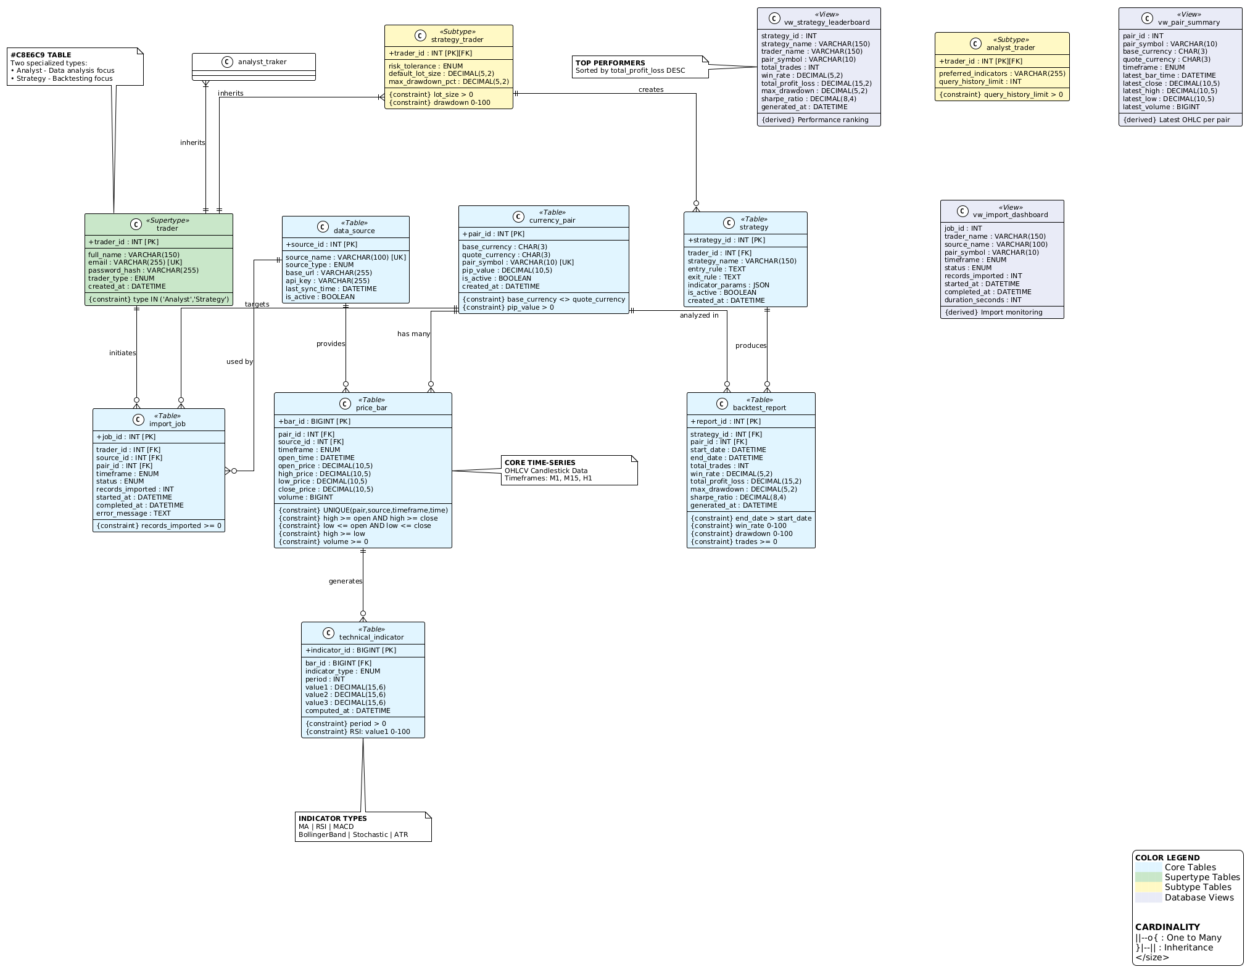

CHAPTER 3: LOGICAL DATABASE DESIGN

3.1. RELATIONAL SCHEMA
The following relational schema was derived from the FX Nexus EERD using standard ERD-to-relational mapping rules. Each entity maps to one relation. The Trader supertype-subtype hierarchy uses the shared primary key method (analyst_trader.TraderID and strategy_trader.TraderID are both primary keys and foreign keys referencing trader.TraderID). Many-to-one relationships are represented by placing the foreign key in the many-side relation.
Notation: * = Primary Key, † = Foreign Key

Relation Name | Relation Schema (Attributes — PK underlined, FK noted)
currency_pair | currency_pair(PairID*, BaseCurrency, QuoteCurrency, PairSymbol, PipValue, IsActive, CreatedAt)
data_source | data_source(SourceID*, SourceName, SourceType, BaseURL, APIKey, LastSyncTime, IsActive)
trader | trader(TraderID*, FullName, Email, PasswordHash, TraderType, CreatedAt)
analyst_trader | analyst_trader(TraderID*†, PreferredIndicators, QueryHistoryLimit) — TraderID FK→trader
strategy_trader | strategy_trader(TraderID*†, RiskTolerance, DefaultLotSize, MaxDrawdownPct) — TraderID FK→trader
price_bar | price_bar(BarID*, PairID†, SourceID†, Timeframe, OpenTime, OpenPrice, HighPrice, LowPrice, ClosePrice, Volume) — PairID FK→currency_pair, SourceID FK→data_source
technical_indicator | technical_indicator(IndicatorID*, BarID†, IndicatorType, Period, Value1, Value2, Value3, ComputedAt) — BarID FK→price_bar
strategy | strategy(StrategyID*, TraderID†, StrategyName, EntryRule, ExitRule, IndicatorParams, IsActive, CreatedAt) — TraderID FK→strategy_trader
backtest_report | backtest_report(ReportID*, StrategyID†, PairID†, StartDate, EndDate, TotalTrades, WinRate, TotalProfitLoss, MaxDrawdown, SharpeRatio, GeneratedAt) — StrategyID FK→strategy, PairID FK→currency_pair
import_job | import_job(JobID*, TraderID†, SourceID†, PairID†, Timeframe, Status, RecordsImported, StartedAt, CompletedAt, ErrorMessage) — TraderID FK→trader, SourceID FK→data_source, PairID FK→currency_pair
Table 1: FX Nexus Relational Schema — 10 Relations

3.2. FUNCTIONAL DEPENDENCIES
The following functional dependencies (FDs) were identified for all 10 relations. FDs are derived directly from the domain semantics of each entity and the business rules established in the system. Only non-trivial FDs are listed.

# | Relation | Functional Dependencies (FDs)
FD-01 | currency_pair | PairID → BaseCurrency, QuoteCurrency, PairSymbol, PipValue, IsActive, CreatedAt
FD-02 | currency_pair | PairSymbol → BaseCurrency, QuoteCurrency, PipValue, IsActive
FD-03 | data_source | SourceID → SourceName, SourceType, BaseURL, APIKey, LastSyncTime, IsActive
FD-04 | data_source | SourceName → SourceType, BaseURL, APIKey, LastSyncTime
FD-05 | trader | TraderID → FullName, Email, PasswordHash, TraderType, CreatedAt
FD-06 | trader | Email → TraderID, FullName, PasswordHash, TraderType
FD-07 | analyst_trader | TraderID → PreferredIndicators, QueryHistoryLimit
FD-08 | strategy_trader | TraderID → RiskTolerance, DefaultLotSize, MaxDrawdownPct
FD-09 | price_bar | BarID → PairID, SourceID, Timeframe, OpenTime, OpenPrice, HighPrice, LowPrice, ClosePrice, Volume
FD-10 | price_bar | (PairID, SourceID, Timeframe, OpenTime) → BarID, OpenPrice, HighPrice, LowPrice, ClosePrice, Volume
FD-11 | technical_indicator | IndicatorID → BarID, IndicatorType, Period, Value1, Value2, Value3, ComputedAt
FD-12 | strategy | StrategyID → TraderID, StrategyName, EntryRule, ExitRule, IndicatorParams, IsActive, CreatedAt
FD-13 | backtest_report | ReportID → StrategyID, PairID, StartDate, EndDate, TotalTrades, WinRate, TotalProfitLoss, MaxDrawdown, SharpeRatio, GeneratedAt
FD-14 | import_job | JobID → TraderID, SourceID, PairID, Timeframe, Status, RecordsImported, StartedAt, CompletedAt, ErrorMessage
Table 2: Functional Dependencies per Relation

3.3. NORMALIZATION TO 3NF
All 10 relations in FX Nexus were verified against the criteria for First Normal Form (1NF), Second Normal Form (2NF), and Third Normal Form (3NF). The analysis below confirms that all relations satisfy 3NF without requiring decomposition, as the schema was designed with normalization principles embedded from the start.

1NF Compliance (all relations): All attribute domains are atomic — no multi-valued or composite attributes exist in any relation. Arrays (e.g., preferred indicators) are stored as VARCHAR strings, not set-valued fields. All rows are uniquely identifiable via their primary key. All 10 relations satisfy 1NF.

2NF Compliance (all relations): 2NF requires no partial dependency of a non-key attribute on part of a composite primary key. Only price_bar has a composite candidate key (PairID, SourceID, Timeframe, OpenTime). All non-key attributes (OpenPrice, HighPrice, LowPrice, ClosePrice, Volume) depend on the entire composite key — not on any proper subset. All remaining relations have a single-column primary key, so partial dependency is not possible. All 10 relations satisfy 2NF.

3NF Compliance (all relations): 3NF requires no transitive dependency — no non-key attribute should depend on another non-key attribute. In analyst_trader and strategy_trader, all attributes depend solely on TraderID (PK/FK). In backtest_report, StrategyID and PairID are foreign keys — their presence does not create transitive dependencies because strategy and currency_pair are independent normalized relations. In strategy, StrategyName, EntryRule, and ExitRule all depend only on StrategyID. No relation contains a non-key attribute that functionally determines another non-key attribute. All 10 relations satisfy 3NF.

Relation | Normal Form | Justification
currency_pair | 3NF | PK=PairID. PairSymbol→BaseCurrency,QuoteCurrency is a candidate key dependency (not partial or transitive). All non-key attributes depend only on PK.
data_source | 3NF | PK=SourceID. SourceName is a candidate key; SourceName→SourceType is CK dependency, not transitive. No partial or transitive FDs exist.
trader | 3NF | PK=TraderID. Email is a CK. All non-key attributes depend fully and directly on PK. No transitive dependencies.
analyst_trader | 3NF | PK=TraderID (FK to trader). All attributes depend solely on TraderID. No partial or transitive FDs — relation is in 3NF.
strategy_trader | 3NF | PK=TraderID (FK to trader). All attributes depend solely on TraderID. No partial or transitive FDs — relation is in 3NF.
price_bar | 3NF | PK=BarID. Composite CK=(PairID,SourceID,Timeframe,OpenTime). No non-key attribute depends on part of the PK or transitively on another non-key attribute.
technical_indicator | 3NF | PK=IndicatorID. All attributes depend directly on IndicatorID. Value2 and Value3 are nullable — their absence does not create partial dependency. In 3NF.
strategy | 3NF | PK=StrategyID. All non-key attributes depend fully and directly on StrategyID. TraderID is a FK, not a transitive dependency source. In 3NF.
backtest_report | 3NF | PK=ReportID. All attributes depend directly on ReportID. StrategyID and PairID are FKs forming no transitive chain since strategy and currency_pair are separate normalized relations. In 3NF.
import_job | 3NF | PK=JobID. All non-key attributes depend directly on JobID. Three FKs (TraderID, SourceID, PairID) — no transitive FDs since they are in separate relations. In 3NF.
Table 3: Normalization Status of All Relations

CHAPTER 4: IMPLEMENTATION

4.1. LANGUAGE / FRAMEWORK
Component | Technology / Version | Purpose
DBMS | MySQL 8.0+ | Primary relational database management system
Programming Language | Python 3.9+ | Backend logic, database connectivity, GUI application
GUI Framework | Tkinter (built-in) | Desktop graphical user interface — 7 functional pages
Database Driver | mysql-connector-python | Python-to-MySQL connection and stored procedure calls
SQL Tools | MySQL Workbench 8.0 | Schema design, query testing, and administration
Version Control | Git + GitHub | Source code management and collaboration
Development Environment | VS Code / PyCharm | Code editing and debugging

4.2. DATABASE CONNECTIVITY
The FX Nexus GUI application connects to MySQL using the mysql-connector-python library. All database write operations are performed exclusively through stored procedures using cursor.callproc(). Read-only SELECT queries are permitted only against views (vw_pair_summary, vw_strategy_leaderboard, vw_import_dashboard) and simple table SELECTs for browsing. No raw INSERT, UPDATE, or DELETE SQL is issued directly from the GUI — all mutations go through stored procedures or the trigger layer.

Component | Detail
Programming Language | Python 3.9+
GUI Framework | Tkinter (built-in Python library — no additional install required)
Database Driver | mysql-connector-python (install: pip install mysql-connector-python)
Connection Method | mysql.connector.connect() with host, port, user, password, database parameters
DBMS | MySQL 8.0+
Query Execution | All write operations via stored procedures using cursor.callproc(). Read-only views via cursor.execute() SELECT only.
Error Handling | Try/except blocks on every DB call; errors displayed in GUI messagebox dialogs
Security | Passwords hashed (SHA-256 simulation); no plain SQL strings from GUI; all writes through stored procedures
Table 4: Database Connectivity Details

4.3. STORED PROCEDURES, FUNCTIONS, AND TRIGGERS
All core business operations in FX Nexus are implemented as stored procedures or functions in the MySQL database layer. The GUI application calls these by name using cursor.callproc(), ensuring no raw SQL logic is embedded in the application code. The following table summarizes all database objects:

Procedure/Function | Parameters | Description
sp_get_price_bars() | pair_symbol, timeframe, start_date, end_date | Retrieves OHLCV price bars for a given currency pair, timeframe, and date range. Used by GUI Price Bars page.
sp_insert_trader() | full_name, email, password_hash, trader_type, risk_tolerance, pref_indicators | Inserts a new Trader supertype record and the correct subtype (analyst_trader or strategy_trader) in one atomic operation.
sp_strategy_performance() | trader_id | Returns all backtest report results for strategies owned by a given trader, ordered by total profit/loss descending.
sp_update_import_status() | job_id, status, records, error_msg | Updates the status, records_imported, and error_message of an import job. Trigger auto-sets completed_at.
sp_compute_ma() | pair_id, timeframe, period | Computes Moving Average indicator values for all bars of a given pair and timeframe and inserts results into technical_indicator.
fn_pip_difference() | pair_id, price1, price2 | Returns the pip difference between two prices for a given currency pair using stored pip_value.
fn_bar_count() | pair_id, timeframe | Returns the total count of price bars stored for a specific currency pair and timeframe.
Table 5: Stored Procedures and Functions

Trigger | Event | Description
trg_check_analyst_type | BEFORE INSERT on analyst_trader | Validates that the trader_type in the trader table is "Analyst" before allowing insertion into analyst_trader. Enforces exclusive EERD specialisation.
trg_check_strategy_type | BEFORE INSERT on strategy_trader | Validates that the trader_type is "Strategy" before allowing insertion into strategy_trader. Enforces exclusive specialisation.
trg_import_job_complete | BEFORE UPDATE on import_job | Automatically sets completed_at = CURRENT_TIMESTAMP when status transitions to "Completed" or "Failed".
trg_update_last_sync | AFTER INSERT on price_bar | Updates the last_sync_time in data_source after each new price_bar insertion, keeping sync timestamps current automatically.
Table 6: Database Triggers

4.4. VIEWS AND INDEXES
Three views provide pre-joined, optimized read access for the GUI dashboard and reporting pages:
View Name | Description
vw_pair_summary | Shows active currency pairs joined with their latest price bar per timeframe — provides close, high, low, and volume at a glance without writing complex queries.
vw_strategy_leaderboard | Joins backtest_report, strategy, trader, and currency_pair to display a ranked performance dashboard sorted by total profit/loss descending.
vw_import_dashboard | Joins import_job, trader, data_source, and currency_pair to show all import job statuses with computed duration in seconds.
Table 7: Database Views

Nine indexes are defined to optimize the most frequent query patterns in FX Nexus, particularly time-series range queries on price_bar:
Index Name | Table | Columns & Purpose
idx_pb_pair_time | price_bar | (pair_id, timeframe, open_time) — Primary composite index for fast time-series range queries by pair and timeframe.
idx_pb_source | price_bar | (source_id) — Speeds up queries filtering bars by data source.
idx_pb_open_time | price_bar | (open_time) — Enables fast date-range scans across all pairs.
idx_ti_bar | technical_indicator | (bar_id) — Speeds up joins between price_bar and technical_indicator.
idx_ti_type_period | technical_indicator | (indicator_type, period) — Optimises queries filtering by indicator type and period (e.g., RSI-14).
idx_br_strategy | backtest_report | (strategy_id) — Speeds retrieval of all reports for a strategy.
idx_br_pair_date | backtest_report | (pair_id, start_date, end_date) — Enables efficient date-range backtest analysis per pair.
idx_ij_trader_status | import_job | (trader_id, status) — Optimises dashboard queries for pending/running jobs per trader.
idx_strategy_trader | strategy | (trader_id) — Speeds up listing all strategies for a trader.
Table 8: Database Indexes

4.5. GUI INTERFACES
The FX Nexus GUI application is implemented in Python using Tkinter. It features a professional layout with a navigation menu and 7 functional pages. All pages that perform write operations call stored procedures through cursor.callproc() — no direct SQL is executed from the GUI layer per Milestone 3 requirements.

GUI Page | Operations | Description
Login / Connect | Database Connectivity | User enters host, port, username, password, and database name. Connects via mysql-connector-python.
Dashboard | Read (View) | Displays row counts for all 10 tables and top 10 strategies by profit via vw_strategy_leaderboard. Refresh button updates stats.
Price Bars | Read via SP | Calls sp_get_price_bars() with pair symbol, timeframe, and date range. Results displayed in scrollable table.
Traders | Create, Read, Delete | Calls sp_insert_trader() to add traders with correct subtype. Browse all traders. Delete selected trader with confirmation.
Currency Pairs | Create, Read, Update | Insert new currency pairs. Browse all pairs. Toggle is_active status with one click.
Strategies | Read via SP | Calls sp_strategy_performance() by trader ID. Browse all strategies. View leaderboard via vw_strategy_leaderboard.
Import Jobs | Create, Read, Update via SP | Create new import jobs. Calls sp_update_import_status() to transition job status. Dashboard via vw_import_dashboard.
Indicators | Create via SP, Read | Calls sp_compute_ma() to compute and store Moving Average indicators. Browse all indicator records.
Table 9: GUI Pages and Operations

GUI Design Principles: The interface uses a dark color scheme (#1A2035 background) with gold accent headings, styled entry widgets with placeholder text, hover-effect buttons, and color-coded ttk.Treeview tables with alternating row shading. All error conditions are caught and displayed via messagebox dialogs. Connection credentials are entered on a login page before the main application loads.
[See Screenshots of GUI in project submission / GitHub repository]
Figure 2: FX Nexus GUI — Dashboard, Price Bars, Traders, and Import Jobs pages
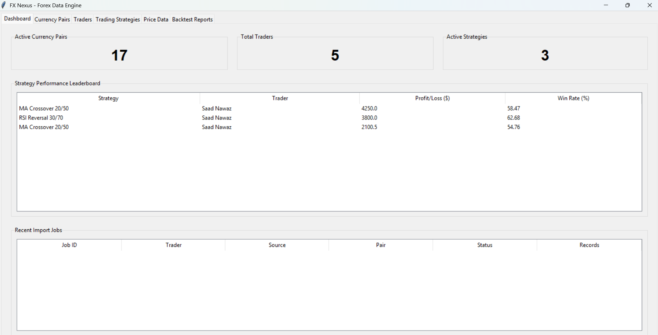
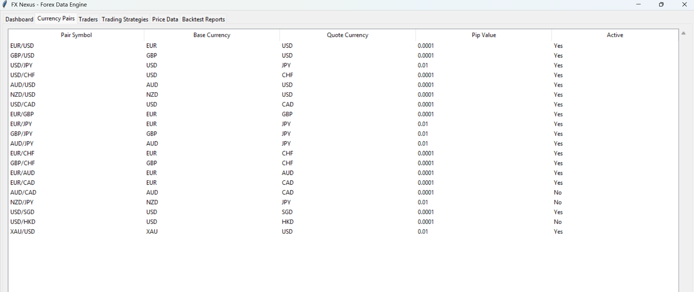
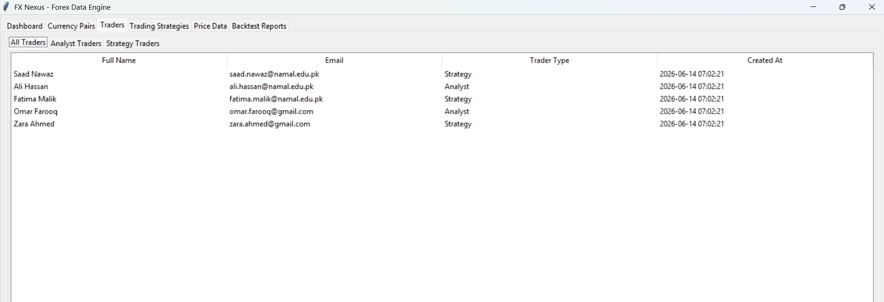
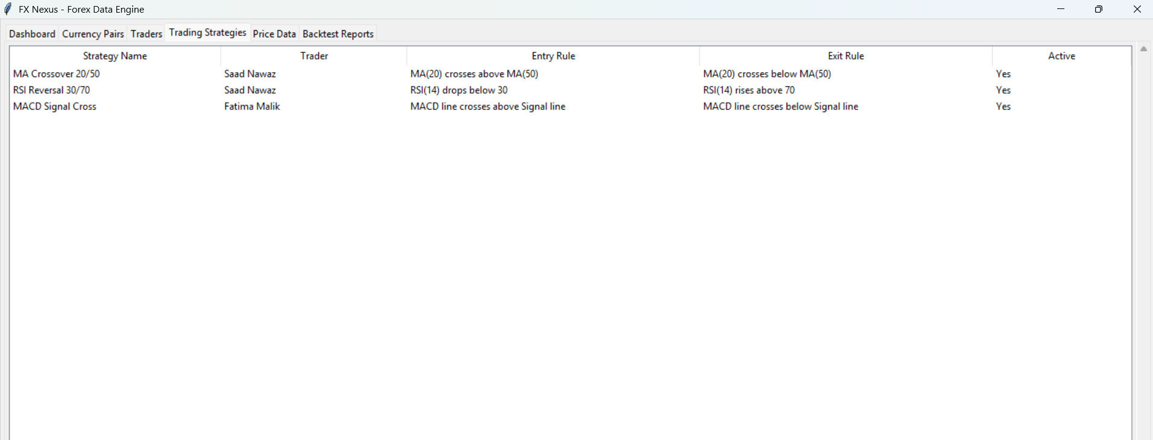
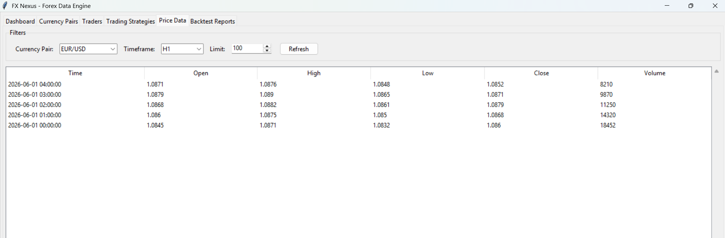

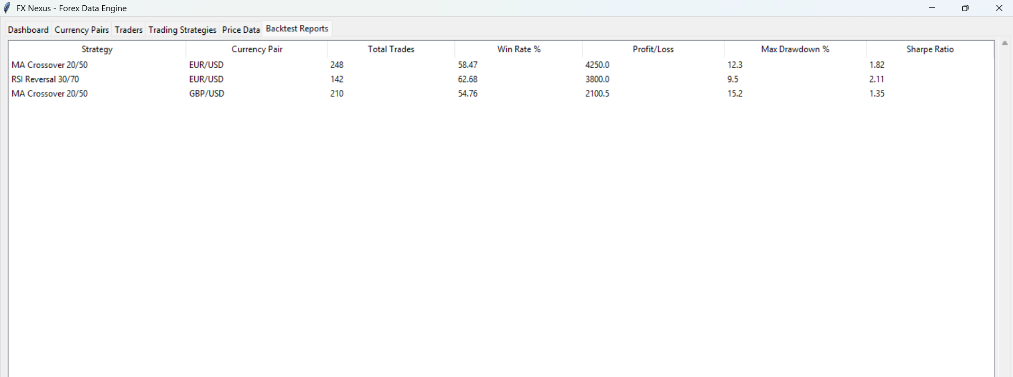

REFERENCE:
[1] Bank for International Settlements (BIS), "Triennial Central Bank Survey: Foreign Exchange Turnover in April 2025," BIS, 2025. [Online]. Available: https://www.bis.org/press/p250930.htm
[2] R. Elmasri and S. Navathe, Fundamentals of Database Systems, 7th ed. Pearson Education, 2016.
[3] C. J. Date, An Introduction to Database Systems, 8th ed. Addison-Wesley, 2004.
[4] MySQL 8.0 Reference Manual, Oracle Corporation. [Online]. Available: https://dev.mysql.com/doc/refman/8.0/en/
[5] Yahoo Finance API. [Online]. Available: https://www.yahoofinanceapi.com
[6] OANDA API Documentation. [Online]. Available: https://www.oanda.com
[7] TimescaleDB Documentation. [Online]. Available: https://docs.timescale.com
[8] MetaQuotes Ltd., "MetaTrader 5 Platform." [Online]. Available: https://www.metatrader5.com
[9] LeapRate, "Research paper on CLSS FX dataset." [Online]. Available: https://www.leaprate.com/forex/data
[10] KX (kx.com), "Backtesting at Scale with Highly Parallel Analytics." [Online]. Available: https://kx.com/blog

APPENDIX: AI USAGE AND PROMPTS

In accordance with CSC-271 Milestone 3 instructions, the following AI tools were used for understanding and drafting. All AI-generated content was reviewed, verified for technical accuracy, and adapted by the student.

AI Tools Used:
- Claude (Anthropic) — claude.ai — Used for generating dbDDL.sql (schema, indexes, views, triggers, stored procedures, functions), dbDML.sql (20+ rows per table, UPDATE/DELETE statements), Python Tkinter GUI source code, README.md, and the complete Milestone 3 report document.
- ChatGPT (OpenAI) — Used in Milestone 1 for initial proposal drafting and content structuring.
- Gemini AI (Google) — Used in Milestone 1 for database design and analytics guidance.

# | Prompt Summary | Purpose
1 | Read Milestone 1 proposal PDF. Understand FX Nexus fully. | Context loading
2 | Read Milestone 2 PDF. Generate entity tables, data dictionary, business rules, relationships, and DOCX report. | Milestone 2 completion
3 | Read Milestone 3 PDF and DOCX template. Generate: full dbDDL.sql with schema/indexes/views/triggers/SPs/functions, dbDML.sql with 20+ rows per table, Python Tkinter GUI using stored procedures, README.md, and complete DOCX report. | Milestone 3 completion
4 | Identify all FDs for each relation in FX Nexus and prove all 10 tables are in 3NF. | Normalization justification
5 | Write sp_compute_ma and sp_insert_trader stored procedures for FX Nexus MySQL schema. | Stored procedure code
Table 10: AI Prompts Used in Milestone 3

