**Arabische Basbousa**

**Ingredients:**

**2 cups coarse semolina**

**1/2 cup butter**

**1 cup sugar**

**1 cup plain yogurt or Sour Cream**

**almonds to garnish or 1/3 pistachios or cashews**

**2 eggs**

**some Lemon peel**

**1 1/2 cup water**

**How to make basbousa:**

1. A picture containing person

   Description automatically generatedIn a deep bowl, add farina, sugar, baking powder, eggs and everything else. Mixing everything well.
2. Mix eveything together until it looks like that:

1. Grease a tray with oil

1. 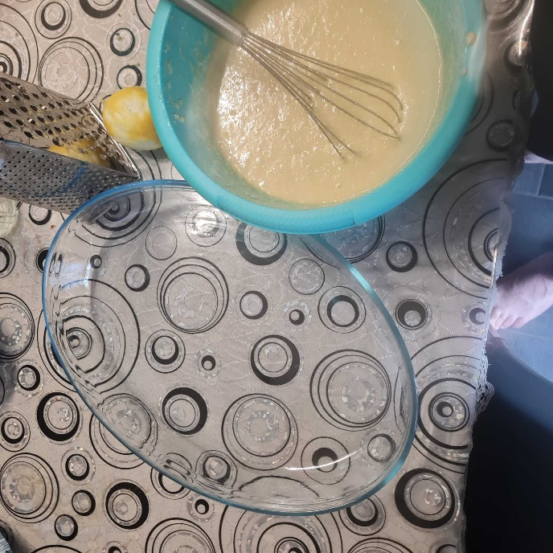press the mix down onto square baking dish or round pie pan.The cake mix should be about 1 inch thick.Cut a diamond or square design in the cake with a butter knife.
2. Place an almond or any other type of nut you have on hand onto each pre-cut square.

1. Bake at 400 degrees for 30 min to 40 mins until it's a bronze brown color. If no color forms on the top turn on broiler for 1-2 minutes until the top is golden/bronze. Cut the Cake again along the pre-cut lines and pour cold syrup on top while its hot so it can absorb all through.

1. A picture containing indoor, wall, pan, tiled

   Description automatically generatedprepare the serup: Put on water with sugar and boil for 10-20 minutes
2. place the serup on the basbousa

1. your basbousa is done: have fun eating!