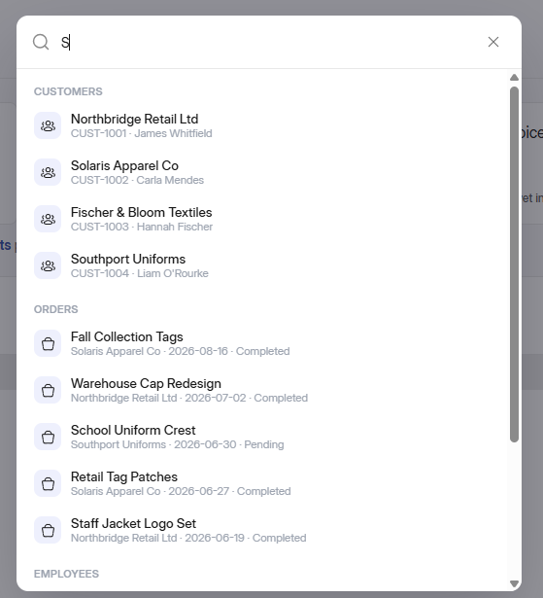

Jb bhi koi letter likheinge, os letter sei start hone wale words hi sirf show hongey, like solaris, southport, school uniform, staff jacket. Also orders ke sec ko last mei rakho because orders bohut saare hongey, also, panel acha banaya hai bs ek cheez or add krdo TAGS, customers ke opr suggested tags “customers, employees, orders, invoices” ye add krdo. Tu admin jb bhi “/” dalega osko tag suggest hojayenge phr wo jo bhi likhega suppose “/orders” phr oske aagr wo koi letter like “s” likhta hai tu osko sirf “S” sei start hone wale orders hi show hongey. And jb wo “/orders” likhega tu “/orders” brand primary blue color sei highlight hojayega, jese chatgpt mei hota hai.
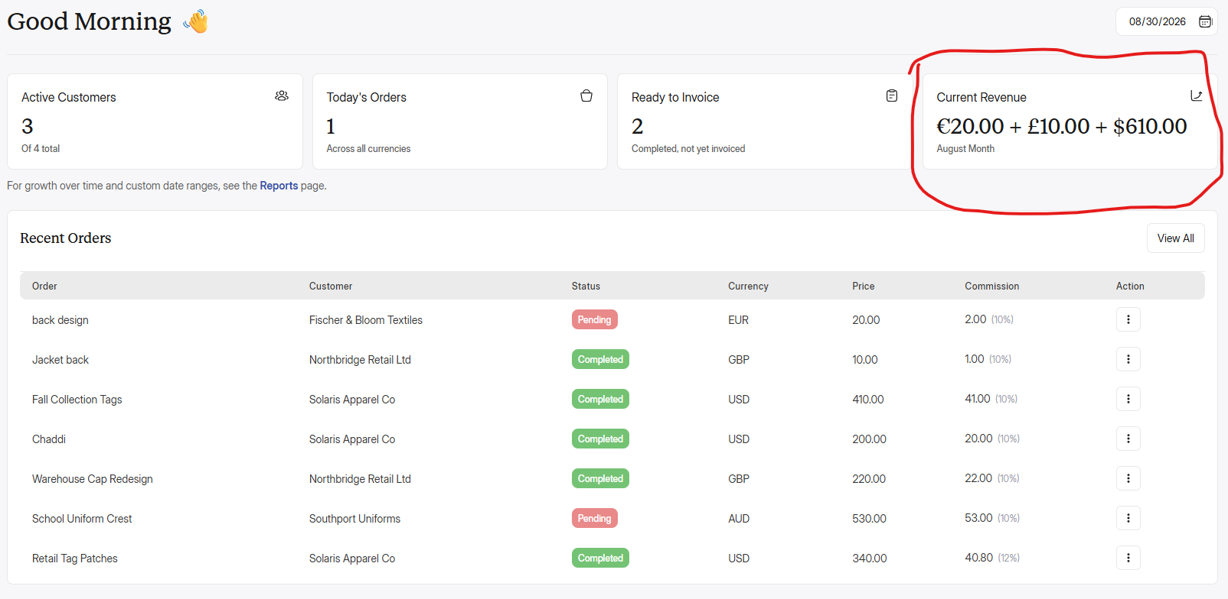
Also, dashboard mei ye current revenue change krdeina. This was my mistake yaha “Current Revenue” nhi “Total Income” aana hai, jo pkr mei show hoga. Wese ye by default today ka show karega jitna bhi dashboard ka data hai. But jb koi opr sei date set kareiga tu osko pore dashboard ka data os date ke acc show hoga. Ye by default tu today ka dikhayega but yaha calendar mei option do ki admin jo jitne days ka data dekhna hai wo click krke select karsake. Jese 1 of aug sei 10 of aug ka data dekhna hai tu admin calendar pr click krke 1 aug to 10 aug select kare then wo on 10 days ka data dekh sakta hai and Total income mei bhi 10 days ki total income sum hokr show hogi. And kitne days ka ya kis month ka data dikha rahe ho wo total income ki amount ke neeche bhi show krwana, like “1 aug - 10 aug”. Agr Today hai tu total income mei only “Today” aajeyga. And agr pore month ka hai tu “July Month” aese aajayega.

Is grey bar ke opr sei stroke remove krdo

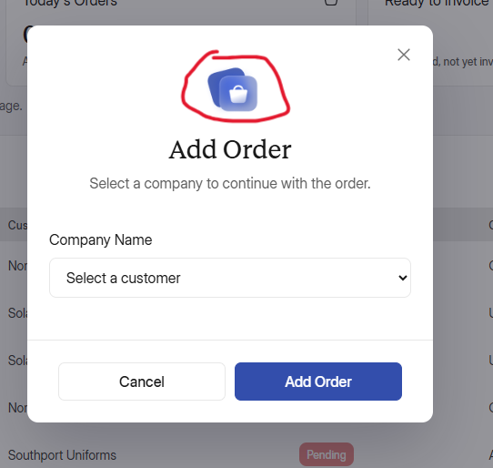
Ye icon change karo, icons saare svgs mei hi use hongey, png ya jpg mei nhi. Warna quality kharab aayegi jese isme aarahi and ye pichka howa bhi hai. Also dropdown field set karo

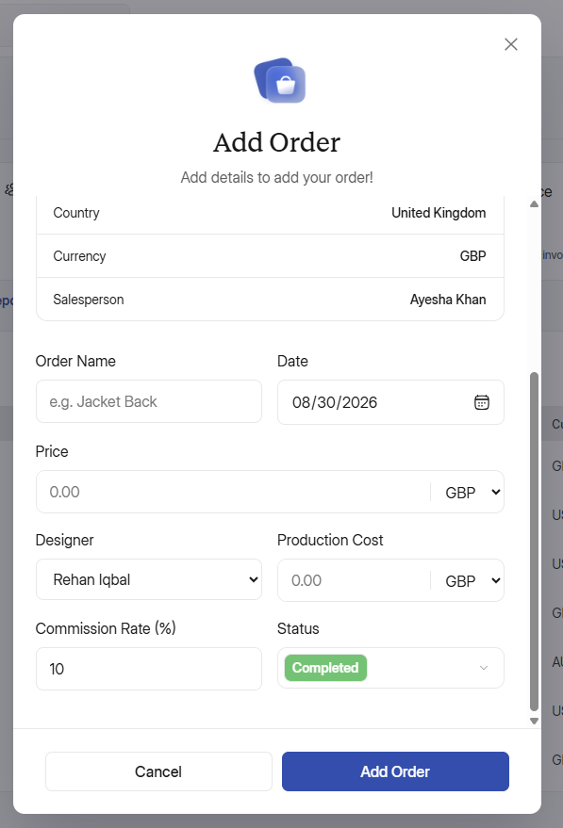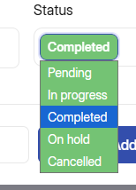
Saare dropdown fields ko set karo, also ye completed default nhi hoga, pending default hoga and ye status ka dropdown bura lag raha hai, isko simple dropdown rakho jese baai subka rakha hai and osme Pending, In progress, Completed etc etc inko inke capsule shape mei daalkr inke colors mei rakh kr onhe dropdown mei rakho. Pochlena agr confusion hotu.

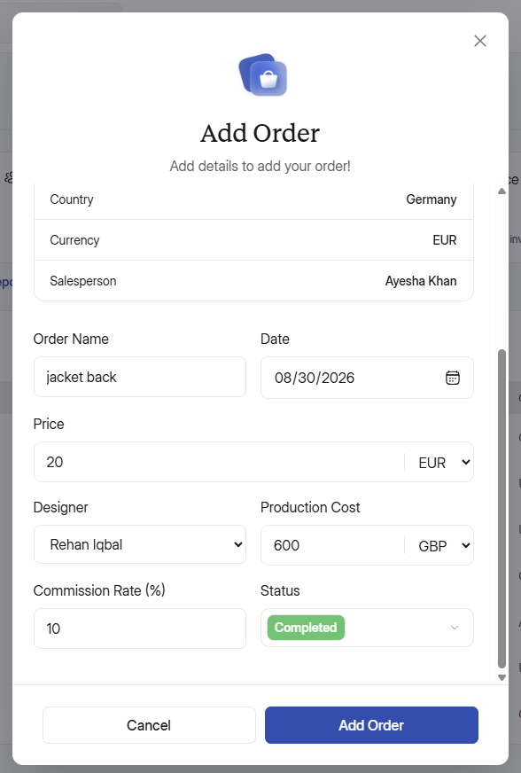
Production cost ki default currency PKR hogi, dekho ye yaad rakho jitne bhi Inhouse management hogi like, production cost, salaries, sales commissions, pay slips, etc etc wo sub humari settings mei jo default currency humne PKR dali hoi hai ossei linked hai, osme PKR hai tu inhouse management mei jitni cheeze hai wo sub PKR mei show hongi, and agr waha koi or dosri currency hai tu phr inhouse management sub os currency ke acc show hoga. Also, 300 pkr default production cost krdo, mei client sei pochlonga onka default kiya hai phr wo yaha set krdeinge. Buy by default abhi 300pkr kardo client cost manually bhi change krsakta hai baad mei but currency wohi rahegi jo settings mei default currency selected hai.Koi bhi confusion hotu pochleina.

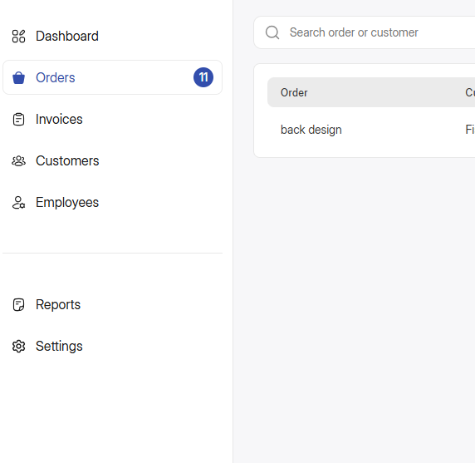
Orders ke tab mei order ek hi hai but isme indication 11 ki hai, yaha indication sirf pending and inprogress orders ki hi hongi, agr koi order onhold, cancelled ya completed hai tu wo automatically is indication counts sei minus hojayega. Sirf wo orders yaha indicate hongey wo inprogress ya pending hai, suppose 2 orders pending and 3 in progress hai tu indication “5” show hogi. Label size same circle hi rahega sirf number change hoga. And jb koi order in progress ya pending mei nhi hai tu ye indication bhi remove hojayegi.

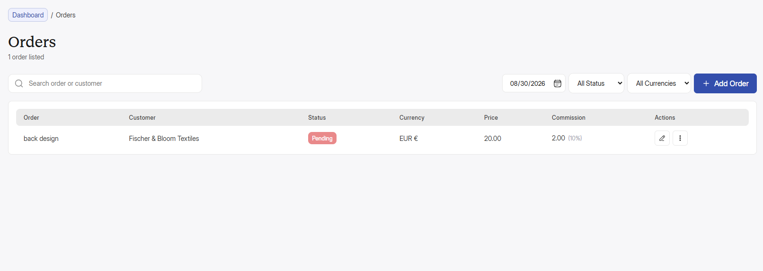
Saare pages mei jitni fields hai onhe theek karo, khaas toor pr dropdowns

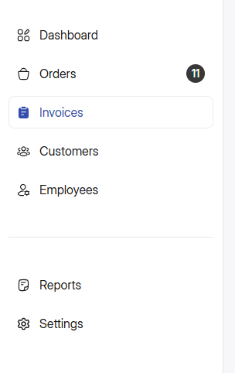
Invoices mei bhi same hoga, agr koi invoice unpaid hai tu jitne bhi unpaid hai wo yaha pr indicate hoga jese orders mei horaha hai.

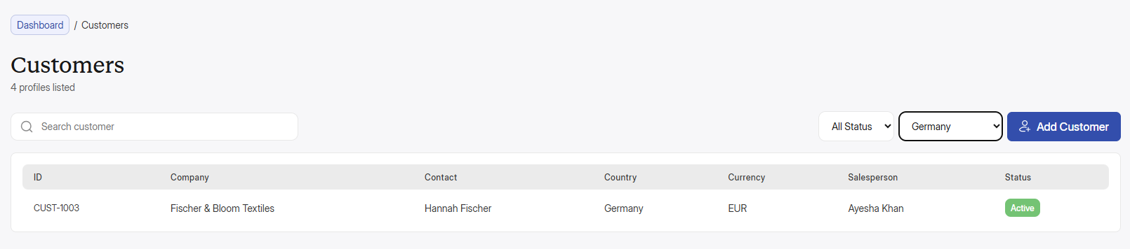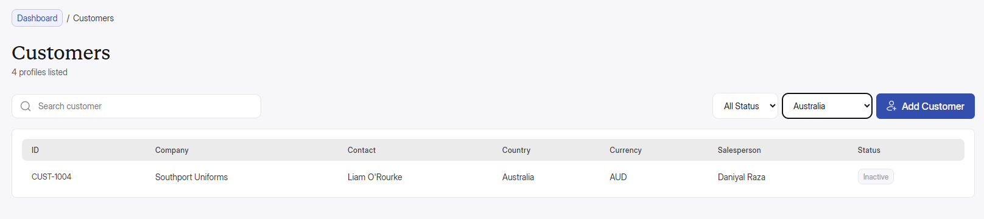
Yawr ye table mei last column ki width same karo, sirf is customers mei nhi balke pori web app mei jitne bhi tables hai main pages pr like invoices, orders, customers, employees etc etc subke last columns “status, actions” etcs ko same width karo.

