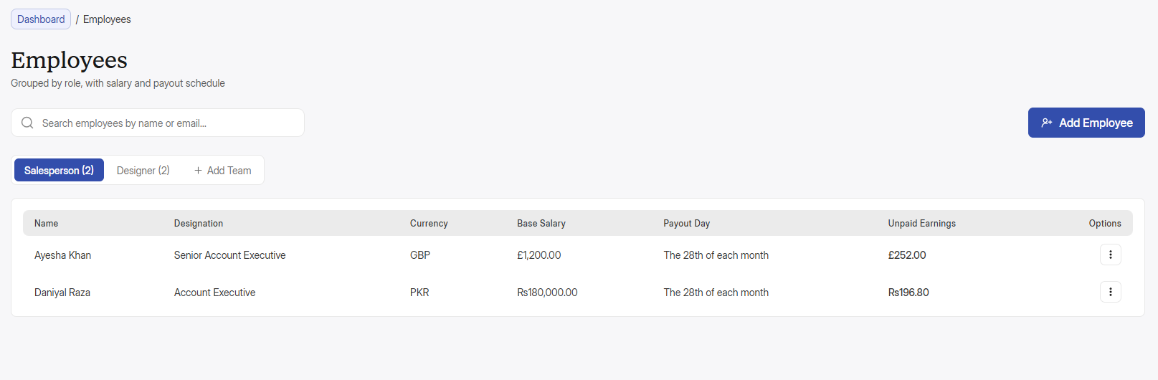
Isme bhi table mei last column ki width sub pages ki tarha same karo and “Options” kahi use nhi hoga, only “Action” use karo. Also, add employee ke button ka icon theek karo wo sahi nhi hai.

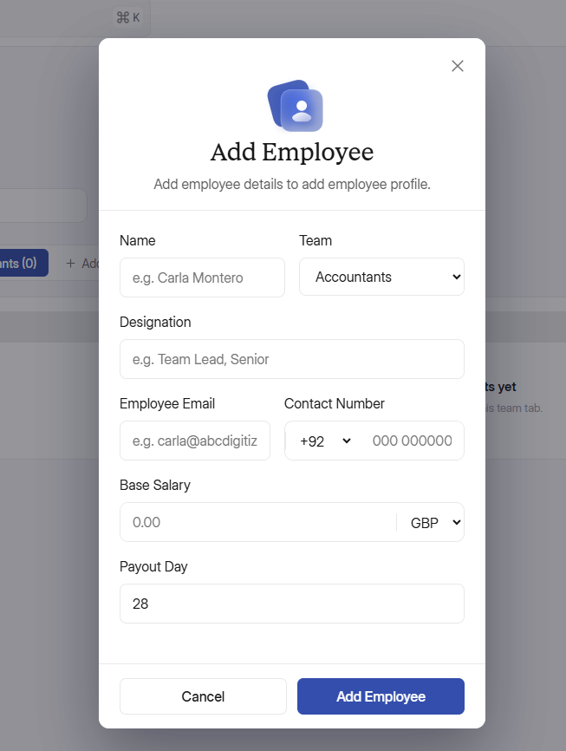
Add employee ka popup awkwardly width mei chota hai baaqi popups ke acc, iske width size ko baaqi same popups like add order and customer ke size ke similar karo and baaqi popups ko bhi dekhleina ki wo same ho. Also, add employee mei suggestions pakistani version mei do, like Name mei Zain Ahmed ya similar name, employee email mei “abc123@gmail.com” ye daaldo. Contact number ki number dropdown mei gap bohut zyada lag raha is field ko or issei similar baaqi fields bhi wo set karo. +92 ke baad gap thora kam karo or padding saari fields sei match karo or subki same rakho. Also, Payout day me filhal default “5” rakho. Mei client sei default day pochlonga phr wo yaha adjust hojayega. Also, jb employees ka payout day qareeb hoga tu employees ke dashboard mei onhe payout day wale din notification milega ki aaj onka payout day hai, and admin ko bhi ki employee ka aaj payout day hai.

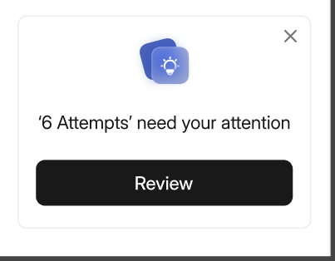
Same goes with invoices, ki jb customer ka payout day ayega tu os din admin ke side panel mei is tarha sei notification show hogi, and osme button “Check Invoices” ka hoga. Jb amdin button pr click kareiga tu wo invoices ke tab mei chala jaega jaha ossei sirf on customers ki list show hogi jinka aaj payout day hai. Also ye notification, notification panel mei bhi aayega. In case admin close krta hai side panel sei tu wo baad mei notification panel sei jaakr check invoices ke button pr click krke review krsakta hai. Also, mei close icon add krna bhool gaya tha wo mene add krdiya hai. And sidepanel mei sirf imp notifications hi show hongi. Like, someone trying to login the dashboard then wo show hogi and admin jb review pr click kareiga tu notification panel open hoga jaha pr ossei button milega, I did or secure it. I did pr click kareiga tu wo phr kuch action nhi karega but agr wo secure it kareiga tu os laptop ya mob sei admin panel band hojayega and admin ko change pass pr le jayega settings mei jaha admin apna actual pass daalkr then new pass daalsakta hai. Is tarha ke mazeed security cheeze add krni hai taake isko secure krsake.

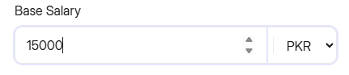
Ye salary mei jo 2 additional arrows hai upward downward wale issei hr jagah sei remove krdo inki need nhi hai

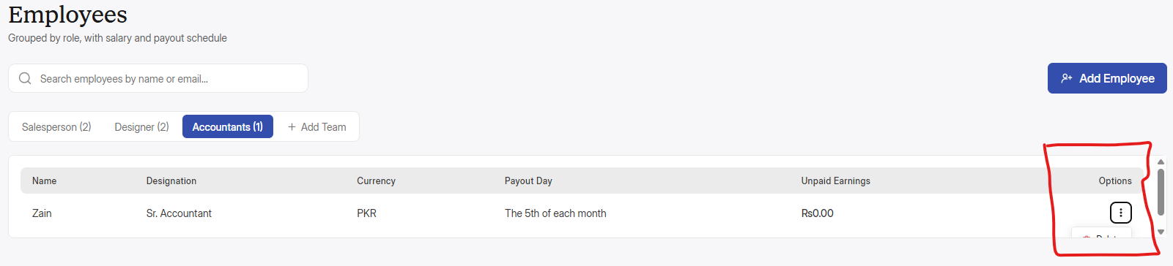
Pore web app mei yehi same issue hai, jb bhi kisi action pr click karo tu oska popup table ke andr hi open horaha hai, jissei side wale scroller sei scroll krke dekhna par rha hai, yehi mene last time bhi kaha tha, is issue ko bhi solve kardo.

Also, employees mei profile mei enter karne ke liye mujeh inke name pr click karna parh raha hai tabhi enter horaha hai, jbke hover krne pr highlight horaha hai but click karo tu profile open nhi horahi sirf name pr click krne sei horahi hai

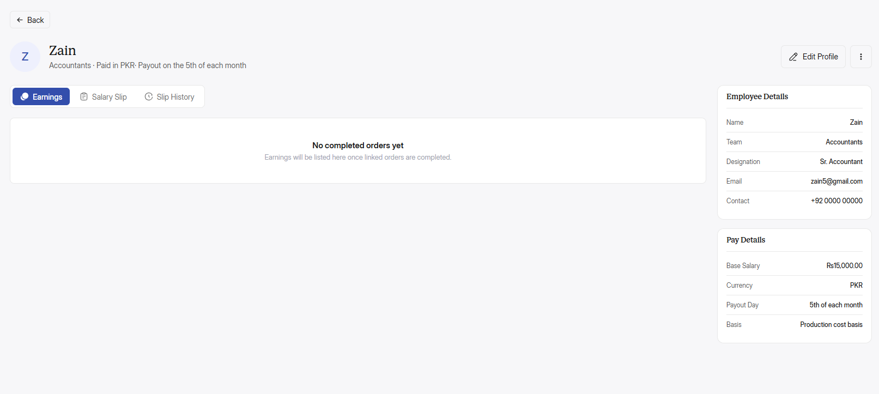
Baaqi koi bhi new team add hogi, jese mene accountants kari hai tu onki profile mei sirf, salary slip and slip history show hongey kisi bhi new team ko add krne mei, jo default hai sales and designers sirf onme earnings aayengi.

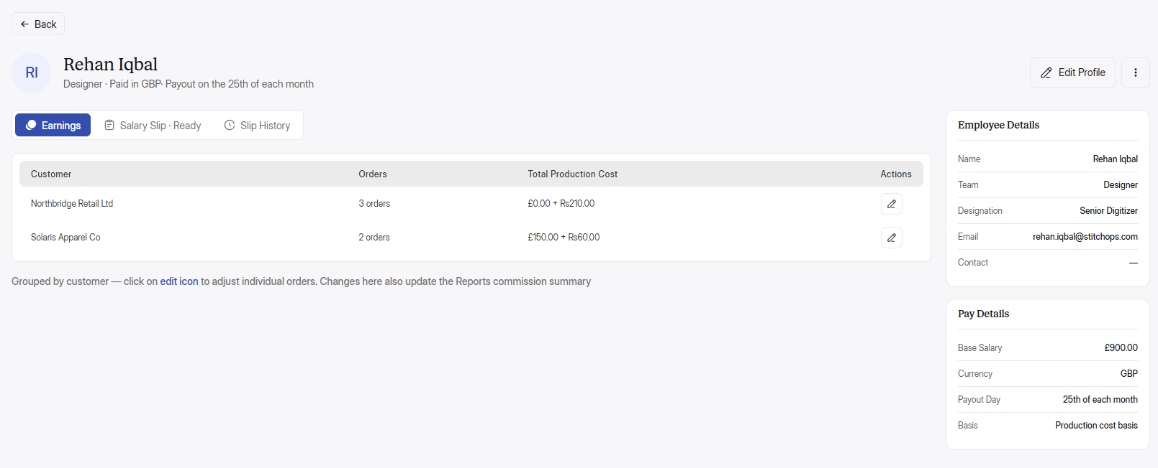
Production cost PKR mei hi show hogi. Also, total amount show hogi, jese northbridge brand ke 3 orders hai tu teeno orders ki jo bhi cost thi wo sub mila kr total production cost mei show hogi. Remember, har ek brand ke jitne orders hai wo apas mei sum hokr show hongey, but dosre brand ke sath sum nhi hongey, like brand 1 ke 3 orders, sum krke onki amount, then brand 2 ke 5 orders and sum krke onki amount, is tarha and inme ek dropdown option bhi add krdo ki jb koi inpr click karei tu onko os brands ke saare orders show hojayenge, like

Brand 1 4 orders Rs. 2000 ↓
Order 1 Rs. 500
Order 2 Rs. 500
Order 3 Rs. 500
Order 4 Rs. 500

Just like slip history mei kiya hai. And ye dropdown opt sirf designer mei nhi balke sales mei bhi add hoga ki total commission but jb click kiya tu expand hokr hr order ki list with each order commission.

Lekin salary slip mei jesa abhi hai, brand ka name and total orders and sum of total orders. Bs wohi rahega. Jo opr change batai hai wo sirf earnings mei hongi

Also, again commissions, earnings, productions cost. Jitni bhi in-house terms hai wo sub PKR yaani settings ki selected default currency mei show hongi.

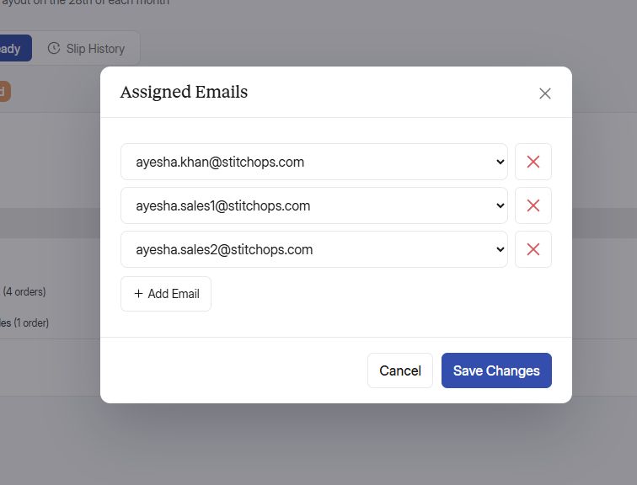
Sales mei assigned emails ki fields set karo and ek assigned email dobara again dropdown ya kisi or sales person ke dropdown ya even kisi or assigned email ke option mei show nhi hogi, agr wo email ek person ko assigned hai tu wo ossi ke pass show hogi. Is popup mei same emails 3 bar show horahi hai. Issei set karo. Also, jisko jo email assigned hai wo settings mei assigned email ke tab pr oska name mentioned hoga.

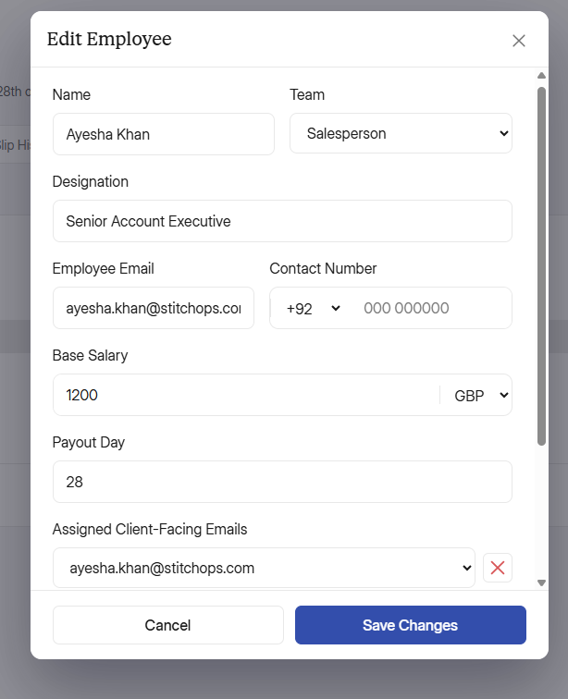
Also, my bad mene commission rate ka option add nhi kiya, wo mene design mei bhi add krdiya hai and jaha jaha commission rate ka option aayega waha dropdown nhi hoga waha % ka icon aayega, mene design mei set krdiya hai. Jo bhi commission yaha set kiya jayega sirf wohi add order mei show hoga, and wo changeable nhi hoga. Agr admin ko commission rate change krna hai tu osko yaha employee ki profile mei aakr krna parhega. Also, ye commission field sirf sales mei hi rakhna, ye baaqi teams like designers ya baaqi koi bhi team jo admin add kareiga osme show nhi hogi.

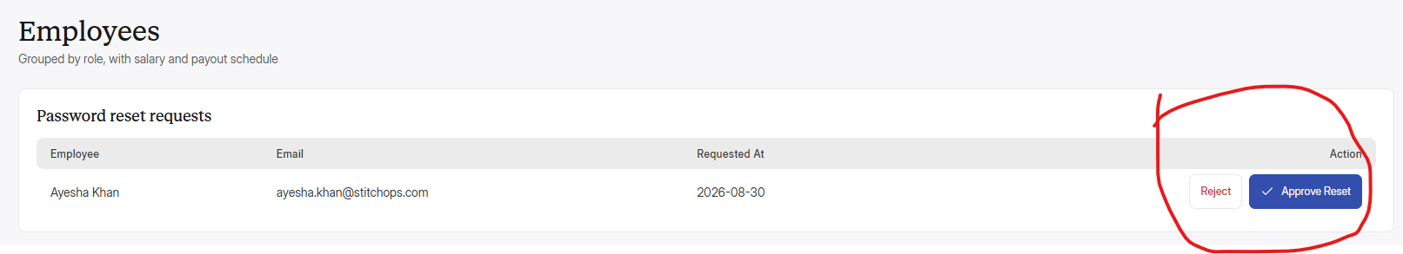
Iske last column ki alignment set karo, title and button alignments

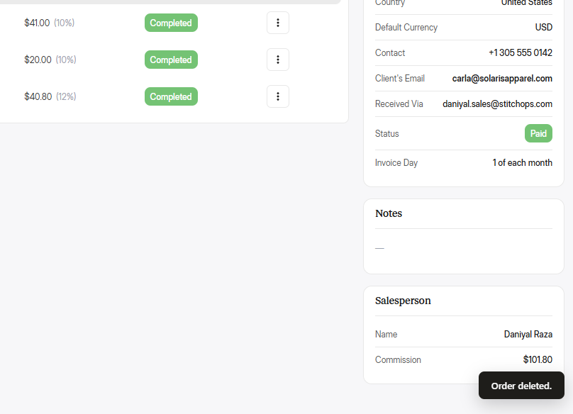
Delete order krne pr, order direct delete horaha hai. Tu better hai ki delete order krne pr ek popup show krwado delete ka. Phr agr admin delete pr click kare tu order delete hojayega and ye corner pr jo order deleted hai yaha “Order deleted. Undo” undo add krdo and ye foran hi khatam jaaraha tu yaha iska time increase krdo jese email mei hota hai email sent krne ke baad undo ka option aata hai kuch seconds ke liye. Wese hi iske bhi seconds increase krdo.

