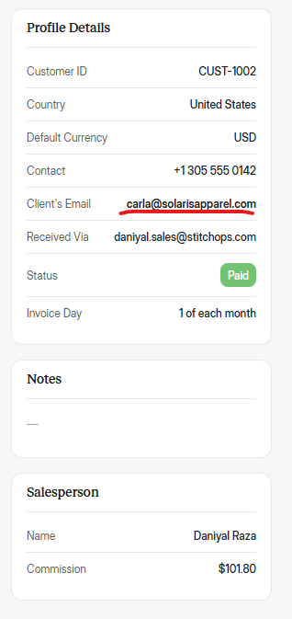
Font weights same rakho. Har jagah check karo ki font sizes, styles, weights same ho ek jesi cheezon ke.

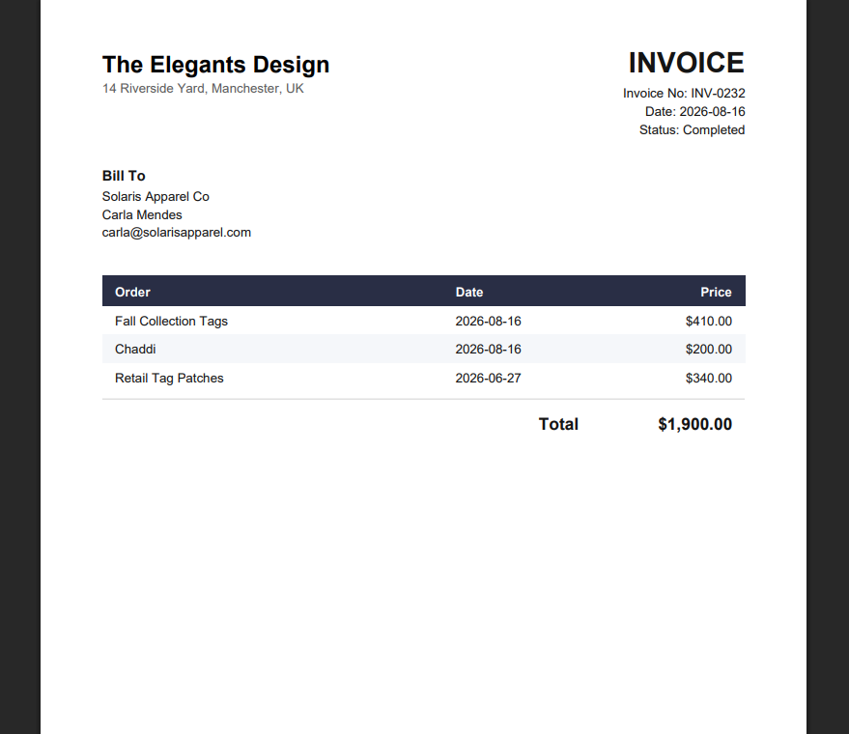
Invoices sahi download and show horahi hai, abhi ke liye theek hai but invoice design client wala hi show hoga jo client dega. Okay!

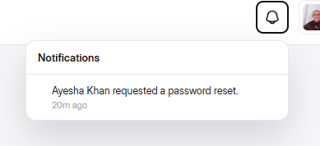
Navigation panel acha banaya hai no doubt. Isko same insta wale notification panel krdo. Mtlb new notifications thori highlighted krdo jo humara light grey ya bilkul minimal light color use horaha hai ossei. And jese ye abhi mene employee ki acc sei pass change krwane ke liye forgot pass kara tha tu agr koi employee ki notification ho tu ossei pehle oski dp lagado or employee ne dp nhi set ki hoi tu oska dp mei oske Name ke initials add krdo. Jese customers ya currently employees ke howe we hai design mei.

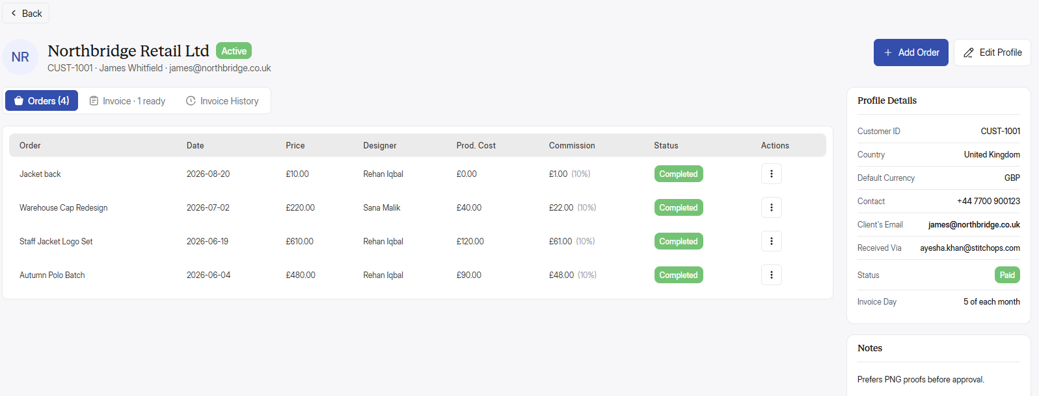
Orders add honge ke baad onke statuses just click krke adjust krsakte hai. Like order added with the status “Pending”, then first click “In-progress”, then 2nd click “Completed”, 3rd click “On Hold” and then 4th click “Cancelled”. Again koi click kareiga tu ye wapis “Pending” pr aajayega. And agr admin ne order add krte waqt order ko default pending sei hatakr In-progress select krke add kiya hai tu loop wese hi chalega ki in-progress ke opr click krne pr completed ka aayega then on hold and so on.
Reason: admin rooz ke multiple orders handle kr raha hoga tu wo baar baar edit order krke change nhi krsakta statuses ko wo hectic hoga.

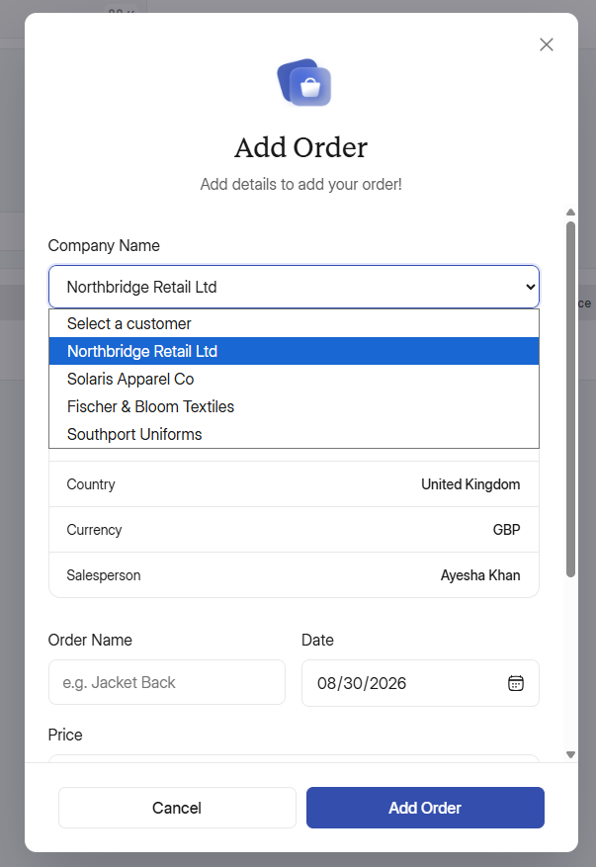
Isko dropdown ke sath search field ki tarha bhi target karo. Dropdown pr click krke wo customers ki list dekh sakta hai but wo direct name bhi type krsakta hai ya phr sirf ek 2 letters likh kr multiple customers sei find bhi krsakta hai like:
I typed “S”
S
> Solaris Apparel Co
> Southport Uniforms

Is tarha sei mujeh 2 name show hogaye jinke initials mere typed letter sei start hai.
Reason: client ke 400 500 customers hai wo ek ek ko list sei dhoond kr nhi put karega wo hectic hoga.
Jb client customer find krke osko select karega tu oski saari details automatically put hojayengi, sirf osko necessary fields like order name and price put krne hongey and baaqi cheeze by default hogi but wo onhe manually change krsakta hoga agr krna hoga tu.

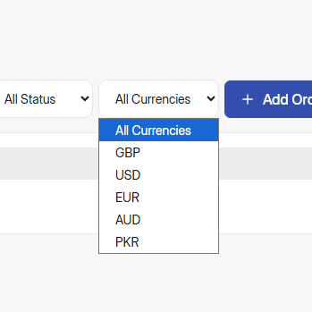
Orders mei ya customer ke related kisi cheez mei PKR nhi show hoga. Only foreign currencies show hongi. PKR sirf inhouse jese salaries, commission, production cost, total income, etc etc ke liye use hoga

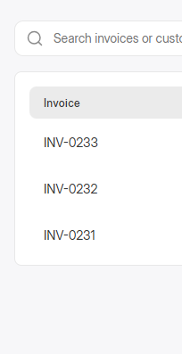
Invoice ID & Customer ID same hi rahegi har jagah in invoices, customers, customer profiles and etc etc. alg alg nhi aayegi. And inhe By default “CUST” customer sei represent krwao “INV” invoice sei nhi. Like “CUST-0000” aese. Baaqi client sei confirm bhi krlonga ki wo kiya use krte hai “CUST or INV”.

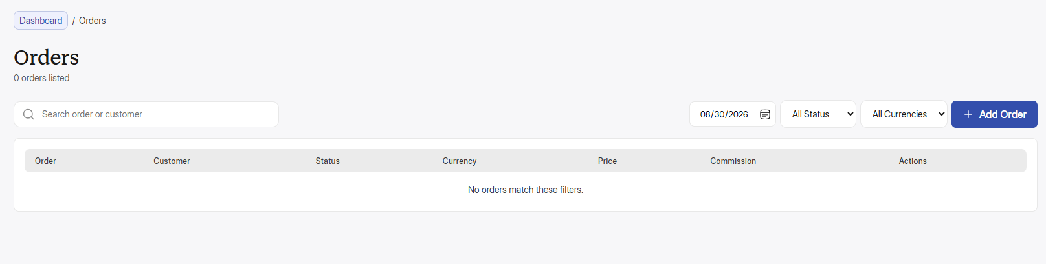
Jb admin orders search karega tu jo bhi letter add karega jese “ja” tu jo bhi order name “ja” sei start horaha hoga wo orders show hojayenge. And issei table mei ek new column add hoga, wo hoga date ka jo subse start mei aayega orders sei bhi pehle and idhr saare saari dates ke orders show hongey jinke initials “ja” sei start horahe ho and opr date ka filter default hojayega “mm/dd/yyyy” aese. Lekin jb admin search krne ke baad date ke filter ko apply kareiga tu ossei sirf ossi date ke saare orders show hongey acc to the name or words he typed in search bar.

Same goes with other things like invoices and all.

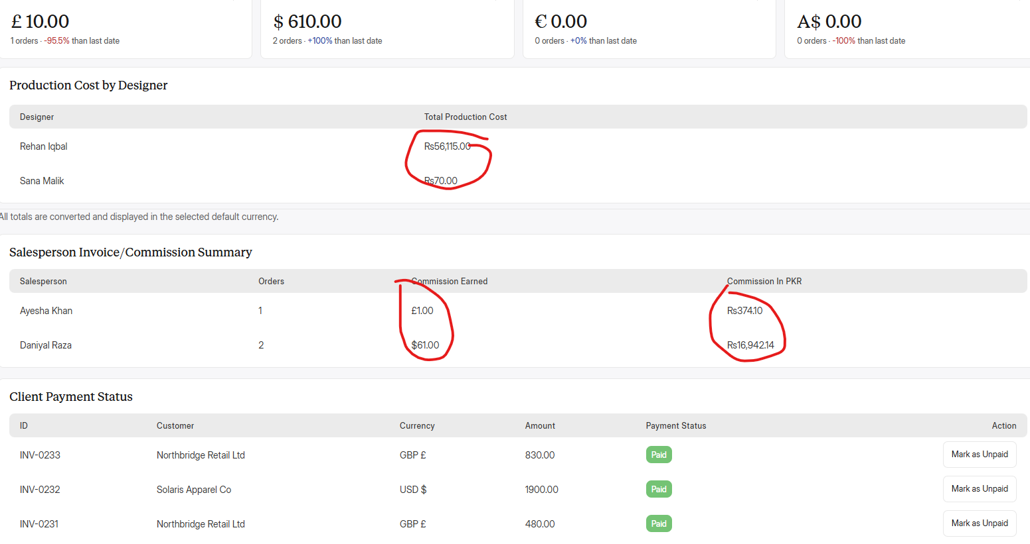
Also try to add a space between currency symbol and the numbers like “Rs. 60,000” or “$ 50”. Issei clean and visible hota hai num, abhi ek dum ghusa ghusa lag raha hai.

Also Idk but I’m feeling ki pori web app mei “Inter Display” font ki letter spacing default nhi hai balke kam ki hoi hai. Osko check karo kiuki design mei letter spacing kholi kholi hai but web app mei letter chipke howe hai.

Also, ek salesperson ke customer multiple countries sei bhi hosakte hai tu agr let suppose 2 countries sei hai ek sales person ke customer tu onko onke total commissions 2 diff currencies mei show hongey and then onka sum and total krke wo pkr mei show hongey jese design mei given hai. Tum logo ne ye functionality banai hogi but web app mei abhi show nhi horahi tu just reminder ke toor pr ye bata raha.

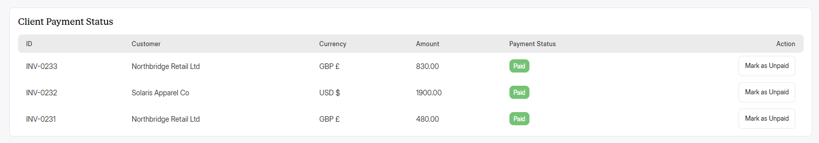
Yaha sirf unpaid hi show hongi, jo paid hogai hai wo yaha sei hat jayengi. Reports mei ye sec ek kind of notification ki tarha hai ki abhi tk inki invoices paid nhi hoi hai. Admin ko bar bar invoices mei jaakr status filter lagakr dekhne ki ya filter out krne ki need nhi hogi. wo just reports mei aayega oske saamne sirf wo show hongi jo unpaid hai. And kitne mahino sei unpaid hai wo bhi like 2 months, 3 months, 4 months etc etc

