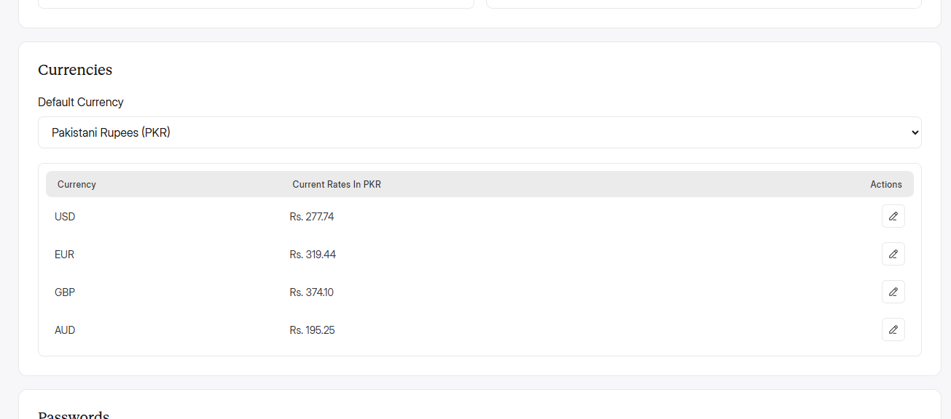
Ye currencies rate kaha sei get krwa rahe ho? Kiuki USD and EUR and mazeed dosri currencies ke rate google sei diff hai. Inhe real time mei update krwana hai every day.

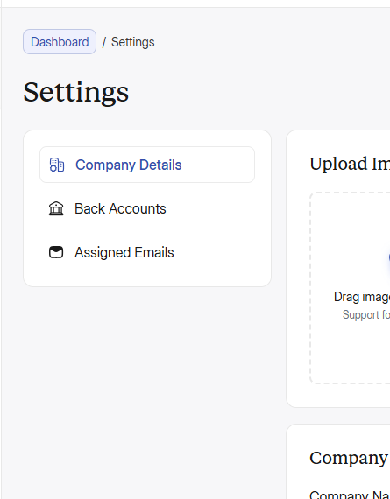
Main side panel ki tarha iske selected tab ka icon bhi filled hoga ye abhi just stroke hi dikha raha hai selected tab mei, also Assigned email selected nhi but tab bhi wo filled hai. Icons ko sahi karo and icons only mere given icons use karo. Agr chaho tu mere pass huge icons ki pori paid file pari hai wo lelo osme saare paid icons hai diff styles mei. And saare icons, even designed icons jo PNG and JPG mei use hai add order, customer and employees etc wale wo bhi SVG mei hi use karo.
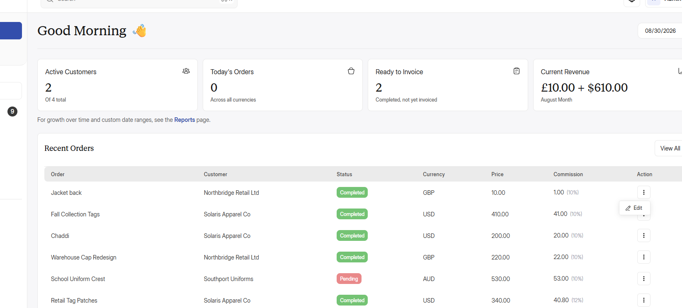
Orders jaha bhi hai, orders tab, dashboard, customer profiles etc etc hr jagah 3 dots mei edit and delete ka option rakho and delete krne pr wo popup show hoga jo mene opr define kiya hai then delete krne pr undo ka option bhi.

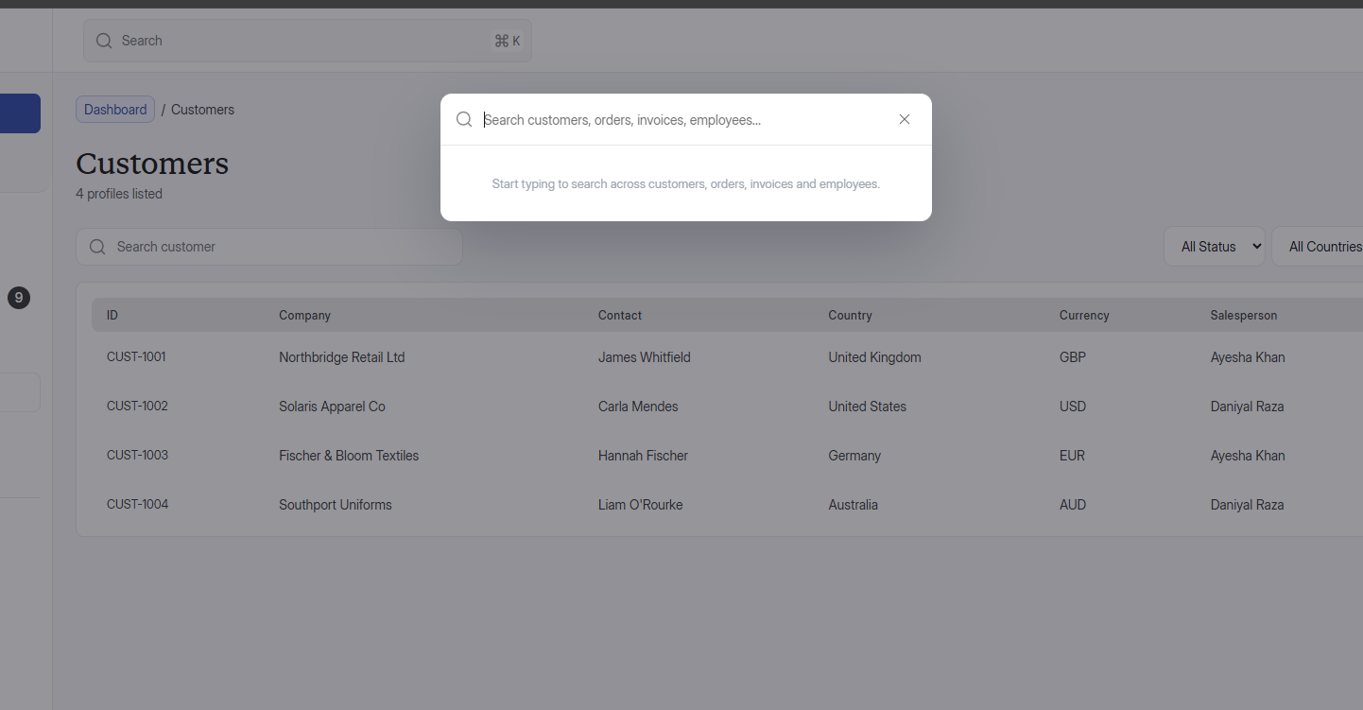
One thing more, add animation ki jb koi search pr click karei tu wo search field smoothly mid align hojaye and expand hojaye is popup mei. Then jb koi filled krke search karlei tu wapis sei concise hokr apni jagah pr chali jaye. Jese iphone mei hai smooth animations

Also, kuch micro animations bhi add krdo abhi ye bilkul plain hai. Thori animations hongi tu acha lagega and interactive hoga. But micro level pr karna taake animation overload na ho, jisei ye heavy hojaye. Simple and clean but smooth animations lekin slow mat rakhna zyada warna lag wali feel aayegi.
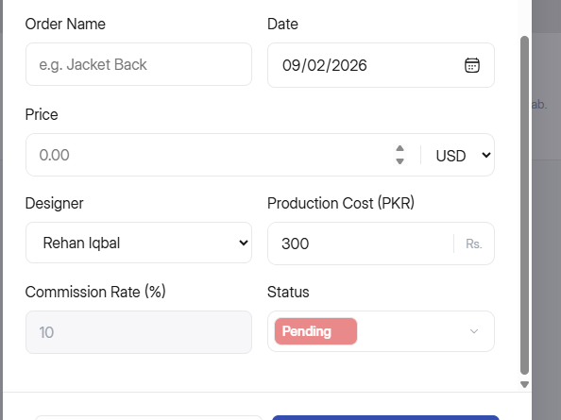
Change default production cost 300 to 400 pkr and redesign the commission rate field everywhere in the web app according to the design.

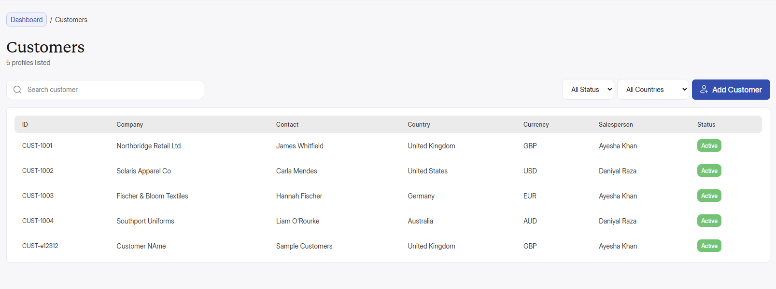
Add Free trial & Paid Trial client status filter before “All Status” filter, also list it with the name of “Customer Type” in the Table as well after the “Currency” column. And ye capsule shape me hi show hoga jese active/in-active show horaha hai status ke column mei but in their respective colors jo customer ki profile mei added hai.

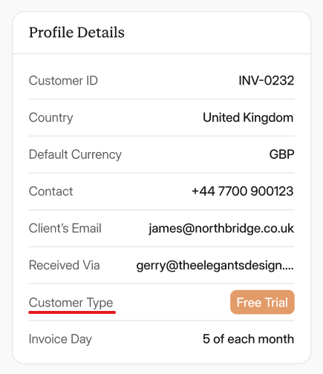
Also, everywhere in the profile jaha bhi Free Trial / Paid ke liye Status use howa hai osko change krke “Customer Type” put krdo

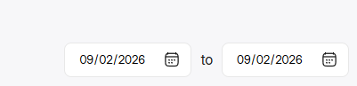
Ye wala date filter har jagah add karo jaha jaha single date ka filter hai. Jaha jaha dates moujood hai pori web app mei waha sirf ye wala filter use hoga jisme “this” to “that” date select krsakte hon, and voice suno kaha kaha add krne ko kaha hai date ka filter. Also, add it in customers as well!

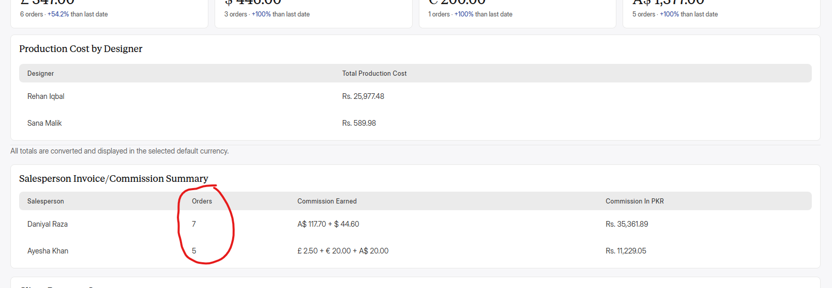
Just like Salesperson Invoice mei orders ka column hai jo batata hai ki total kitne orders salesperson ke aaye hai jiska yeh commission bana hai wese hi same orders ka column bhi Production Cost by Designer mei add krdo. Jaha ye pata chalega ki kis designer ko kitne orders assign howe hai.

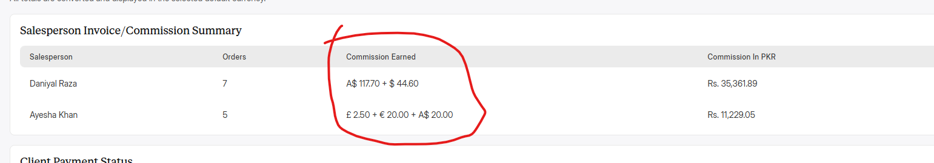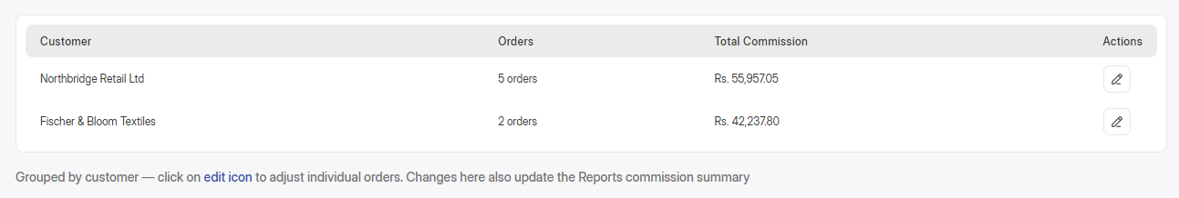
Jese Reports mei salesperson invoice mei commission earned show horaha hai customers ki currencies mei wese hi Salesperson ki profile me bhi ye commission earned add hoga. But wo sirf os ek currency mei show honga jis currency mei customer is web app mei registered hai by admin ya sales person, and wohi commission earned mei jo commission hoga wo PKR mei bhi show hoga dosre column mei jese reports mei hora hai “Commission in PKR”.

Also, ek customer ke agr 5 orders hai tu oska break down bhi designer wali profile ke breakdown ki tarha hoga in dropdown ki jb koi os row pr click kareiga tu wo open hojayega and jb koi re-click kareiga tu ya dosri row pr click kareiga tu close hojayega, like this

Customer Orders Commission Earned Commission in PKR
Brand 1 3 orders $800 Rs. 222040 ↓
Order 1 $200 Rs. 55510
Order 2 $300 Rs. 83265
Order 3 $300 Rs. 83265
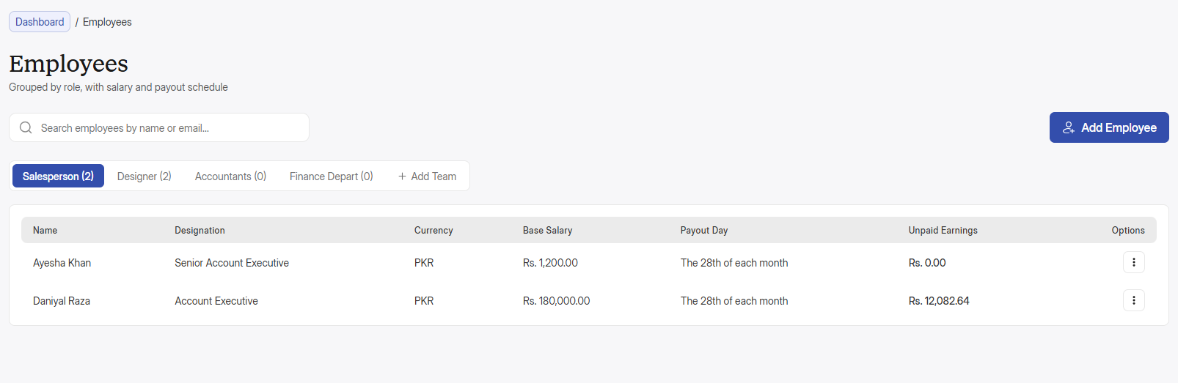
Also guys my bad, mei ek cheez add krna bhool gaya ki Teams tu add hogai but inhe edit ya remove krne ka option hi nhi hai tu mene new screens design mei banadi hai, and comment add krdiya hai new screens ka, neeche wala screenshow onhi me sei ek screen hai.

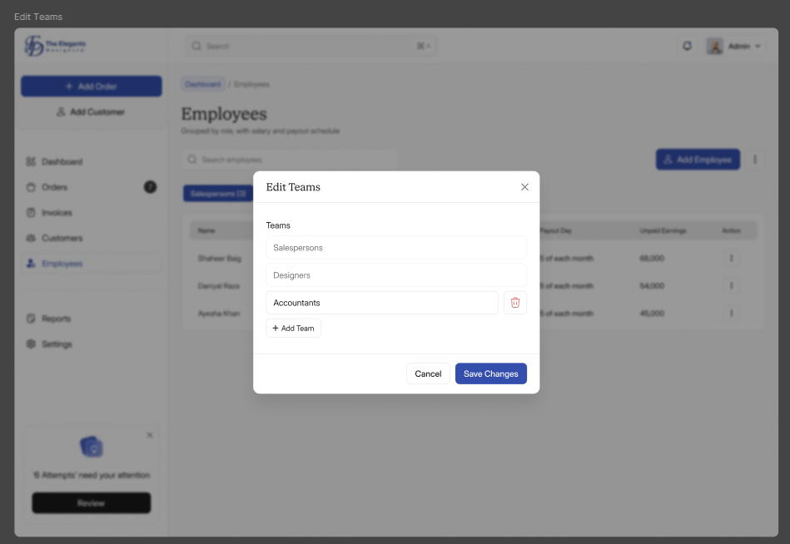

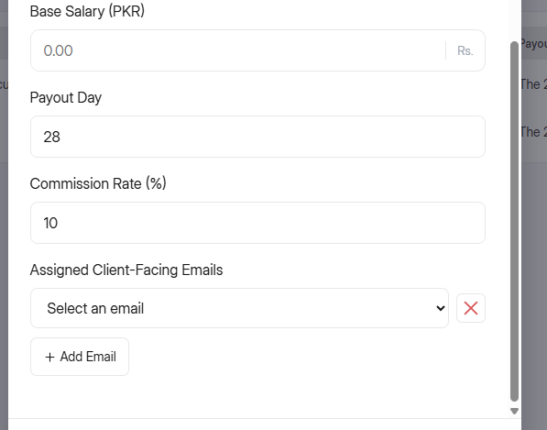
Add employee mei kaafi design inconsistencies hai. Inko set krdo figma design ko dekh kr.

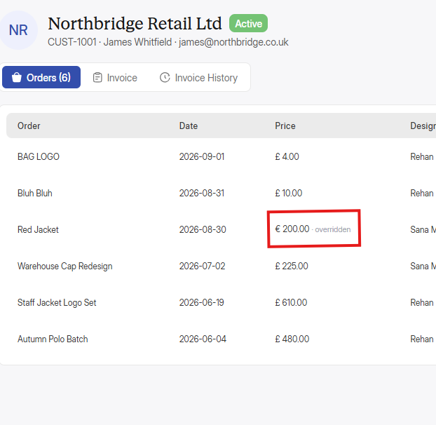
Overridden kiya hai??

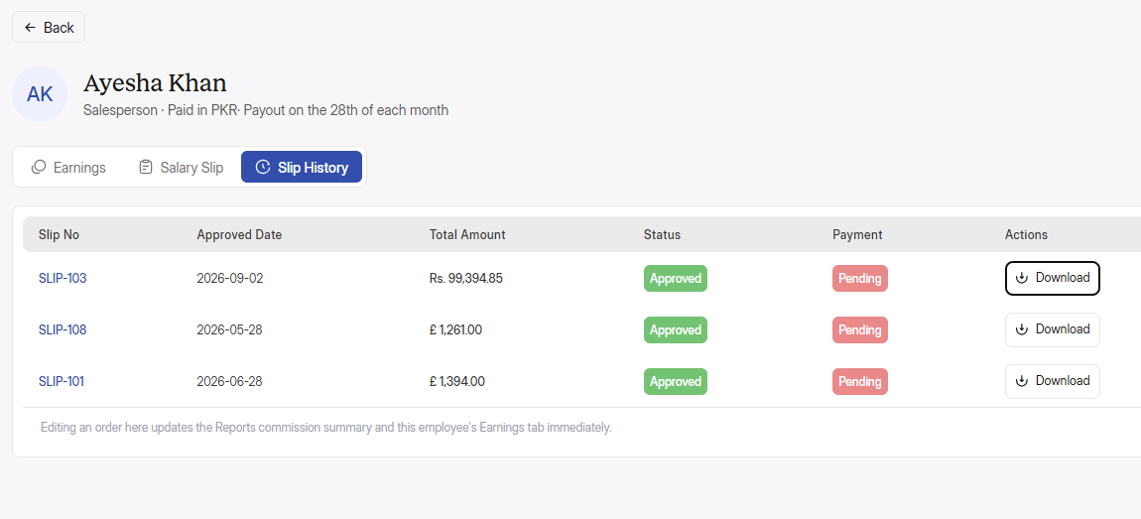
Employees ki Salary slip download nhi horahi hai.

Also guys, mei invoice redesign karonga tabhi employees salary receipt bhi redesign karonga ossi format mei wo invoice and receipts banegi.

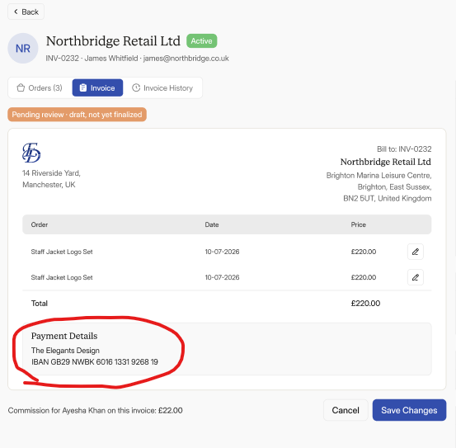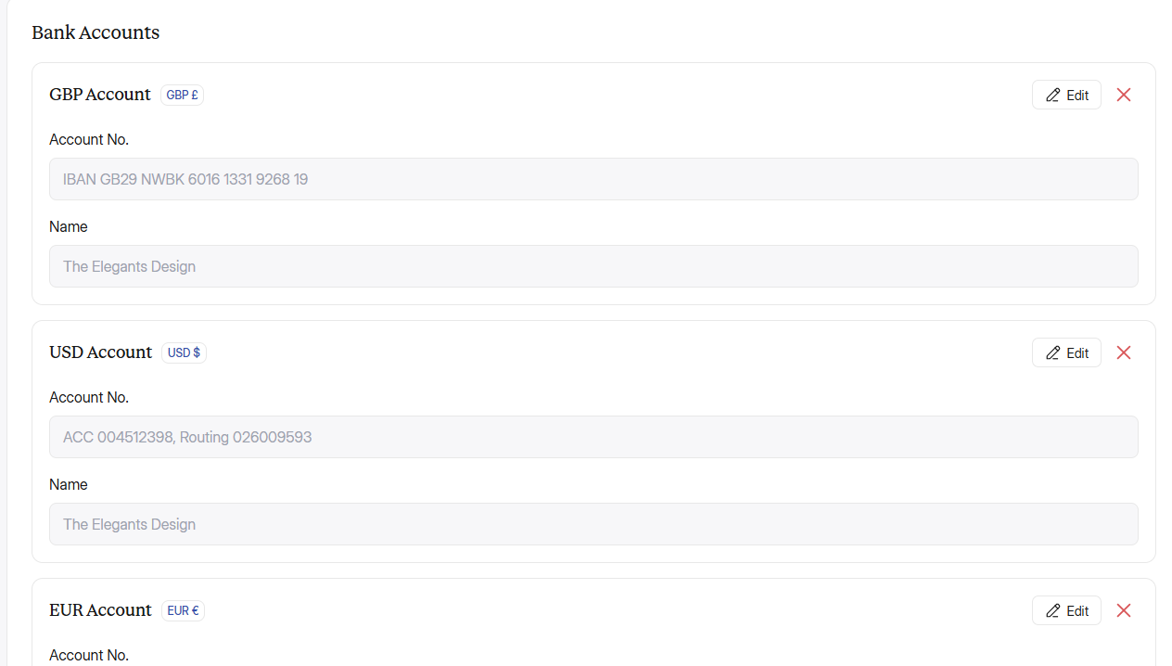
Invoices mei payment details mei or bhi info add hongi and sub currencies ke accounts and countries mei diff details jaati hai tu os hisaab sei mei Settings mei Bank accounts and Customer invoice mei payment details mei kuch new options add kare hai, oske acc yaha add kardo.

