**COAL Lab-00**

**------------------------------------------------------**

**Name: Saad Nisar Butt**

**Reg. no: cs211246**

**Class: BS-CS-3C-1**

**------------------------------------------------------**

**Literature Review:**

In this lab, we learned the basic knowledge of how hardware performs basic logic functions. RISC-V is an international open instruction set architecture to implement in microprocessors. HDL (Hardware Description Language) is used to describe structure and behaviors of circuits. Verilog is a Hardware Description Language to design digital systems. It follows gate-level, dataflow and behavioral modeling.

**Task:**

Implement AND gate function using Verilog code.

**AND GATE:**

And gate is a basic logic gate which gives high if bth of the inputs are high or low if any of the inputs is low

Y

B

A

**Truth Table:**

|  |  |  |
| --- | --- | --- |
| **A** | **B** | **Y** |
| 0 | 0 | 0 |
| 0 | 1 | 0 |
| 1 | 0 | 0 |
| 1 | 1 | 1 |

**Block Diagram:**

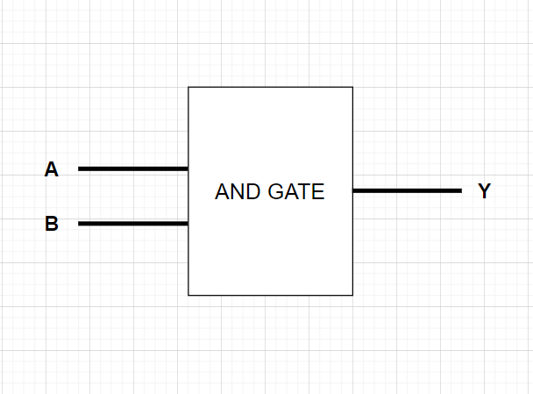

**Boolean Equation**

Y = A . B

**Verilog Code:**

design.v

module gate(A,B,Y);

    // Declaring inputs

    input A,B;

    // Declaring output

    output Y;

    // Using gate level modeling

    and(Y,A,B);

endmodule

testbench.v

module tb();

    // variables

    reg P, Q;

    wire R;

    // declaring design // dut (Design Under Test)

    gate dut(.A(P),.B(Q),.Y(R));

    // All possible input value for and gate

    initial begin

      P <= 1'b0;

      Q <= 1'b0;

      #100;

      P <= 1'b0;

      Q <= 1'b1;

      #100;

      P <= 1'b1;

      Q <= 1'b0;

      #100;

      P <= 1'b1;

      Q <= 1'b1;

      #100;

    end

    initial begin

      $dumpfile("dump.vcd"); // value change dump // variable change dump

      $dumpvars(0);

    end

endmodule

**Waveforms:**



  