**COAL Lab-03**

**Introduction to Assembly Language & Venus Simulator**

**------------------------------------------------------**

**Name:** Saad Nisar Butt

**Reg. no:** cs211246

**Class:** BSCS-3C-1

**------------------------------------------------------**

**Literature Review:**

**Assembly Language:**

Assembly Language is closer to low level language which is machine language or Machine. It is human readable representation of computer’s native language. It is a command based language and each assembly language instruction specifies both the operation to perform and the operands on which to operate. We introduce simple arithmetic instructions and show how these operations are written in assembly language. We then define the RISC-V instruction operands: registers, memory, and constants.

**Venus Simulator:**

Venus is an emulator for RISC-V computers. It allows users to run programs written in RISC-V assembly language without having access to a computer running a RISC-V chip.

**Registers:**

Instructions need to access operands quickly so that they can run fast, but operands stored in memory take a long time to retrieve. Therefore, most architecture specifies a small number of registers that hold commonly used operands. The RISC-V architecture has 32 registers, called the register set, stored in a small multi ported memory called a register file. The fewer the registers, the faster they can be accessed.

**Machine Code:**

Assembly language is convenient for humans to read. However, digital circuits understand only 1’s and 0’s. Therefore, a program written in assembly language is translated from mnemonics to a representation using only 1’s and 0’s, called machine language. RISC-V makes the compromise of defining four main instruction formats: R-type, I-type, S/B-type, and U/J-type.

**Lab Exercise 1:**

**Task:**

Translate the Given High Level Code to Assembly Language

|  |  |
| --- | --- |
| **High - Level Code** | **RISC-V Assembly Code** |
| a = b − c; | sub s0, s1, s2 |
| f = (g + h) − (i + j); | add t0, s3, s4  add t1, s5, s6  sub s7, t0, t1 |

**Lab Exercise 2:**

**Task:**

Convert the following RISC-V Assembly code into Machine Code

add x9, x5, x6

andi x10, x8, 0x6

or x5, x6, x7

slli x10, x6, 0x8

**Solution:**

**add x9, x5, x6**

|  |  |  |  |  |  |
| --- | --- | --- | --- | --- | --- |
| 0000000 | 00110 | 00101 | 000 | 01001 | 0110011 |

Machine Code: 0000 0000 0110 0010 1000 0100 1011 0011

Hexadecimal Code: 006284B3

**andi x10, x8, 0x6**

|  |  |  |  |  |
| --- | --- | --- | --- | --- |
| 000000000110 | 01000 | 111 | 01010 | 0010011 |

Machine Code: 0000 0000 0110 0100 0111 0101 0001 0011

Hexadecimal Code: 00647513

**or x5, x6, x7**

|  |  |  |  |  |  |
| --- | --- | --- | --- | --- | --- |
| 0000000 | 00111 | 00110 | 110 | 00101 | 0110011 |

Machine Code: 0000 0000 0111 0011 0110 0010 1011 0011

Hexadecimal Code: 007362B3

**slli x10, x6, 0x8**

|  |  |  |  |  |
| --- | --- | --- | --- | --- |
| 000000001000 | 00110 | 001 | 01010 | 0010011 |

Machine Code: 0000 0000 1000 0011 0001 0101 0001 0011

Hexadecimal Code: 00831513

**Venus Simulation:**

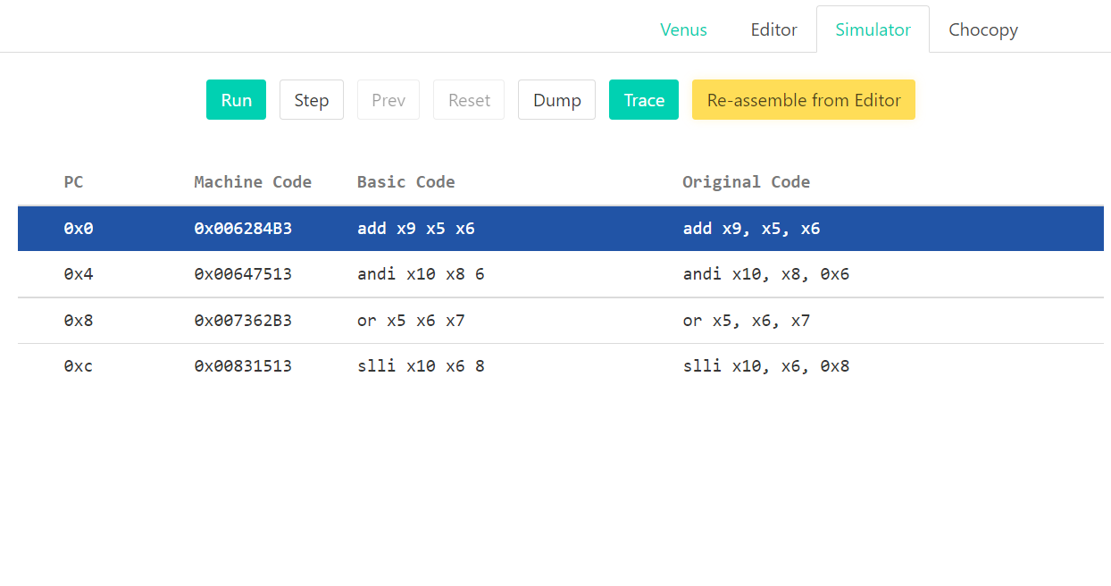

­­**-------------------------------------------------**

**In-Lab Task:**

**Task:**

1. Convert the Given High Level Code on RISC-V Assembly and run it on Venus Simulator. Also write down its Machine Code

**a)**

|  |  |
| --- | --- |
| **High - Level Code** | **RISC-V Assembly Code** |
| a = a + 4; | addi x5, x5, 0x4 |
| b = a - 12; | addi x6, x5, -12 |

**addi x5, x5, 0x4**

|  |  |  |  |  |
| --- | --- | --- | --- | --- |
| 000000000100 | 00101 | 000 | 00101 | 0010011 |

Machine Code: 0000 0000 0100 0010 1000 0010 1001 0011

Hexadecimal Code: 00428293

**addi x6, x5, -12**

|  |  |  |  |  |
| --- | --- | --- | --- | --- |
| 111111110100 | 00101 | 000 | 00110 | 0010011 |

Machine Code: 1111 1111 0100 0010 1000 0011 0001 0011

Hexadecimal Code: FF428313

**Venus Simulation:**

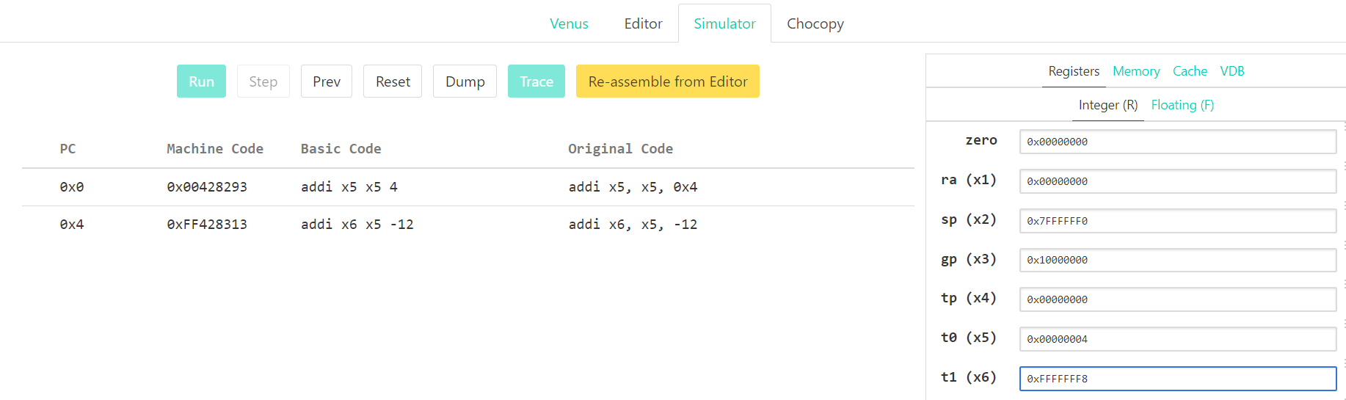

**b)**

|  |  |
| --- | --- |
| **High - Level Code** | **RISC-V Assembly Code** |
| If (g < h)  g = g + 1  else  h = h - 1 | j main  Label:  addi x5, x5, 0x1  main:  blt x5, x6, Label  addi x6, x6, -1 |

**blt x5, x6, Label**

|  |  |  |  |  |  |
| --- | --- | --- | --- | --- | --- |
| 1111111 | 00110 | 00101 | 100 | 11101 | 1100011 |

Machine Code: 1111 1110 0110 0010 1100 1110 1110 0011

Hexadecimal Code: FE62CEE3

**addi x5, x5, 0x1**

|  |  |  |  |  |
| --- | --- | --- | --- | --- |
| 000000000001 | 00101 | 000 | 00101 | 0010011 |

Machine Code: 0000 0000 0001 0010 1000 0010 1001 0011

Hexadecimal Code: 00128293

**addi x6, x6, -1**

|  |  |  |  |  |
| --- | --- | --- | --- | --- |
| 111111111111 | 00110 | 000 | 00110 | 0010011 |

Machine Code: 1111 1111 1111 0011 0000 0011 0001 0011

Hexadecimal Code: FFF30313

**Venus Simulation:**

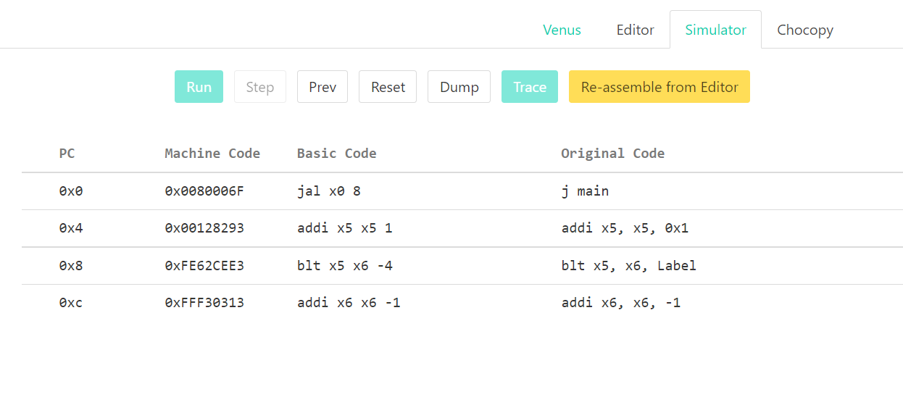

**-------------------------------------------------**

**Post-Lab Tasks**

**Task # 1:**

Write down a simple C program to add, multiply and divide two integer numbers. Convert the C code into assembly and machine code and stimulate it on Venus.

**C Code:**

int main()

{

    int a = 4;

    int b = 2;

    int add = a + b;

    int mul = a * b;

    int div = a / b;

    printf("Add: %d\n", add);

    printf("Mul: %d\n", mul);

    printf("Div: %d\n", div);

    return 0;

}

**RISC-V Assembley Code:**

addi x5, x0, 0x4

addi x6, x0, 0x2

add x7, x5, x6

mul x28, x5, x6

div x29, x5, x6

**addi x5, x0, 0x4**

|  |  |  |  |  |
| --- | --- | --- | --- | --- |
| 000000000100 | 00000 | 000 | 00101 | 0010011 |

Machine Code: 0000 0000 0100 0000 0000 0010 1001 0011

Hexadecimal Code: 00400293

**addi x6, x0, 0x2**

|  |  |  |  |  |
| --- | --- | --- | --- | --- |
| 000000000010 | 00000 | 000 | 00110 | 0010011 |

Machine Code: 0000 0000 0010 0000 0000 0011 0001 0011

Hexadecimal Code: 00200313

**add x7, x5, x6**

|  |  |  |  |  |  |
| --- | --- | --- | --- | --- | --- |
| 0000000 | 00110 | 00101 | 000 | 00111 | 0110011 |

Machine Code: 0000 0000 0110 0010 1000 0011 1011 0011

Hexadecimal Code: 006283B3

**mul x28, x5,x6**

|  |  |  |  |  |  |
| --- | --- | --- | --- | --- | --- |
| 0000001 | 00110 | 00101 | 000 | 11100 | 0110011 |

Machine Code: 0000 0010 0110 0010 1000 1110 0011 0011

Hexadecimal Code: 02628E33

**div x29, x5,x6**

|  |  |  |  |  |  |
| --- | --- | --- | --- | --- | --- |
| 0000001 | 00110 | 00101 | 100 | 11101 | 0110011 |

Machine Code: 0000 0010 0110 0010 1100 1110 1011 0011

Hexadecimal Code: 0262CEB3

**Venus Simulation:**

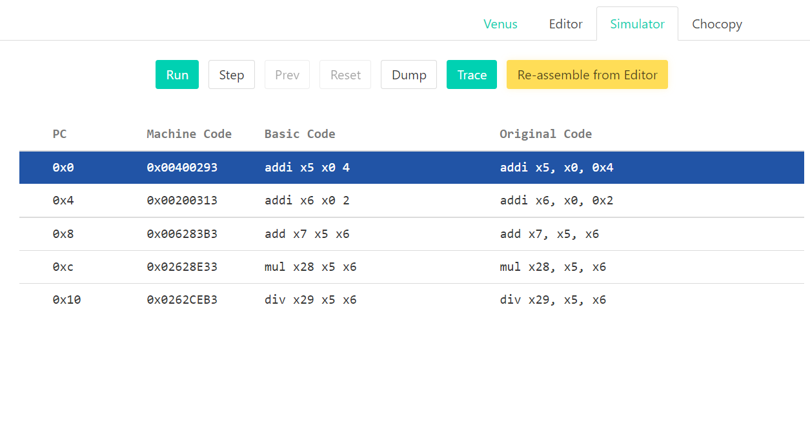

Addition



Multiplication



Division

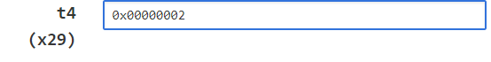

**Task # 2:**

Write down a simple C program to find out the prime numbers between 1-10 and give the final count of prime numbers. Convert the C code into assembly and machine code and stimulate it on Venus.

**C Code:**

int main()

{

    int c = 0;

    int flag;

    for (int i = 2; i < 11; i++) {

        flag = 1;

        for (int j = 2; j <= (i / 2); j++) {

            if ((i % j) == 0) {

                flag = 0;

            }

        }

        if (flag) {

            c++;

        }

    }

    printf("Prime numbers are %d times from 1 to 10", c);

    return 0;

}

**RISC-V Assembly Code:**

addi x30, x0, 0 # c = 0

addi x31, x0, 0 # flag = 0;

addi x5, x0, 0x2 # i=2

addi x6, x0, 0xa # condition 10

outer_loop_start:

bge x5, x6, outer_loop_end # if (i >= 10)

addi x31, x0, 0x1 # flag = 1

   addi x7, x0, 0x2 # j=2

   div x9, x5, x7 # i/2

   inner_loop_start:

                 bgt x7, x9, inner_loop_end # if(j <= (i/2))

                 rem x28, x5, x7

                 bne x28, x0, label1

                 addi x31, x0, 0 # flag = 0

        label1:

   addi x7, x7, 1 # j++

   j inner_loop_start

   inner_loop_end:

        bne x31, x0, label2

        j here

    label2:

         addi x30, x30, 1

here:

addi x5, x5, 1 # i++

j outer_loop_start

outer_loop_end:

**addi x30, x0, 0**

|  |  |  |  |  |
| --- | --- | --- | --- | --- |
| 000000000000 | 00000 | 000 | 11110 | 0010011 |

Machine Code: 0000 0000 0000 0000 0000 1111 0001 0011

Hexadecimal Code: 00000F13

**addi x31, x0, 0**

|  |  |  |  |  |
| --- | --- | --- | --- | --- |
| 000000000000 | 00000 | 000 | 11111 | 0010011 |

Machine Code: 0000 0000 0000 0000 0000 1111 1001 0011

Hexadecimal Code: 00000F93

**addi x5, x0, 0x2**

|  |  |  |  |  |
| --- | --- | --- | --- | --- |
| 000000000010 | 00000 | 000 | 00101 | 0010011 |

Machine Code: 0000 0000 0010 0000 0000 0010 1001 0011

Hexadecimal Code: 0020293

**addi x6, x0, 0xA**

|  |  |  |  |  |
| --- | --- | --- | --- | --- |
| 000000001010 | 00000 | 000 | 00110 | 0010011 |

Machine Code: 0000 0000 1010 0000 0000 0011 0001 0011

Hexadecimal Code: 00A00313

**bge x5, x6, outer_loop_end**

|  |  |  |  |  |  |
| --- | --- | --- | --- | --- | --- |
| 0000001 | 00110 | 00101 | 101 | 11100 | 1100011 |

Machine Code: 0000 0010 0110 0010 1101 1110 0110 0011

Hexadecimal Code: 0262DE63

**addi x30, x0, 0**

|  |  |  |  |  |
| --- | --- | --- | --- | --- |
| 000000000001 | 00000 | 000 | 11111 | 0010011 |

Machine Code: 0000 0000 0001 0000 0000 1111 1001 0011

Hexadecimal Code: 00100F93

**addi x30, x0, 0**

|  |  |  |  |  |
| --- | --- | --- | --- | --- |
| 000000000010 | 00000 | 000 | 00111 | 0010011 |

Machine Code: 0000 0000 0010 0000 0000 0011 1001 0011

Hexadecimal Code: 00200393

**div x9, x5, x7**

|  |  |  |  |  |  |
| --- | --- | --- | --- | --- | --- |
| 0000001 | 00111 | 00101 | 100 | 01001 | 0110011 |

Machine Code: 0000 0010 0111 0010 1100 0100 1011 0011

Hexadecimal Code: 00272C4B3

**bgt x7, x9, inner_loop_end**

|  |  |  |  |  |  |
| --- | --- | --- | --- | --- | --- |
| 0000000 | 00111 | 01001 | 100 | 11000 | 1100011 |

Machine Code: 0000 0000 0111 0100 1100 1100 0110 0011

Hexadecimal Code: 0074CC63

**rem x28, x5, x7**

|  |  |  |  |  |  |
| --- | --- | --- | --- | --- | --- |
| 0000001 | 00111 | 00101 | 110 | 11100 | 0110011 |

Machine Code: 0000 0010 0111 0010 1110 1110 0011 0011

Hexadecimal Code: 0272EE33

**bne x28, x0, label1**

|  |  |  |  |  |  |
| --- | --- | --- | --- | --- | --- |
| 0000000 | 00000 | 11100 | 001 | 01000 | 1100011 |

Machine Code: 0000 0000 0000 1110 0001 0100 0110 0011

Hexadecimal Code: 000E1463

**addi x31, x0, 0**

|  |  |  |  |  |
| --- | --- | --- | --- | --- |
| 000000000000 | 00000 | 000 | 11111 | 0010011 |

Machine Code: 0000 0000 0000 0000 0000 1111 1001 0011

Hexadecimal Code: 00000F93

**addi x7, x7, 1**

|  |  |  |  |  |
| --- | --- | --- | --- | --- |
| 000000000000 | 00111 | 000 | 00111 | 0010011 |

Machine Code: 0000 0000 0000 0011 1000 0011 1001 0011

Hexadecimal Code: 00038393

**bne x31, x0, label2**

|  |  |  |  |  |  |
| --- | --- | --- | --- | --- | --- |
| 0000000 | 00000 | 11111 | 001 | 01000 | 1100011 |

Machine Code: 0000 0000 0000 1111 1001 0100 0110 0011

Hexadecimal Code: 000F9463

**addi x30, x30, 1**

|  |  |  |  |  |
| --- | --- | --- | --- | --- |
| 000000000001 | 11110 | 000 | 11110 | 0010011 |

Machine Code: 0000 0000 0001 1111 0000 1111 0001 0011

Hexadecimal Code: 001F0F13

**addi x5, x5, 1**

|  |  |  |  |  |
| --- | --- | --- | --- | --- |
| 000000000001 | 00101 | 000 | 00101 | 0010011 |

Machine Code: 0000 0000 0001 0010 1000 0010 1001 0011

Hexadecimal Code: 00128293

**Venus Simulation:**

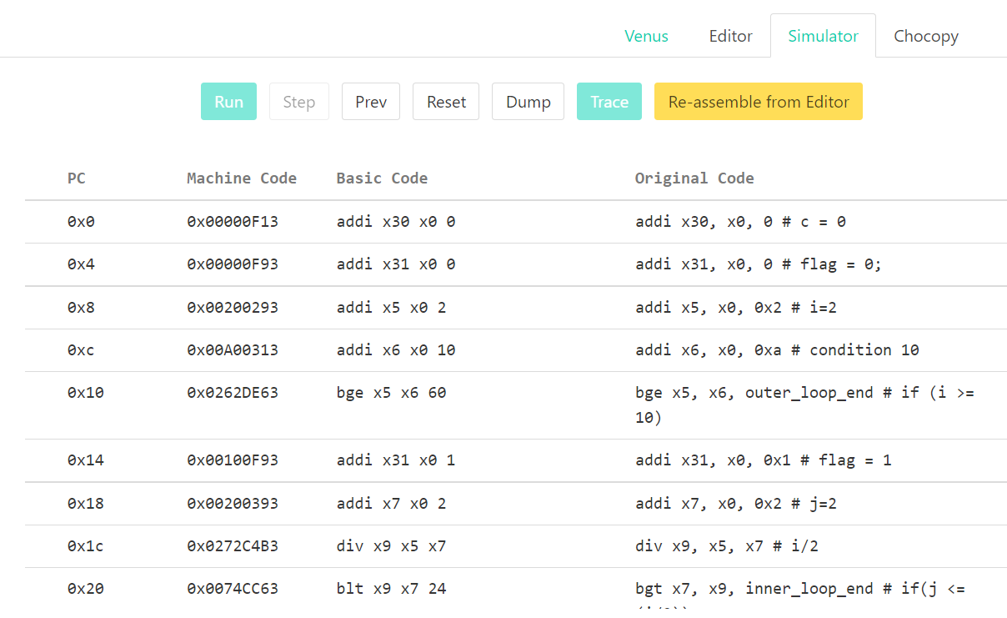

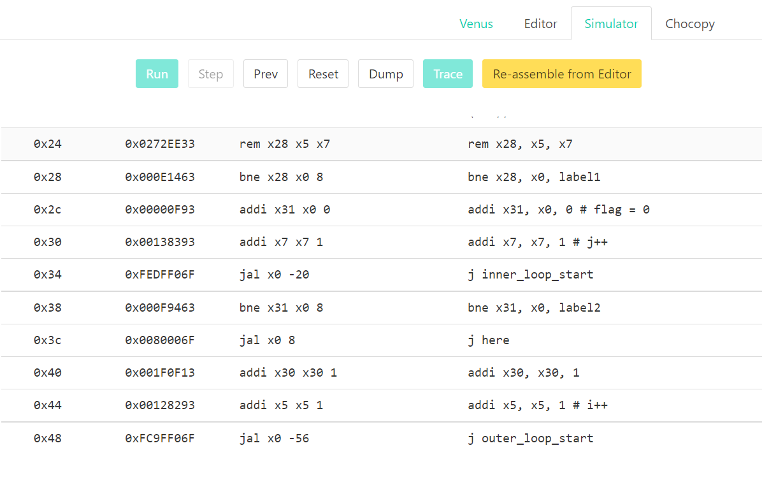

Final register value



  