**COAL Lab-08**

**Designing Microarchitecture-III**

**------------------------------------------------------**

**Name:** Saad Nisar Butt

**Reg. no:** cs211246

**Class:** BSCS-3C-1

**------------------------------------------------------**

**Literature Review:**

**I-Type**

|  |  |  |  |  |
| --- | --- | --- | --- | --- |
| 31:20 | 19:15 | 14:12 | 11:7 | 6:0 |
| **imm11:0** | **rs1** | **func3** | **rd** | **op** |
| 12 bits | 5 bits | 3 bits | 5 bits | 7 bits |

**Lab Tasks**

**Task 1:**

**Verilog Code**

**Single_Cycle.v**

`include "./ProgramCounter/design.v"

`include "./InstructionMemory/design.v"

`include "./RegisterFile/design.v"

`include "./ControlUnit/Control_Unit.v"

`include "./ControlUnit/DecoderModules/main_decoder.v"

`include "./ControlUnit/DecoderModules/alu_decoder.v"

`include "./SignExtension/design.v"

`include "./ALU/design.v"

`include "./DataMemory/design.v"

`include "./Adder/design.v"

module Single_Cycle(clk, reset);

    input clk, reset;

    // Interim wire declaration

    wire[31:0] PC_w;

    wire [31:0] Instruction;

    wire [31:0] RD1;

    wire [31:0] Extended;

    wire [31:0] ALUResult;

    wire RegWrite;

    wire [31:0] RD;

    wire [31:0] NextIns;

    wire [2:0] ALUControl;

    wire [31:0] X,Y;

    // Module Instantiation

    Program_Counter Program_Counter (  // fetch cyle starts

        .PCNext(NextIns),

        .clk(clk),

        .reset(reset),

        .PC(PC_w)

    );

    Instruction_Memory Instruction_Memory (

        .reset(reset),

        .A(PC_w),

        .RD(Instruction)

    );                                 // fetch cyle ends

    Control_Unit Control_Unit (  // Decode cycle satrts

        .zero(),

        .op(Instruction[6:0]),

        .func3(Instruction[14:12]),

        .func7(),

        .PCSrc(),

        .RegWrite(RegWrite),

        .ALUSrc(),

        .MemWrite(),

        .ResultSrc(),

        .ImmSrc(),

        .ALUControl(ALUControl)

    );

    Register_File Register_File (

        .A1(Instruction[19:15]),

        .A2(),

        .A3(Instruction[11:7]),

        .WD3(RD),

        .clk(clk),

        .reset(reset),

        .WE3(RegWrite),

        .RD1(RD1),

        .RD2()

    );

    Sign_Extension Sign_Extension (

        .ImmInst(Instruction[31:20]),

        .ImmExt(Extended)

    );                              // Decode cycle ends

    Flags_ALU ALU (

        .A(RD1),

        .B(Extended),

        .ctrl(ALUControl),

        .Result(ALUResult),

        .Z(),

        .N(),

        .C(),

        .V()

    );

    Data_Memory Data_Memory (

        .A(ALUResult),

        .WD(),

        .clk(clk),

        .reset(reset),

        .WE(1'b0),

        .RD(RD)

    );

    Adder Adder (

        .Inp1(PC_w),

        .Inp2(32'd4),

        .Sum(NextIns)

    );

endmodule

**Program_Counter design.v**

module Program_Counter(PCNext, clk, reset, PC);

    input [31:0] PCNext;

    input clk, reset;

    output reg [31:0] PC;

    always @(posedge clk) begin

        if (reset == 1'b1) begin

            PC <= 32'h00000000;

        end

        else begin

            PC <= PCNext;

        end

    end

endmodule

**Instruction_Memory design.v**

module Instruction_Memory(reset, A, RD);

    input reset;

    input [31:0] A;

    output [31:0] RD;

    // Memory

    reg [31:0] mem [1023:0]; // 8bit = byte, 16bit = half-word, 32bit = word

    assign RD = (reset == 1'b1) ? 32'h00000000 : mem[A[31:2]];

    initial begin

      mem[0] <= 32'h00000013;

      mem[1] <= 32'h0002A203;

      mem[2] <= 32'h0042A203;

    end

endmodule

**Control_Unit.v**

module Control_Unit(zero, op, func3, func7, PCSrc, RegWrite, ALUSrc, MemWrite, ResultSrc, ImmSrc, ALUControl);

    input zero, func7;

    input [6:0] op;

    input [2:0] func3;

    output PCSrc, RegWrite, ALUSrc, MemWrite, ResultSrc;

    output [1:0] ImmSrc;

    output [2:0] ALUControl;

    wire [1:0] ALUOp;

    wire op5, Branch;

    assign op5 = op[5];

    main_decoder main_dec (

        .op(op), .RegWrite(RegWrite), .ALUSrc(ALUSrc), .MemWrite(MemWrite),

        .ResultSrc(ResultSrc), .Branch(Branch), .ImmSrc(ImmSrc), .ALUOp(ALUOp)

    );

    alu_decoder alu_dec (

        .ALUOp(ALUOp), .func3(func3), .op5(op5), .func7_5(func7), .ALUControl(ALUControl)

    );

    assign PCSrc = zero & Branch;

endmodule

**Decoder_Modules**

**main_decoder.v**

module main_decoder(op, RegWrite, ALUSrc, MemWrite, ResultSrc, Branch, ImmSrc, ALUOp);

    input[6:0] op;

    output RegWrite, ALUSrc, MemWrite, ResultSrc, Branch;

    output [1:0] ImmSrc, ALUOp;

    assign RegWrite = ((op == 7'b0000011) | (op == 7'b0110011)) ? 1'b1 : 1'b0;

    assign ALUSrc = ((op == 7'b0000011) | (op == 7'b0100011)) ? 1'b1 : 1'b0;

    assign MemWrite = ((op == 7'b0100011)) ? 1'b1 : 1'b0;

    assign ResultSrc = ((op == 7'b0000011)) ? 1'b1 : 1'b0;

    assign Branch = ((op == 7'b1100011)) ? 1'b1 : 1'b0;

    assign ImmSrc = ((op == 7'b0100011)) ? 2'b01 : (op == 7'b1100011) ? 2'b10 : 2'b00;

    assign ALUOp = ((op == 7'b0110011)) ? 2'b10 : (op == 7'b1100011) ? 2'b01 : 2'b00;

endmodule

**alu_decoder.v**

module alu_decoder(ALUOp, func3, op5, func7_5, ALUControl);

    input [1:0] ALUOp;

    input [2:0] func3;

    input op5, func7_5;

    wire [1:0] signal;

    output [2:0] ALUControl;

    assign signal = {op5, func7_5};

    assign ALUControl = (ALUOp == 2'b00) ? 3'b000 :

                        (ALUOp == 2'b01) ? 3'b001 :

                        ((ALUOp == 2'b10) & (func3 == 3'b000) & (signal == 2'b11)) ? 3'b001 :

                        ((ALUOp == 2'b10) & (func3 == 3'b000) & (signal != 2'b11)) ? 3'b000 :

                        ((ALUOp == 2'b10) & (func3 == 3'b010)) ? 3'b101 :

                        ((ALUOp == 2'b10) & (func3 == 3'b110)) ? 3'b011 :

                        ((ALUOp == 2'b10) & (func3 == 3'b011)) ? 3'b010 : 3'b000;

endmodule

**Register_File design.v**

module Register_File(A1, A2, A3, WD3, clk, reset, WE3, RD1, RD2);

    input [4:0] A1, A2, A3; // A1->rs1 | A2->rs2 | A3->rd

    input clk, reset, WE3; // WE3 -> a key signal to let write or not - Write Enable

    input [31:0] WD3; // WD3 -> Write Data

    output [31:0] RD1, RD2;

    // 32 registers of 32-1bits

    reg [31:0] register[31:0];

    initial begin

      register[5] = 32'h00000000;

    end

    // reading from registers which are operands

    assign RD1 = (reset == 1'b1) ? 32'd0 : register[A1];

    assign RD2 = (reset == 1'b1) ? 32'd0 : register[A2];

    always @(negedge clk) begin

        if((WE3 == 1'b1) & (A3 != 5'h00)) begin

            register[A3] <= WD3;

        end

    end

endmodule

**Sign_Extension design.v**

module Sign_Extension(ImmInst, ImmExt);

    input [11:0] ImmInst;

    output [31:0] ImmExt;

    assign ImmExt = {{20{ImmInst[11]}} , ImmInst};

endmodule

**ALU design.v**

module Flags_ALU(A, B, ctrl, Result, Z, N, C, V);

  // inputs

  input [31:0] A, B;

  input [2:0] ctrl;

  // outputs

  output [31:0] Result;

  // Flags for Zero, Negative, Carry and Overflow respectively.

  output Z,N,C,V;

  // interim wires

  wire [31:0] A_and_B, A_or_B, B_not, A_sum_B;

  wire [31:0] S1;

  wire [31:0] not_Result;

  wire Cout, xor_A_Sum, xnor_A_B_ctrl0, ctrl1_not;

  // Logic Designing

  // And

  assign A_and_B = A & B;

  // Or

  assign A_or_B = A | B;

  // Not

  assign B_not = ~B;

  // 2x1 Mux for addition or subtraction

  assign S1 = (ctrl[0] == 1'b1) ? B_not : B;

  // Addition / Subtraction

  assign {Cout, A_sum_B} = A + S1 + ctrl[0];

  // Result output through 4x1 Mux

  assign Result = (ctrl[1:0] == 2'b00) ? A_sum_B :

                  (ctrl[1:0] == 2'b01) ? A_sum_B :

                  (ctrl[1:0] == 2'b10) ? A_and_B : A_or_B;

  // Flags Outputs

  // for zero checking

  assign not_Result = ~Result;

  assign Z = &(not_Result);

  // for negative checking

  assign N = Result[31];

  //for carry checking

  assign ctrl1_not = (~ctrl[1]);

  assign C = ctrl1_not & Cout;

  // for overflow checking

  assign xor_A_Sum = A_sum_B[31] ^ A[31];

  assign xnor_A_B_ctrl0 = ~(A[31] ^ B[31] ^ ctrl[0]);

  assign V = ctrl1_not & xor_A_Sum & xnor_A_B_ctrl0;

endmodule

**Data_Memory design.v**

module Data_Memory(A, WD, clk, reset, WE, RD);

    input [31:0] A, WD;

    input clk, reset, WE;

    output [31:0] RD;

    reg [31:0] memory [1023:0];

    initial begin

      memory[0] = 32'h00000001;

      memory[1] = 32'h00000010;

      memory[2] = 32'h00000100;

      memory[3] = 32'h00001000;

      memory[4] = 32'h00010000;

    end

    // read

    assign RD = (WE == 1'b0) ? memory[A] : 32'h00000000;

    // write

    always @(posedge clk) begin

        if (WE == 1'b1) begin

            memory[A] <= WD;

        end

    end

endmodule

**testbench.v**

module tb();

    reg clk=0, reset;

    Single_Cycle dut (

        .clk(clk),

        .reset(reset)

    );

    always begin

       clk = ~clk;

       #50;

    end

    initial begin

      reset <= 1'b1;

      #100;

      reset <= 1'b0;

      #500;

      $finish;

    end

    initial begin

      $dumpfile("dump.vcd");

      $dumpvars(0);

    end

endmodule

**Waveforms**

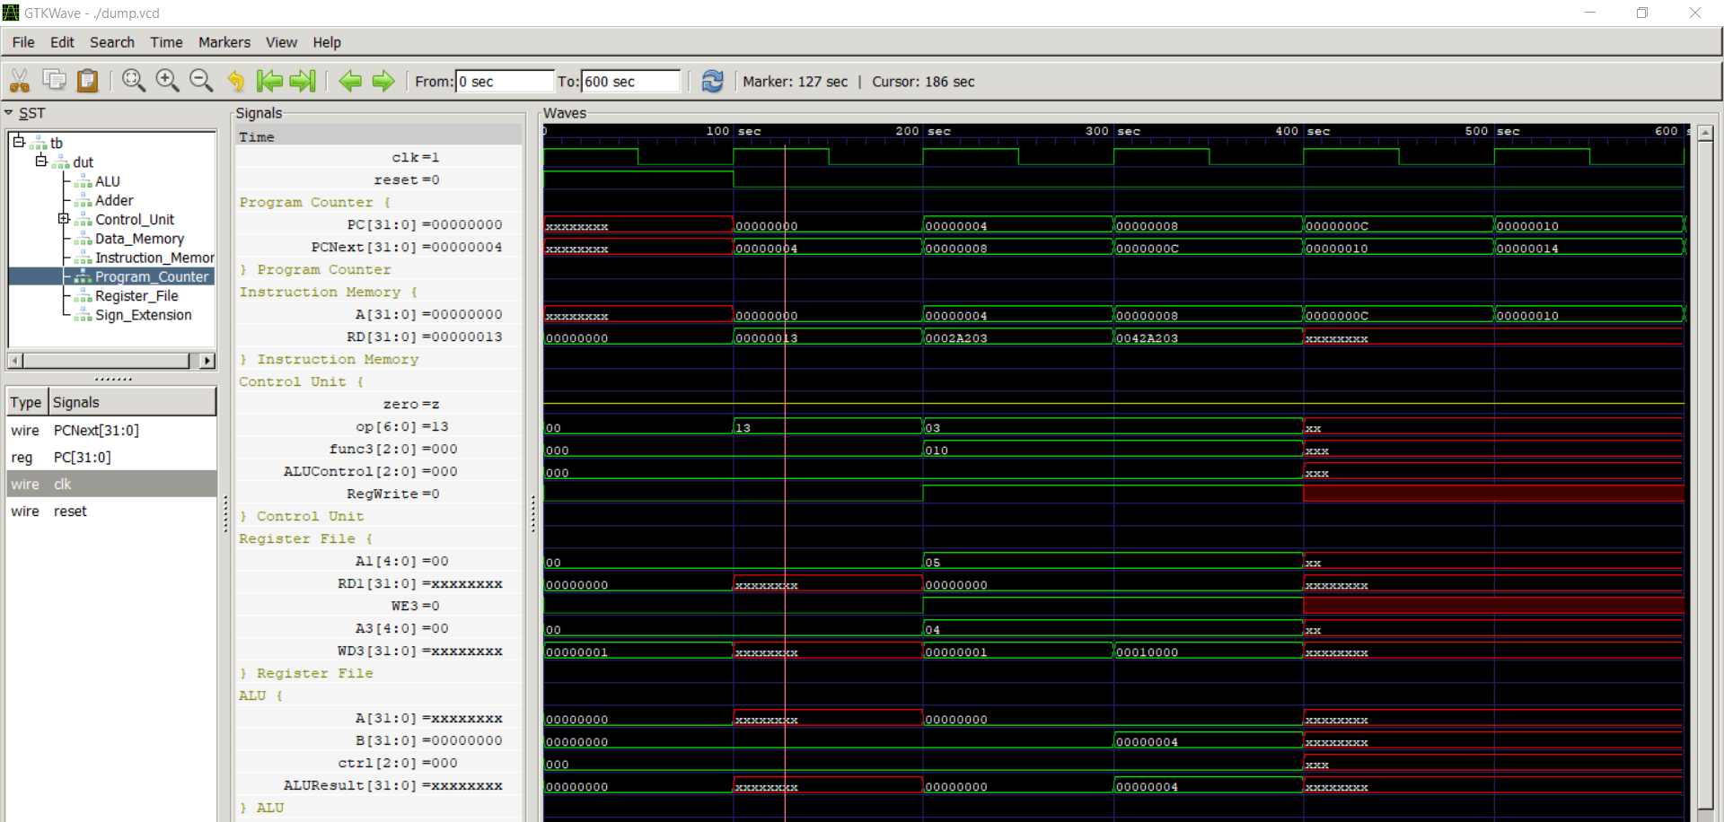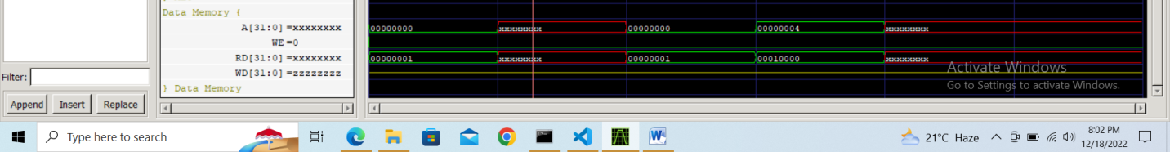

**Use these instructions for this task**

addi x5, x0, 4 # storing 4 in register x5

addi x6, x0, 6 # storing 6 in register x6

addi x20, x20, 0x20 # setting memory’s base address

sw s0, 0x0(x20) # storing s0’s added value in memory

sw s1, 0x4(x20) # storing s1’s subtracted value in memory

**\* -------------------------------------- \***