



**Project Report**

**Topic: 16-Bit Barrel Shifter**

**Group members:**

Muhammad Usman (cs211208)

Saad Nisar Butt (cs211246)

**Literature Review:**

A barrel shifter is a digital circuit that can shift a data word by a specified number of bits without the use of any sequential logic, only pure combinational logic. It has a control input that specifies the number of bit positions that it shifts by. The Barrel Shifter is similar to the Shift Register (Multi-bit), except that bits shifted of the register are shifted back into the opposite end of the register. It rotates the bit to be shifted. For example, in right shift operations, the LSBs shifted out of the register are shifted into the MSBs.

It can be implemented as a sequence of multiplexers. In this implementation, the output of one MUX is connected to the input of the next MUX in a way that depends on the shift distance. The number of multiplexers required is **n*log2(n)** , for an **n** bit word.

For 16-bit barrel shifter --- 16*log2(16) = 64

i.e. 64 multiplexers are required to implement the circuitry of 16-bit barrel shifter.

For the right shift operation, a 2x1 mux is used as a module. A control signal will determine the number of bits to be shifted. When implementing a barrel shifter with a sequence of shift multiplexers, each shifts a word by 2^k bit positions (1,2,4,8...) for different values of k. The number of multiplexing stages is relative to the width of the input. For 16-bit input, there are 4 stages. Each stage’s shifting depends on control signal’s bit.

**Block Diagram:**

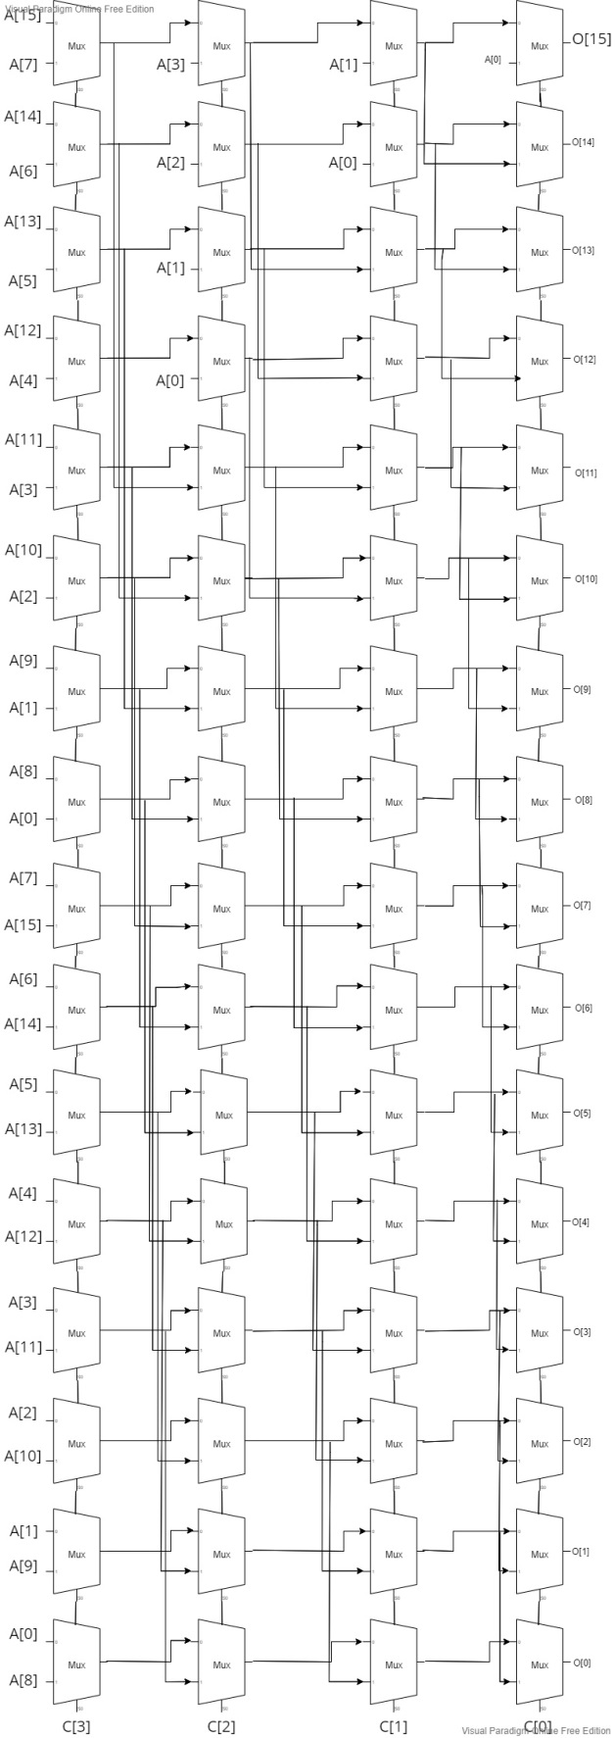

**Boolean Equation:**

**For 2x1 MUX**

$O= \overline{C}.A0+C.A1$

**Verilog Code:**

**design.v**

`include "mux.v"

module barrel(A,C,O);

    input[15:0] A;

    input[3:0] C;

    output[15:0] O;

    wire [15:0] x,y,z;

    //8bit shift right

    mux mux_15(A[15], A[7], C[3], x[15]);

    mux mux_14(A[14], A[6], C[3], x[14]);

    mux mux_13(A[13], A[5], C[3], x[13]);

    mux mux_12(A[12], A[4], C[3], x[12]);

    mux mux_11(A[11], A[3], C[3], x[11]);

    mux mux_10(A[10], A[2], C[3], x[10]);

    mux mux_9(A[9], A[1], C[3], x[9]);

    mux mux_8(A[8], A[0], C[3], x[8]);

    mux mux_7(A[7], A[15], C[3], x[7]);

    mux mux_6(A[6], A[14], C[3], x[6]);

    mux mux_5(A[5], A[13], C[3], x[5]);

    mux mux_4(A[4] ,A[12], C[3], x[4]);

    mux mux_3(A[3], A[11], C[3], x[3]);

    mux mux_2(A[2], A[10], C[3], x[2]);

    mux mux_1(A[1], A[9], C[3], x[1]);

    mux mux_0(A[0], A[8], C[3], x[0]);

    //4bit shift right

    mux mux_31(x[15], A[3], C[2], y[15]);

    mux mux_30(x[14], A[2], C[2], y[14]);

    mux mux_29(x[13], A[1], C[2], y[13]);

    mux mux_28(x[12], A[0], C[2], y[12]);

    mux mux_27(x[11], x[15], C[2], y[11]);

    mux mux_26(x[10], x[14], C[2], y[10]);

    mux mux_25(x[9], x[13], C[2], y[9]);

    mux mux_24(x[8], x[12], C[2], y[8]);

    mux mux_23(x[7], x[11], C[2], y[7]);

    mux mux_22(x[6], x[10], C[2], y[6]);

    mux mux_21(x[5], x[9], C[2], y[5]);

    mux mux_20(x[4], x[8], C[2], y[4]);

    mux mux_19(x[3], x[7], C[2], y[3]);

    mux mux_18(x[2], x[6], C[2], y[2]);

    mux mux_17(x[1], x[5], C[2], y[1]);

    mux mux_16(x[0], x[4], C[2], y[0]);

    //2bit shift right

    mux mux_47(y[15], A[1], C[1], z[15]);

    mux mux_46(y[14], A[0], C[1], z[14]);

    mux mux_45(y[13], y[15], C[1], z[13]);

    mux mux_44(y[12], y[14], C[1], z[12]);

    mux mux_43(y[11], y[13], C[1], z[11]);

    mux mux_42(y[10], y[12], C[1], z[10]);

    mux mux_41(y[9], y[11], C[1], z[9]);

    mux mux_40(y[8], y[10], C[1], z[8]);

    mux mux_39(y[7], y[9], C[1], z[7]);

    mux mux_38(y[6], y[8], C[1], z[6]);

    mux mux_37(y[5], y[7], C[1], z[5]);

    mux mux_36(y[4], y[6], C[1], z[4]);

    mux mux_35(y[3], y[5], C[1], z[3]);

    mux mux_34(y[2], y[4], C[1], z[2]);

    mux mux_33(y[1], y[3], C[1], z[1]);

    mux mux_32(y[0], y[2], C[1], z[0]);

    //1bit shift right

    mux mux_63(z[15], A[0], C[0], O[15]);

    mux mux_62(z[14], z[15], C[0], O[14]);

    mux mux_61(z[13], z[14], C[0], O[13]);

    mux mux_60(z[12], z[13], C[0], O[12]);

    mux mux_59(z[11], z[12], C[0], O[11]);

    mux mux_58(z[10], z[11], C[0], O[10]);

    mux mux_57(z[9], z[10], C[0], O[9]);

    mux mux_56(z[8], z[9], C[0], O[8]);

    mux mux_55(z[7], z[8], C[0], O[7]);

    mux mux_54(z[6], z[7], C[0], O[6]);

    mux mux_53(z[5], z[6], C[0], O[5]);

    mux mux_52(z[4], z[5], C[0], O[4]);

    mux mux_51(z[3], z[4], C[0], O[3]);

    mux mux_50(z[2], z[3], C[0], O[2]);

    mux mux_49(z[1], z[2], C[0], O[1]);

    mux mux_48(z[0], z[1], C[0], O[0]);

endmodule

**mux.v**

module mux(A0, A1, C, O);

    input A0, A1, C;

    output O;

   // assign O = (C == 1'b0) ? A0 : A1;

    assign O = ~C & A0 | C & A1;

endmodule

**testbench.v**

module tb();

    reg[15:0] A;

    reg[3:0] C;

    wire[15:0] O;

    barrel dut(.A(A), .C(C), .O(O));

    initial begin

      $dumpfile("dump.vcd");

      $dumpvars(0);

    end

    initial begin

        A <= 16'b1010101010101010;

        C <= 4'b0000;

        #100;

        A <= 16'b1010101010101010;

        C <= 4'b0001;

        #100;

        A <= 16'b1000000000000001;

        C <= 4'b0100;

        #100;

        A <= 16'b1000000100010001;

        C <= 4'b1000;

        #100;

        $finish;

    end

endmodule

**Waveforms:**

