LAB TASK – FTP

Name: Saad Nisar Butt

Registration no: cs211246

Class: BSCS-6C

Topology

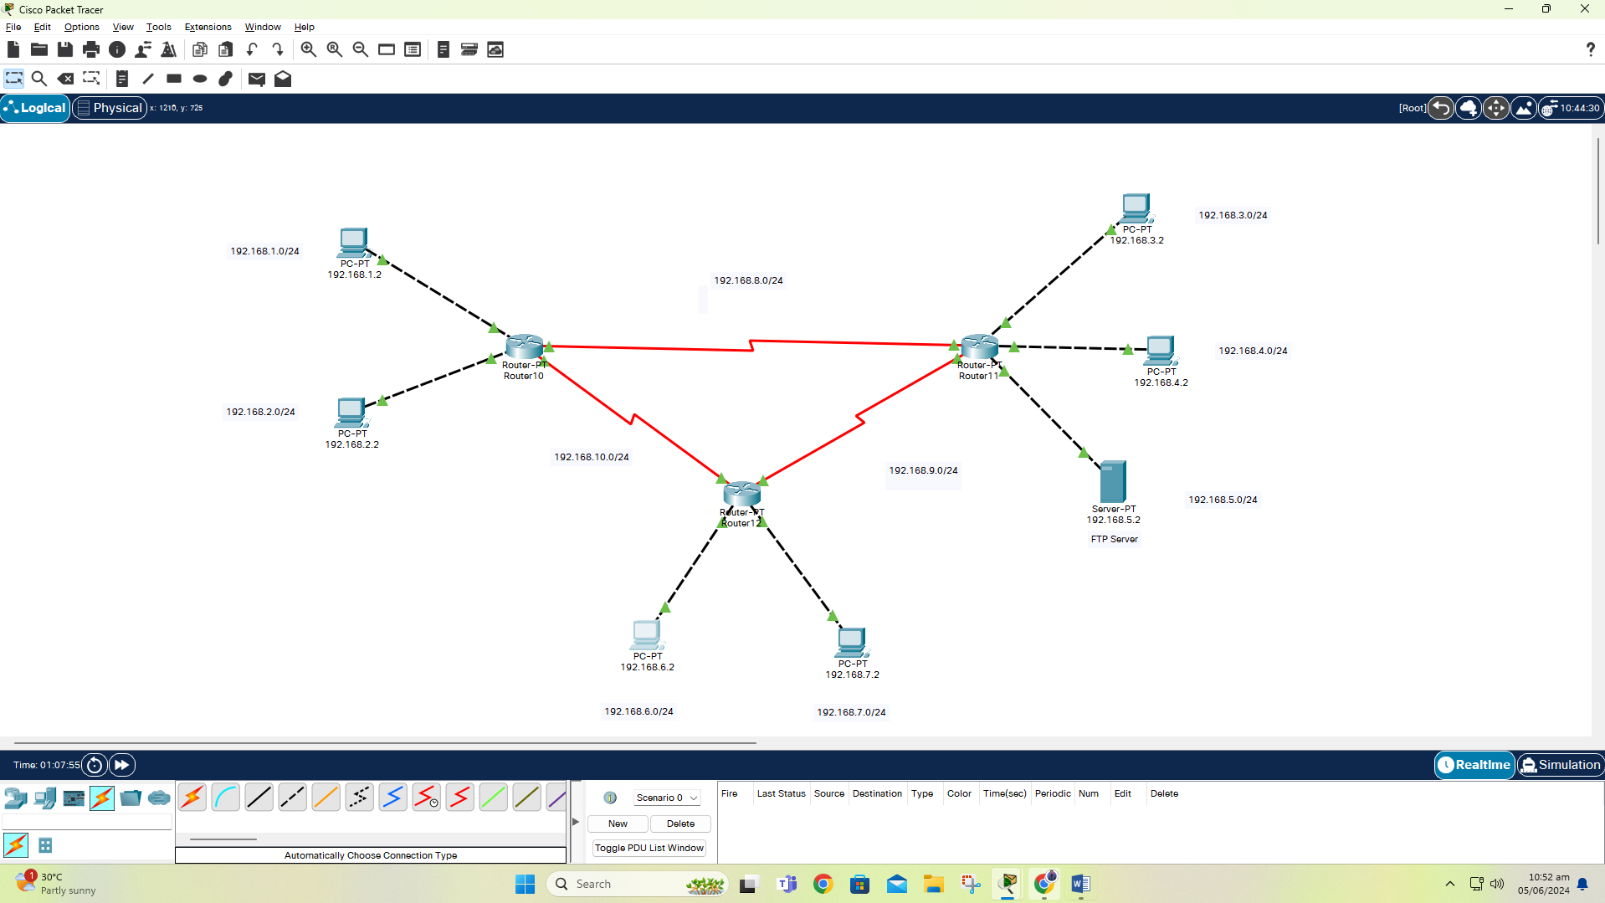

File saad_cs211246.txt uploaded on FTP server from client 192.168.2.2

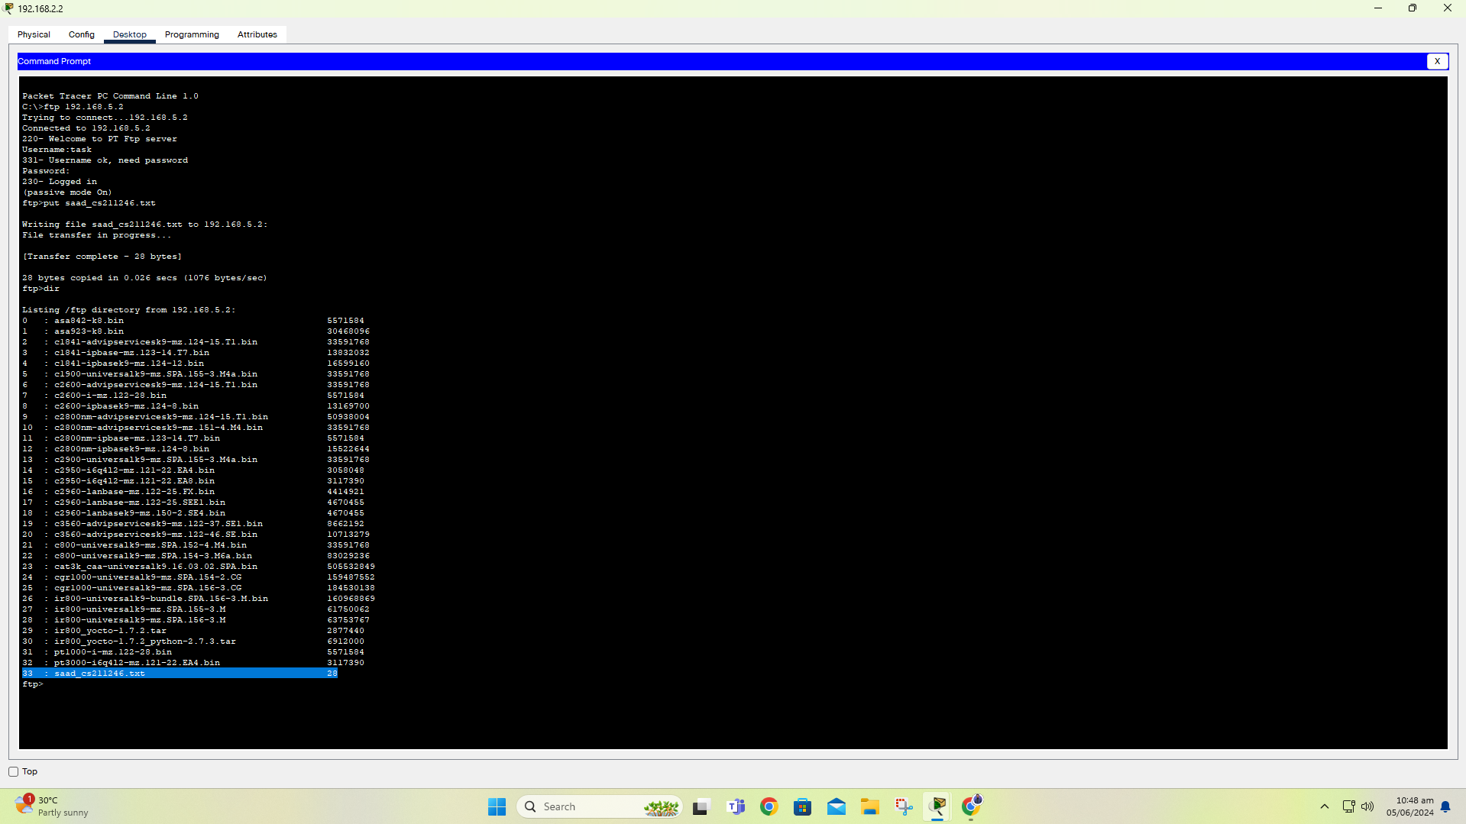

File saad_cs211246.txt downloaded from FTP server on client 192.168.6.2

