TEST REPORT
Brute-Force Password Cracker
Multi-threaded password recovery · WPF / .NET 8 / C#
Author: [ Your full name ]
Student ID: [ Your ID ]
Course / Group: [ Course — Group ]
Date: 4 June 2026
GitHub repository: [ https://github.com/<you>/BruteForceApp ]
Each task committed as a separate version (v1.0 – v1.3) — see commit history & README.md

1. Project Overview
This application recovers a hashed password by brute force. A random password is created and hashed with SHA-256 + a constant static salt; the attacker side then searches every possible character combination — starting from length 1 — across multiple threads until the matching plaintext is found. The program is built with WPF on .NET 8 and has a graphical interface for password creation, starting/stopping the attack, live progress, elapsed time, and the recovered password. It also benchmarks single-threaded vs multi-threaded execution.
Following the requirements, each major responsibility lives in its own class and file, and the brute-force generator and validator are implemented independently.

Class / file structure
File | Class | Responsibility
PasswordManager.cs | PasswordManager | Creates the random password (length [4,6)) and hashes any string with SHA-256 + static salt.
PasswordValidator.cs | PasswordValidator | Independently checks whether a candidate’s hash equals the target hash.
BruteForceGenerator.cs | BruteForceGenerator | Generates all combinations from length 1 → 6; maps an index to a candidate for partitioning.
BruteForceEngine.cs | BruteForceEngine | Coordinates the multi-threaded attack: partitions the search space, raises progress/found events, stops all threads on success.
PerformanceLogger.cs | PerformanceLogger | Runs and logs the single-thread vs multi-thread benchmark and computes the speedup.
MainWindow.xaml(.cs) | MainWindow | The GUI; wires the classes together and updates the display on the UI thread.

2. UML Class Diagram
The diagram below shows the classes, their attributes and methods, and the relationships between them — composition (filled diamond), aggregation (hollow diamond) and dependency (dashed «uses» arrow), with multiplicities.
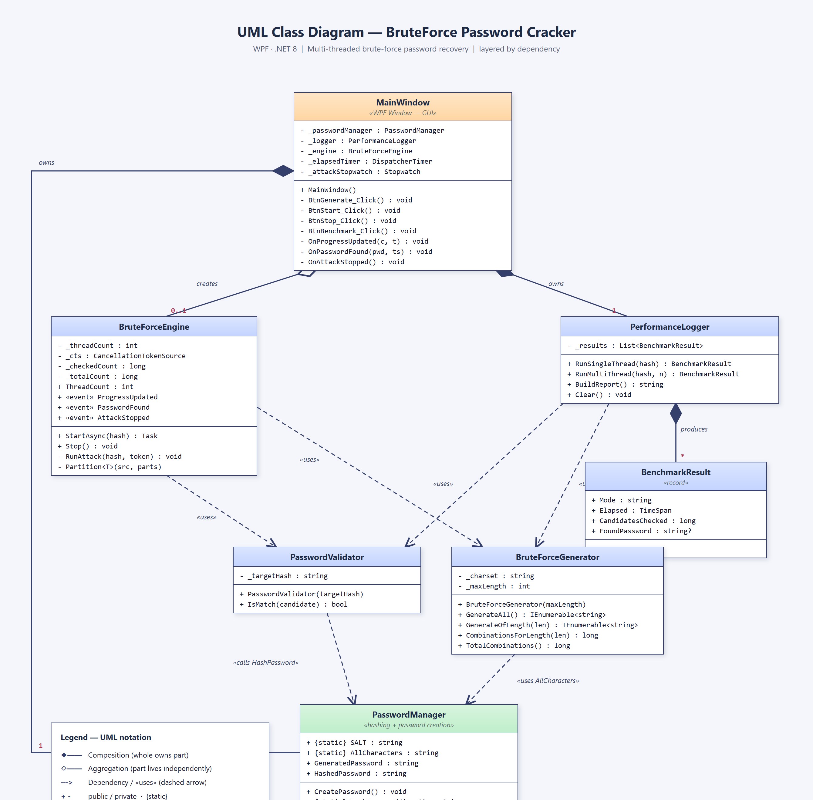

3. Functionality — Requirement by Requirement
Every item from the brief is implemented. The table maps each requirement to where and how it is met.
Requirement | Status | How it is implemented
UML class diagram | Done | Section 2; sources UML_ClassDiagram.puml/.html/.png.
GUI: creation, start/stop, progress, elapsed, result | Done | MainWindow.xaml — Generate, Start/Stop, progress bar + %, elapsed timer, found-password field, log pane.
Each major function in a separate class/file | Done | Six classes in six files (see Section 1).
(a) SHA-256 with a constant static salt | Done | PasswordManager.HashPassword() hashes SALT + input; SALT is a const.
(b) Password length random in [4,6) | Done | _random.Next(4, 6) → 4 or 5 characters.
(c) Brute force length 1 → 6, length unknown | Done | Engine loops length = 1 → 6; it never reads the real length.
(d) Multi-threading (Thread / Task) | Done | Engine uses Task; the benchmark also uses raw Thread.
(e) Use at most (CPU cores − 1) | Done | Math.Max(1, Environment.ProcessorCount - 1) → 7 threads on this 8-core machine.
(f) GUI: start/stop, progress, elapsed, found password | Done | See the screenshots in Section 5.
5. Demonstrate parallel (not sequential) execution | Done | Threads search disjoint index ranges simultaneously; the benchmark shows multi-thread checks more candidates in less wall-clock time.
6. Stop all threads immediately once found | Done | A shared CancellationTokenSource is cancelled on the first match; every thread checks the token each iteration.
7. Generator and validator separate & independent | Done | BruteForceGenerator produces candidates; PasswordValidator only compares hashes — neither references the other.
8. Log single- vs multi-thread performance | Done | PerformanceLogger + the “⚡ Benchmark” button; results in Section 4.

Key design points
- Hashing: SHA256.HashData(UTF8(SALT + candidate)), hex-encoded. The salt is a single constant shared by creation and verification.
- Independent search space: the engine treats the alphabet (a–z, 26 chars) as a number base. Candidate i of a given length is the base-26 representation of i (IndexToCombination). Each thread owns a contiguous slice [start, end) and generates candidates on the fly — true parallelism with no shared list.
- Stop-on-found: the matching thread cancels the shared token; all other threads observe it and return within one iteration.

4. Performance: Single-thread vs Multi-thread
The benchmark runs the same brute force twice against the same hash — first on one thread, then on (CPU cores − 1) threads — and records the wall-clock time and the number of candidates checked. Example run (8 logical cores → 7 worker threads; recovered password “itifg”, length 5):
Mode | Threads | Time elapsed | Candidates checked | Result
Single-thread | 1 | 4.446 s | 4,470,551 | itifg
Multi-thread | 7 | 1.783 s | 4,714,812 | itifg
Speedup (single ÷ multi): 2.49×
The multi-threaded run checked more candidates (4.71M vs 4.47M) yet finished in well under half the time. That is the signature of genuine parallel execution: several threads scan different parts of the keyspace at once, so more total work is done per second. The speedup is below the theoretical 7× because the workload is small (seconds), so thread start-up and the early short lengths add fixed overhead; the gap widens for larger search spaces.

5. Screenshots of the Running Program
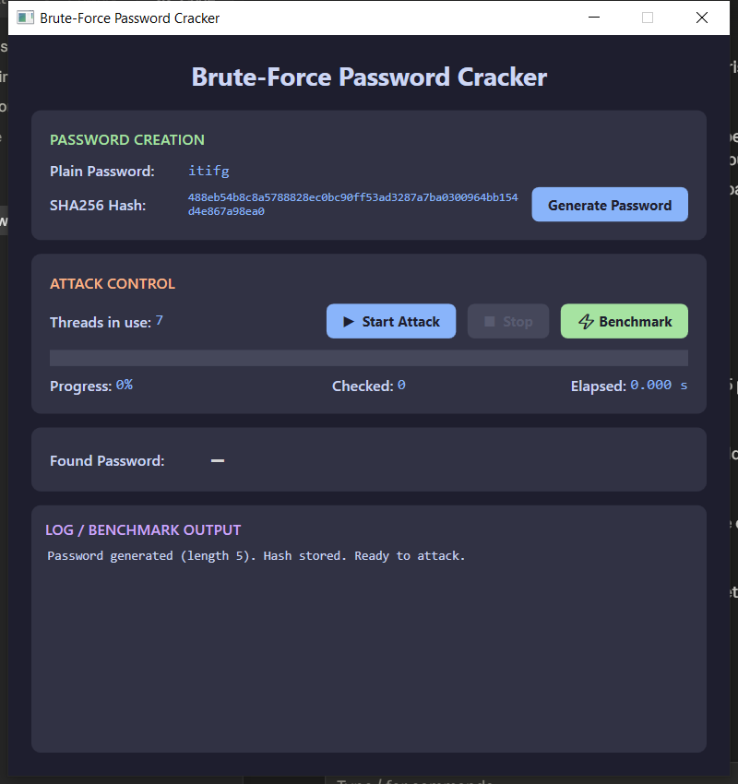

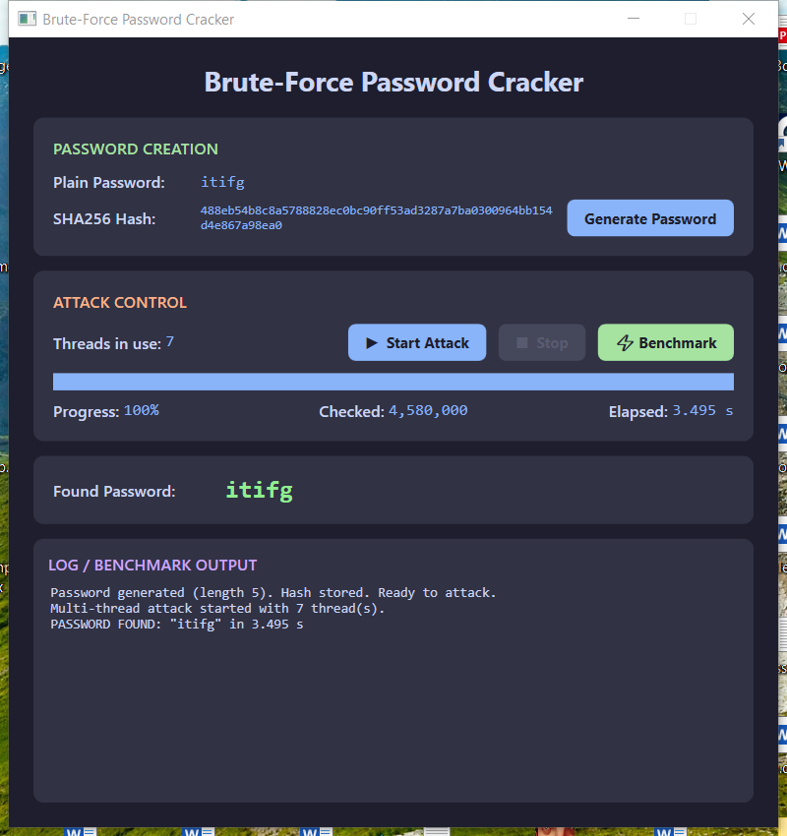

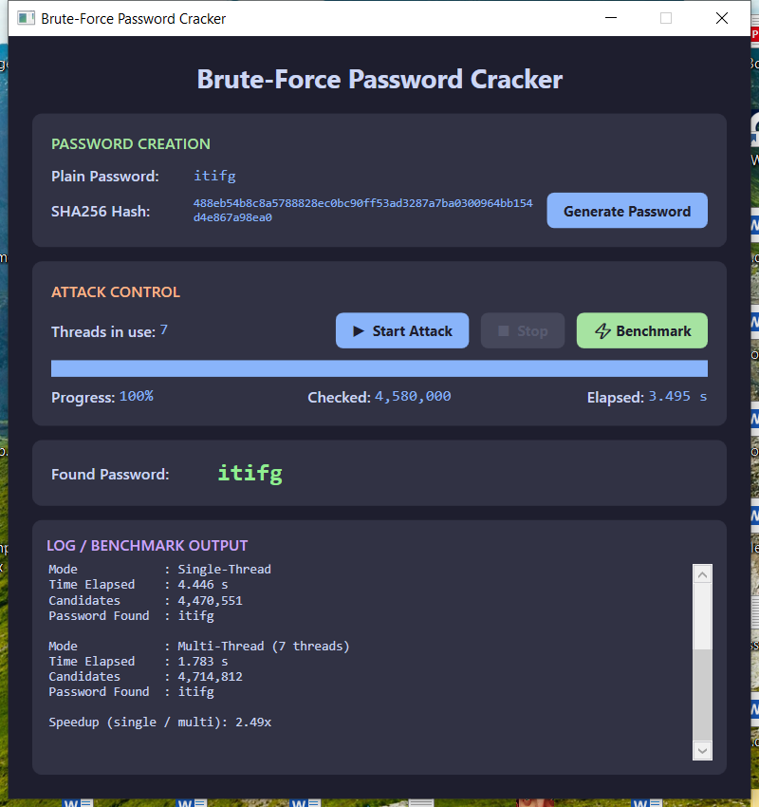

6. Challenges Faced
- Crash the instant the password was found. The engine waited with Task.WaitAll(tasks, token). When a thread found the password it cancelled that same token, so WaitAll threw OperationCanceledException, which propagated onto the UI thread and closed the window. Fix: wait with a plain Task.WaitAll(tasks) and guard the awaited call.
- Memory blow-up from materialising candidates. The first version built a list/queue of every candidate of a length — millions of strings for length 5+. Fix: index-range partitioning with IndexToCombination, so each thread generates its slice on the fly with no large allocation.
- Meaningless progress bar. Measuring progress against the full length-1→6 keyspace (~321M) left a short password showing ~0%. Fix: the denominator grows to include each length as it is reached, and is pinned to 100% on success.
- Demonstrability vs. key space. With the full 62-char alphabet, a length-5 password is ~916M combinations — too slow to demo live. The brief fixes the length but not the alphabet, so a 26-char lowercase set keeps a length 4–5 crack to a few seconds.
- Capturing real screenshots. The states above were produced by driving the live WPF app through Windows UI Automation, not staged mock-ups.

7. How to Build & Run
cd BruteForceApp
dotnet run # or open BruteForceApp.csproj in Visual Studio and press F5

# Compiled debug build:
bin\Debug\net8.0-windows\BruteForceApp.exe
Repository version history: v1.0 implementation v1.1 UML diagram v1.2 fixes + benchmark/screenshots v1.3 report.

