::IOT ASSIGNMENT::

NAME: Saad Faisal

ROLL NO: 23-NTU-CS-1281

Platorm IO running

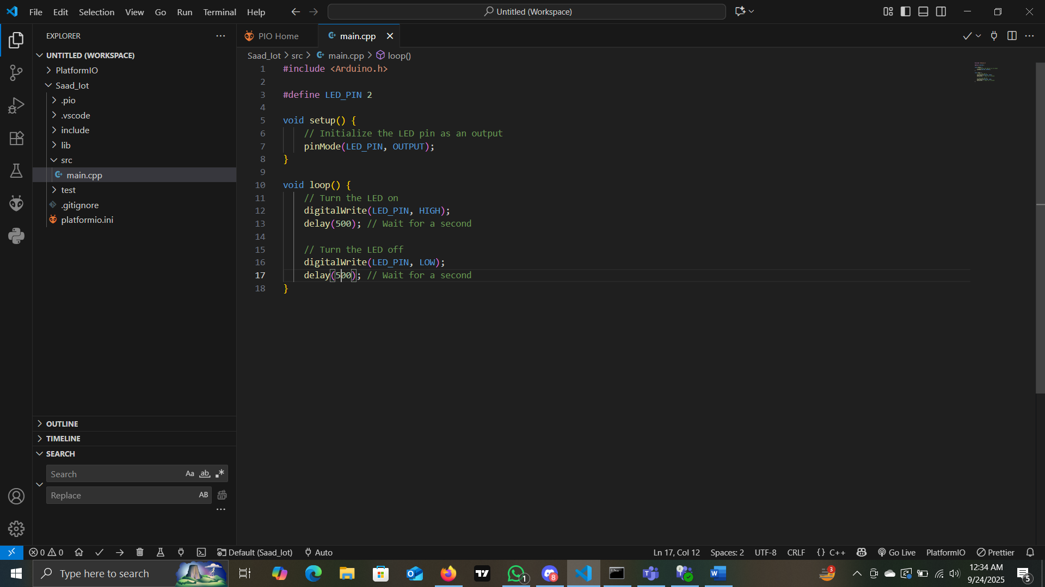

Build Complete

