

**Village & P/O Adam key Cheema The. Daska District SIALKOT**.

**0312-7981029**

**Abrarhassan25146@**

**gmail.com**

**OBJECTIVE**

I am willing to give total support to the organization that I am in, with the experience and capability that I have, in order to achieve organizational goal and create mutual benefits.

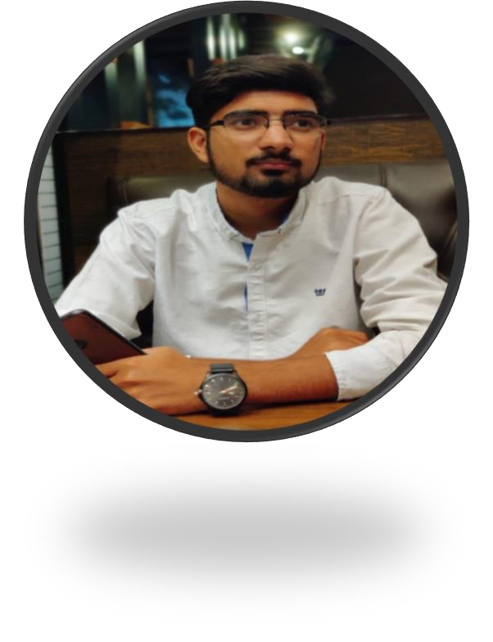

IBRAR HUSSAIN M. MUNIR

# EXPERIENCE

* **Job Helfertech (As Web Developer Suite CRM Laravel and Codeigniter Feb2022 to Continue)**

**PROJECTS & Achievements:** In Helfertech company as Suite CRM Developer working on enterprise project with different frameworks like,SuiteCRM, Codeigniter and Laravel. The Projects done on Helfertech is:

* Helfertech Product (ERP Sys)
* Sudia CRM
* AUS CRM
* Beakon CRM
* Sudia COC

# Job Flash-Logix (As Web Developer Laravel and Codeigniter April2021 to janauary2022)

**PROJECTS & Achievements:** In Flash-Logix company as Laravel Developer working on enterprise project with different frameworks like, Codeigniter and Laravel. Learned and analyze the clients’ business model and provide better solution to their problems. The Projects done on Flash-Logix is:

* Bewerbung (ERP Sys)
* Flow WareHouse System
* AnayaGrandMall
* POS
* Lawyer Management System
* School Managements System

# Job Up work (Graphic Designing - 6Month EDUCATION

**BS (Information Technology) UNIVERSITY**

**of Gujrat (Hafiz Hayat Campus) CGPA 2.82 FYP PROJECT & Others:** In Fyp project we make

Blood Bank System that is totally web based. Maintain the blood and donor record. Keep the employ record.

* C++, Data Structure, Database, OOP, Visual Basic, HTML, PHP, JQuery, Operating System, Computer Communication and Networking, information Security

# TOOLS AND TECHNOLOGIES

HTML, CSS, Bootstrap PHP, Laravel,SuiteCRM, Codeiganter, OOP, JQuery, Word, Excel, PowerPoint, Adobe Photoshop, Adobe illustrator, Adobe XD, Adobe In-design, Photoshop Express.

# PROFESSIONAL SKILLS

* Software Testing & Debugging Test Plan and Script Development Configuration & Troubleshooting
* Intelligent in communication
* Time/Project Management
* Self-motivation
* Conflict Resolution