AndroidManifest.xml shows two Activites
MainActivity & Activity2

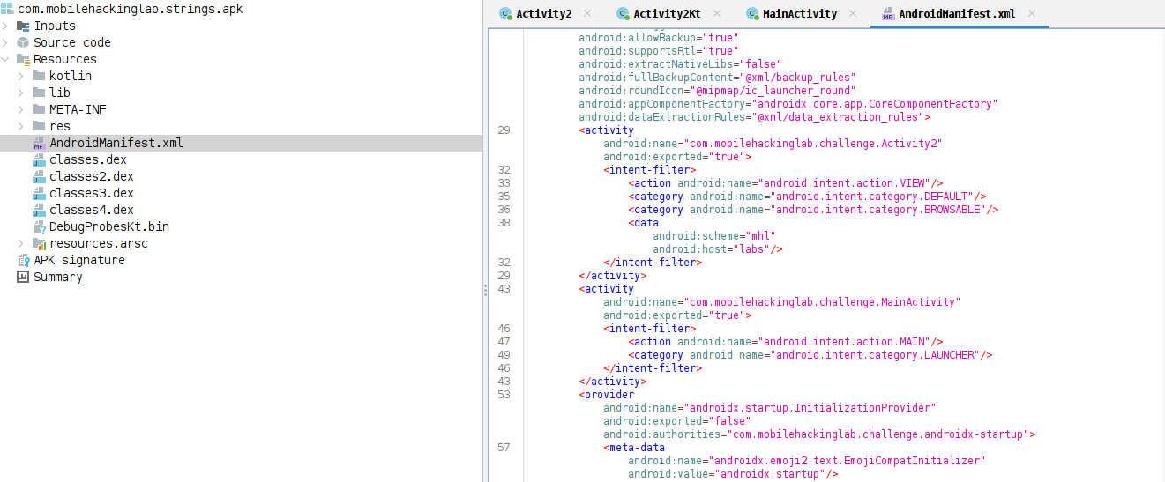
MainActivity has a KLOW() function that is saving the date in sharedpreference file name DAD4 using key UUU0133. And also loading challenge native library.native library are most often C or C++ libraries.

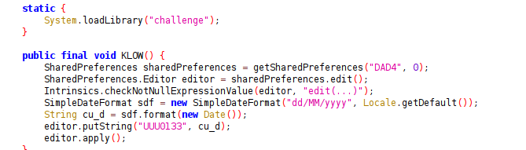

Activity2 is doing a number of check and in the end execute the getflag().

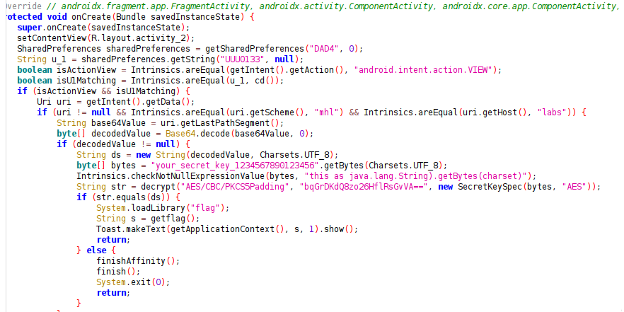
Its accessing the saved date and comparing it with the output of cd() function.
Cd() is also generating current date in similar fomat.
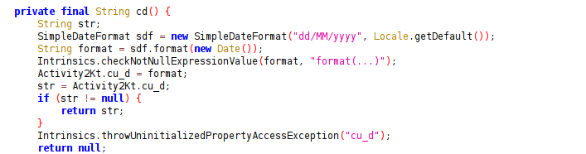
Its checking whether the activity was invoked with VIEW intent.
Its checking the uri scheme and host, and last path segment, decoding it.
And then performs the decryption. If the decrypted string matches ,it proceeds with executing the flag.

Lets try to decrypt the string.

Activity2 file gives us the key and Mode.

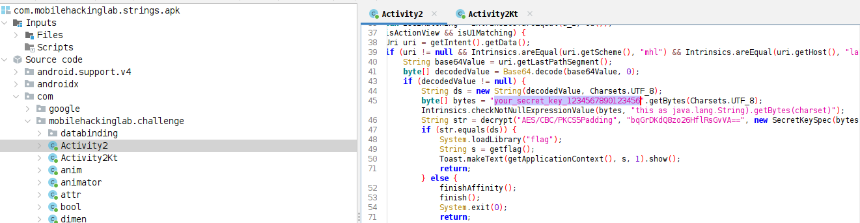

While Activity2kt gives us the IV

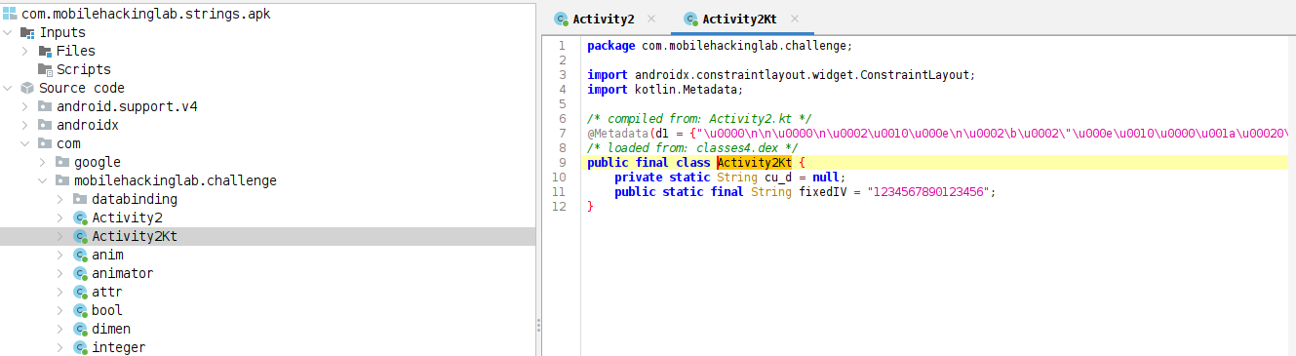

Decrypting the key with cyber chef

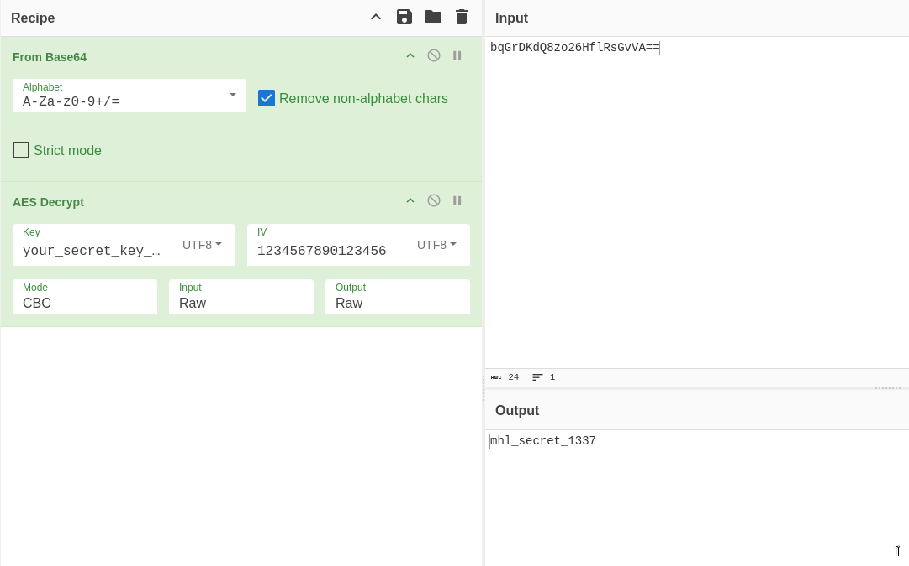
Now we will write frida script. To hook the methods and then interact with MainActivity and Activity2. And then scan memory to print the flag.

Here is the frida script code.

Java.perform(function () {

//---------------------------------------------HOOK MAIN ACTIVITY FUNCTIONS------------------
setTimeout(function () {

Java.choose("com.mobilehackinglab.challenge.MainActivity" , {
onMatch : function(instance){
console.log("Found instance: "+instance);
console.log("call KLOW func: " + instance.KLOW());
},
onComplete:function(){}

});
}, 1000);

//---------------------------------------------HOOK ACTIVITY2 FUNCTIONS------------------
setTimeout(function () {
Java.choose("com.mobilehackinglab.challenge.Activity2" , {
onMatch : function(instance){
console.log("Found instance: "+instance);
console.log("cd func: " + instance.cd());
console.log("native func: " + instance.getflag());
},
onComplete:function(){}

});
}, 5000);

//---------------------------------------------MEMORY SCAN FOR FLAG------------------
setTimeout(function () {
//find libflag.so from modules
const m = Process.getModuleByName("libflag.so")
console.log(JSON.stringify(m));
//console.log(hexdump(m.base,{length:m.size}));

// scan module memory for flag format
const pattern = '4d 48 4c 7b'; // MHL{

Memory.scan(m.base, m.size, pattern, {
onMatch(address, size) {
console.log('Memory.scan() found match at', address,
'with size', size);
},
onComplete() {
console.log('Memory.scan() complete');
}
});

const results = Memory.scanSync(m.base, m.size, pattern);// [{"address":"0x7025edb83fc0","size":4}]
console.log("Result:" + JSON.stringify(results));
const flag_addr = results[0].address;
console.log(hexdump(flag_addr,{length: 30}));
console.log("ASCII Flag: " + flag_addr.readCString());

}, 10000);

});

and this will be the intent command to interact with the app.
adb shell am start -a android.intent.action.VIEW -W -d "mhl://labs/bWhsX3NlY3JldF8xMzM3" -n com.mobilehackinglab.challenge/.Activity2

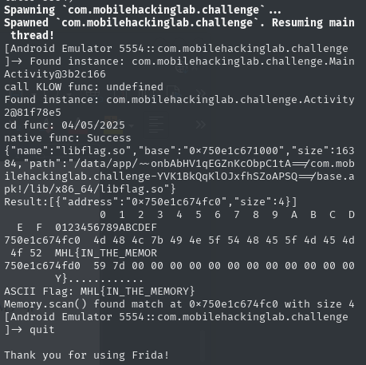

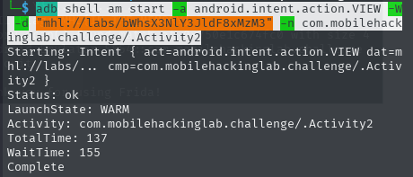

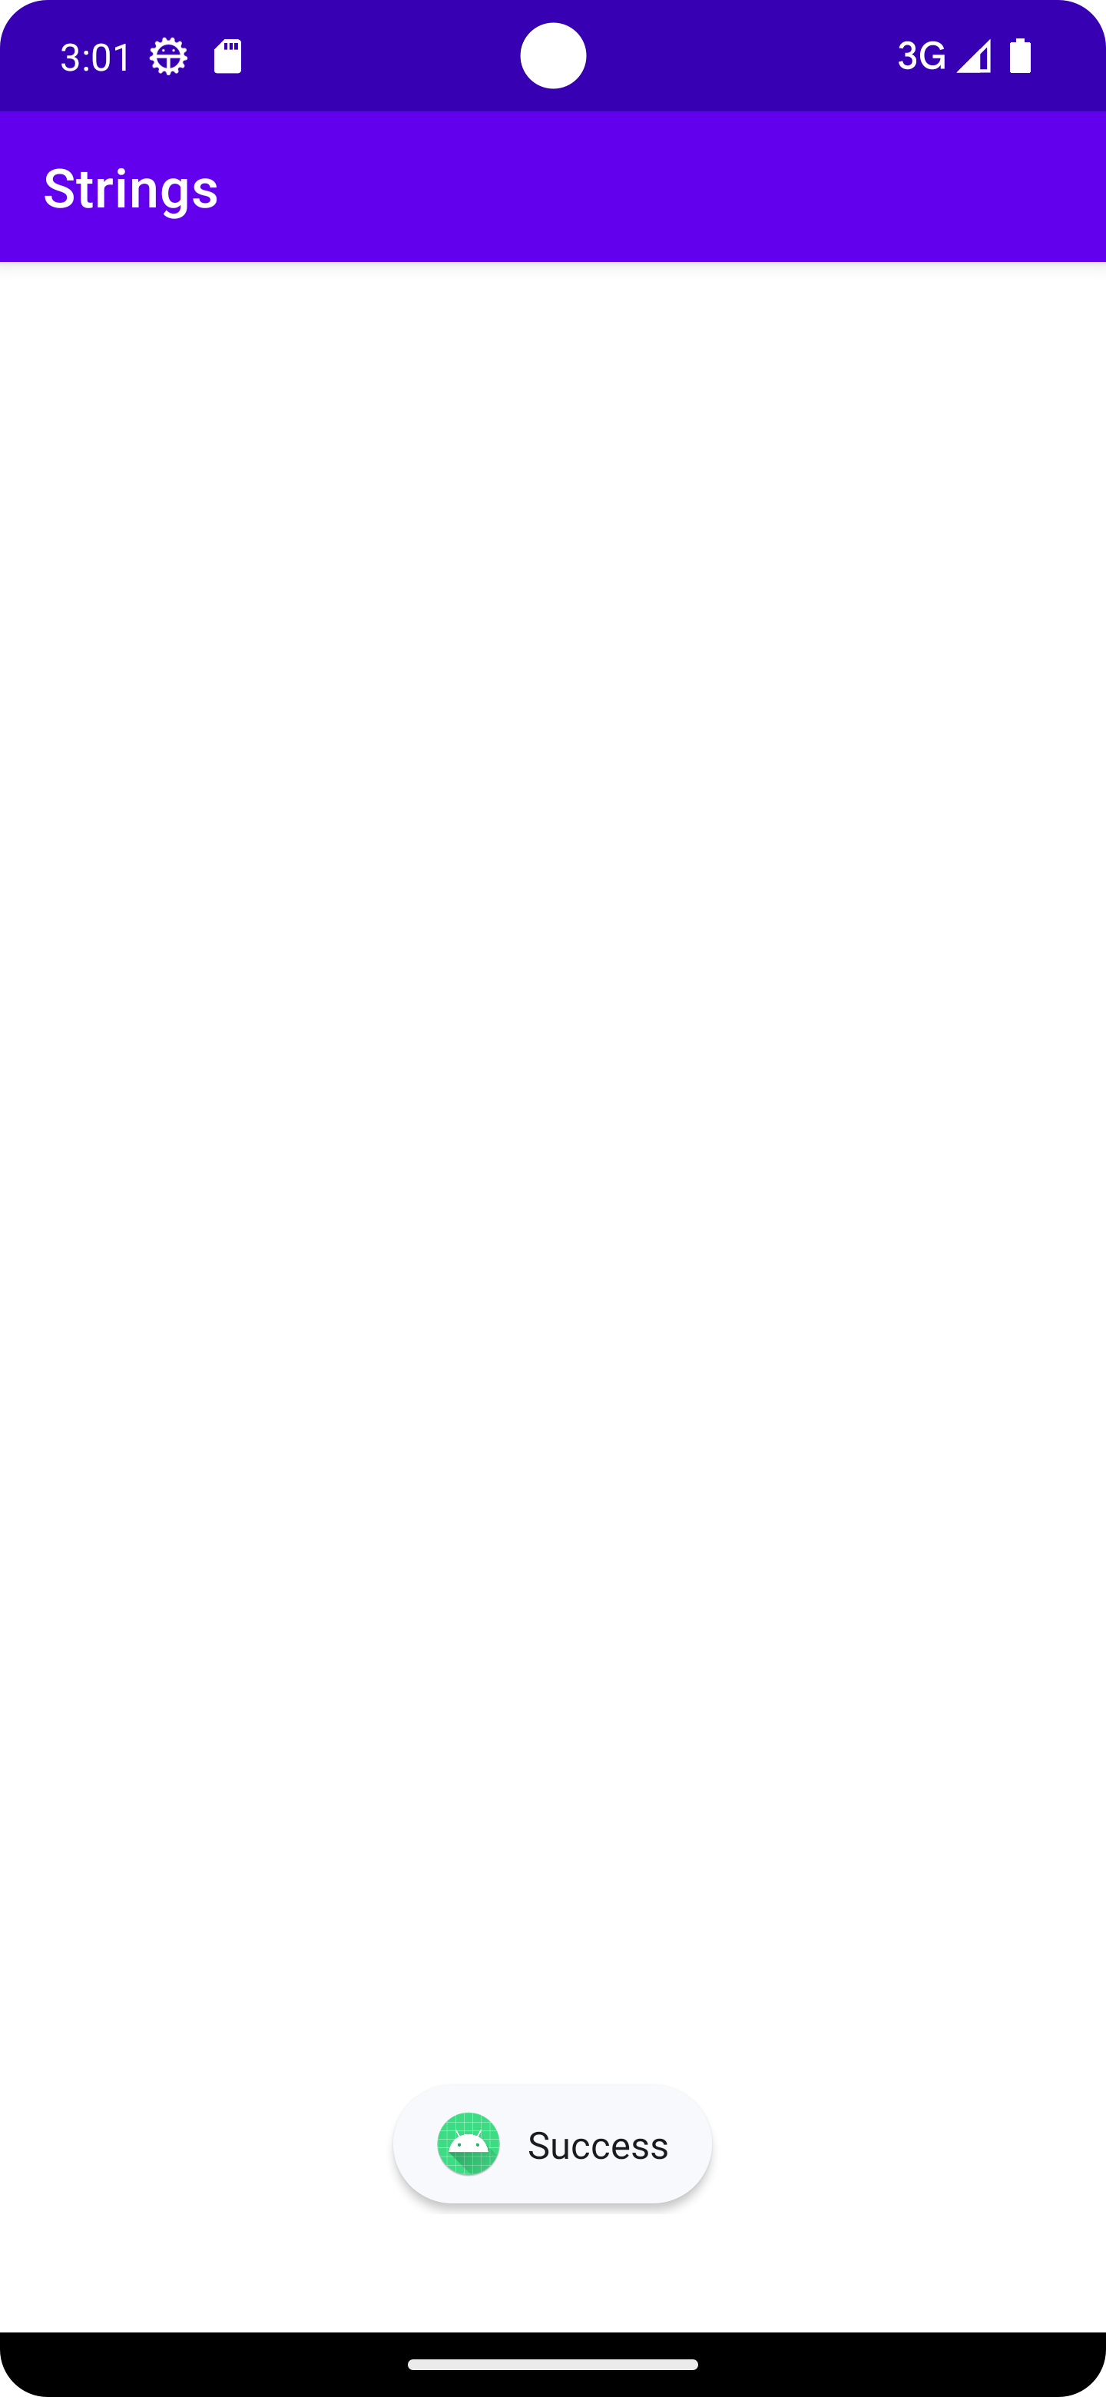

1- so we setup frida hooking with java.perform.
2-Hook MainActivity’s KLOW() Method.
3-Hook Activity2’s Methods cd() and getflag()
4-Memory Scan for Flag Pattern in Native Library (libflag.so)

Flag is printed as ASCII flag : MHL{IN_THE_MEMORY}

