NAME: MUHAMMAD SAAD BIN SHAFIQ

PROJECT NAME: CALCULATOR

CONTENT OF PROJECT REPORT:

- Objective
- Theory
- Implementation
- Debugging test-run

Objective:

The objective of our project is to implement a 16-bit calculator that would perform following arithmetic and trigonometric operations.

1-Addition
2-Subtraction
3-Multiplication
4-Divison
5-Square
6-Cube
7-Factorial
8-Power 9-Trigonometry.

Theory:

An electronic calculator is typically a portable electronic device used to perform calculations, ranging from basic arithmetic to complex mathematics. A calculator is a device that performs arithmetic operations on numbers. calculators can do only addition, subtraction, multiplication, and division which is basic.

In this project we have computed the assembly language code (8086) to do the basic functions, I have simulated the programmed in emulator software. This is a microprocessor emulator with an integrated 8086 Assembler. The emulator can run programs on a Virtual Machine, and emulate real hardware including screen, memory, and input and output devices. It helps you program in assembly language. The source code is compiled by assembler and then executed on Emulator step-by-step, allowing you to watch registers, flags and memory while your program runs.

The code we made acts like a 16 bits calculator that would perform arithmetic and trigonometric operations (Addition (+), Subtraction (-), Multiplication (*), Division (/), Square (^2), Cube (^3), Factorial (!), Power (^), Trigonometry (Sin, Cos, Tan)). This calculator can perform 16 bits arithmetic and trigonometric operations. As our calculator acts like a 16 bits calculator so it has a range from 0-65535. We can enter any number in this range. If we enter a number having range above it would hit an error.
In our calculator when we run, it displays a menu that asks us to enter a choice from (1-9).
If we enter 1, we will be able to perform addition operation.
If we enter 2, we will be able to perform multiplication operation.
If we enter 3, we will be able to perform subtraction operation.
If we enter 4, we will be able to perform division operation.
If we enter 5, we will be able to perform square operation.
If we enter 6, we will be able to perform cube operation.
If we enter 7, we will be able to perform factorial operation.
If we enter 8, we will be able to perform power operation.
If we enter 9, we will be able to perform trigonometric operation.

After selecting one of our choices, we will get to that operation, and it will ask the user to enter numbers. There are two numbers that must be entered.
It will ask the user to please enter the first number and then the second number after entering that we will get the result of that operation that we chose.

Addition operation:

If we enter 1, we will be able to perform addition operation. Then the compiler will ask to enter the first number after entering the first number it will ask the user to enter the second number after that we will simply get our result of addition.

Multiplication operation:

If we enter 2, we will be able to perform Multiplication operation. Then the compiler will ask to enter the first number after entering the first number it will ask the user to enter the second number after that we will simply get our result of multiplication.

Subtraction operation:

If we enter 3, we will be able to perform subtraction operation. Then the compiler will ask to enter the first number after entering the first number it will ask the user to enter the second number after that we will simply get our result of subtraction.

Division operation:

If we enter 4, we will be able to perform division operation. Then the compiler will ask to enter the first number after entering the first number it will ask the user to enter the second number after that we will simply get our result of division.

Square operation:

If we enter 5, we will be able to perform square operation. Then the compiler will ask to enter the number after entering that we will simply get our result of Square.

Cube operation:

If we enter 6, we will be able to perform cube operation. Then the compiler will ask to enter the number after entering that we will simply get our result of cube.

Factorial operation:

If we enter 7, we will be able to perform factorial operation. Then the compiler will ask to enter the number after entering that we will simply get our result of addition.

Power operation:

If we enter 8, we will be able to perform power operation. Then the compiler will ask to enter the power of base after entering the power of base it will ask to enter the base number after entering that we will simply get our result of power operation.

Trigonometric operation:

If we enter 9, menu will appear and there will be three choices.
1-Sin theta
2-Cos theta
3-Tan theta
If we enter 1, we will be able to perform sin theta, if we enter 2, we will be able to perform cos theta and similarly if we enter 3, we will be able to perform tan theta.

Sin theta:

After entering the choice, the compiler will ask the user to enter the value of perpendicular after entering the value of perpendicular it will ask the user to enter the value of hypotenuse after entering these values, we will get our answer of sin theta.

Cos theta:

After entering the choice, the compiler will ask the user to enter the value of base after entering the value of base it will ask the user to enter the value of hypotenuse after entering these values, we will get our answer of cos theta.

Tan theta:

After entering the choice, the compiler will ask the user to enter the value of perpendicular after entering the value of perpendicular it will ask the user to enter the value of base after entering these values, we will get our answer of tan theta.

FLOW CHART OF OUR CALCULATOR:

USER

FIRST NUMBER

SECOND NUMBER

Enter choice (1
-
9)

Result

Performing operation

First number (operator) second number

IMPLEMENTATION:

include emu8086.inc org 100h

.DATA

num1 dw ? num2 dw ? result dw ? temp dw ? perpendicular dw ? hypotenuse dw ? base dw ?

MAIN PROC

.CODE

jmp start

hey: db 0dh,0ah,0Dh,0Ah,0Dh,0Ah,0dh,"*********************** A SIMPLE CALCULATOR *********************** ",0Dh,0Ah,0Dh,0Ah,0Dh, '$'
Introduction1: db 0Dh,0Ah, "GROUP MEMBERS:",0Dh,0Ah,0Dh,0Ah, "MALIK
ABDUL HADI(200901053) ",0Dh,0Ah,"M.SAAD BIN SHAFIQ (200901079) "
,0Dh,0Ah,0Dh,0Ah,0Dh,0Ah,'$'
Introduction2: db 0Dh,0Ah,0Dh,0Ah, "WELCOME TO OUR CALCULATOR:
",0Dh,0Ah,0Dh,0Ah,'$' outlining: db "________________________ ",0Dh,0Ah,0Dh,0Ah,'$' Option1: db 0dh,0ah,"1 for Addition",0dh,0ah,"2 for Multiplication",0dh,0ah,"3 for Subtraction",0dh,0ah,"4 for Division", 0Dh,0Ah,"5 for taking Square",0Dh,0Ah,"6 for taking Cube",0Dh,0Ah,"7 for taking Factorial",0Dh,0Ah,"8 for taking Power of a number",0Dh,0Ah,"9 for Trigonometry ",0Dh,0Ah,'$'
choice1: db 0dh,0ah, "Please, enter your choice: ", 0Dh,0Ah, '$' choice2: db 0dh,0ah, "You have selected Addtion: ", 0Dh,0Ah, '$' choice3: db 0dh,0ah, "You have selected Multiplication: ", 0Dh,0Ah, '$' choice4: db 0dh,0ah, "You have selected Subtraction: ", 0Dh,0Ah, '$' choice5: db 0dh,0ah, "You have selected Division: ", 0Dh,0Ah, '$' choice6: db 0dh,0ah, "You have selected Square: ", 0Dh,0Ah, '$' choice7: db 0dh,0ah, "You have selected Cube: ", 0Dh,0Ah, '$' choice8: db 0dh,0ah, "You have selected Factorial: ", 0Dh,0Ah, '$' choice9: db 0dh,0ah, "You have selected Power of a number: ", 0Dh,0Ah, '$' choice10: db 0dh,0ah, "You have selected Trigonometry: ", 0Dh,0Ah, '$'
start:

mov ah,9 mov dx, offset hey
int 21h

mov ah,9
mov dx, offset Introduction1
int 21h

mov ah,9
mov dx, offset Introduction2
int 21h

mov ah,9
mov dx, offset outlining
int 21h

mov ah,9 mov dx, offset Option1
int 21h

mov ah,9 mov dx, offset choice1 int 21h
mov ah,0
int 16h

cmp al,31h je Addition

cmp al,32h je Multiplication

cmp al,33h
je Subtraction

cmp al,34h
je Division

cmp al,35h
je Square

cmp al,36h
je Cube

cmp al,37h
je Factorial

cmp al,38h
je Power

cmp al,39h je Trigonomtery

jmp start

Addition:

mov ah,9 mov dx, offset choice2
int 21h

print "Please enter the first number: "

call scan_num print 10 print 13 mov num1,cx
mov ax,num1

print "Please enter the second number: "

call scan_num print 10 print 13
mov num2,cx
mov bx,num2 add ax,bx
mov result,ax

print "So Addition of two numbers is: "

call print_num print 10 print 13 print 10 print 13

print "Thanks for using our calculator :)))"
ret hlt
Multiplication:

mov ah,9 mov dx, offset choice3
int 21h

print "Please enter the first number: "

call scan_num print 10 print 13 mov num1,cx
mov ax,num1

print "Please enter the second number: "

call scan_num
print 10 print 13
mov num2,cx mov bx,num2 mul bx mov result,bx

print "So Multiplication of two numbers is: "

call print_num print 10 print 13 print 10 print 13

print "Thanks for using our calculator :)))"
ret hlt

Subtraction:

mov ah,9 mov dx, offset choice4
int 21h

print "Please enter the first number: "

call scan_num print 10 print 13 mov num1,cx mov ax,num1

print "Please enter the second number: "

call scan_num print 10 print 13 mov num2,cx mov bx,num2 SUB ax,bx
mov result,ax

print "So Subtraction of two numbers is: "

call print_num print 10 print 13 print 10
print 13

print "Thanks for using our calculator :)))"
ret hlt
Division:

mov ah,9 mov dx, offset choice5
int 21h

print "Please enter the first number: "

call scan_num print 10 print 13 mov num1,cx
mov ax,num1

print "Please enter the second number: "

call scan_num print 10 print 13

mov num2,cx mov bx,num2 xor dx, dx div bx
mov result,bx

print "So Division of two numbers is: "

call print_num print 10 print 13 print 10 print 13

print "Thanks for using our calculator :)))"
ret hlt Square:

mov ah,9 mov dx, offset choice6
int 21h

print "Please enter the number: "

call scan_num print 10 print 13 mov num1,cx
mov ax,num1

mul ax

print "So Square of the number is: "

call print_num print 10 print 13 print 10 print 13

print "Thanks for using our calculator :)))" ret hlt
Cube:

mov ah,9 mov dx, offset choice7
int 21h

print "Please enter the number: "

call scan_num print 10 print 13
mov num1,cx
mov ax,num1
mov bx,ax
mul ax mul bx

print "So Cube of the number is: "

call print_num print 10 print 13 print 10 print 13

print "Thanks for using our calculator :)))"
ret hlt

Factorial: mov ah,9 mov dx, offset choice8
int 21h

print "Please enter the number: "

call scan_num print 10 print 13 mov num1,cx mov ax,num1 mov cx,ax
dec cx
l2: mul cx
loop l2

print "So Factorial of the number is: " call print_num print 10 print 13 print 10 print 13

print "Thanks for using our calculator :)))"
ret
hlt

Power:
mov ah,9 mov dx, offset choice9
int 21h

print "Please enter the Power of Base: "

call scan_num print 10 print 13 mov num1,cx
mov dx,num1

print "Now enter the Base: "

call scan_num print 10 print 13 mov num2,cx mov bx,num2 mov ax,1h mov cx,dx l3: mul bx loop l3

print "So Power of the number(base) is: "
call print_num print 10 print 13 print 10 print 13

print "Thanks for using our calculator :)))" ret hlt
Trigonomtery:

mov ah,9 mov dx, offset choice10 int 21h print 10 print 13 print 10 print 13 print "Menu :"
print 10 print 13 print "______" print 10 print 13 print 10 print 13 print "1- Sin theta" print 10 print 13 print 10 print 13 print "2- Cos theta" print 10 print 13 print 10 print 13 print "3- Tan theta" print 10 print 13 print 10 print 13

mov ah,9 mov dx, offset choice1 int 21h
mov ah,0 int 16h

cmp al,31h
je Sin

cmp al,32h
je Cos

cmp al,33h
je Tan

Sin:

print "You have selected Sin theta: " print 10 print 13 print 10 print 13
print " Sin theta = Perpendicular/hypotenuse " print 10 print 13 print 10 print 13
print "Please enter the value of Perpendicular: "
call scan_num mov perpendicular,cx mov ax,perpendicular print 10 print 13 print 10 print 13
print "Please enter the value of hypotenuse: "
call scan_num mov hypotenuse,cx mov bx,hypotenuse print 10 print 13 print 10 print 13 xor dx, dx div bx mov result,bx print "So the answer of Sin theta is : "
call print_num print 10 print 13 print 10 print 13
print "Thanks for using our calculator :)))"
ret
hlt

Cos:

print "You have selected Cos theta: " print 10 print 13 print 10 print 13
print " Cos theta = Base/hypotenuse "
print 10 print 13 print 10 print 13
print "Please enter the value of Base: " call scan_num
mov base,cx mov ax,base print 10 print 13 print 10 print 13
print "Please enter the value of hypotenuse: "
call scan_num mov hypotenuse,cx mov bx,hypotenuse print 10 print 13 print 10 print 13 xor dx, dx div bx mov result,bx print "So the answer of Cos theta is : "
call print_num print 10 print 13 print 10
print 13
print "Thanks for using our calculator :)))"
ret hlt

Tan:

print "You have selected Tan theta: " print 10 print 13 print 10 print 13
print " Tan theta = Perpendicular/Base " print 10 print 13 print 10 print 13
print "Please enter the value of Perpendicular: "
call scan_num mov perpendicular,cx mov ax,perpendicular print 10 print 13 print 10 print 13
print "Please enter the value of Base: "
call scan_num mov base,cx mov bx,base print 10 print 13 print 10 print 13 xor dx, dx div bx mov result,bx print "So the answer of Tan theta is : "
call print_num print 10 print 13 print 10
print 13
print "Thanks for using our calculator :)))"
ret hlt

DEFINE_SCAN_NUM
DEFINE_PRINT_NUM
DEFINE_PRINT_NUM_UNS

ENDP
END MAIN

Debugging test-run:
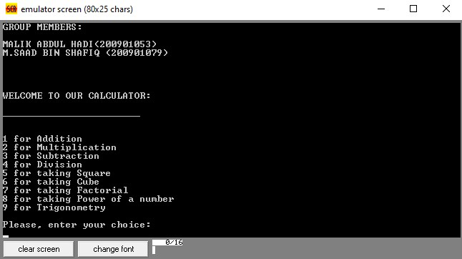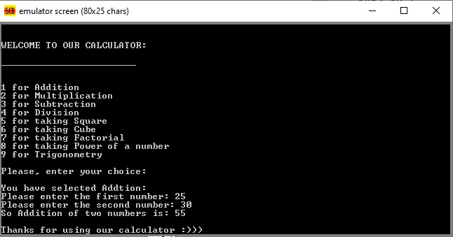

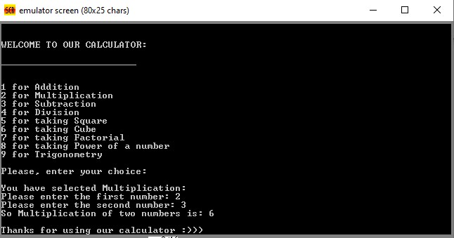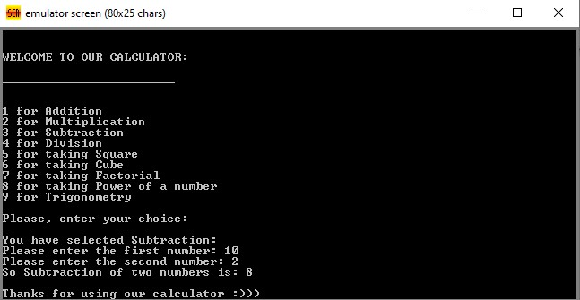
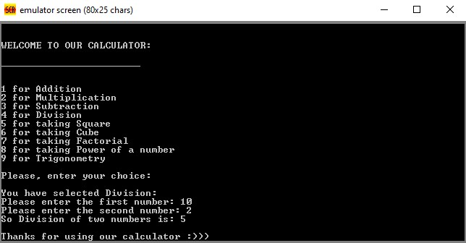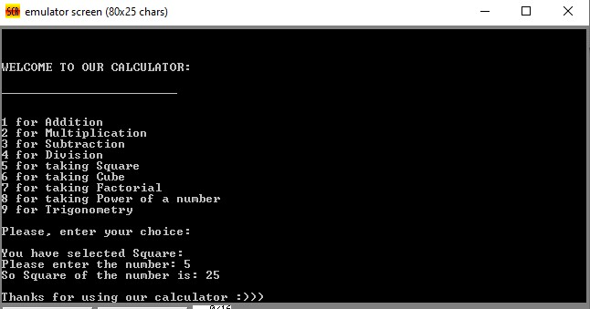
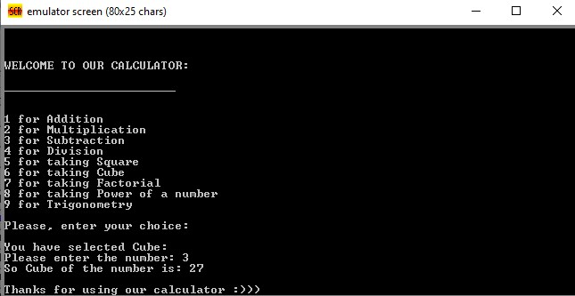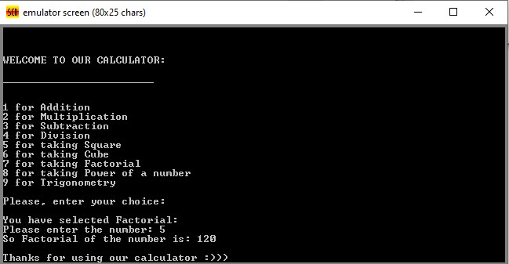

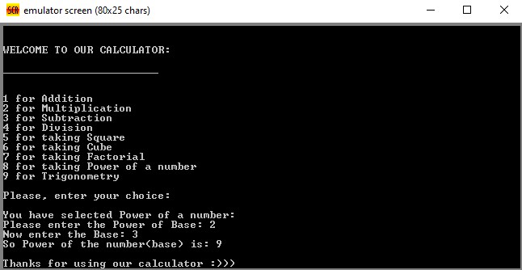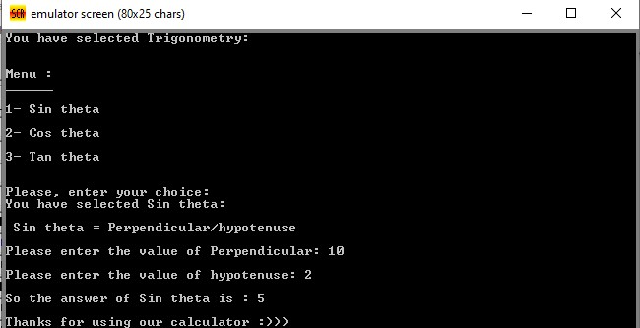

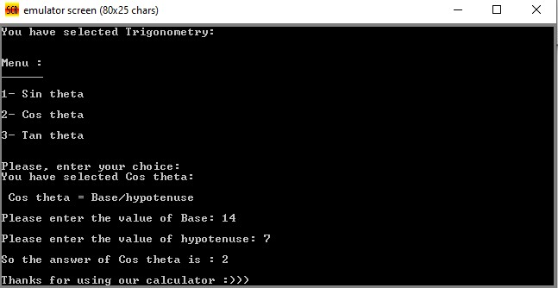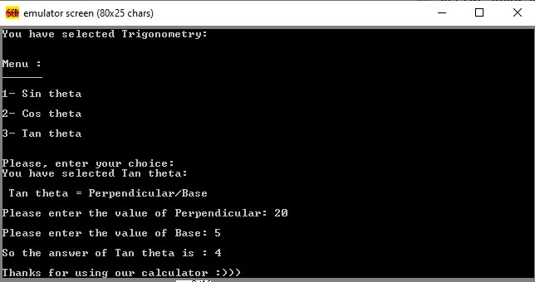

END

