**Name:** M. Saad Bin Shafiq

**Project Title:** Library Management System

**Abstract:**

Every system needs management to operate normally. So does a Library for it smooth work flow in this new era of technology. To keep its data intact and accessible, this program has been made. Just think because of data mishap, how many book from the library can be lost and the data of the user if he is a member of library or not. The Admin can easily track record of the user and of the books that has been issued or are there in the library just by one click

Thus, we applied the knowledge of Python OOP, Data Structure gained in class to make a program that covers up such problems in a library.

**Introduction:**

The Project is designed to keep track of two main Bodies Admin and User of a Library. This Project keep track of all the book in the library which book is issued or return and it also keep track of all the user or members of the library. Admin can insert new books if a new book is added in the library or delete if a certain book is available or lost. User can request the admin to issued them a book and check if the book is issued to them or not and also can return the book that they issued from the admin. Each User will have it own user ID

**Objectives:**

1. The main object of the library management system is to manage details of members, issues, books, student.
2. Library Management system helps in maintaining data of books issued to learners.
3. Library Management system helps in maintaining data of books available in the library.
4. This helps librarians spot any particular book at any given time in the library.
5. It helps in keeping track of the books, catalogues, magazines, etc.
6. This system increases the efficiency of the librarian and better management of the library.
7. This system completely automates all your library’s activities.
8. Easy search of the desired book from the library.

**Implementation:**

1. The Implementation of this program can be accomplished by designing an algorithm that allow the user to add, remove, view, assign, return a book to the member of the library using the Doubly link list and for some feature we will use Stack, Queue and File Handling.
2. Moreover, we will be creating a login system to verify if the user is a member of the library or not and this will be implemented by using the file handling

**Methodology/ Plan development to solve the Problem:**

We are using the Double Link List as we have to insert, delete and search the Book, so the DLL will provide us more efficiency than other data structure. It is easier to perform functions like inserting and deleting through linked lists because we have constant time complexity of big o (1) for such functions in linked lists.We are going to use the following function to create our project.

# Login

At login menu we will be asked to choose if we are an Admin or we are a user. If we choose admin the we will be taken to admin login check to verify if we are admin or not and it will be checked by entering the user name and the password and the same is true for user. If we are a use then we will be asked to enter our login info so we can perform the user specific functions.

# • Admin Login Check

If we choose that we are admin the we will be asked to Enter the user name and the password if it the entered user name and password is true then we will be asked to choose a function we want to perform e.g Add Book.

o If Admin:

# Þ Add Book

Using the function Insertnewbook we add node as a book in the DLL and at the same time that node is added in a file name Book.py to keep record of the books.

# Þ Del Book

Using the function Deletebook we delete the node in the DLL and also from the file named Book.py

# Þ Issue Book

In Issue Book Function First we will check the request of the user who want to issue the book the first person that requested will be issued the book first and after that every other in a queue will be severed. After taking the request we will issued the book to the user and del the book from the files and add it in a dictionary to keep record of book issued.

# Þ View Books

In View Book Function we will traverse the whole DLL and check each node (node are books) if the book user looking for is a node of DLL then we will return that the book is available in the Library. Þ **View Record of Issued Books**

View Record of the Issued function will give us a list of the book that has been issued to the users and currently not available in the library.

# • User Login Check

This Function will check the user if the user is the member of the library by check it user id , user name and password if it is true then the user can have access to the library and we will able to perform the specific functions e.g Request for issue Book.

o If User:

# Þ Request For Issue Book

In this function the user will be able to request for a book and will wait for his/her turn. If the user is the first in the queue then he/she we will issued the book first.

# Þ Return Book

The return book function is used for returning the book by the user. The user can easily return the book to the library. à **Reissue:**

The Book user recently return if he/she wants to reissue it the user can easily use this function.

# Þ View Book

In View Book Function we will traverse the whole DLL and check each node (node are books) if the book user looking for is a node of DLL then we will return that the book is available in the Library.

Þ **View if Book is Issued or not**

This function is used by the user to check is the admin issued him/her the book or not.

# • Register Your-Self

If the User is not register they cannot login in to issue a book so before login we have a function for those user who are not register but want to be a member of the library then they can register their self easily.

**Output:**

The Output is from the python IDE Spyder we build our project on this IDE and run it as the given ouput shown and we have shown a little interface and functionality of out program.

**The Main Menu**

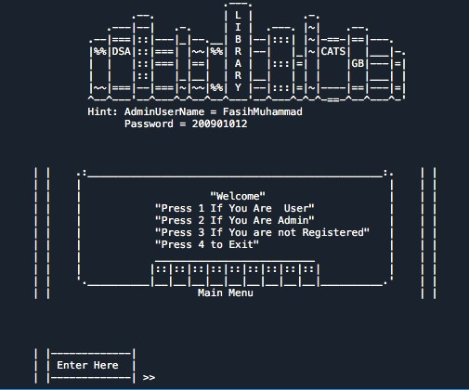

# If we choose 2 from Main Menu If we choose 1 from main menu

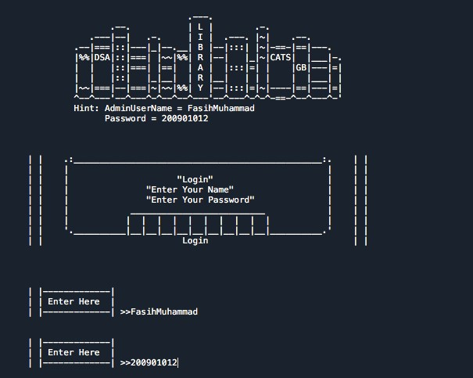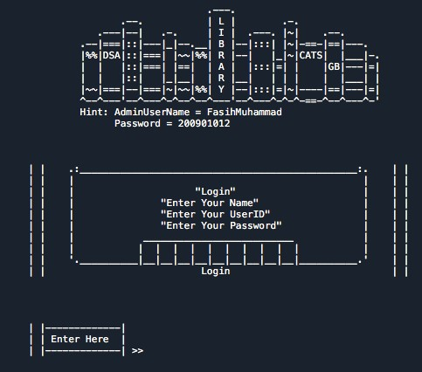

**Function we can perform as an Admin**

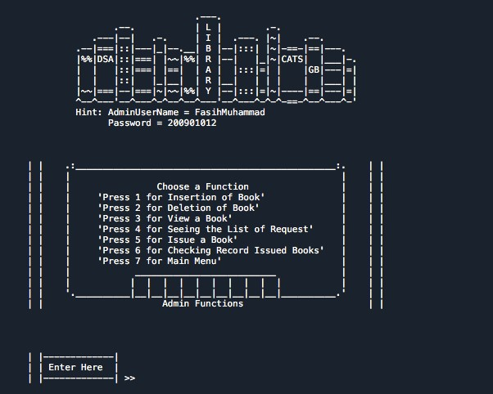

**Function you can perform as a User**

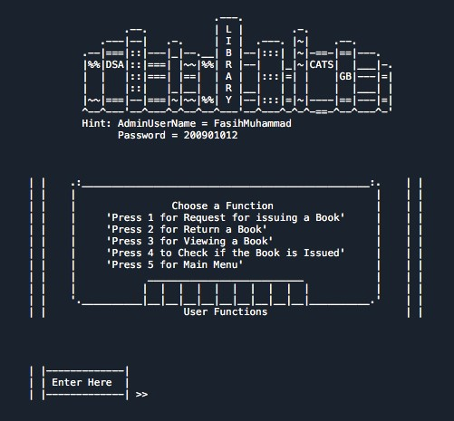

**Exit**

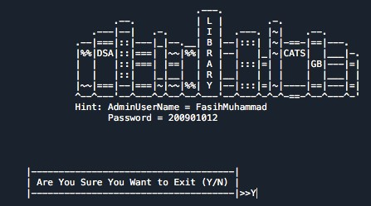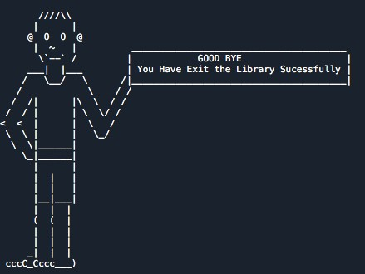

**Specifications:**

1. Doubly Link List is used for the insertion and Deletion and for traversal of the Books in Library.
2. File Handling is used for keeping the record of Books and User Data.
3. Each Module has specific set of function that are linked together as per Requirement.
4. To keep the program running util the user wants to exit, while loops are used.
5. Create different Ascii logo and arts to give our code a little user interface.
6. With DLL we also use Queue and Stack in the Code.
7. Classes, Break Statements, If-Else, Functions, Loops, Nested Loops, File Handling, Modules these concepts also have been demonstrated in the Code.

**Conclusion:**

This project is computerizing the work in a library, it is more convenient than the manual system. The computerization makes the managing process fast, safe and reliable. The program is thoroughly checked by entering dummy data, it worked as per the requirement, performing all functions. The program is great for a small, normal libraries. In future it can have more features like requesting more than one book, Ask for delivering a certain book at home or we can also add that if the user did not return the book till a certain date he\she will be fined and we can also add features like auto issued the book to the user etc.