**PROJECT: NUMBER SYSTEM CONVERSION**

**INTRODUCTION:**

* The Number System Conversion Project in C is a consoled based application and created using c programming language.
* This project is compiled in Code::Blocks IDE using GCC compiler.
* This Project is used for Number System Conversion, the user can effectively change over any number framework such as: binary to decimal, binary to octal, binary to hexadecimal. Decimal to binary, Decimal to octal and Decimal to hexadecimal.
* The user must select numbers and after that enter the number agreeing to their change.
* This extend has made the number framework transformation quick and simple for the user.
* This project is easy to operate and understandable to the users.

**FEATURES OF THE PROJECT:**

* The programming of number conversion is to convert numbers in different systems have been embed in the code of this project.
* You have the main menu to choose your own choice of conversion.(Number System Conversion)
* If you have nothing to do with the program, you can directly exit from the main menu.
* System CLS function is used to clear the screen and get you to other option when you entered something from main menu.
* This number system conversion is quick and efficient and if you entered the wrong number it will get you back to main menu again.

**SCREEN SHOT OF FEATURES OF PROJECT:**

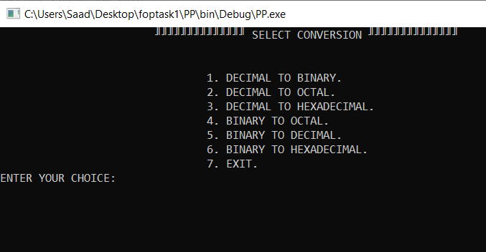

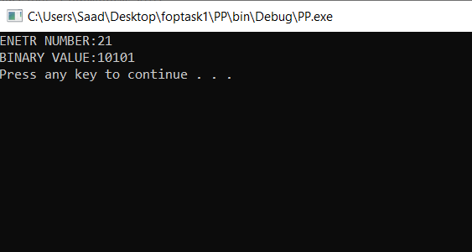

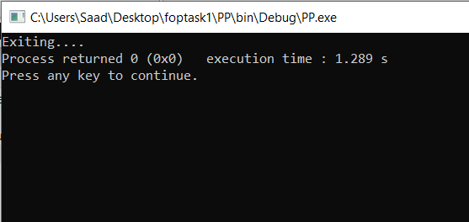

**FLOWCHART:**

