HireIQ
QA TEST PLAN
End-to-End Acceptance Testing — v1.10.0

 | Field | Value
 | Document Version | v1.1
 | Product Version | v1.10.0 (Analytics v1)
 | Test Date | ______________
 | Tester Name | ______________
 | Environment | Local Dev
 | Total Test Cases | 85 (was 78 in v1.0)

What is new in v1.1
Added Module 11: Analytics Page (7 new test cases) covering KPI cards, funnel chart, time-at-stage chart, source performance table, period filter, and job filter behaviour.

Pre-Test Setup

Required Before Starting Tests
- All 5 backend services running: postgres, core-api (3001), ai-engine (3002), whatsapp (3003), scheduler (3004)
- Frontend running on http://localhost:3000
- WhatsApp mock accessible at http://localhost:3003/mock
- Database has seeded data: 6 talent pool candidates + 10 Cloud Architect pipeline candidates
- Browser: Chrome or Edge, latest version
- Hard refresh (Cmd+Shift+R) before each module to avoid cached state

Quick Verification Commands
- curl -s http://localhost:3001/health → expect status: ok
- curl -s http://localhost:3002/health → expect status: ok
- curl -s http://localhost:3003/health → expect status: ok
- cd ~/hireiq && git log --oneline -3 → expect to see v1.10.0 commits

Test Summary by Module

# | Module | Cases | Priority | Time
1 | Login & Dashboard Overview | 6 | Critical | 5 min
2 | Job Creation Wizard | 8 | Critical | 10 min
3 | CV Inbox — Upload & Score | 10 | Critical | 15 min
4 | Talent Pool — Re-scoring | 8 | High | 10 min
5 | Drawer Consistency (3 Contexts) | 9 | High | 15 min
6 | Pipeline & Funnel Visualization | 7 | High | 10 min
7 | WhatsApp Screening Simulation | 8 | Critical | 15 min
8 | AI Recommendation & Approval Flow | 10 | Critical | 20 min
9 | Dashboard Real-Time Refresh | 6 | Critical | 10 min
10 | Edge Cases & Error Handling | 6 | Medium | 10 min
11 | Analytics Page — KPIs, Funnel, Sources [NEW] | 7 | High | 12 min

Total estimated time: ~2 hours for full test pass

MODULE 1
Login & Dashboard Overview
Verify entry point and dashboard KPIs render correctly

Objective: Confirm user can access HireIQ and Dashboard displays correct KPIs in two-row layout.

# | Step | Action | Expected Result | Pass/Fail | Notes
1.1 | Navigate | Open http://localhost:3000 in browser | Page loads. No 404 or error. Sidebar visible on left. | Partial | Icon in tab also shows logo  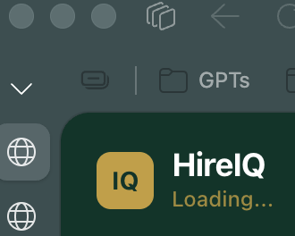  Left side under HireIQ it shows Loading even after waiting for long time  
1.2 | Sidebar Check | Verify sidebar shows: Dashboard, Jobs, CV Inbox, Talent Pool, Analytics, Settings | All 6 navigation items visible. Active item highlighted in gold. | Pass
1.3 | Click Dashboard | Click Dashboard from sidebar | URL changes to /dashboard. KPI cards render in 2 rows. | Pass
1.4 | Row 1 KPIs | Verify Row 1 (Action Items) shows: Awaiting Review, In Screening, Shortlisted, Interviewing | All 4 KPI cards visible. Numbers shown. | Pass
1.5 | Row 2 KPIs | Verify Row 2 (Performance) shows: CVs Processed, Conversion Rate, WhatsApp Response Rate, Talent Pool Size | All 4 KPI cards visible. Numbers shown. | Pass
1.6 | Recent Activity | Scroll to Recent Activity feed. Verify at least one entry | Feed shows recent actions with timestamp and candidate name. | Pass

MODULE 2
Job Creation Wizard
Verify 4-step job creation workflow

# | Step | Action | Expected Result | Pass/Fail | Notes
2.1 | Open Jobs | Click Jobs in sidebar | URL: /jobs. List of existing jobs displayed. | Pass
2.2 | New Job | Click "+ New Job" button | Wizard opens. Step 1 of 4 visible. | Pass
2.3 | Step 1 | Fill: Title=QA Test Role, Company=Test Corp, Country=UAE, Currency=AED, Salary 20000-35000 | All fields accept input. Next enabled. | Partial | Country: It shows UK and Ksa which was in original design. It need to be removed.  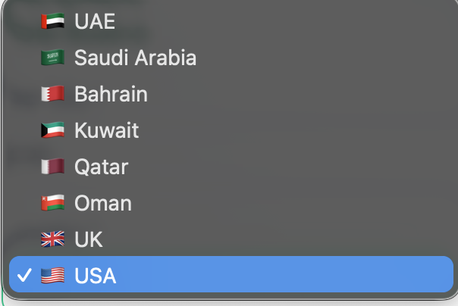
2.4 | Step 2 — JD | Click Next → "Paste Existing JD" → paste 3 paragraphs | Step 2 of 4 displayed. Text area accepts paste. | Partial | By default.. Paste JD should appear and AI Builder come on right side so that If someone wants to use he can click on it.  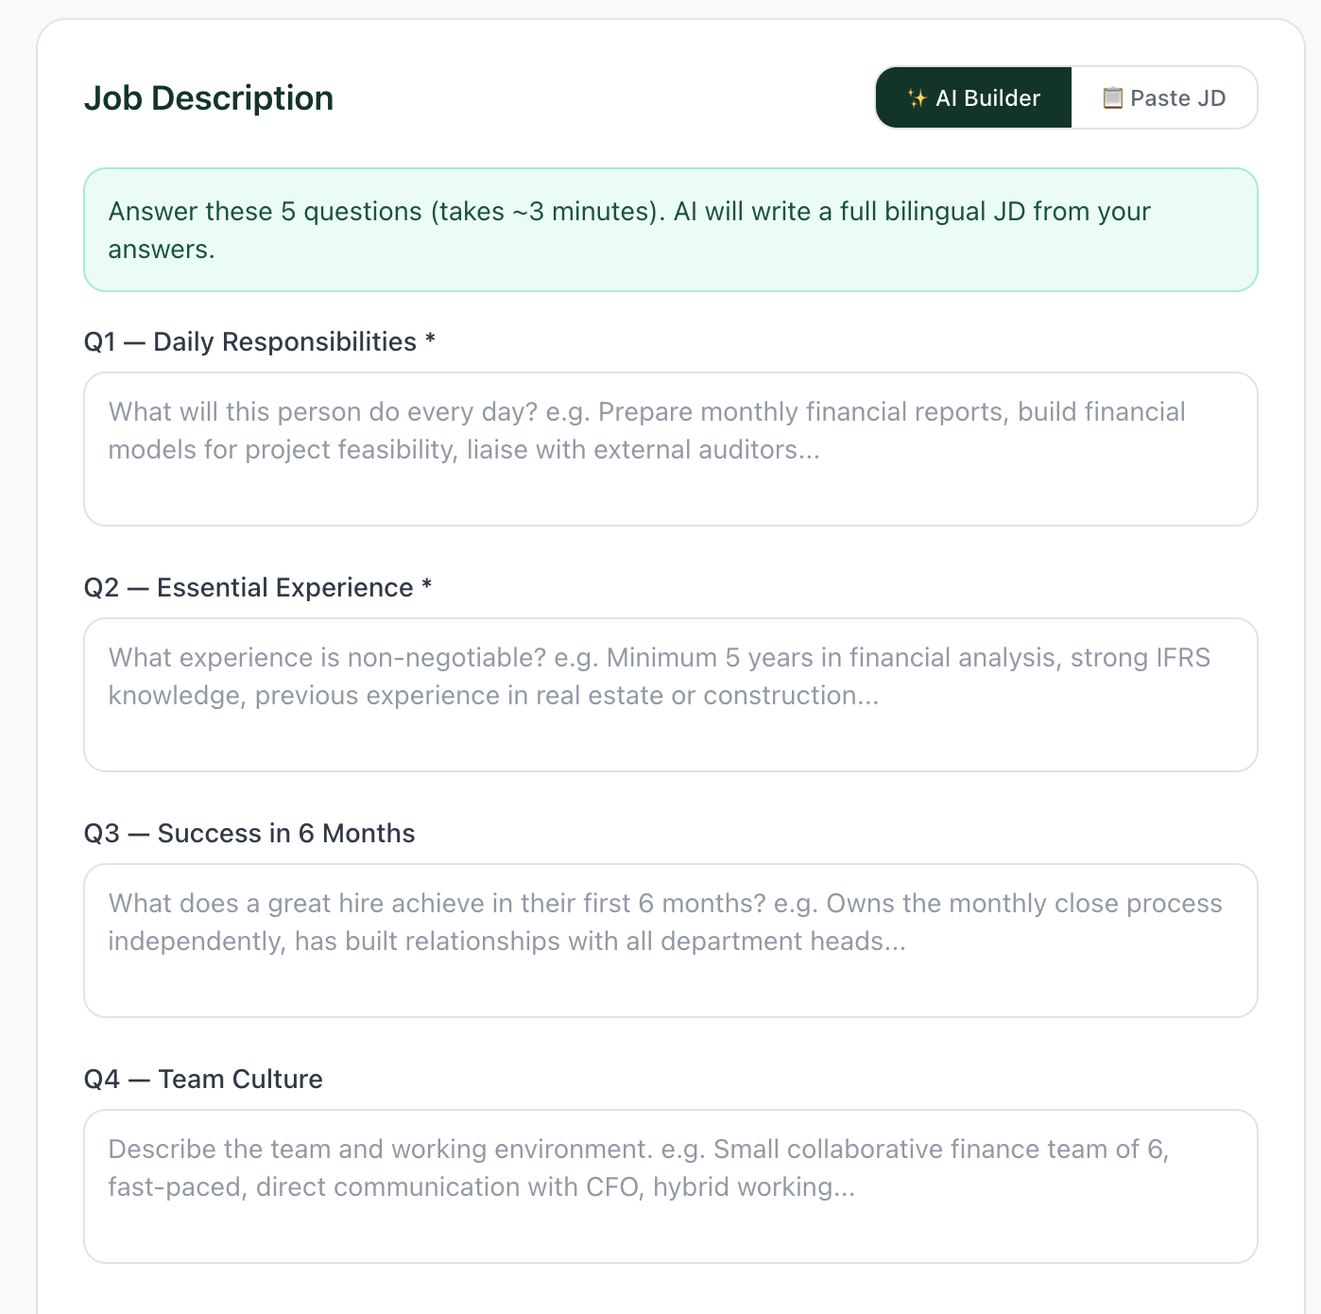
2.5 | Step 3 | Add Must-Have: AWS, Docker. Add Nice-to-Have: Python. | Step 3 of 4. Tags added as chips. | Partial | Auto-approve – WhatsApp immediately. Word immediately is slightly misleading as recruiter can still approve or reject like for others. We can color code it but let recruiter to decide …. Am I correct or its not right?  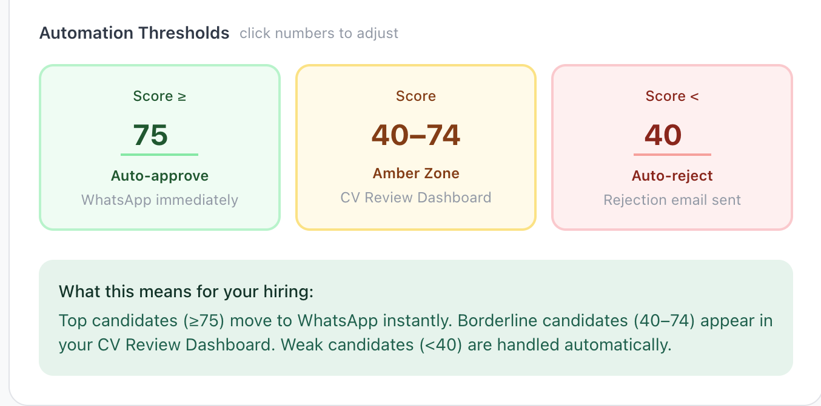
2.6 | Step 4 — Questions | Click Next. Toggle "Show Arabic version". | 5 questions in English. Arabic shown when toggled. | Pass | Can we give an option to recruiter to add custom questions
2.7 | Activate | Click "Create & Activate Job" | Toast: success. Redirects to job pipeline page. | Pass
2.8 | Pipeline | Confirm new job pipeline shows empty Applied with funnel summary | Funnel: 0/0/0/0/0. Kanban columns visible. | Pass

MODULE 3
CV Inbox — Upload & Score
Verify CV upload, AI parsing, and scoring workflow

# | Step | Action | Expected Result | Pass/Fail | Notes
3.1 | Open CV Inbox | Click CV Inbox in sidebar | URL: /cv-inbox. Upload area + Pending Review table visible. | Pass
3.2 | Source Selector | Verify dropdown lists: LinkedIn, Bayt, Naukri, Agency, Other | All 5 source options present. | Pass
3.3 | Job Selector | Verify "Target Job" dropdown lists active jobs | Dropdown populated (deduplicated). | Pass
3.4 | Select Source & Job | Source=LinkedIn, Job=Cloud Architect. Tick PDPL consent. | Both selected. Consent checked. | Pass
3.5 | Upload CV | Drag-drop a PDF CV | Upload starts. Banner: "AI parsing..." then "Complete". | Pass
3.6 | Verify Parsing | Wait 10-15s. Verify candidate appears newest first | Row visible with parsed name, role, experience, score chip. | Pass
3.7 | CV Screening Score | Verify score chip shows realistic value (60-95) | Score visible. Color: green ≥75, amber 55-74, red <55. | Pass
3.8 | Click Candidate | Click candidate row | Drawer slides in. Gold "Match for: [Job]" card visible. | Pass
3.9 | Drawer Content | Verify: gold score card, source pill, must-have skills ✓/✗, hard filter, work exp, education, certs | All sections render with data. | Pass | With email adress can we have a placeholder for whatsapp number.
3.10 | Action Buttons | Verify 4 buttons: "✅ Approve to L1", "+ Add to Pool", "✗ Reject", "↓ Download CV" | All buttons present. | Partial | Download CV is not there

MODULE 4
Talent Pool — Re-scoring
Verify re-scoring works for ALL jobs

# | Step | Action | Expected Result | Pass/Fail | Notes
4.1 | Open Talent Pool | Click Talent Pool in sidebar | URL: /talent-pool. Source breakdown visible. | Pass
4.2 | Initial State | Verify table shows accepted candidates with stored scores | Table populated. Scores shown. | Pass
4.3 | Job Dropdown | Click "Match candidates to job" dropdown | Active jobs listed (no duplicates). | Fail | 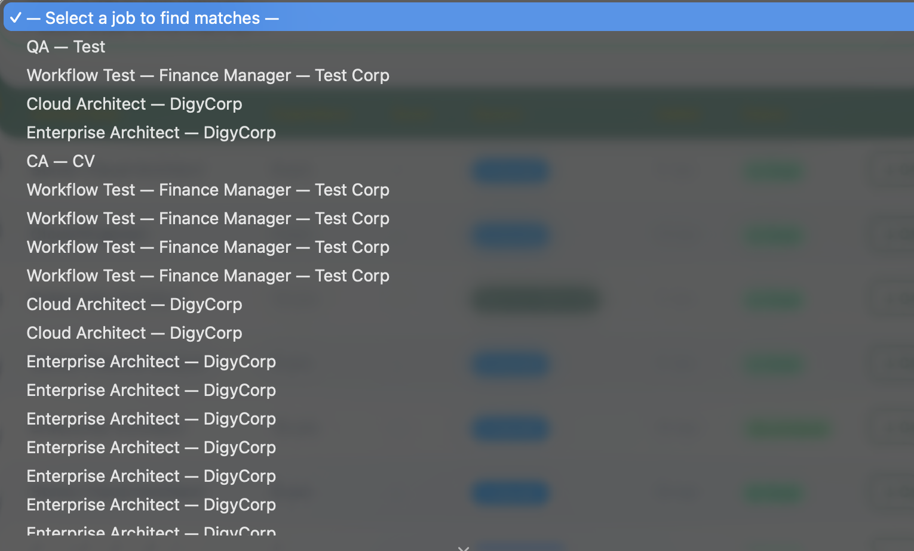
4.4 | Cloud Architect | Choose "Cloud Architect — DigyCorp" | Table re-renders with fresh scores for this job. | Partial | Filter is not working correctly. I click on the job I created during QA test and it shows Enterprise Architect and Cloud DevOps Engineer roles which are not relevant. Some are fine and some are not
4.5 | Enterprise Architect | Change to "Enterprise Architect — DigyCorp" | Table re-renders with different rankings. UUID fix verified. | Partial | Enterprise Architect works fine but resources are duplicated  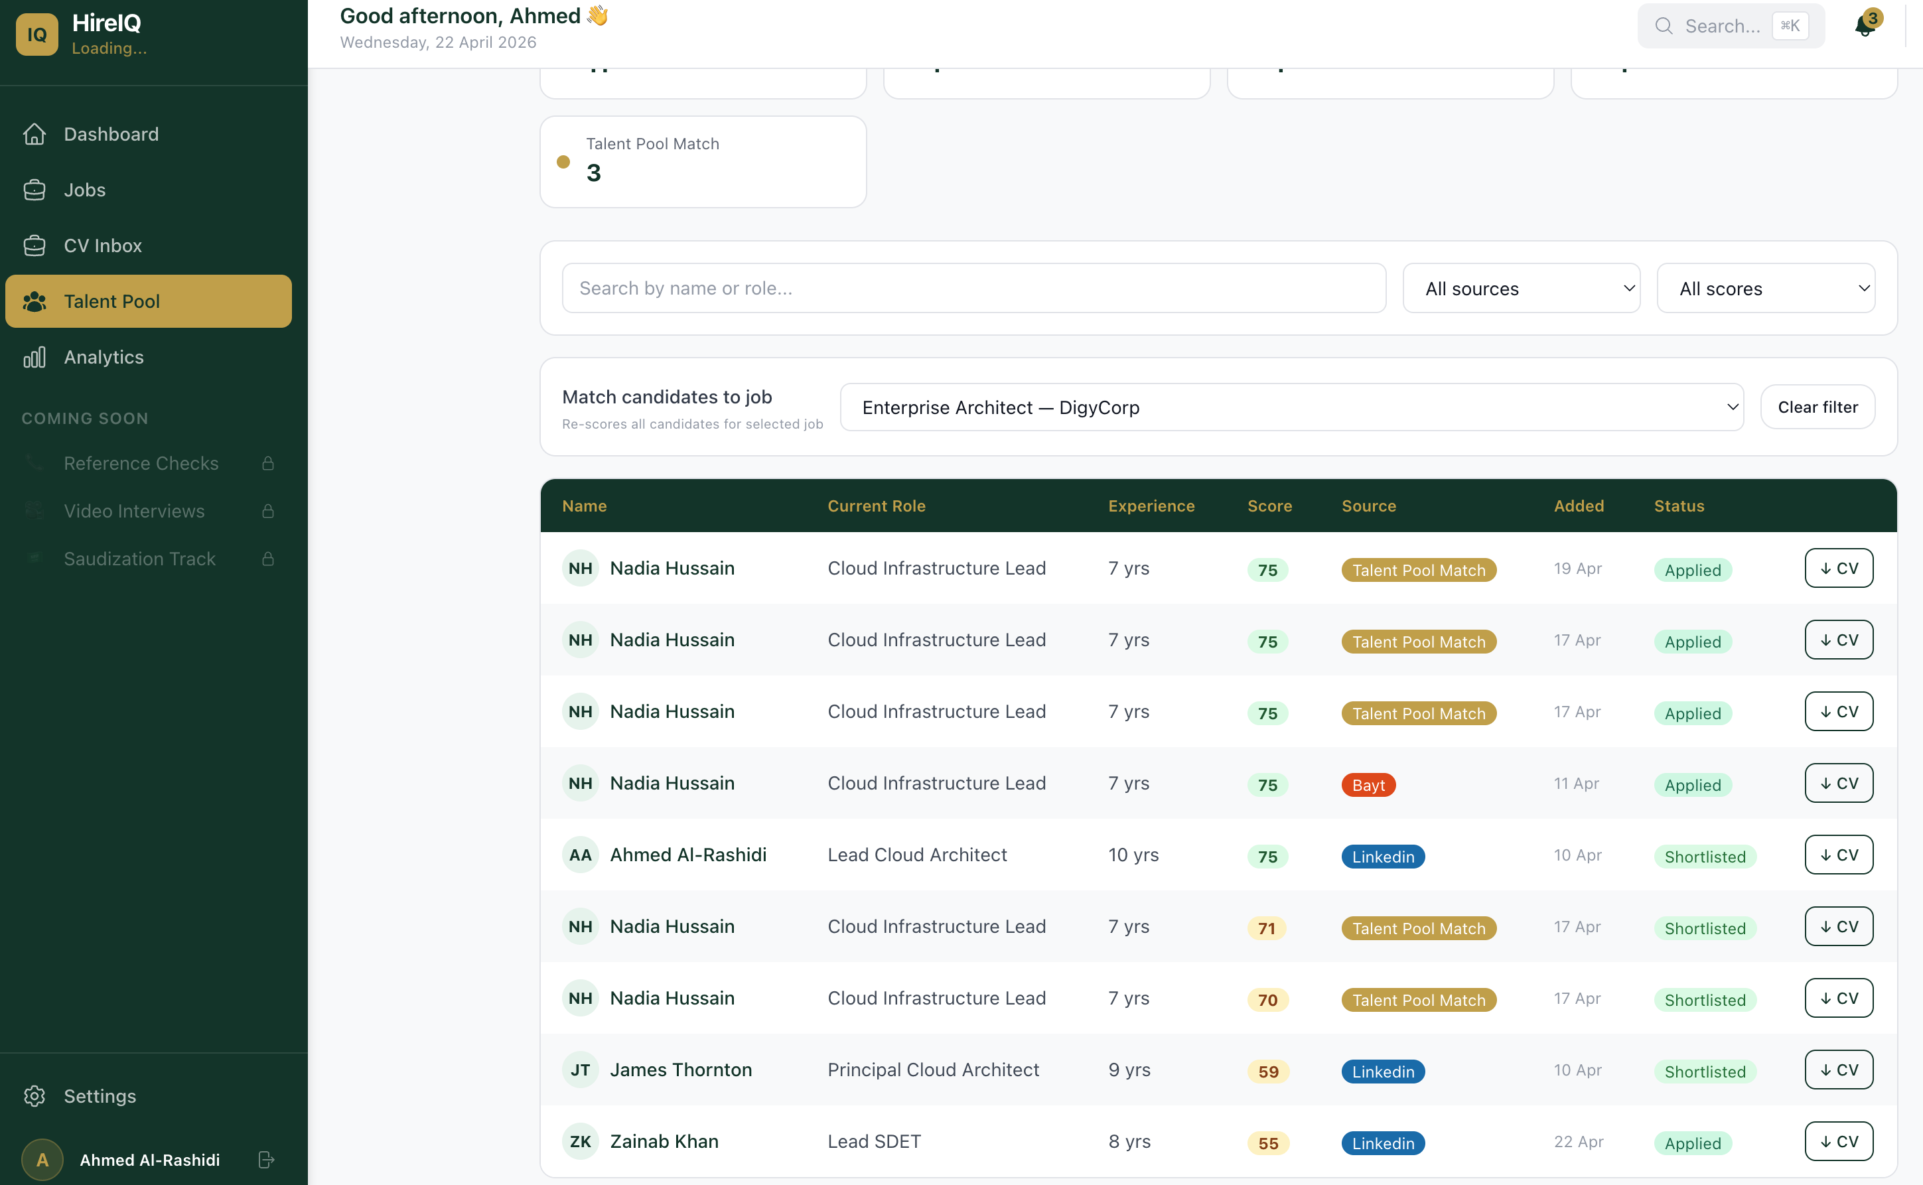
4.6 | Click Candidate | Click any candidate name | Drawer opens. Header: "Match for: Enterprise Architect". | Pass
4.7 | Drawer Score | Verify drawer shows ONLY current CV Screening Score (not historic composite) | Big score number. No old breakdown. | Pass
4.8 | Job History | Scroll drawer. Verify "Job History" section visible (TP context only) | Section renders with at least one entry. | Fail | I can see only Applied Jobs with no history  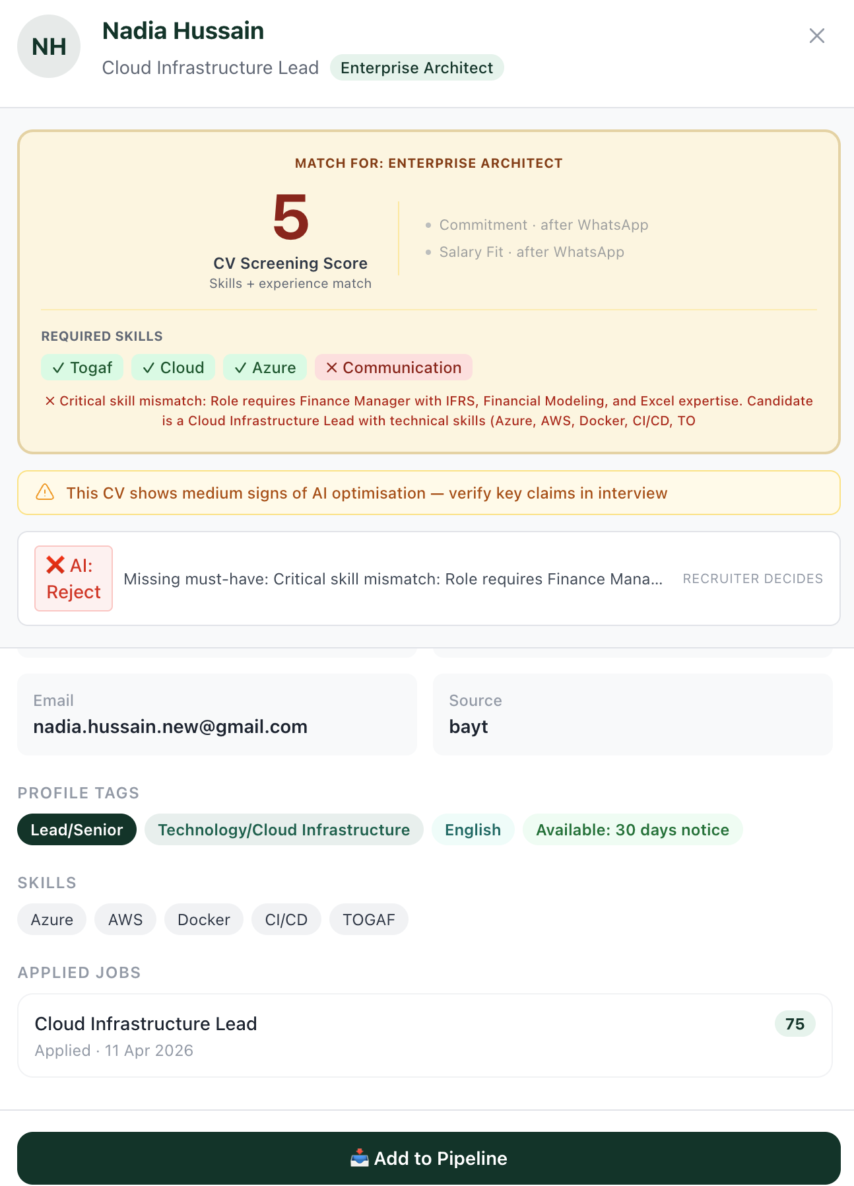

MODULE 5
Drawer Consistency Across 3 Contexts
Verify unified drawer per context

# | Step | Action | Expected Result | Pass/Fail | Notes
5.1 | TP Drawer Open | From /talent-pool with job selected, click candidate | Drawer opens with gold card + job-match pill | Pass
5.2 | TP Primary Button | Verify primary is "📥 Add to Pipeline" | Correct button text and icon | Pass
5.3 | TP Job History | Verify Job History block visible (TP only) | Section renders. | Fail
5.4 | CV Inbox Drawer | Navigate to /cv-inbox, click candidate | Drawer opens with gold card + source pill | Pass
5.5 | CV Inbox Primary | Verify primary is "✅ Approve to L1" | Correct button text | Pass
5.6 | CV Inbox Confirm Modal | Click Approve. Verify modal with cost warning | Modal mentions WhatsApp screening + cost | Pass | But we don’t want to show the API cost to customer. We can have warning but don’t mention the cost for API calls
5.7 | Pipeline Drawer | Click candidate in Applied column | Drawer with gold card + stage badge "Applied" | Pass
5.8 | Pipeline Tabs | Verify tabs at bottom: Summary / WhatsApp Chat / CV | 3 tabs render. Pipeline-only. | Pass
5.9 | Pipeline Approve | Verify primary is "Approve to L1" | Correct button text | Pass

MODULE 6
Pipeline & Funnel Visualization
Verify funnel + kanban work correctly

# | Step | Action | Expected Result | Pass/Fail | Notes
6.1 | Open Pipeline | Click any active job → Pipeline | Funnel summary visible above kanban. | Pass
6.2 | Funnel Cards | Verify 5 cards: Applied / L1 / L2 / L3 / Final Shortlist | All 5 cards visible with counts. | Pass
6.3 | Conversion Rate | Verify conversion rate badge top-right | Percentage shown. | Pass
6.4 | Drop-off | Verify drop-off arrows between cards | Arrows with percentages. | Pass
6.5 | Kanban | Verify 5 columns render with candidate cards | All columns populated. | Pass
6.6 | Card Badge | Verify each card shows AI badge (✅/⚠️/⏳/❌) | Badges visible per stage. | Pass
6.7 | Drag | Try dragging candidate Applied → L1 | Drag works. Stage updates. Funnel updates. | Pass

MODULE 7
WhatsApp Screening Simulation
Verify mock WhatsApp screening completes

# | Step | Action | Expected Result | Pass/Fail | Notes
7.1 | Pre-condition | From Talent Pool, add Omar Al-Mansoori to Cloud Architect | Toast confirms. Omar in Applied. | Pass
7.2 | Approve to L1 | Open Omar in Pipeline drawer. Click "Approve to L1". Confirm modal. | Stage changes. Card shows 🔄 Screening. | Fail | L1 shows ‘Pending Interview Invite’  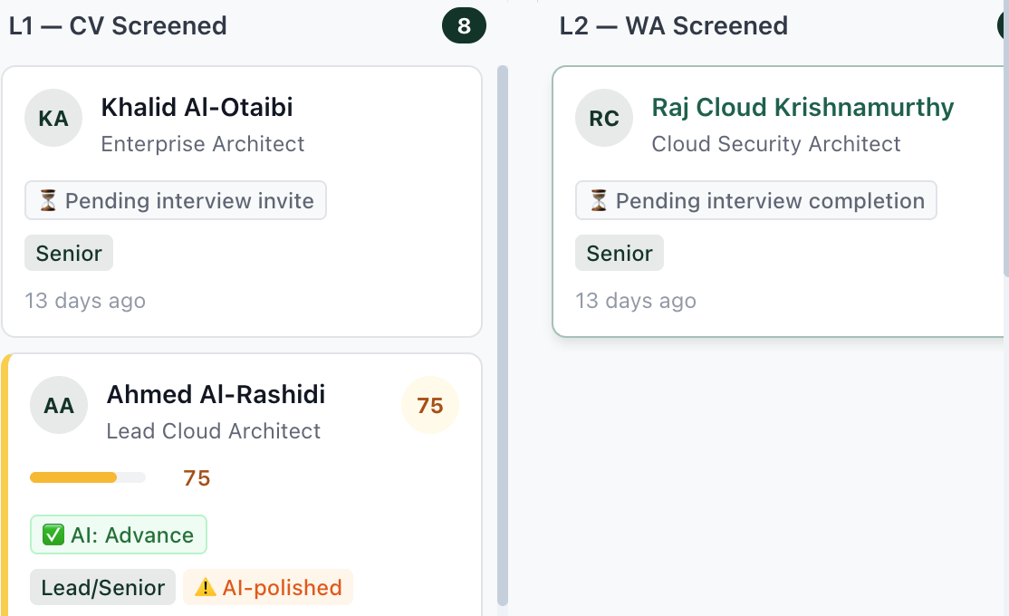  Also there is no option to download CV
7.3 | Loading State | Card shows "🔄 Screening..." for ~15-20s | Visible loading state. | Fail
7.4 | Open Mock | Open http://localhost:3003/mock in new tab | Mock UI loads. Simulate section visible. | Pass
7.5 | Manual Sim | Click "Simulate" if needed | Loading. Completes in ~15s. | Pass
7.6 | Score Calc | Return to Pipeline. Click Omar. | Drawer shows full composite + 3 sub-scores. | Partial | At Level-1 (after AI CV screening): We should have CV Match score  At Level-2 (after whatsapp): We should have Commitment + Salary fit  At Level-3 (After Interview): Domain knowledge Score  Overall score is based on the weightage results of CV match, Commitment, Salary and Domain knowledge… recruiter can edit the weightage as it depends on type of job role. Also in current someone’s score shown and someone not shown. Clean the duplication as well. Need to keep short for demo  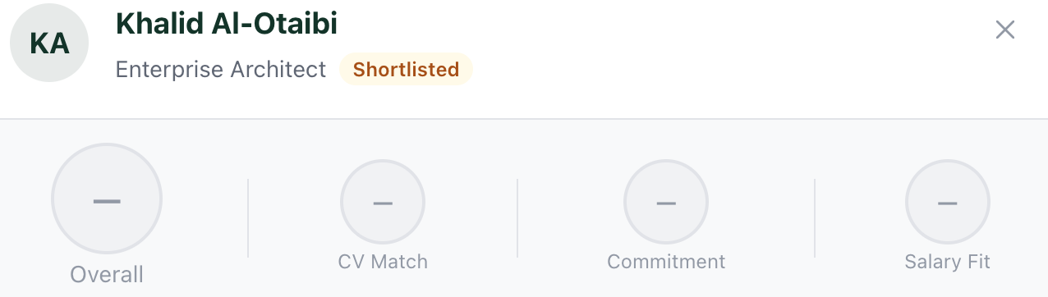
7.7 | AI Rec | Verify AI Recommendation: Advance/Hold/Reject with reasoning | Recommendation populated. | Pass | When rejected it generates message to candidate and it applies to all levels
7.8 | No Auto-Advance | Verify Omar is STILL in L1 (not auto-moved to L2) | Stays at L1. Manual approve required. | Pass

MODULE 8
AI Recommendation & Approval Flow
Verify "AI proposes, recruiter decides"

# | Step | Action | Expected Result | Pass/Fail | Notes
8.1 | Applied AI Rec | From Pipeline, find candidate in Applied with composite | Card shows AI badge: ✅/⚠️/❌ | Pass
8.2 | Drawer Reason | Click candidate. Verify AI Recommendation reason shown | Reasoning text visible. | Partial | Text is hidden. It should be clickable showing all details  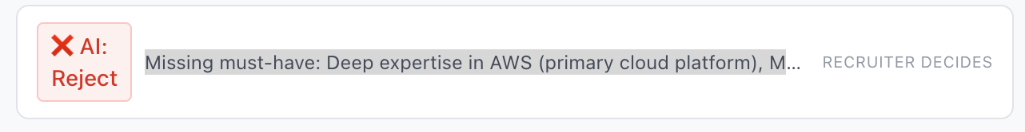
8.3 | Approve | Click "Approve to L1" → confirm modal | Stage changes. Recommendation cleared. Card moves. | Partial | 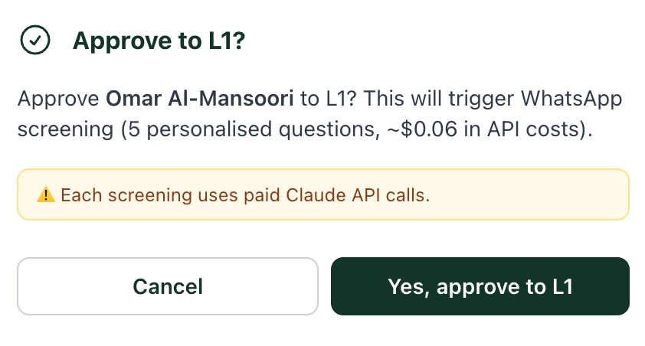  We should not show the message of API. Its irrelevant for customer
8.4 | L1 Pending | New L1 cards show: ⏳ Pending interview invite | Gray badge visible. | Pass
8.5 | Backward Drag | Drag L1 candidate back to Applied | Stage reverts. Recommendation recomputed. | Fail | Fit into Applied
8.6 | History | Open candidate. Pipeline stage history captured | JSON contains both transitions. | Fail
8.7 | Hold Rec | If candidate has Hold, verify reason shown | Reason: "Borderline" or similar. | Pass
8.8 | Reject Rec | If candidate has Reject, verify reason explains | Reason: "Missing must-have" or "CV doesn't match". | Pass
8.9 | Single Action | Each stage drawer has ONLY ONE primary "Approve to [next]" | One button. No duplication. | Pass
8.10 | L2-Final Stubs | For L2/L3/Final, verify "Pending [action]" badges | Pending badges shown. | Pass

MODULE 9
Dashboard Real-Time Refresh
Verify v1.9.0 query invalidation works

# | Step | Action | Expected Result | Pass/Fail | Notes
9.1 | Open 2 Tabs | Tab 1: /dashboard. Tab 2: /talent-pool | Both tabs loaded. | Pass
9.2 | Note KPIs | Tab 1: Note all 8 KPI numbers + Recent Activity top | Numbers recorded. | Pass | 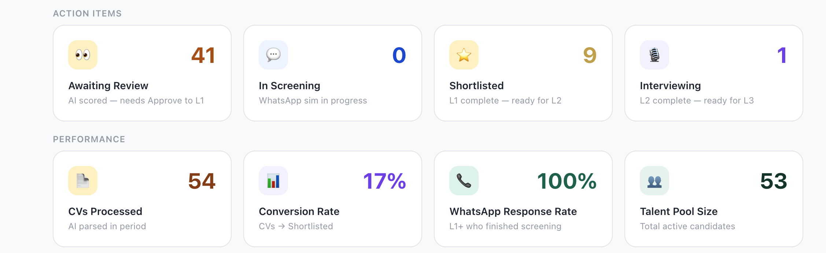
9.3 | Add to Pipeline | Tab 2: Select Cloud Architect → click candidate → Add to Pipeline | Toast confirms. | Pass
9.4 | Switch & Verify | Switch to Tab 1. Wait 1-2s. Compare KPIs. | "Awaiting Review" +1. Recent Activity updated. | Pass | 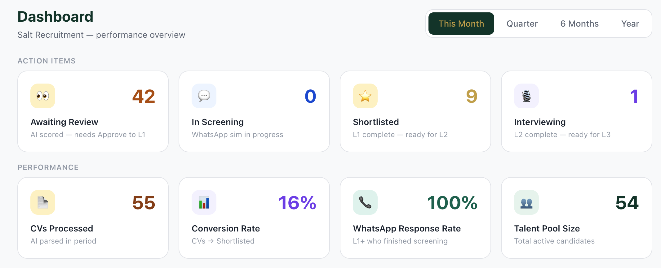
9.5 | Approve to L1 | Tab 2: Open job pipeline, find candidate, Approve to L1 | Stage changes. Async screening starts. | Pass
9.6 | KPI Updates | Tab 1: Watch "Awaiting Review" -1, "In Screening" +1 | KPIs update without manual refresh. | Pass

MODULE 10
Edge Cases & Error Handling
Verify graceful handling

# | Step | Action | Expected Result | Pass/Fail | Notes
10.1 | Empty Search | Talent Pool with no job selected | Shows pool with "Select job" hint. | Pass
10.2 | Drawer During Screening | Click candidate while their screening is in progress | Drawer shows "🔄 in progress" banner. No Approve button. | Pass
10.3 | Reject | Open any drawer. Click "✗ Reject" | Confirmation modal. On confirm: candidate hidden. | Pass
10.4 | Refresh Mid-Action | During screening, hard refresh page | Page reloads. State preserved. | Pass
10.5 | Long CV | Upload 5+ page PDF | Parsing completes. Score generated. No timeout. | Pass
10.6 | Invalid CV | Upload non-CV file | Either parses with low score OR clean error. No crash. | Pass

MODULE 11
Analytics Page — NEW in v1.10.0
Verify Analytics page KPIs, charts, and filters

Objective: Confirm Analytics page loads with KPIs, funnel chart, time-at-stage chart, source performance table, period filter, and job filter behaviour.

# | Step | Action | Expected Result | Pass/Fail | Notes
11.1 | Open Analytics | Click Analytics in sidebar | URL: /analytics. Page loads with header + period filter + KPI cards + 2 charts + source table. | Pass
11.2 | KPI Cards | Verify 4 KPI cards: Active Jobs, Avg Time to Fill, Hire Rate, Cost per Hire | All 4 cards render. Cost per Hire shows "Coming Soon" pill. Time to Fill shows "—" if no hires yet. | Pass
11.3 | Funnel Chart | Verify Pipeline Funnel Conversion bar chart shows 5 stages: Applied / L1 / L2 / L3 / Final | Bars colored by stage (slate / gold / blue / purple / green). Drop-off % shown between bars. | Pass
11.4 | Time at Stage | Verify horizontal bar chart with healthy threshold colors (green <3d / amber 3-7d / red >7d) | Chart renders. Legend shows color code. Empty stages shown as gray. | Pass
11.5 | Source Performance | Verify table shows Source / Candidates / Hires / Conversion Rate / Avg Composite | At least 3 sources visible. Sorted by candidate count descending. | Pass
11.6 | Period Filter | Click period pills 30d → 90d → 180d → 365d | Funnel and tables update with period. Active Jobs unchanged (always current state). | Pass
11.7 | Job Filter & Mobile | Select Cloud Architect from job dropdown. Then resize browser to phone width. | Funnel narrows. Active Jobs stays at agency total. Layout: KPIs 2x2, charts stack, tables horizontal-scroll. | Pass

Test Execution Summary

# | Module | Total | Passed | Failed/Blocked
1 | Login & Dashboard Overview | 6 | ___ | ___
2 | Job Creation Wizard | 8 | ___ | ___
3 | CV Inbox — Upload & Score | 10 | ___ | ___
4 | Talent Pool — Re-scoring | 8 | ___ | ___
5 | Drawer Consistency | 9 | ___ | ___
6 | Pipeline & Funnel | 7 | ___ | ___
7 | WhatsApp Screening Simulation | 8 | ___ | ___
8 | AI Recommendation & Approval | 10 | ___ | ___
9 | Dashboard Real-Time Refresh | 6 | ___ | ___
10 | Edge Cases & Error Handling | 6 | ___ | ___
11 | Analytics Page [NEW] | 7 | ___ | ___
 | TOTAL | 85 | ___ | ___

Defect Log

Use this section to record any failed test cases with reproduction steps.

# | Test ID | Description | Severity | Status
1 | ___ | ___________________________________________ | Critical / High / Medium / Low | Open / Fixed
2 | ___ | ___________________________________________ | ___ | ___
3 | ___ | ___________________________________________ | ___ | ___
4 | ___ | ___________________________________________ | ___ | ___
5 | ___ | ___________________________________________ | ___ | ___
6 | ___ | ___________________________________________ | ___ | ___
7 | ___ | ___________________________________________ | ___ | ___
8 | ___ | ___________________________________________ | ___ | ___

Sign-Off

 | Role | Name | Signature | Date
 | Tester (QA) | ________________ | ________________ | ________________
 | Project Advisor (Ali) | ________________ | ________________ | ________________
 | Product Owner (Saad) | ________________ | ________________ | ________________

HireIQ QA Test Plan v1.1 | Confidential | github.com/saadkarim12/hireiq

