**Introduction to Computing**

**Lab-V**

**Topic: cout statements, arithmetic operations**

**Objective: Learning how to print data on console including strings, arithmetic expression evaluations and literal constants**

1. You are required to make a separate project for each of the tasks given below
2. All tasks are to be submitted on CMS Portal

## Lab Task 1 (Medium)

Write a C++ program to print a filled diamond shape on console using cout statement as shown below:

**OUTPUT:**

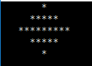



## Lab Task 2 (Hard)

Print Square in the middle of console screen as follows:

**OUTPUT:**

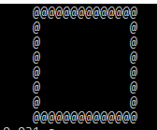

## Lab Task 3 (Hard)

Print the following shape on console screen:

**OUTPUT:**

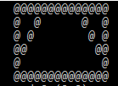

## Lab Task 4 (Hard)

Print the following on console screen:

**OUTPUT:**

