URL: <http://maahad.org/website/>

Image size (267.65x178.42)

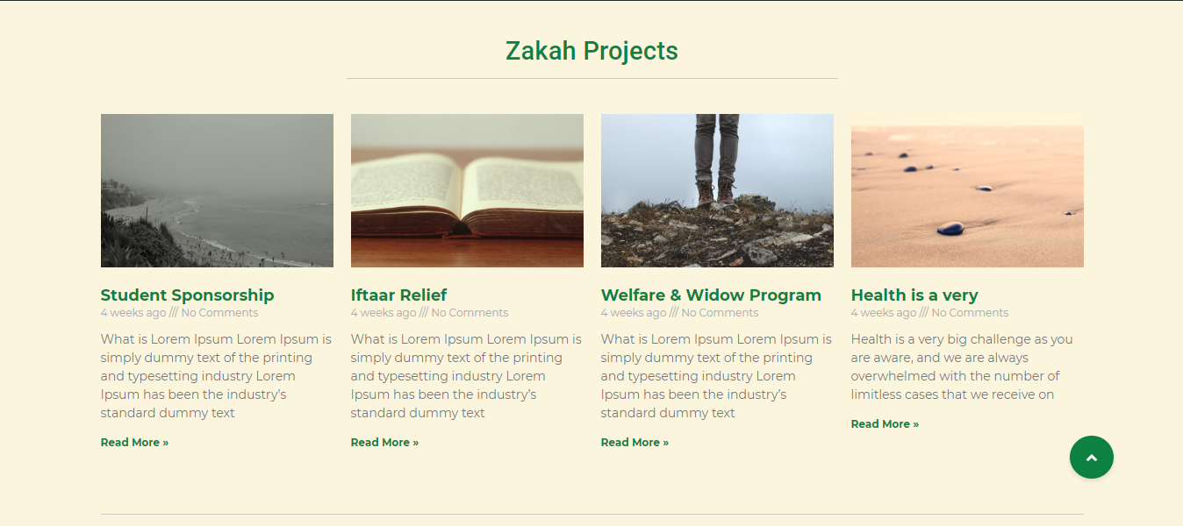

Image size (363.58x242.38)

