Link: <https://digitalopment.ae/>

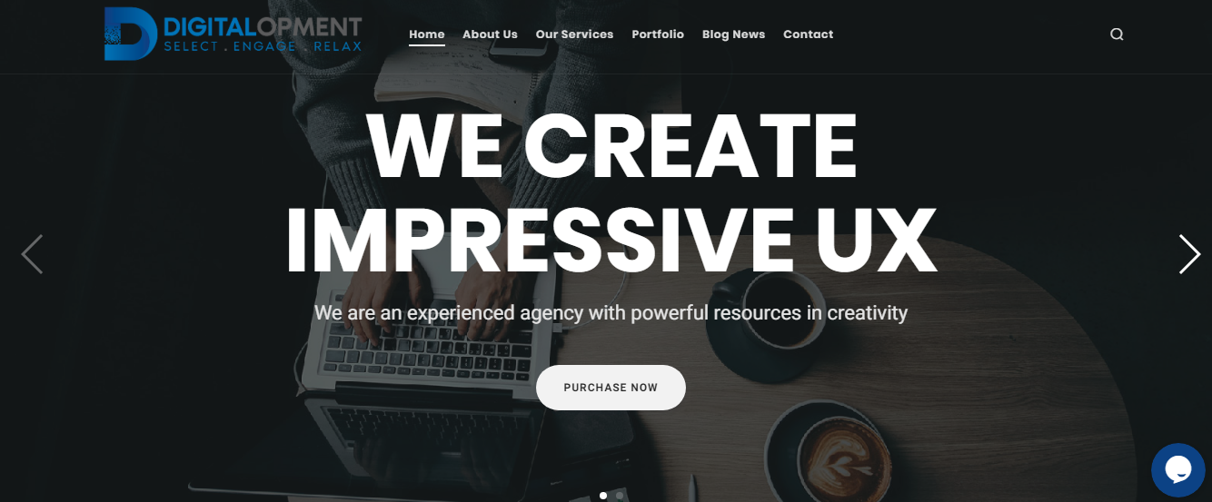

(Slider Content with heading)

---------------------------------------------------------------------------------------------------------------------------------------------------------------------------------------------(16 words) use this (UAE)..

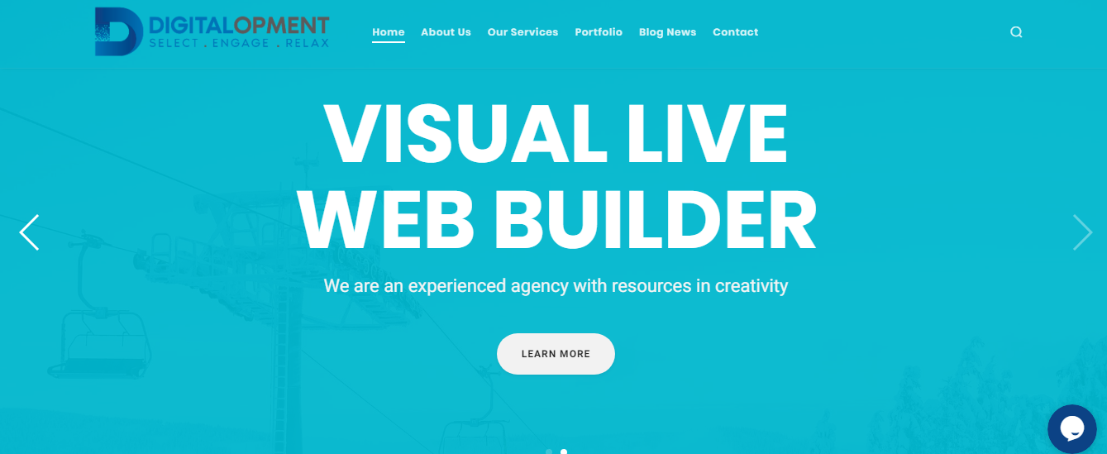

(Slider Content with heading)

---------------------------------------------------------------------------------------------------------------------------------------------------------------------------------------------(16 words) use this (UAE)..

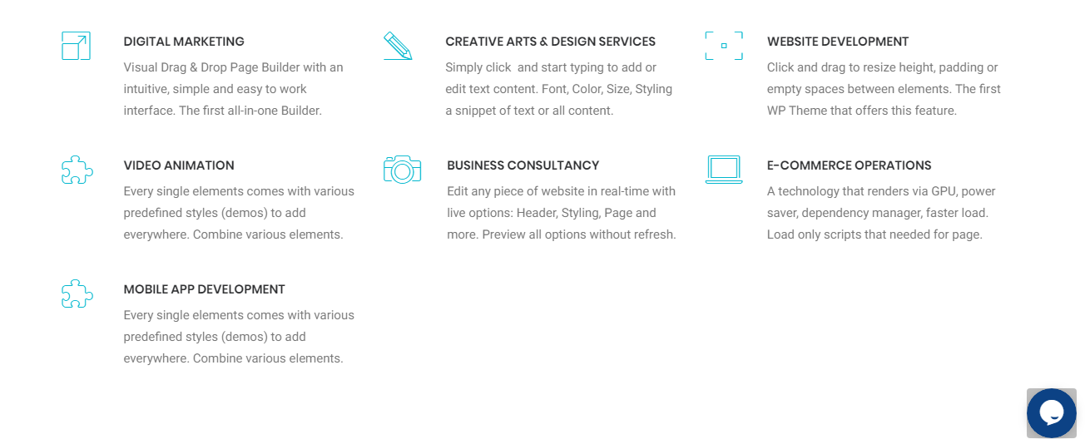

## **DIGITAL MARKETING:**

-----------------------------------------------------------------------------------------------------------------------------------------------------------------------------------------------------------------------------(19 Words).

## **CREATIVE ARTS & DESIGN SERVICES:**

-----------------------------------------------------------------------------------------------------------------------------------------------------------------------------------------------------------------------------(19 Words).

## **WEBSITE DEVELOPMENT:**

-----------------------------------------------------------------------------------------------------------------------------------------------------------------------------------------------------------------------------(19 Words).

## **VIDEO ANIMATION:**

-----------------------------------------------------------------------------------------------------------------------------------------------------------------------------------------------------------------------------(19 Words).

## **BUSINESS CONSULTANCY:**

-----------------------------------------------------------------------------------------------------------------------------------------------------------------------------------------------------------------------------(19 Words).

## **E-COMMERCE OPERATIONS:**

-----------------------------------------------------------------------------------------------------------------------------------------------------------------------------------------------------------------------------(19 Words).

## **MOBILE APP DEVELOPMENT:**

-----------------------------------------------------------------------------------------------------------------------------------------------------------------------------------------------------------------------------(19 Words).

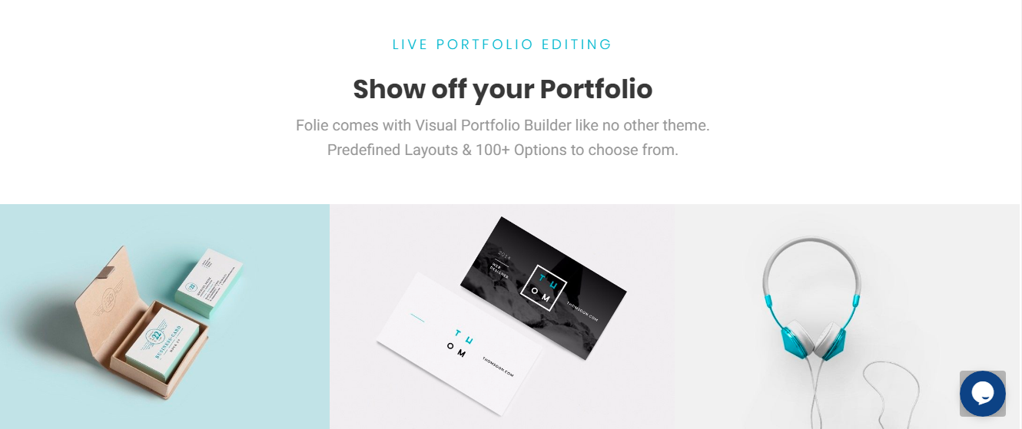

--------------------------------------------------------------------------------------------------------------------------------------------------------------------------------------------------------------------------------------------------------------------------------------(26 words)

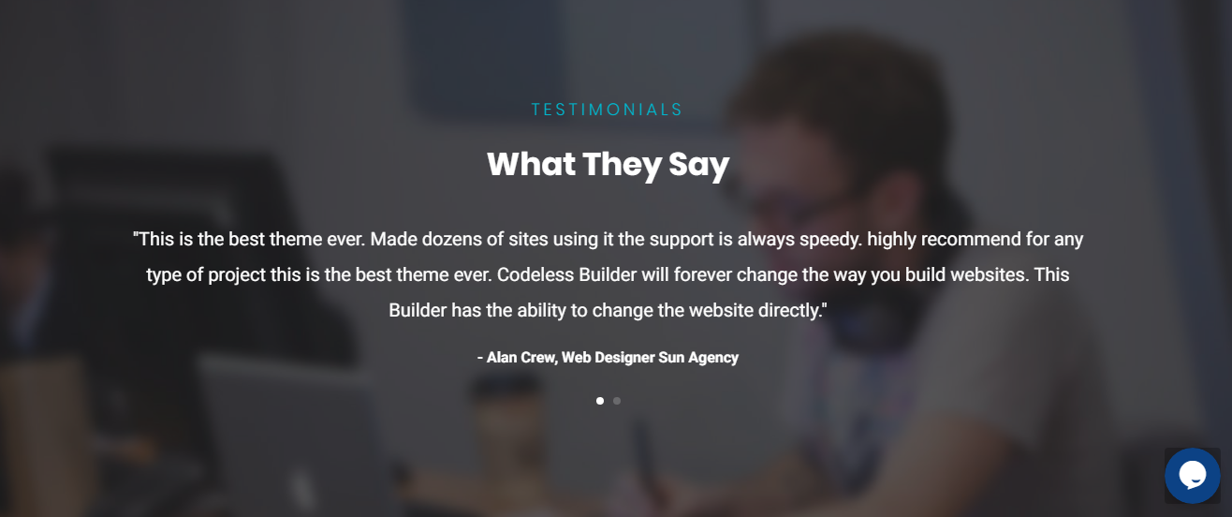

------------------------------------------------------------------------------------------------------------------------------------------------------------------------------------------------------------------------------------------------------------------------------------------------------------------------------------------------------------------------------------------------(36 words)

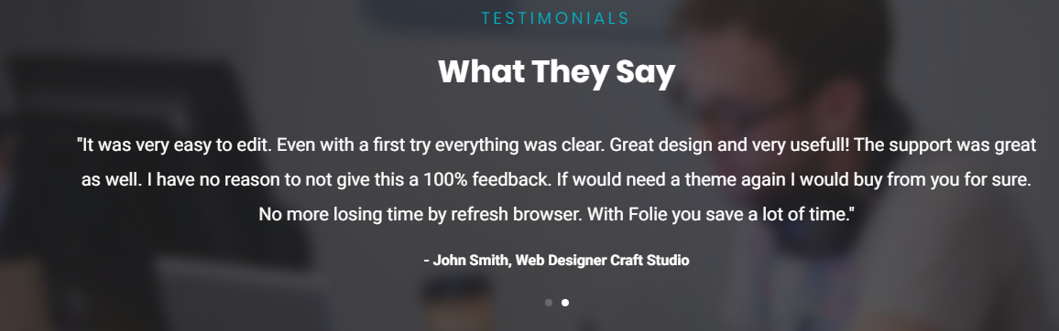

------------------------------------------------------------------------------------------------------------------------------------------------------------------------------------------------------------------------------------------------------------------------------------------------------------------------------------------------------------------------------------------------(36 words)



---------------------------------------------------------------------------------------------------------------------------------------------(10 words)

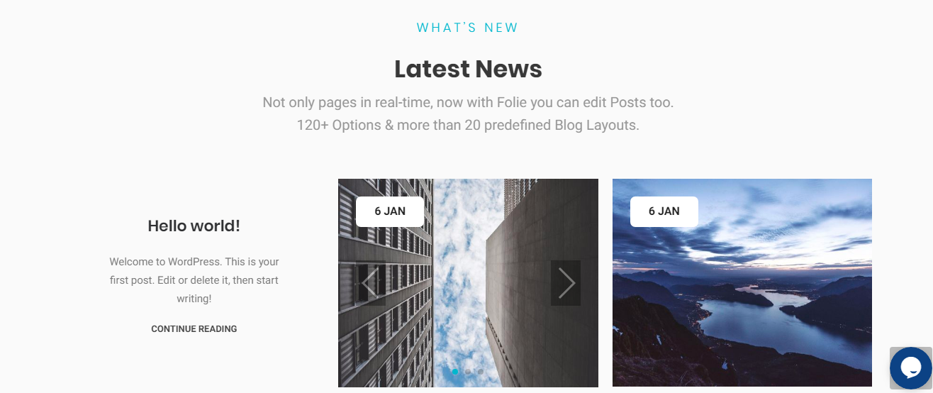

----------------------------------------------------------------------------------------------------------------------------------------------------------------------------------------------------------------------------------------------------------------------------------------------------(26 words)

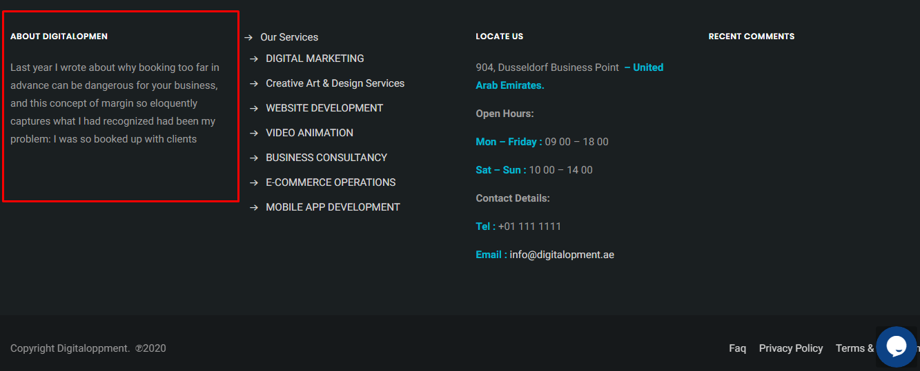

-----------------------------------------------------------------------------------------------------------------------------------------------------------------------------------------------------------------------------------------------------------------------------(40 words)