LabVIEW TiePie HS3 FSK Message Transmission
Code Explanation, Run Guide, and Debugging Notes

Document purpose
This document explains how the implemented LabVIEW project works: how a text message is encoded into a two-frequency FSK waveform, transmitted through the TiePie HS3 generator, acquired on CH1, decoded back into text, and displayed on the LabVIEW front panel. It also includes operation steps, screenshot placeholders, and known debugging notes.

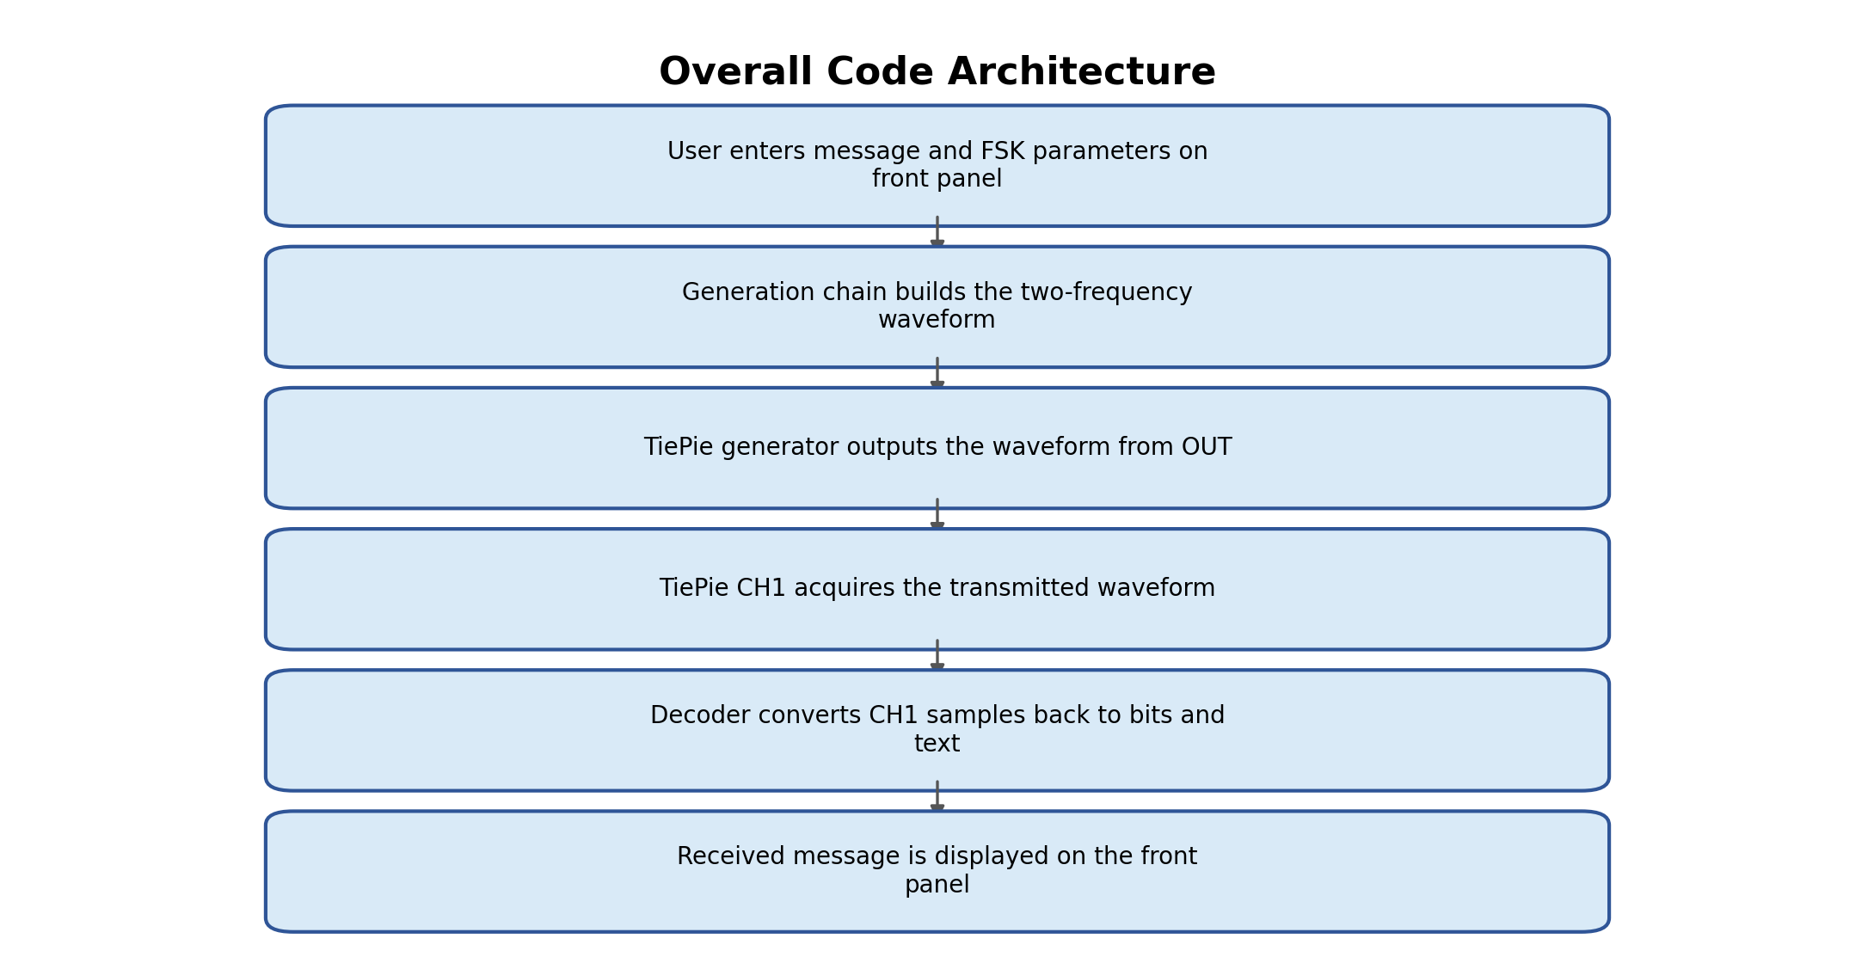
Figure 1. Overall implementation flow.

1. Project scope and implemented behavior
The implementation focuses on direct generation, acquisition, and decoding of an FSK-style signal using the TiePie HS3 interface already present in the base VI.
Scope statement
The implementation is designed around a direct hardware loopback test path: TiePie generator OUT connected to TiePie CH1. The coding/decoding logic is independent of the acoustic path, but the current explanation focuses on the direct OUT-to-CH1 test because that is the most reliable way to validate the code.

2. Main project files and VI roles
The project is organized around three main LabVIEW VIs. The main VI controls the TiePie hardware and coordinates generation, acquisition, and decoding. The other two VIs are modular subVIs used for waveform creation and message decoding.
File / VI | Role | Notes
TiePie_acq_gen.vi | Main VI / project controller | This is the main VI used to run the project. It contains the front-panel controls and coordinates the complete flow: message input, waveform generation, TiePie arbitrary generator setup, acquisition from CH1, and display of the decoded received message.
Waveform Gen.vi | FSK waveform generator subVI | This subVI creates the transmit waveform from the message. It converts the text message into bits, maps each bit to one of the two selected frequencies, builds the sine segments, concatenates them, converts the waveform to U16 generator format, and prepares the padded waveform for the TiePie arbitrary generator.
decode.vi | FSK decoder subVI | This subVI decodes the acquired CH1 waveform. It uses a Goertzel-style frequency-energy comparison to detect which of the two frequencies is present in each bit window, reconstructs the bit stream, converts the bits back into ASCII characters, and returns the received message.
Support files such as hs3.dll, hs3f8.hex, and hs3f12.hex remain in the project folder for the TiePie hardware interface, but they are not custom logic VIs. The custom implementation work is mainly contained in the three VIs listed above.

3. Front-panel controls and indicators
The front panel is used both for running the transmission test and for debugging. The main user-facing controls are listed below.
Control / Indicator | Purpose | Recommended value / behavior
Transmission Message | Text message to encode and transmit | Example: A, AB, ABCD
Expected Characters | Number of characters expected by the decoder | Value automatically fetched via string length (no need to enter)
Frequency 1 | Frequency used for bit 0 | Example: 2000 Hz
Frequency 2 | Frequency used for bit 1 | Example: 4000 Hz
Bit Duration | Duration of each bit segment | Example: 0.05 s
Sampling Rate | Sample rate used for generation and decoding | Must be at least twice the highest frequency; higher is better. Example: 50000 Hz.
Amplitude / Offset | Generator output settings | Common test values: amplitude around 1 V and DC offset 0 V.
No. of samples / Postsamples | Acquisition record length settings | These are updated automatically based on generated waveform length; the user should not manually edit them during normal operation.
Received Message | Decoded output text | Shows the decoded result from CH1 acquisition.
CH1 graph | Acquired waveform display | Used to verify that the generated waveform is actually acquired by the TiePie input.

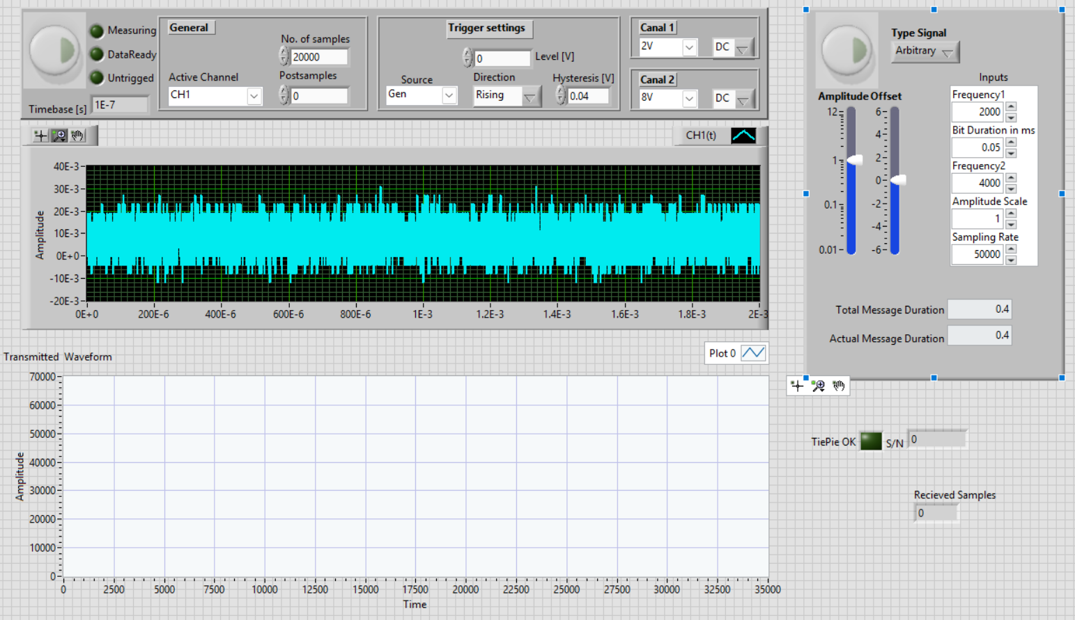4. Communication method: two-frequency FSK
The message is encoded using two-frequency frequency shift keying. One frequency represents bit 0 and the other frequency represents bit 1. The frequency remains constant during one bit duration, then the next bit is generated using the frequency assigned to that next bit.
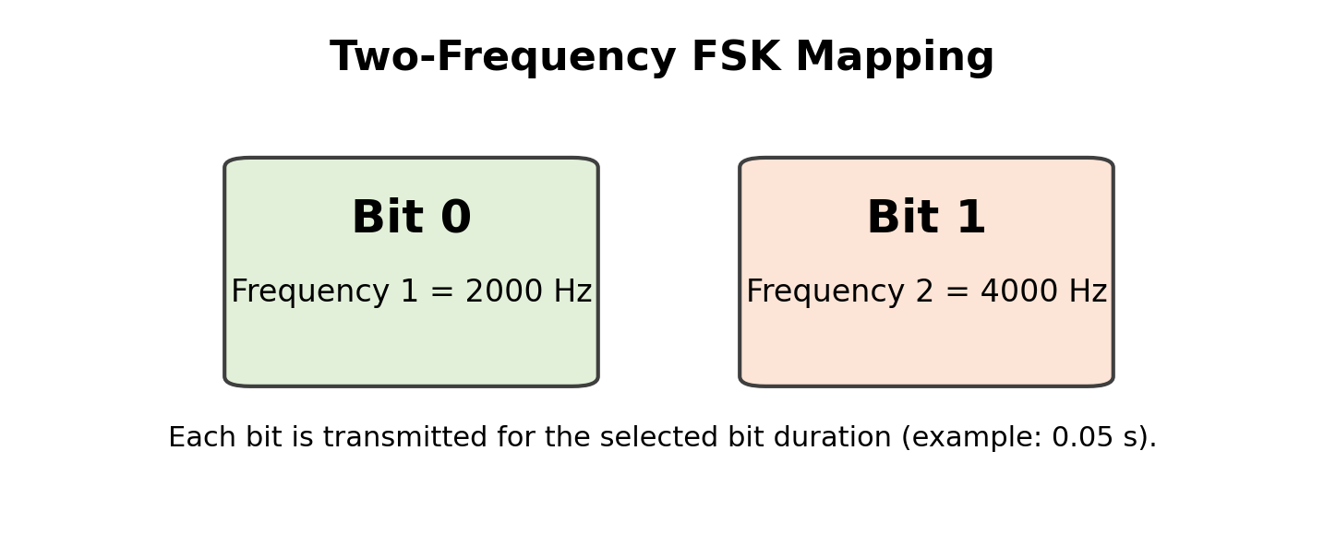
Figure 2. Bit-to-frequency mapping used by the implementation.
Example: character A
ASCII A = decimal 65
Binary = 01000001
If Frequency 1 = 2000 Hz and Frequency 2 = 4000 Hz:
A is transmitted as: 2000, 4000, 2000, 2000, 2000, 2000, 2000, 4000 Hz

5. Generation chain
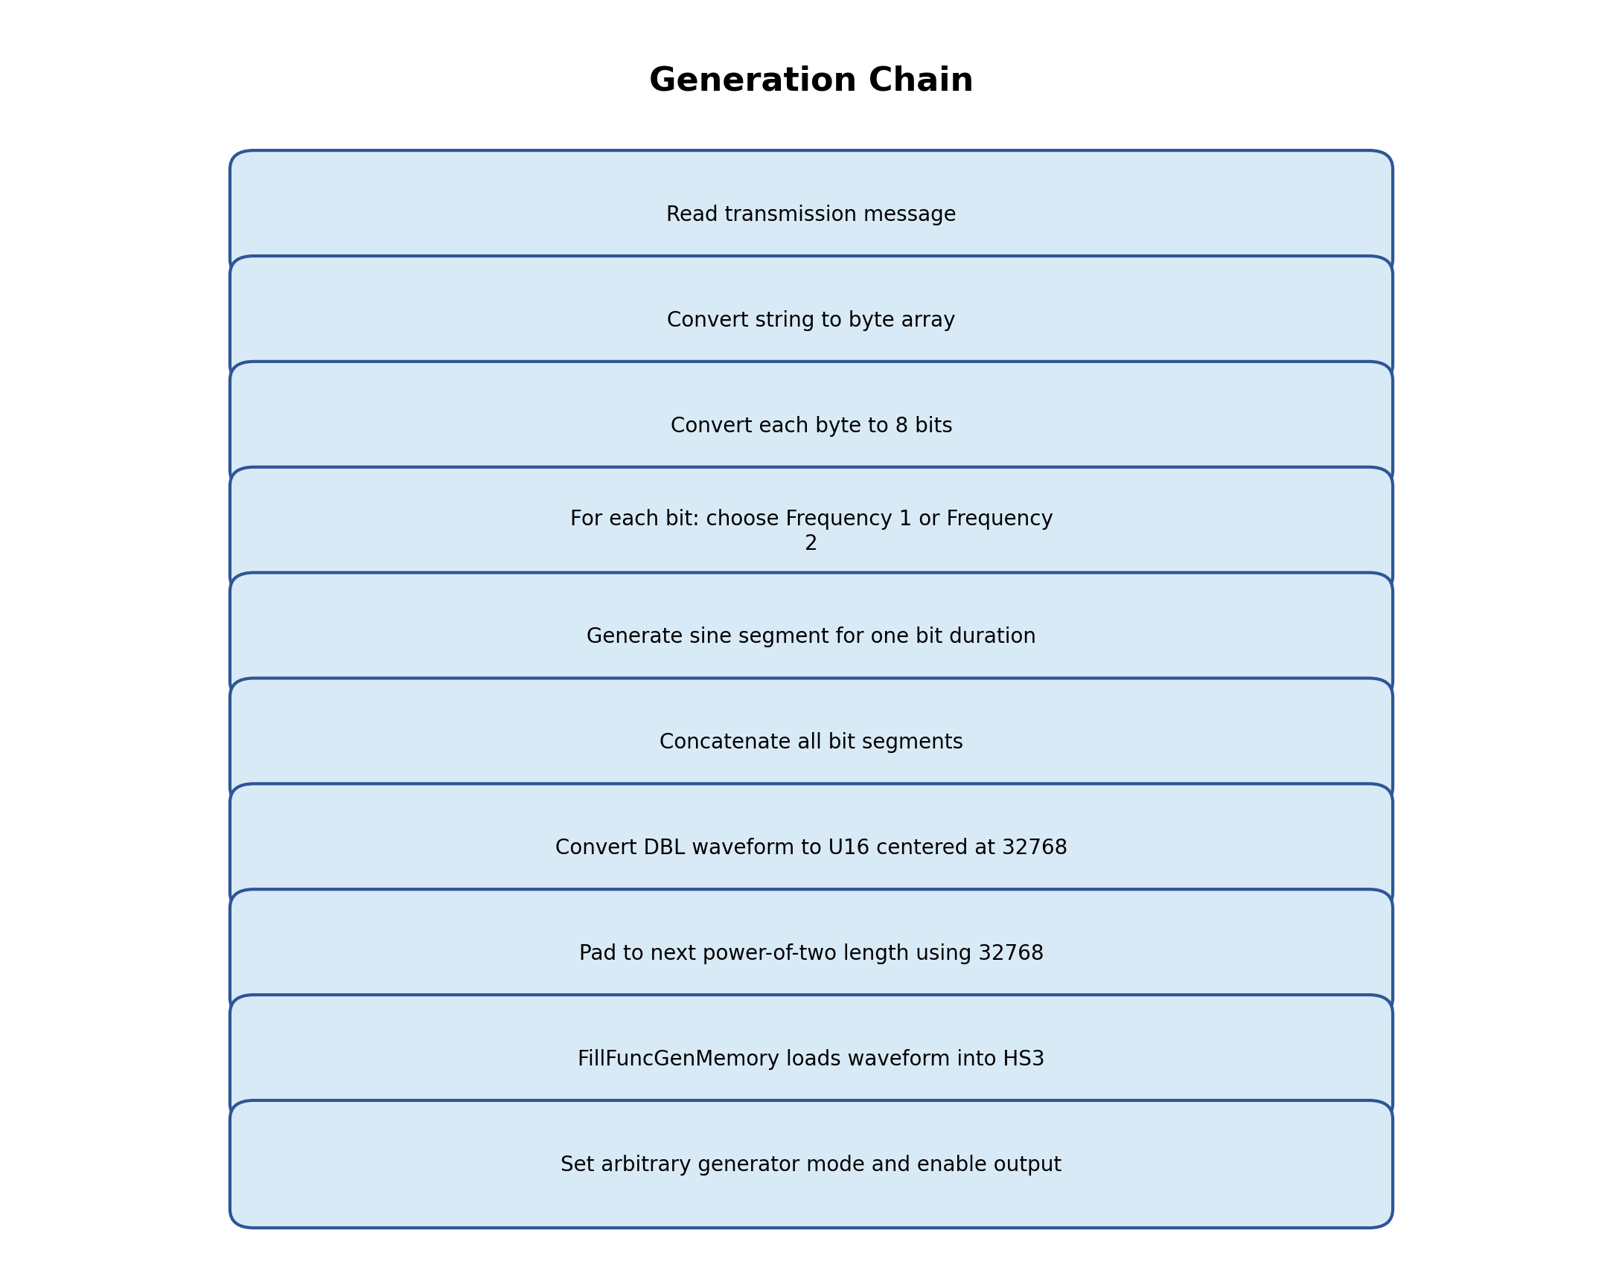
Figure 3. Generation chain block diagram.
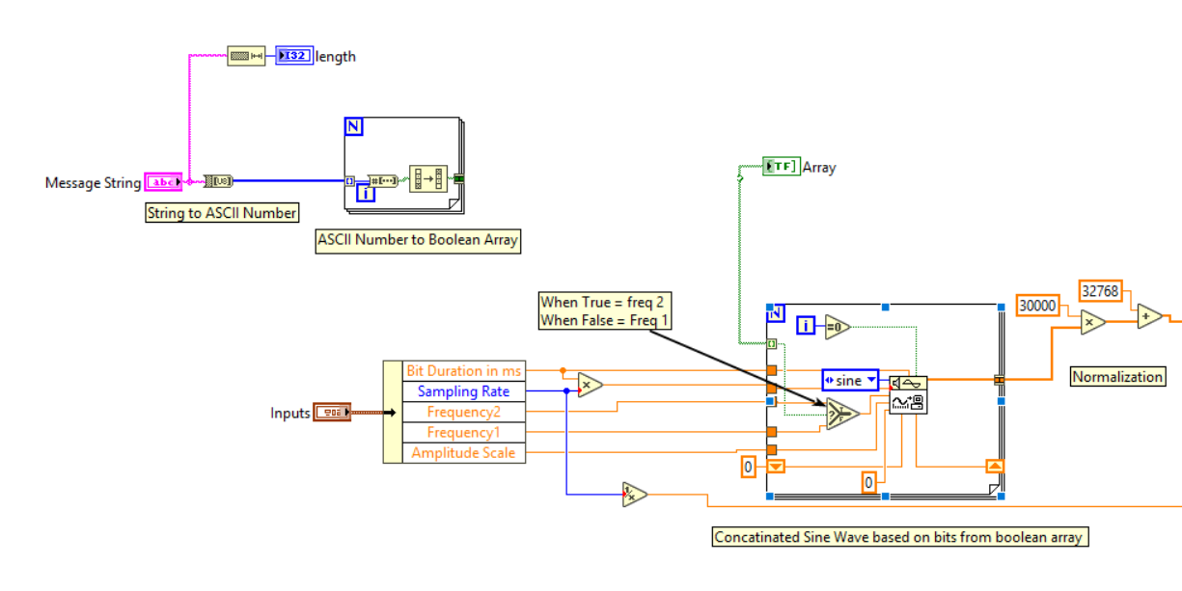

5.1 Text-to-bit conversion
The transmission message is first converted from a string into bytes. Each byte is then split into 8 bits. The implementation uses the same bit order for generation and decoding, so the decoded bytes reconstruct the original text.
Transmission Message = "A"
String to byte array -> [65]
65 in binary -> 01000001
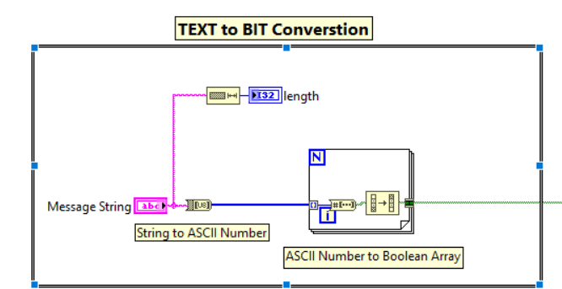

5.2 Per-bit sine segment generation
A For Loop processes the Boolean bit array. On each iteration, the bit value selects which frequency to use. If the bit is 0, Frequency 1 is used; if the bit is 1, Frequency 2 is used. The Signal Generator by Duration VI creates one sine segment for that bit duration. All segments are concatenated into one complete waveform.
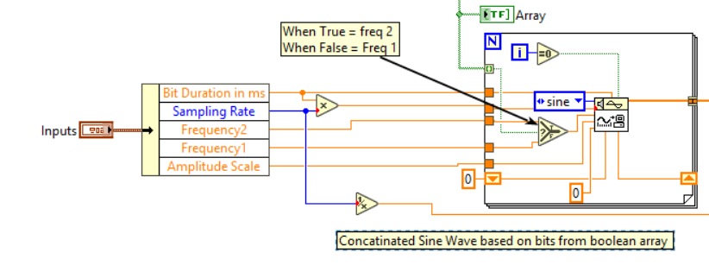
Signal Generator by Duration input | Value used
Signal type | Sine
Frequency | Frequency 1 for bit 0, Frequency 2 for bit 1
Duration | Bit duration, example 0.05 s
# of samples | Sampling rate × bit duration
Amplitude | Amplitude scale, usually 1 before U16 conversion
DC offset | 0 for normalized DBL waveform
Phase | Can be handled with phase in/out to avoid discontinuity

5.3 U16 conversion for TiePie arbitrary memory
The generated waveform starts as a DBL waveform around -1 to +1. TiePie arbitrary memory expects unsigned 16-bit samples. Therefore the waveform is centered around the U16 mid-point value 32768.
U16_value = 32768 + 30000 × sine_signal
Why 30000 and not 32768?
32768 × +1 would reach 65536, which exceeds U16 maximum 65535.
30000 leaves safe headroom and avoids clipping or overflow.
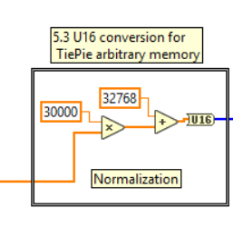

5.4 Padding
The generated U16 waveform is padded to the next power-of-two length before loading it into the TiePie arbitrary generator. The padding value is 32768, because 32768 corresponds to the zero-voltage center in U16 generator data.
Example for one character A:
Samples per bit = 50000 × 0.05 = 2500
Useful message samples = 8 × 2500 = 20000
Next power of two = 32768
Padding samples = 32768 - 20000 = 12768
Padding value = 32768
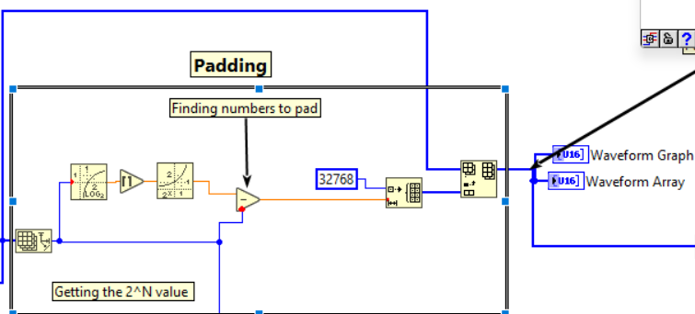

5.5 TiePie generator DLL call sequence
After the padded U16 array is prepared, the arbitrary waveform is loaded into the TiePie generator and played through the generator output. The important difference is that normal sine testing uses DDS mode, while the FSK waveform uses linear arbitrary mode.
DLL call | Value | Purpose
SetFuncGenEnable | 0 | Ensure the generator is idle before loading the new waveform.
SetFuncGenMode | 2 | Linear mode for arbitrary waveform playback.
SetFuncGenSignalType | 5 | Select arbitrary waveform signal type.
SetFuncGenAmplitude | User amplitude | Set generator output amplitude.
SetFuncGenDCOffset | 0 | No DC offset for normal test.
FillFuncGenMemory | Padded length + U16 array | Load the generated FSK waveform into TiePie memory.
SetFuncGenFrequency | Sampling rate | In linear mode this is the generator playback sampling clock.
SetFuncGenOutputOn | 1 | Enable generator output path.
SetFuncGenEnable | 1 | Start output generation.
SetFuncGenEnable | 0 | Stop output after the intended buffer duration in one-shot mode.
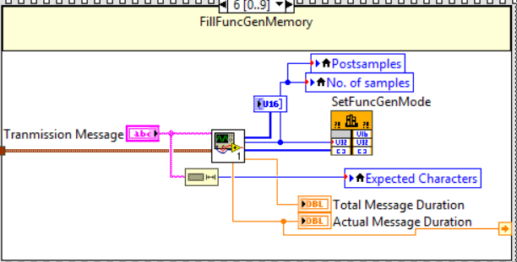

5.6 Generation timing
For one-shot transmission, the generator should run for the duration of the padded waveform and then stop. The duration should be calculated instead of hard-coded.
Generator wait time in milliseconds = 1000 × padded waveform length / sampling rate
Example for A:
1000 × 32768 / 50000 = 655.36 ms
Example for AB:
Useful samples = 2 × 8 × 2500 = 40000
Padded samples = 65536
Wait = 1000 × 65536 / 50000 = 1310.72 ms
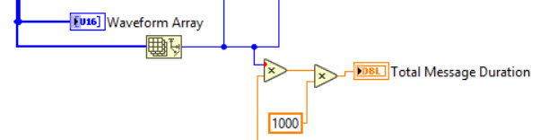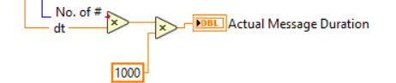

6. Acquisition chain
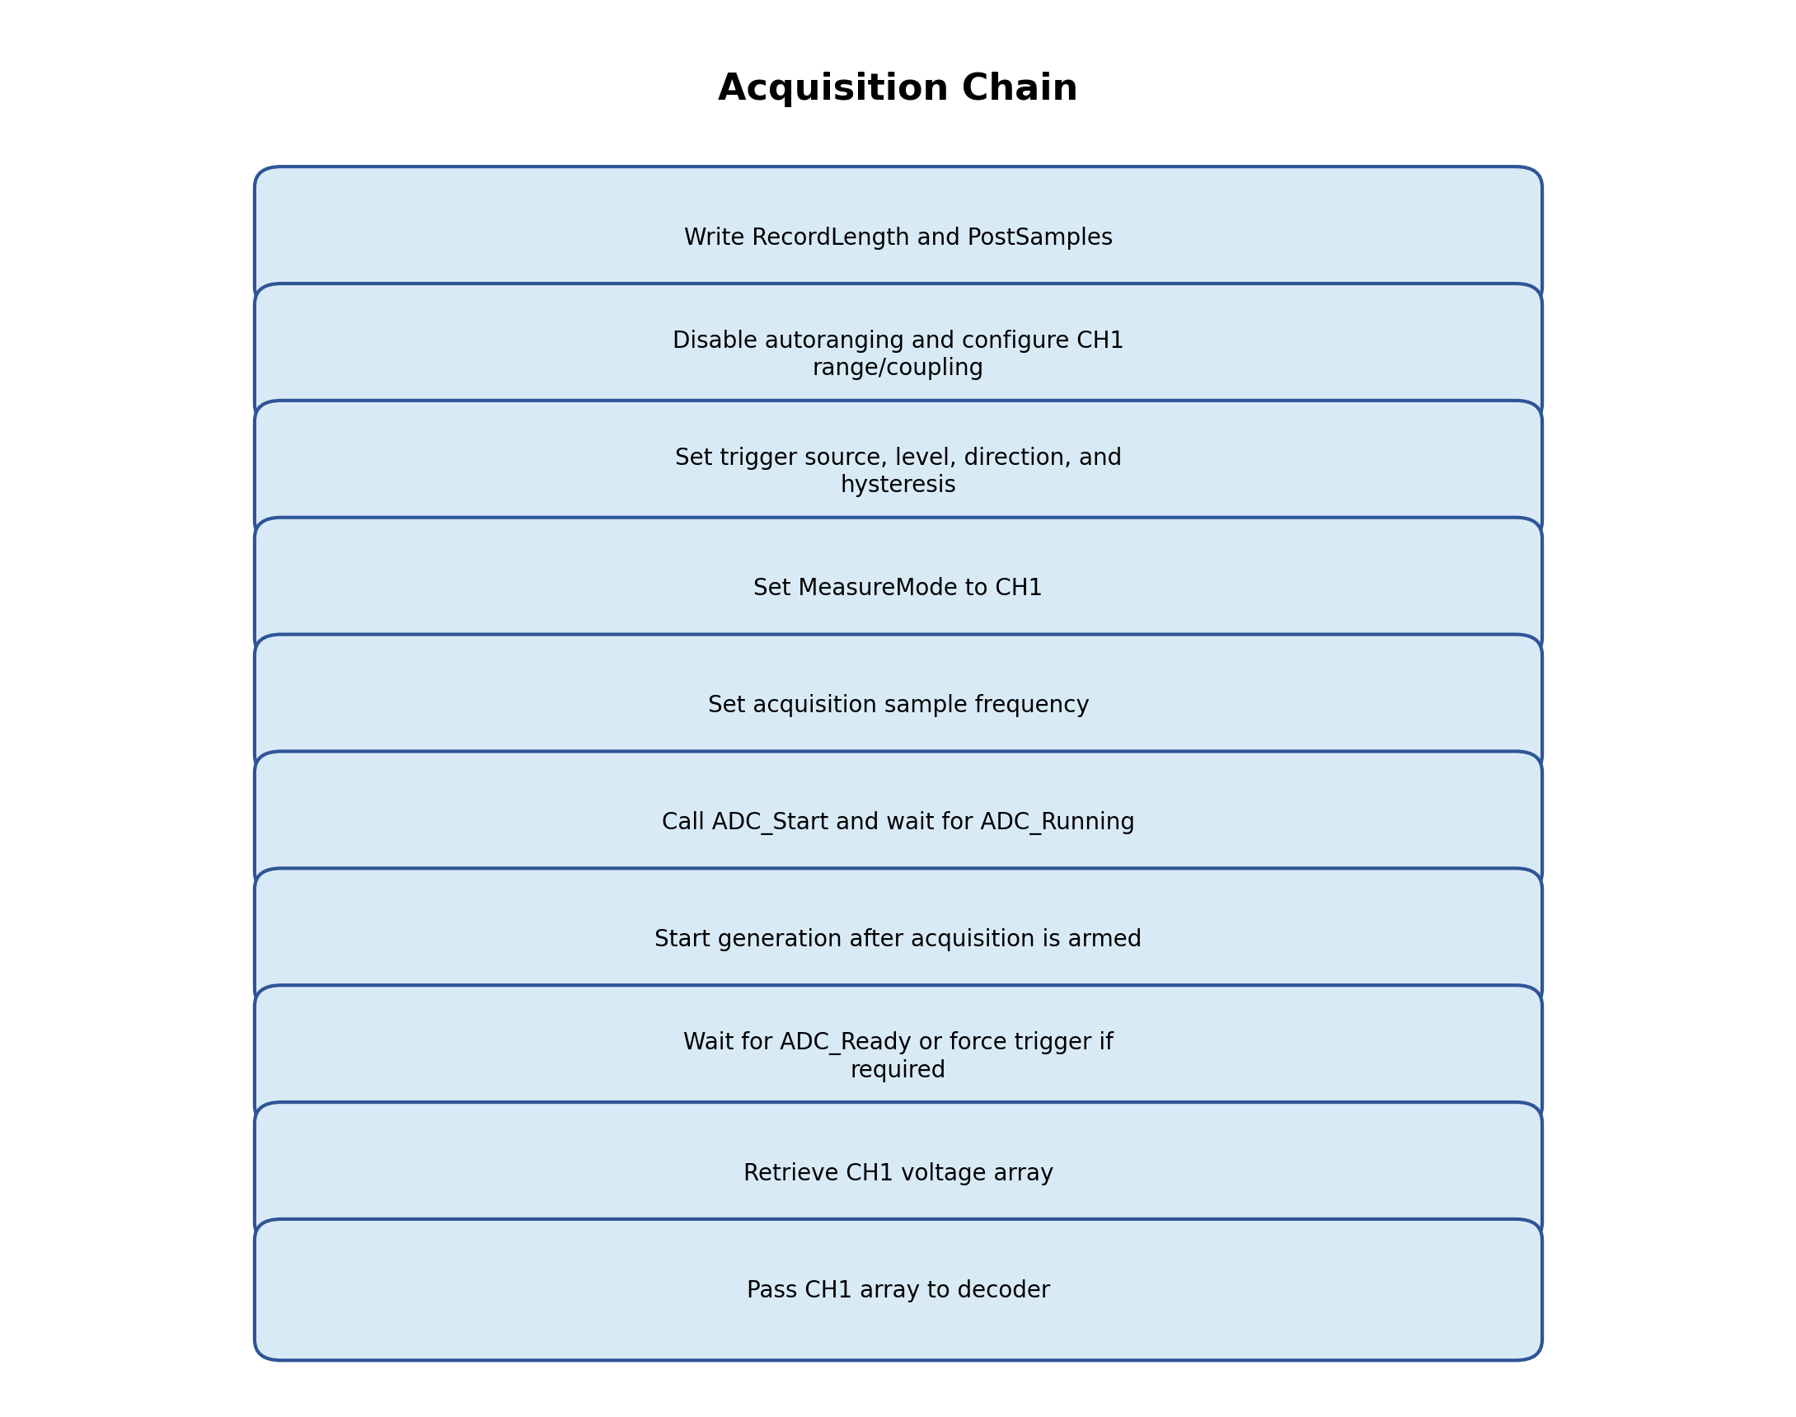
Figure 4. Acquisition chain block diagram.
The acquisition chain is kept close to the existing TiePie base template. The added logic mainly ensures the acquisition length follows the generated waveform length, then the acquired CH1 waveform is passed into the decoder.

6.1 Recommended acquisition settings
Setting | Recommended value | Reason
Active Channel | CH1 | The TiePie OUT signal is connected to CH1.
No. of samples | Padded waveform length (written via local variable) | Captures the complete generated buffer.
Postsamples | Same as No. of samples (written via local variable) | Captures the waveform after the trigger.
Source | Gen for synchronized test | Uses the generator event as the acquisition trigger.
CH1 range | 2 V or suitable range | Enough range for the signal while keeping good resolution.
CH1 coupling | DC for direct OUT-to-CH1 loopback | Direct loopback signal should be acquired directly.
Sample frequency | Same as generation sampling rate  (written via input cluster) | Ensures samples-per-bit calculation matches generation.
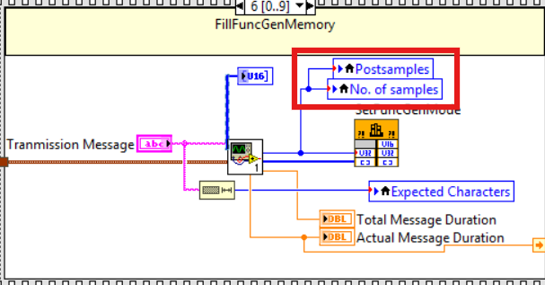
Figure 1: Size of Padded Array = No of samples
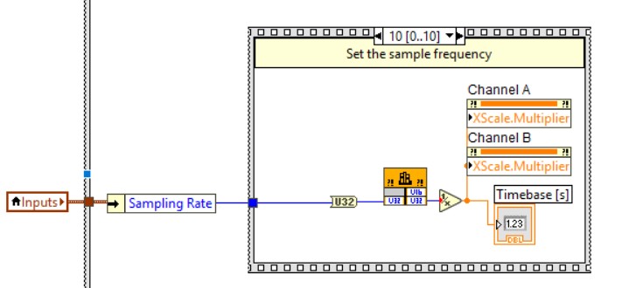
Figure 2: Acquisition Frequency

6.2 Acquisition DLL call sequence
DLL call | Typical value / input | Purpose
SetRecordLength | No. of samples | Sets total number of samples to acquire per channel.
SetPostSamples | Postsamples | Sets how many samples are captured after the trigger.
SetAutoRanging | CH1 off, CH2 off | Prevents the range from changing during acquisition.
SetTriggerSource | Gen / None / CH1 | Selects how the acquisition is triggered.
SetTriggerMode | Rising | Trigger edge setting.
SetTriggerHys | 0.04 V typical | Hysteresis for analog trigger stability.
SetTriggerLevel | 0 V typical for Gen source | Trigger level; mainly relevant for analog trigger source.
SetMeasureMode | CH1 | Acquire CH1 data.
SetSensitivity | CH1 range | Sets input range.
SetCoupling | DC | Direct loopback coupling.
SetSampleFrequency | Sampling rate | Sets acquisition sampling frequency.
ADC_Start | No input | Starts acquisition.
ADC_Running | Read result | Confirms measurement is running.
ADC_Ready | Read result | Becomes 1 when data is ready.
ADC_ForceTrig | Optional after timeout | Forces trigger if measurement does not trigger.
ADC_GetDataVolt / ADC_GetDataVoltCh | CH1 voltage array | Retrieves acquired voltage samples.
ADC_Abort | No input | Stops any running measurement when needed.
Automatic sample length update
The No. of samples and Postsamples controls should be written programmatically from the generated padded waveform length. This avoids mismatch when changing from one character to multiple characters.

7. Decoding chain
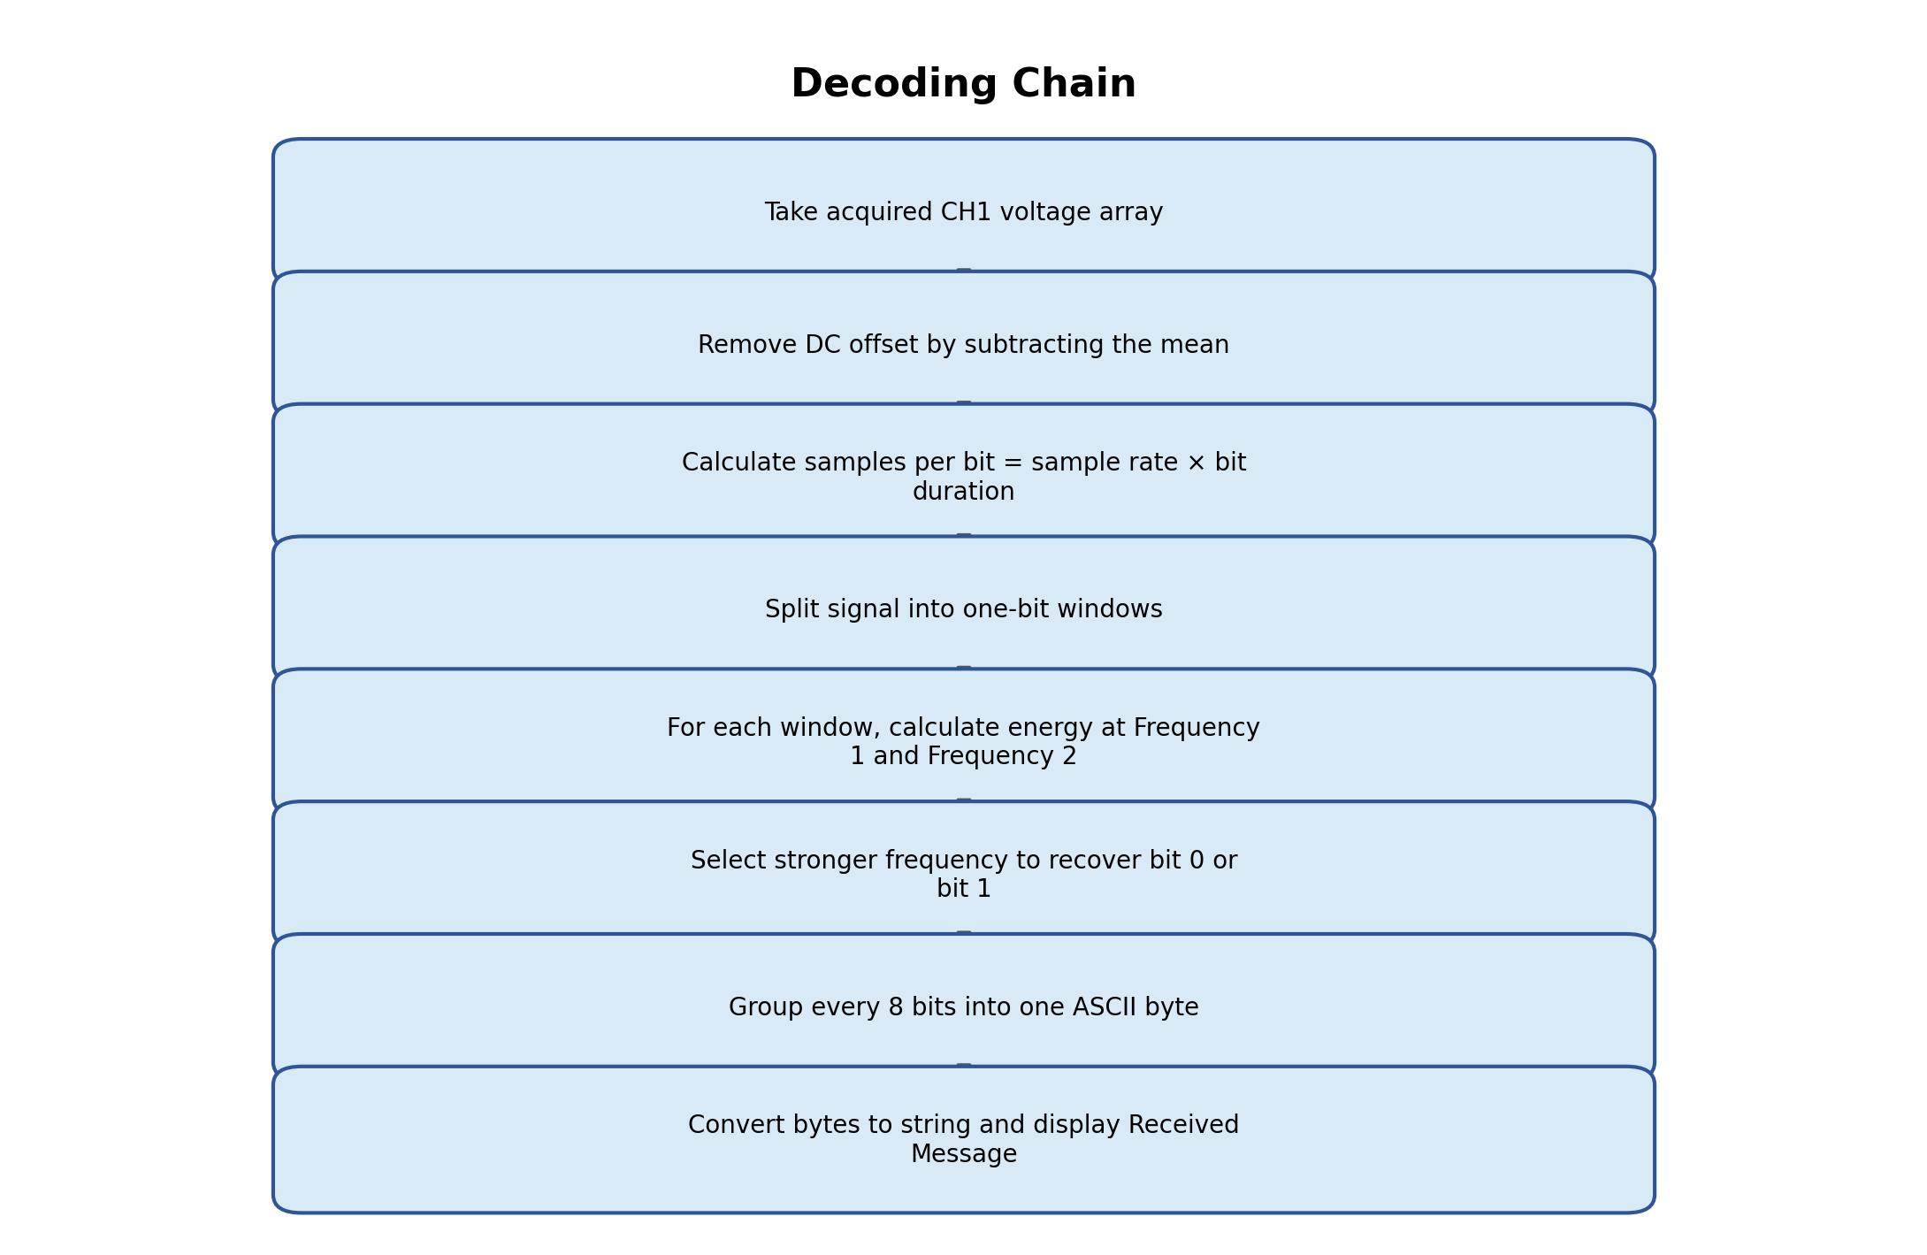
Figure 5. Decoding chain block diagram.
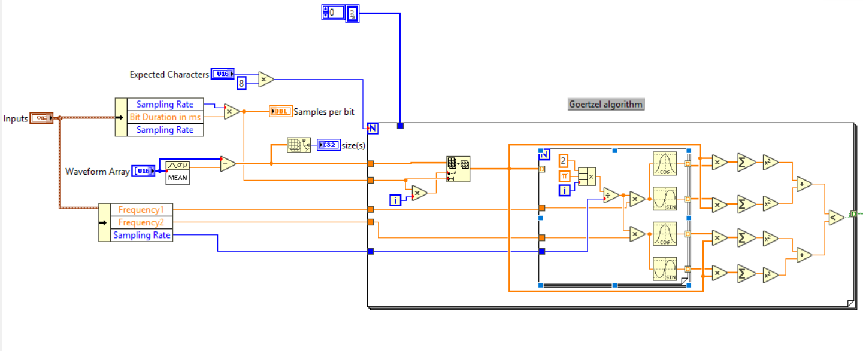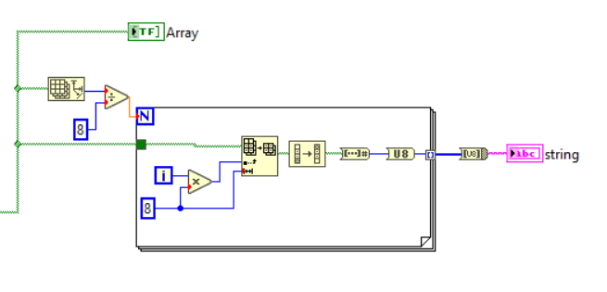

7.1 Decoder inputs
Input | Meaning
CH1 voltage array | The acquired waveform returned by the acquisition chain.
Sampling rate | The acquisition/generation sampling rate used for samples-per-bit calculation.
Bit duration | Duration of each bit, example 0.05 s.
Frequency 1 | Reference frequency for bit 0.
Frequency 2 | Reference frequency for bit 1.
Expected characters | Number of characters to decode.

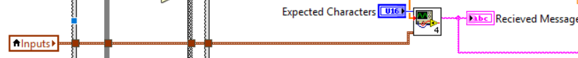

7.2 Remove DC offset
The first decoder step removes the DC offset from the acquired CH1 waveform. This is done by subtracting the average value of the acquired array from every sample.
DC offset = Mean(CH1 array)
Signal without DC = CH1 array - DC offset
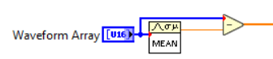

7.3 Bit windows
A window is the subset of the acquired array that belongs to one bit. If the sampling rate is 50000 Hz and bit duration is 0.05 s, then each bit window contains 2500 samples.
Samples per bit = sampling rate × bit duration
Samples per bit = 50000 × 0.05 = 2500
For A = 8 bits:
Useful message samples = 8 × 2500 = 20000
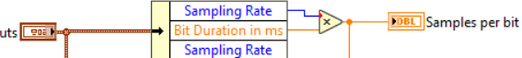

7.4 Frequency-energy comparison
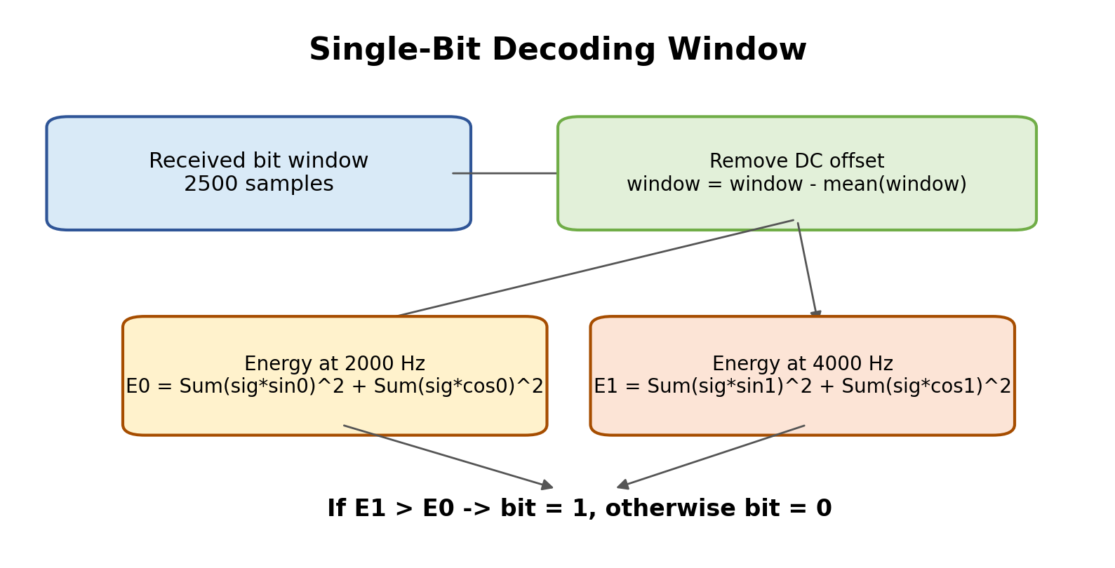
Figure 6. One-bit window energy comparison used by the decoder.
For each bit window, the decoder checks whether Frequency 1 or Frequency 2 is stronger. The robust method is phase-independent correlation: compare the window against sine and cosine references for both frequencies.
For Frequency 1:
E0 = Sum(signal × sin_ref_f1)^2 + Sum(signal × cos_ref_f1)^2
For Frequency 2:
E1 = Sum(signal × sin_ref_f2)^2 + Sum(signal × cos_ref_f2)^2
If E1 > E0, decoded bit = 1
Otherwise, decoded bit = 0
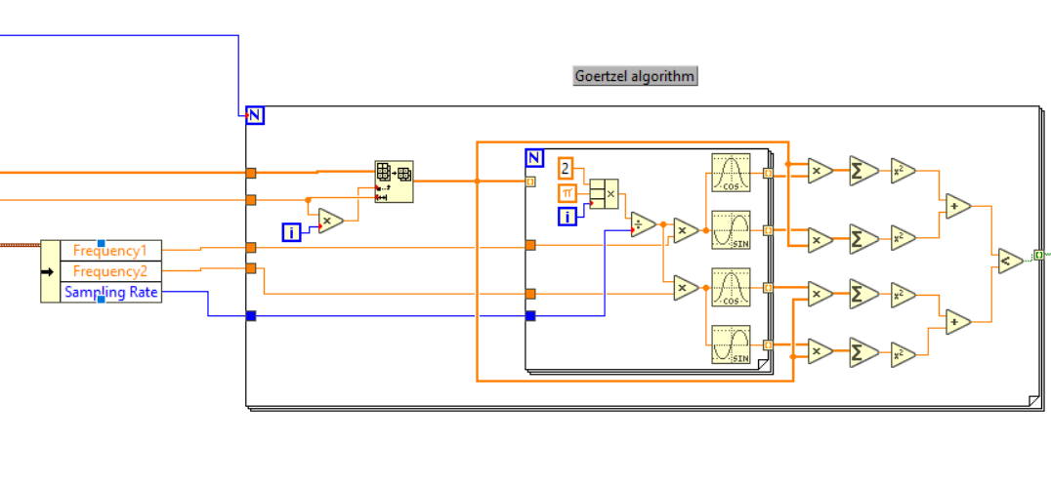

7.5 Convert bits back to text
After all bits are recovered, the decoder groups every 8 bits into one byte and converts that byte into an ASCII character. The bit order must match the generation order. If the generator sends MSB first, the decoder must reconstruct bytes using MSB first.
Example:
Decoded bits = 01000001
Binary 01000001 = decimal 65
ASCII 65 = A
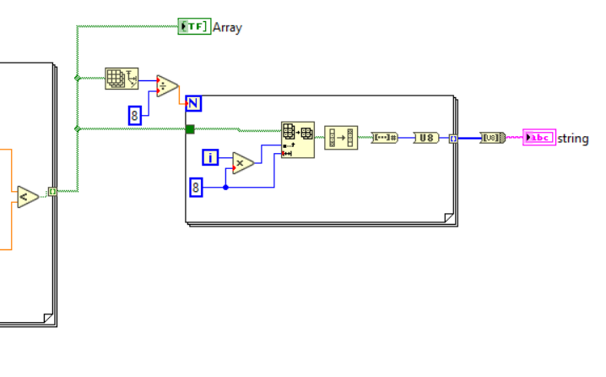

8. Running the project
Use the following steps for normal testing with direct TiePie OUT-to-CH1 loopback.
- Connect TiePie generator OUT directly to CH1.
- Open and run the main VI.
- Enter the transmission message, for example A or ABCD.
- Set Expected Characters to match the message length.
- Use the existing Frequency 1, Frequency 2, bit duration, amplitude, and sampling rate values, unless you intentionally want to test different values.
- Do not manually enter No. of samples or Postsamples; these are updated automatically from the generated waveform length.
- Click Start Acquisition first so CH1 is armed.
- Click Start Generation to transmit the encoded signal.
- Wait for acquisition to become DataReady, then read/decode the waveform.
- Check the Received Message indicator on the front panel.
Frequency selection rule
The two frequencies can be changed from the front panel. The sampling rate must be at least twice the highest selected frequency. For better stability, use significantly more than twice the highest frequency. Example: for 4000 Hz, the absolute minimum is above 8000 Hz, but 50000 Hz is safer.

9. Known behavior and troubleshooting
Observed behavior | Likely reason | Fix / note
Decoder works when using generated waveform directly, but not through hardware | Hardware acquisition path or timing issue, not decoder logic | Verify with sine wave first. Confirm OUT to CH1, correct range, DC coupling, and correct mode.
Only noise appears on CH1 | Generator not actually outputting, wrong mode, too large range, or wrong acquisition timing | Use sine test with SetFuncGenMode = 1 and SignalType = Sine.
Clean sine appears but FSK decodes wrong | FSK acquisition starts at wrong point or includes padding/silence incorrectly | Arm acquisition first; use Gen trigger; decode only useful message samples.
Continuous FSK jitters while generator button is ON | Acquisition may capture from the middle of repeating buffer | For final one-shot test, arm acquisition first and stop generator after calculated buffer duration.
One character works but two characters look wrong/noisy | RecordLength, PostSamples, wait time, or Expected Characters still using old one-character values | Update based on message length. AB needs 40000 useful samples and 65536 padded samples with 50000 Hz and 0.05 s bits.
Received message is random during sine test | Decoder is being applied to a plain sine wave, not FSK data | Ignore decoder output during sine test.
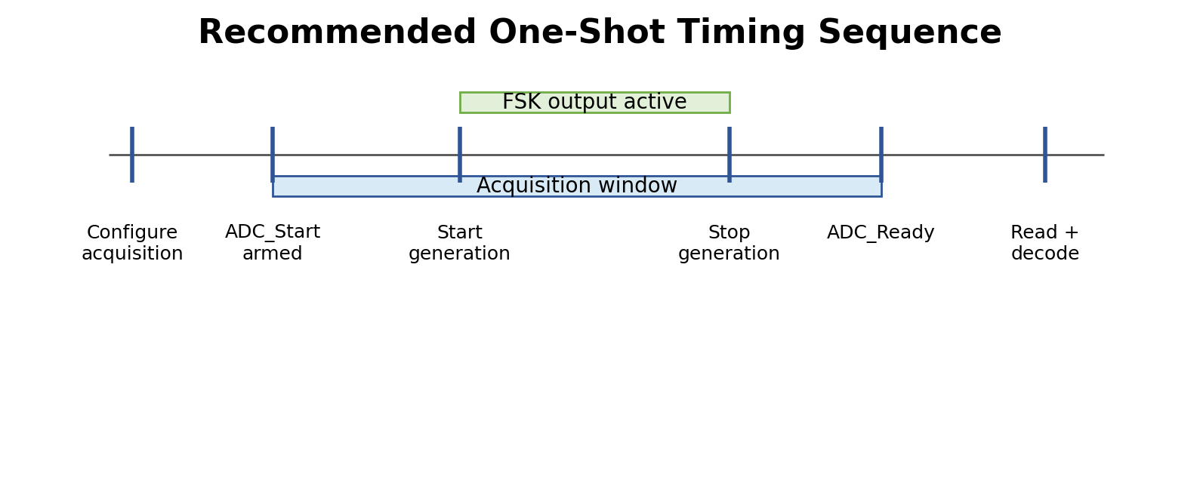
Figure 7. Recommended one-shot timing sequence to avoid missing the short waveform.

10. Pre-Calculation Loop for Acquisition Sample Count
An independent pre-calculation loop is added to calculate the required number of samples as soon as the user enters or updates the transmission message. This loop uses the same waveform-length calculation logic as the Waveform Gen.vi, but it runs before the generation process starts.
This is required because the acquisition must be configured before transmission begins. The TiePie acquisition chain needs the correct values for No. of samples and Postsamples before ADC_Start() is called. However, in the normal generation flow, the waveform length is calculated later during the generation state, which would be too late because acquisition is started first.
To solve this, the loop continuously monitors the transmission message. When the message is changed or entered, it calculates the generated waveform length, including padding, and writes this value to the local variables of:
- No. of samples
- Postsamples
- Expected Characters
This ensures that when the user starts acquisition, the system already knows how many samples must be captured for the current message.
Block Diagram Reference:
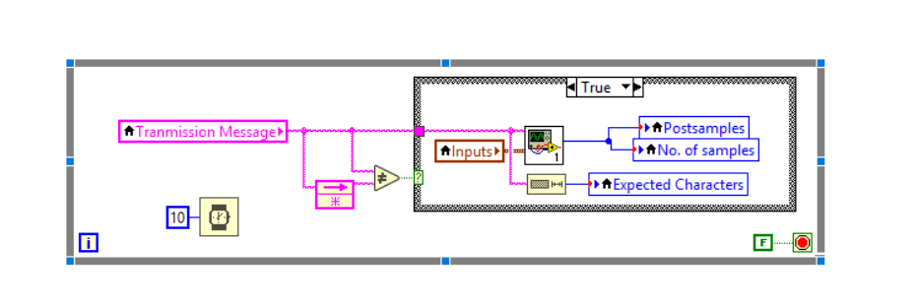

10. Technical reference summary
The implementation uses the TiePie DLL interface through LabVIEW Call Library Function Nodes. Key manual points used in the code are summarized below.
- TiePie DLL Programmer's Manual, Revision 1.29: SetFuncGenMode supports DDS mode and Linear mode. DDS mode uses SetFuncGenFrequency as output signal frequency; Linear mode uses SetFuncGenFrequency as generator sampling clock.
- TiePie DLL Programmer's Manual, Revision 1.29: SetFuncGenSignalType supports Sine and Arbitrary signal types; arbitrary mode plays the waveform memory.
- TiePie DLL Programmer's Manual, Revision 1.29: FillFuncGenMemory loads unsigned 16-bit waveform samples into the generator memory.
- TiePie DLL Programmer's Manual, Revision 1.29: SetFuncGenOutputOn and SetFuncGenEnable control generator output and continuous generation.
- TiePie DLL Programmer's Manual, Revision 1.29: SetRecordLength, SetPostSamples, SetMeasureMode, SetSampleFrequency, ADC_Start, ADC_Running, ADC_Ready, ADC_ForceTrig, and ADC_GetDataVoltCh are used for acquisition.

