Requirements Specifications

P07: ACASA - Automated Compliance Auditing Software integrated with Ai

Student ID | Name
25100132 | Shabbir Kamal
25100277 | Ammad Akram
25100279 | Rida Bilgrami
25100166 | S. M. Aqdas Rizvi

Table of Contents

1. Introduction 3
2. System Actors 4
3. Use Cases 5
3.1 Use Case Diagrams 5
3.2 Description of Use Cases 5
3.2.1 Withdraw cash 5
3.2.2 Transfer funds 6
4. Class Diagram 7
4.1 Diagram 7
4.2 Description 7
5. Sequence Diagrams 8
5.1 Use case Name e.g., Withdraw cash 8
5.2 Use case Name e.g., Transfer funds 8
6. State Diagrams 9
6.1 Diagram details 9
6.2 Diagram 9
7. Non-functional Requirements / Quality Attributes 10
8. Who Did What? 11
9. Review checklist 11

Introduction

<Give an overview of the project here. The overview must highlight the overall objectives of the project and its potential users and customers.>

Overview: ACASA (Automated Compliance Auditing Software using AI) aims to automate the auditing of compliance standards such as HIPAA, ISO 27001, PCI-DSS, and GDPR. It utilizes open-source libraries and AI-driven decision-making to address current market gaps, particularly by offering a cost-effective, fully automated solution. ACASA targets organizations needing to streamline compliance processes, reducing human intervention and error, while improving audit accuracy and efficiency.

Potential Users:
- Compliance Officers
- IT Security Teams
- Executives
- Auditors

System Actors

<List down the actor names and give a 2-3 lines description of the role of each actor>

Actor Name | Description
Compliance Officer | Responsible for ensuring that the organization adheres to relevant compliance standards (e.g., HIPAA).
IT Security Teams | Manage endpoint security and ensure systems remain compliant with industry regulations.
Executives | Require high-level reports on the organization’s compliance status for decision-making purposes.
Auditors | Conduct compliance audits either internally or externally, ensuring adherence to set standards.

Use Cases

Use Case Diagrams

<Use standard UML notation>

Description of Use Cases

[Select 20 most important use cases of your project and create their comprehensive descriptions.]

<Write description of each use case separately using the template below.>

User Authentication

Identifier |  | UC-01
Purpose |  | Secure system access through verified user credentials.
Pre-conditions |  | User is at the login interface.
Post-conditions |  | User is authenticated and logged in.
Step # | Typical Course of Action
 | User logs in
 | System authenticates.
 | System grants access based on credentials.
Step # | Alternate Courses of Action
 | At Step 1 and Step 3 provide password reset or retrieval options if login fails.
Step # | Exception Paths
 | In Step 2, If system cannot access the user database, display an error and log the incident.

User Registration / Sign Up

Identifier |  | UC-02
Purpose |  | Enable new users to create accounts to access system features.
Pre-conditions |  | New user has valid email and agrees to terms.
Post-conditions |  | User account is created and able to access the system.
Step # | Typical Course of Action
 | User provides details;
 | System registers and confirms via email.
Step # | Alternate Courses of Action
1. | If email is already in use, suggest login instead.
Step # | Exception Paths
1. | If registration fails, provide an error message and log the incident.

Document Upload for Compliance Checking

Identifier |  | UC-03
Purpose |  | Allow users to upload documents necessary for compliance evaluation.
Pre-conditions |  | User is authenticated and on the upload interface.
Post-conditions |  | Documents are stored for analysis.
Step # | Typical Course of Action
 | User uploads files
 | System validates and stores them securely.
Step # | Alternate Courses of Action
 | Notify user of unsupported file types or sizes and provide guidance.
Step # | Exception Paths
 | If upload fails due to server issues, log the event and alert the user to try later.

Compliance Report Generation

Identifier |  | UC-04
Purpose |  | Generate comprehensive compliance reports from evaluations.
Pre-conditions |  | Compliance checks are completed.
Post-conditions |  | A detailed report is generated and available to the user.
Step # | Typical Course of Action
 | System compiles data into reports
 | Provides reports to users.
Step # | Alternate Courses of Action
 | Go back to Home Page if report generation is cancelled.
Step # | Exception Paths
 | If report generation fails, notify the user and log the issue for IT support.

Checklist and Proof Storage for Manual Auditing

Identifier |  | UC-05
Purpose |  | Store checklists and proofs for manual auditing of compliance rules.
Pre-conditions |  | User has checklist and proof documents ready for upload.
Post-conditions |  | Documents are stored and indexed for easy retrieval.
Step # | Typical Course of Action
 | User uploads documents
 | System stores and indexes for retrieval.
Step # | Alternate Courses of Action
 | Go back to Home Page if document uploading is cancelled.
Step # | Exception Paths
 | If upload or storage fails, provide error feedback and troubleshooting steps.

Endpoint Device Compliance Check

Identifier |  | UC-06
Purpose |  | Verify endpoint device compliance with security policies.
Pre-conditions |  | Endpoint device information is uploaded to the system.
Post-conditions |  | Compliance report is generated for endpoint devices.
Step # | Typical Course of Action
 | System assesses device configurations.
 | Generates compliance status.
Step # | Alternate Courses of Action
 | Goes back to home page in case of a cancelled scan.
Step # | Exception Paths
 | If the system cannot process data, log the error and notify the user.

Privileged Access Rights Compliance Audit

Identifier |  | UC-07
Purpose |  | Ensure that privileged access rights are granted in compliance with security policies.
Pre-conditions |  | Access rights data is available for audit.
Post-conditions |  | Compliance report on privileged access rights is produced.
Step # | Typical Course of Action
 | System reviews access rights.
 | Produces a compliance report.
Step # | Alternate Courses of Action
 | Goes back to home page if scanning is cancelled.
Step # | Exception Paths
 | If access rights data is corrupt or inaccessible, escalate the issue for technical resolution.

Network Security Compliance Audit

Identifier |  | UC-08
Purpose |  | Assess network settings against compliance with security standards.
Pre-conditions |  | Network configuration data is provided.
Post-conditions |  | Network security compliance report is generated.
Step # | Typical Course of Action
 | System audits network security.
 | Documents compliance in a report.
Step # | Alternate Courses of Action
 | Advises on network configuration changes if compliance is not met.
Step # | Exception Paths
 | If network data retrieval fails, notify the user and log the incident.

Cloud Services Security Compliance Audit

Identifier |  | UC-09
Purpose |  | Verify the security compliance of cloud services used by the organization.
Pre-conditions |  | Cloud service configurations are documented and accessible.
Post-conditions |  | Compliance report on cloud services is produced.
Step # | Typical Course of Action
 | System checks cloud services against security standards.
 | Reports findings.
Step # | Alternate Courses of Action
 | Provide recommendations for security improvements if non-compliance is found.
Step # | Exception Paths
 | If cloud data cannot be accessed, escalate to cloud service providers for resolution.

Access Control Compliance Audit

Identifier |  | UC-10
Purpose |  | Audit the effectiveness and compliance of access control mechanisms with security policies.
Pre-conditions |  | Access control configurations are uploaded to the system.
Post-conditions |  | Detailed compliance report on access controls is available.
Step # | Typical Course of Action
 | System evaluates access controls.
 | Provides detailed compliance feedback.
Step # | Alternate Courses of Action
 | If discrepancies are identified, suggest corrective measures.
Step # | Exception Paths
 | If system fails to retrieve data, log the incident and notify the system administrator.

Information Security Policy Compliance Audit

Identifier |  | UC-11
Purpose |  | Ensure organizational operations adhere to the information security policy.
Pre-conditions |  | Information security policies are documented.
Post-conditions |  | Compliance report on information security policies is generated.
Step # | Typical Course of Action
 | System audits operations.
 | Generates a detailed compliance report.
Step # | Alternate Courses of Action
 | Provide recommendations for improvements if non-compliance is found.
Step # | Exception Paths
 | If policy documents are outdated or missing, initiate a policy review and update process.

Web Filtering Compliance Check

Identifier |  | UC-12
Purpose |  | Confirm that web filtering settings are compliant with organizational policies.
Pre-conditions |  | Web filtering settings are configured and operational.
Post-conditions |  | Compliance report on web filtering settings is generated.
Step # | Typical Course of Action
 | System evaluates web filtering configurations.
 | Reports compliance.
Step # | Alternate Courses of Action
 | Provide recommendations for improvements if non-compliance is found. And notify the user about it.
Step # | Exception Paths
 | If filtering settings cannot be accessed or evaluated, notify IT support.

Employee Data Privacy Compliance Audit

Identifier |  | UC-13
Purpose |  | Audit the handling of employee data to ensure it complies with privacy laws and policies.
Pre-conditions |  | Employee data handling practices are documented.
Post-conditions |  | Compliance report on data privacy is available.
Step # | Typical Course of Action
 | System reviews data handling practices.
 | Reports on compliance.
Step # | Alternate Courses of Action
 | Propose updates to data handling practices to enhance privacy compliance.
Step # | Exception Paths
 | If data practices are not documented, require immediate documentation before proceeding.

Contractual Agreements Compliance Check

Identifier |  | UC-14
Purpose |  | Ensure that contractual agreements adhere to legal and policy standards.
Pre-conditions |  | Contractual documents are available and uploaded.
Post-conditions |  | Compliance report on contractual agreements is generated.
Step # | Typical Course of Action
 | System audits contracts.
 | Reports on compliance.
Step # | Alternate Courses of Action
 | Notify User to revise contracts if non-compliance is detected. And notify the user about it.
Step # | Exception Paths
 | If contract documents are incomplete or inaccessible, notify the responsible party to provide complete documents.

Source Code Access Control Audit

Identifier |  | UC-15
Purpose |  | Verify that access to source code is controlled and compliant with security standards.
Pre-conditions |  | Source code access details are available for review.
Post-conditions |  | Report on source code access compliance is generated.
Step # | Typical Course of Action
 | System reviews source code access; reports on compliance.
 | Reports on compliance.
Step # | Alternate Courses of Action
 | Recommend additional security measures if access controls are inadequate. And notify the user about it.
Step # | Exception Paths
 | If access details are not available or are corrupted, escalate to security for immediate resolution.

Information Classification Compliance Audit

Identifier |  | UC-16
Purpose |  | Ensure information is classified according to defined standards and policies.
Pre-conditions |  | Information classification policies are in place.
Post-conditions |  | Compliance report on information classification is available.
Step # | Typical Course of Action
 | System audits information classification.
 | Produces compliance report.
Step # | Alternate Courses of Action
 | Suggest reclassification of information if current classification does not meet standards. And notify the user about it.
Step # | Exception Paths
 | If classification data is outdated or missing, prompt for an immediate update and reassessment.

Cloud Service Usage Compliance Check

Identifier |  | UC-17
Purpose |  | Verify that the use of cloud services complies with organizational security and privacy policies.
Pre-conditions |  | Cloud service usage data is documented and accessible.
Post-conditions |  | Compliance report on cloud service usage is produced.
Step # | Typical Course of Action
 | System reviews cloud service usage.
 | Reports on compliance.
Step # | Alternate Courses of Action
 | Suggest changes to cloud service configurations to improve compliance. And notify the user about it.
Step # | Exception Paths
 | If usage data cannot be accessed, investigate and resolve access issues.

Terms of Employment Compliance Check

Identifier |  | UC-18
Purpose |  | Ensure terms and conditions of employment comply with legal and organizational standards.
Pre-conditions |  | Employment terms documentation is available.
Post-conditions |  | Compliance report on employment terms is generated.
Step # | Typical Course of Action
 | System reviews employment terms.
 | Reports on compliance.
Step # | Alternate Courses of Action
 | Advise User to update employment terms if they do not meet current standards. And notify the user about it.
Step # | Exception Paths
 | If employment documents are missing or outdated, request updates and delay the compliance check.

Confidentiality Agreement Compliance Audit

Identifier |  | UC-19
Purpose |  | Audit confidentiality agreements to ensure they meet legal and organizational compliance standards.
Pre-conditions |  | Confidentiality agreements are collected and ready for review.
Post-conditions |  | Compliance report on confidentiality agreements is produced.
Step # | Typical Course of Action
 | System reviews confidentiality agreements.
 | Reports on compliance.
Step # | Alternate Courses of Action
 | Provide feedback on agreements and advise improvements if non-compliance is found. And notify the user about it.
Step # | Exception Paths
 | If agreements are not accessible or are incomplete, notify the responsible party to rectify the situation.

Data Protection Impact Assessment Audit

Identifier |  | UC-20
Purpose |  | Secure system access through verified user credentials.
Pre-conditions |  | User is at the login interface.
Post-conditions |  | User is authenticated and logged in.
Step # | Typical Course of Action
 | System conducts impact assessments.
 | Reports on findings.
Step # | Alternate Courses of Action
 | Suggest modification of processes or technologies based on impact assessment findings to enhance data protection. And notify the user about it.
Step # | Exception Paths
 | If the assessment cannot be completed due to lack of data, delay implementation and gather necessary information.

Class Diagram

Diagram

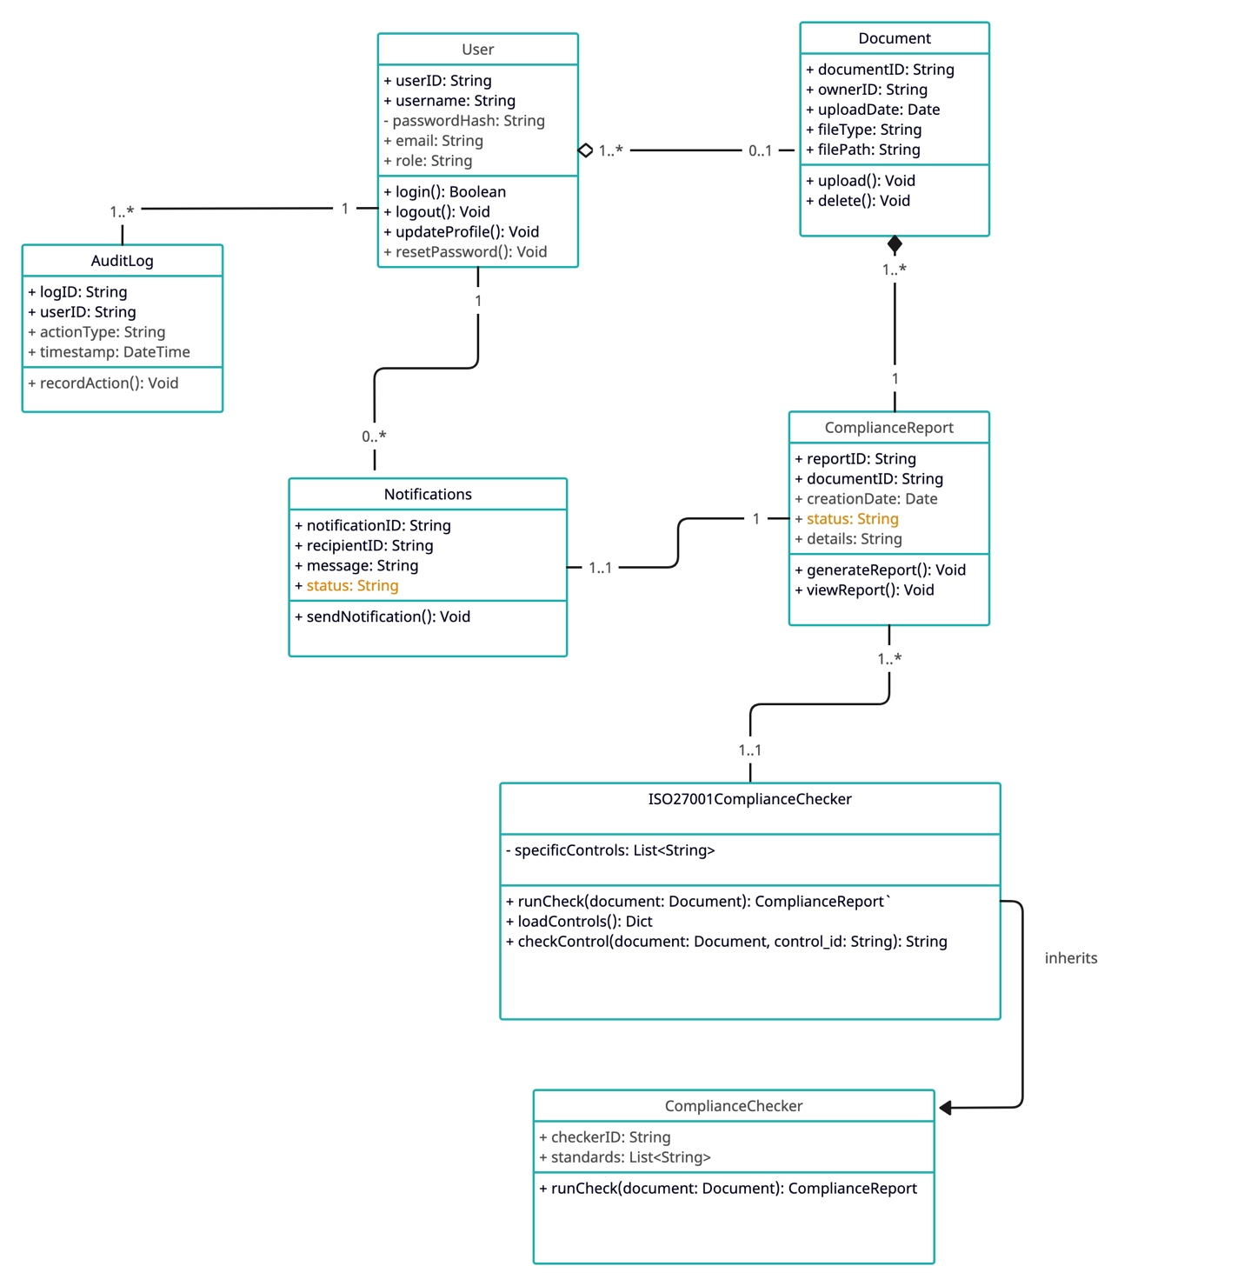

Description

<Give brief description/purpose of each class in the class diagram. Give readable names to classes, attributes and operations.>

1. User
The User class represents individuals who interact with the ACASA system. Users can log in, upload documents, and generate reports. The attributes include userID, which serves as a unique identifier for the user; username, the name used to identify the user; passwordHash, a secure hash of the user's password; email, the user's email address; and role, which defines the user's role (e.g., admin, regular user). The User class has an aggregation relationship with the Document class, as a user can own multiple documents. It also has associations with the AuditLog class, as users have associated audit logs to record their actions, and with the Notification class, as users can receive multiple notifications.

2. Document
The Document class represents files uploaded by users, which can be associated with compliance reports. Its attributes include documentID, which is a unique identifier for the document; ownerID, indicating the user who owns the document; uploadDate, marking the date when the document was uploaded; fileType, which specifies the type of the document (e.g., PDF, DOCX); and filePath, the path where the document is stored. The Document class has a composition relationship with the ComplianceReport class because a compliance report cannot exist without a corresponding document.

3. ComplianceReport
The ComplianceReport class represents the reports generated based on document compliance checks. It includes details about compliance status and related information. The attributes of this class include reportID, a unique identifier for the compliance report; documentID, which links to the document associated with this report; creationDate, marking the date when the report was created; status, indicating the current status of the report (e.g., compliant, non-compliant); and details, which provide additional information about the compliance check. The ComplianceReport class is linked to the Document class through composition.

4. ComplianceChecker
The ComplianceChecker class represents a general compliance checking mechanism that processes documents to generate compliance reports. Its attributes include checkerID, a unique identifier for the compliance checker, and standards, which is a list of compliance standards used for checks. The main operation of this class is runCheck(document: Document), which allows the compliance checker to run a compliance check on a given document. The ComplianceChecker class uses the Document class to generate ComplianceReports.

5. ISO27001ComplianceChecker
The ISO27001ComplianceChecker class is a specialized compliance checker focusing specifically on ISO 27001 standards. It inherits from the ComplianceChecker class, establishing a parent-child relationship. This class includes the attribute specificControls, which is a list of specific controls related to ISO 27001 compliance. Its operations include runCheck(document: Document), which overrides the base method to run checks against ISO 27001 standards; loadControls(), which loads the specific controls for compliance checking; and checkControl(document: Document, control_id: String), which checks a specific control against the document.

6. AuditLog
The AuditLog class records actions performed by users within the system, ensuring accountability and traceability. Its attributes include logID, a unique identifier for the audit log entry; userID, which identifies the user whose action is being logged; actionType, specifying the type of action performed (e.g., upload, download); and timestamp, indicating the date and time when the action occurred. The AuditLog class has an association with the User class, linking audit logs to the specific users who performed the actions.

7. Notification
The Notification class represents messages sent to users to inform them of events, updates, or actions that require their attention. Its attributes include notificationID, a unique identifier for the notification; recipientID, which identifies the user receiving the notification; message, containing the content of the notification; and status, indicating the status of the notification (e.g., sent, read). The Notification class is associated with the User class, as users can receive multiple notifications.

Sequence Diagrams

<Create a sequence diagram for each of the 20 use cases selected above.>

UC – 01: User Authentication

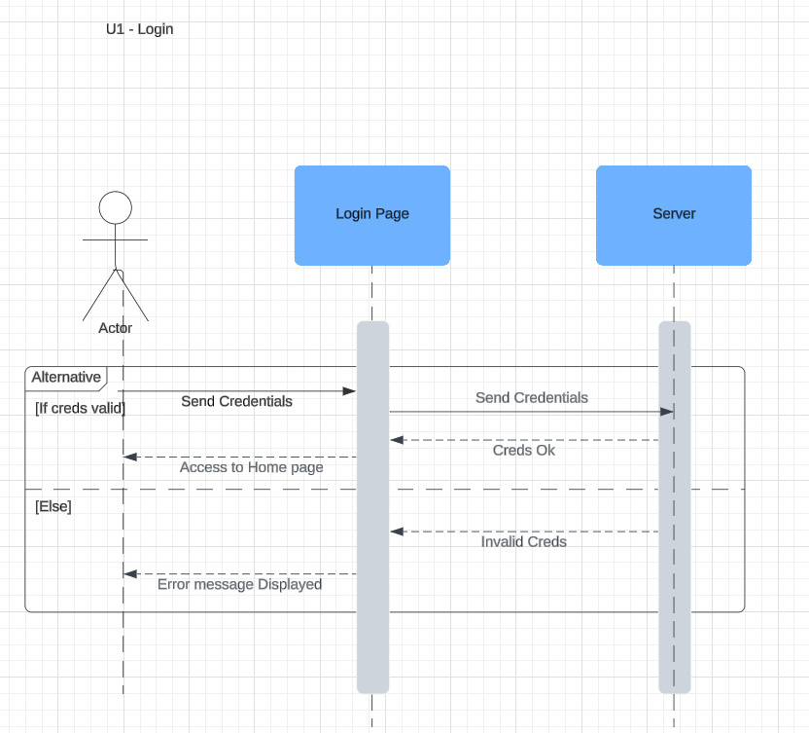

UC – 02: User Registration/Sign Up

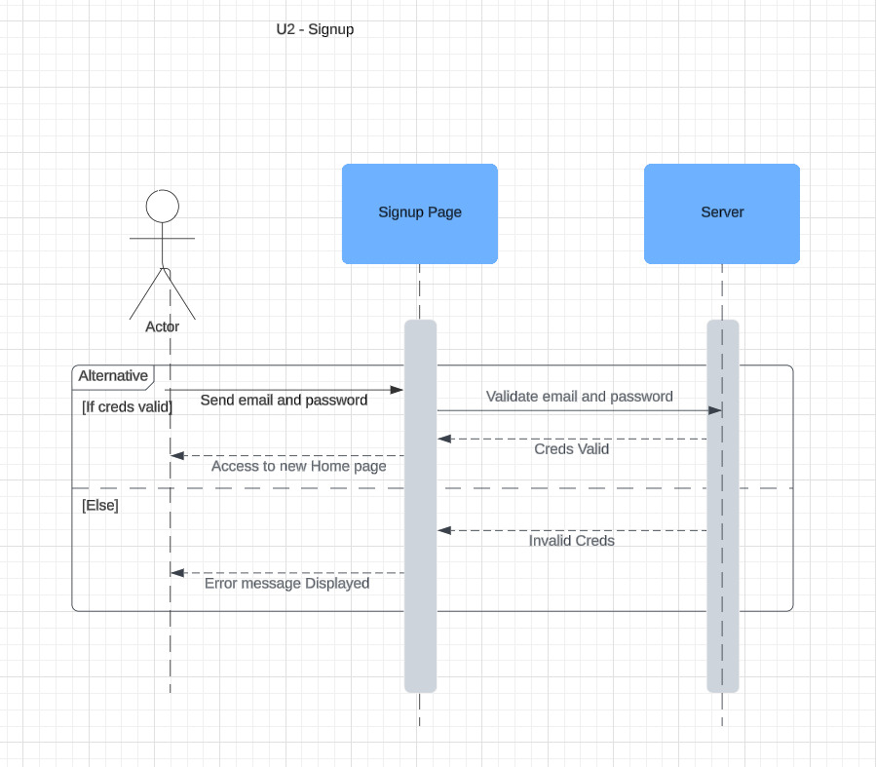

UC – 03: Document Upload for Compliance Checking

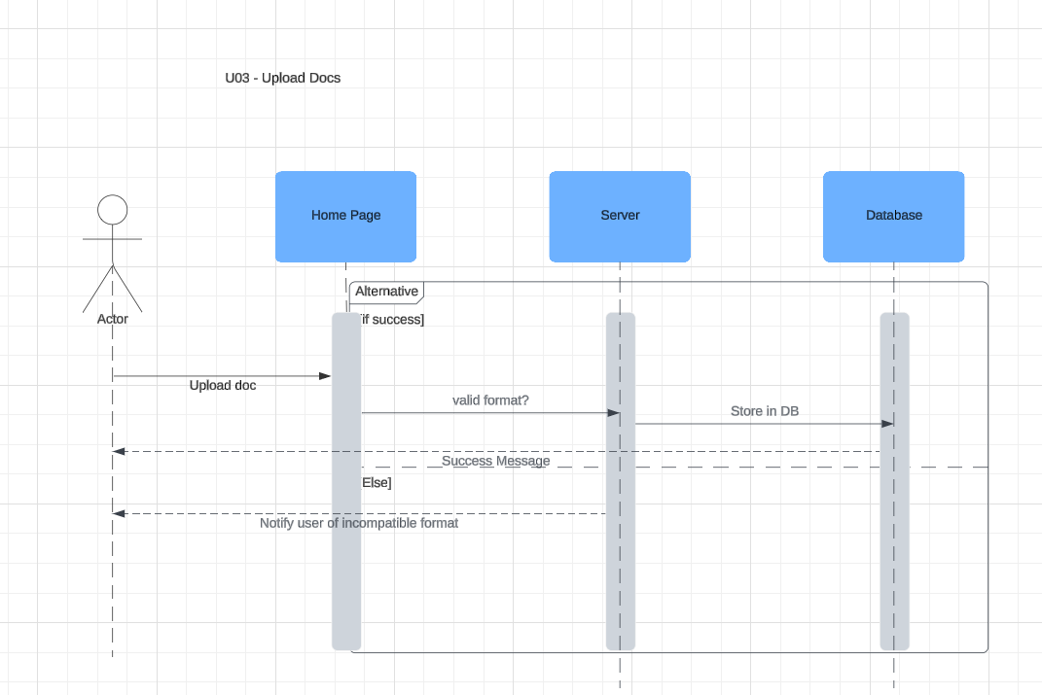

UC – 04: Compliance Report Generation

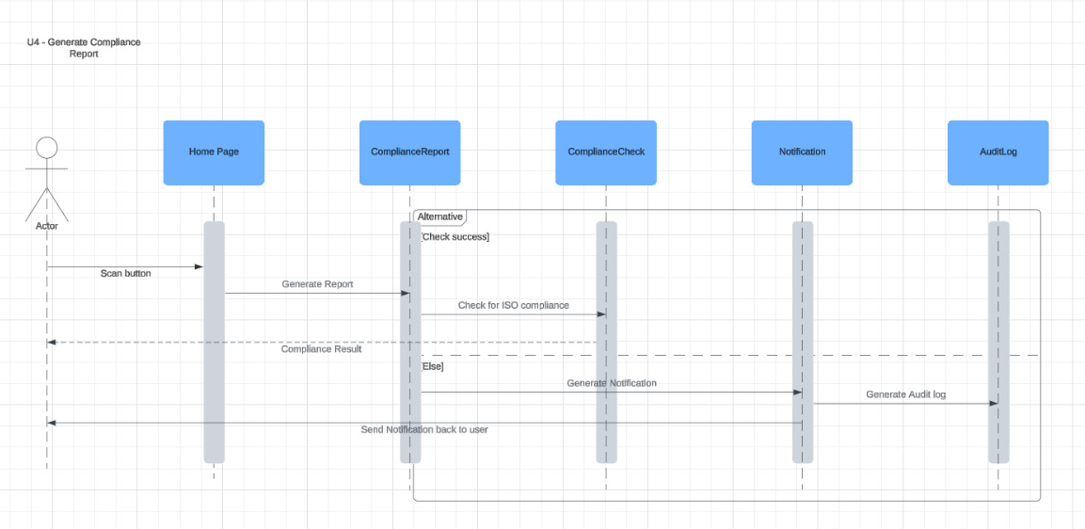

UC – 05: Checklist and Proof Storage for Manual Auditing

UC – 06: Endpoint Device Compliance Check

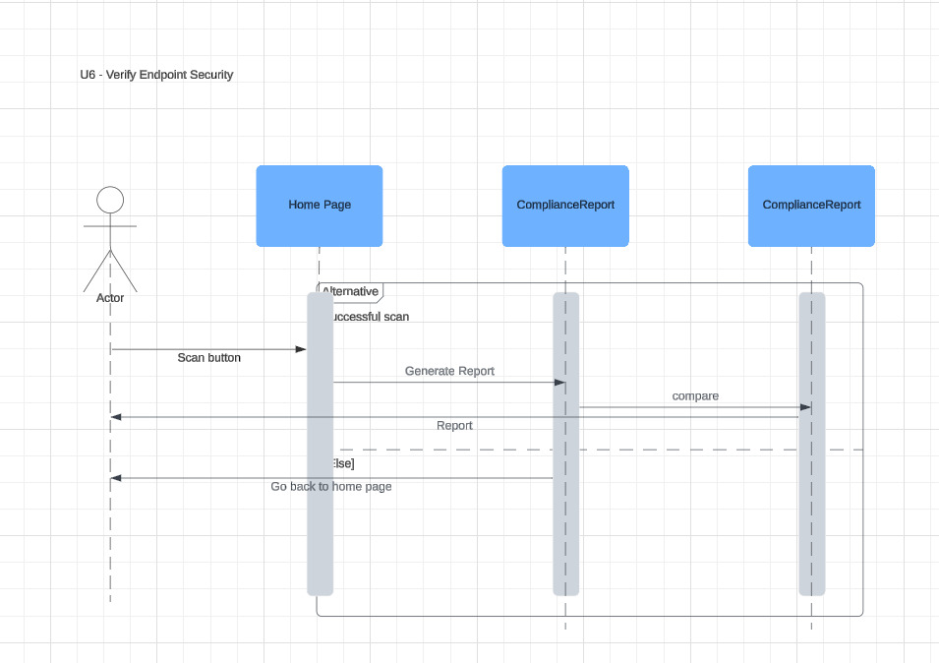

UC – 07: Privileged Access Rights Compliance Audit

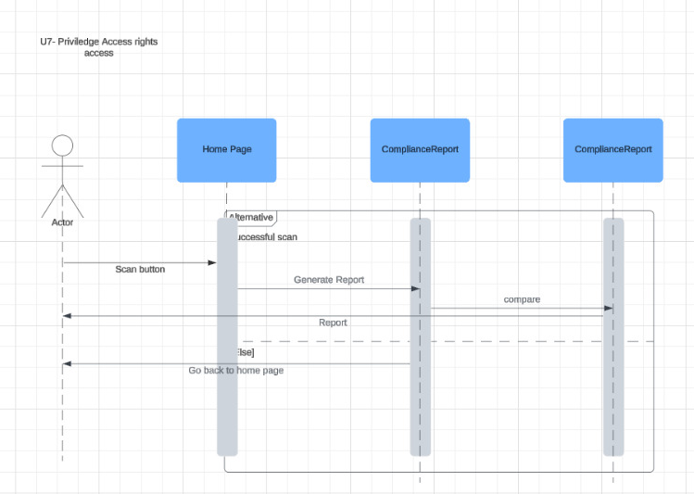

UC – 08: Network Security Compliance Audit

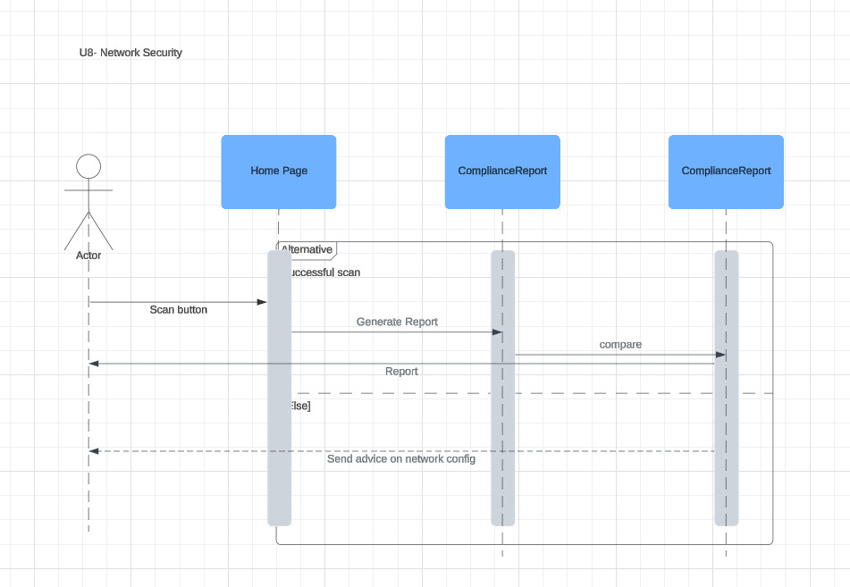

UC – 09: Cloud Services Security Compliance Audit

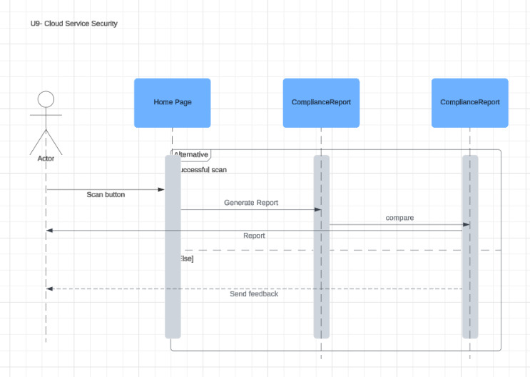

UC – 10: Access Control Compliance Audit

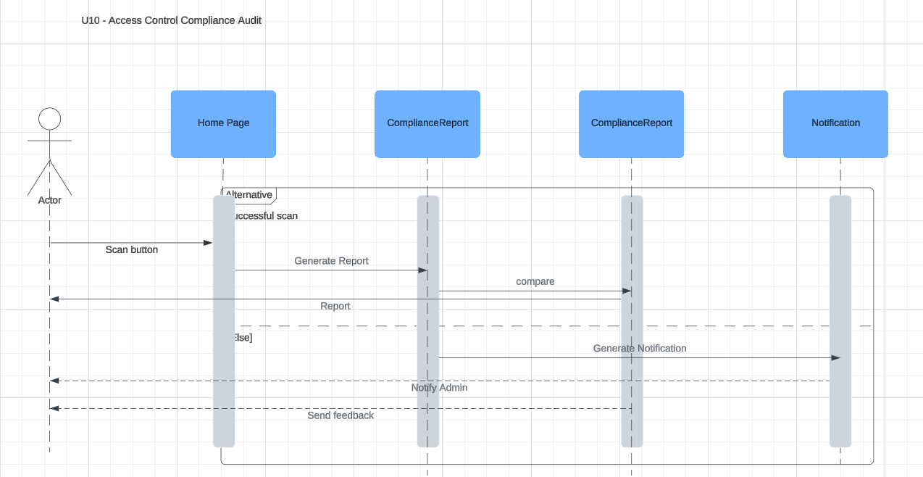

UC – 11: Information Security Policy Compliance Audit

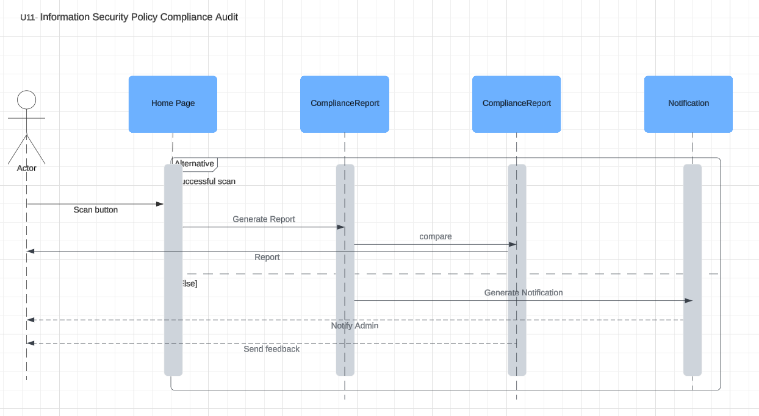

UC – 12: Web Filtering Compliance Check

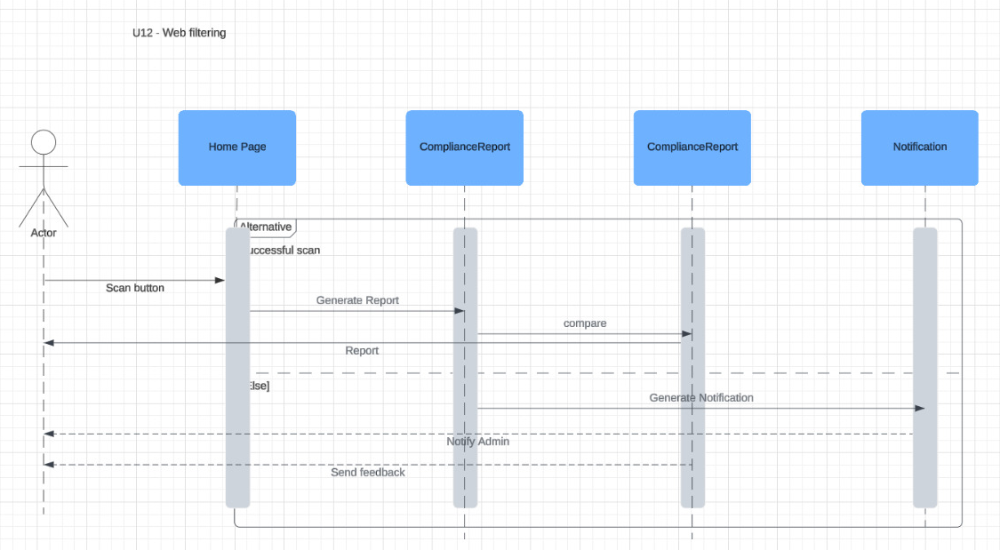

UC – 13: Employee Data Privacy Compliance Audit

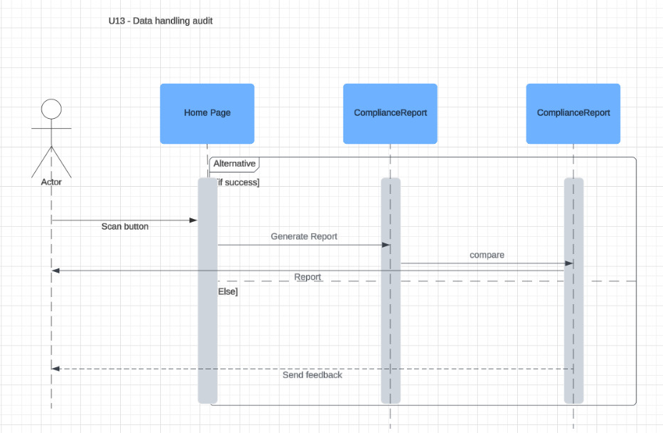

UC – 14: Contractual Agreements Compliance Check

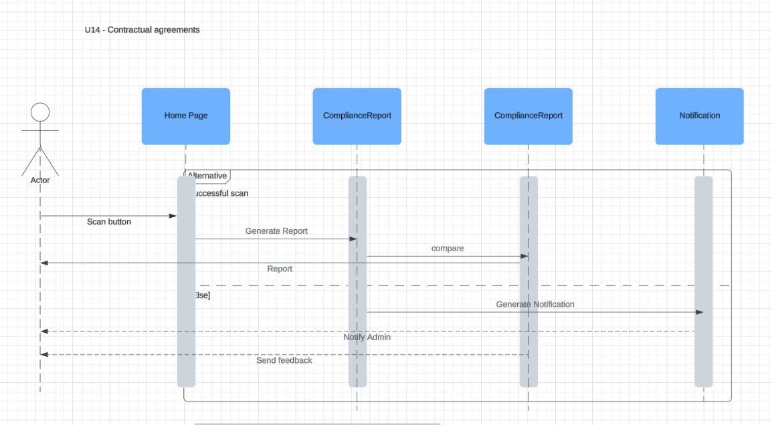

UC – 15: Source Code Access Control Audit

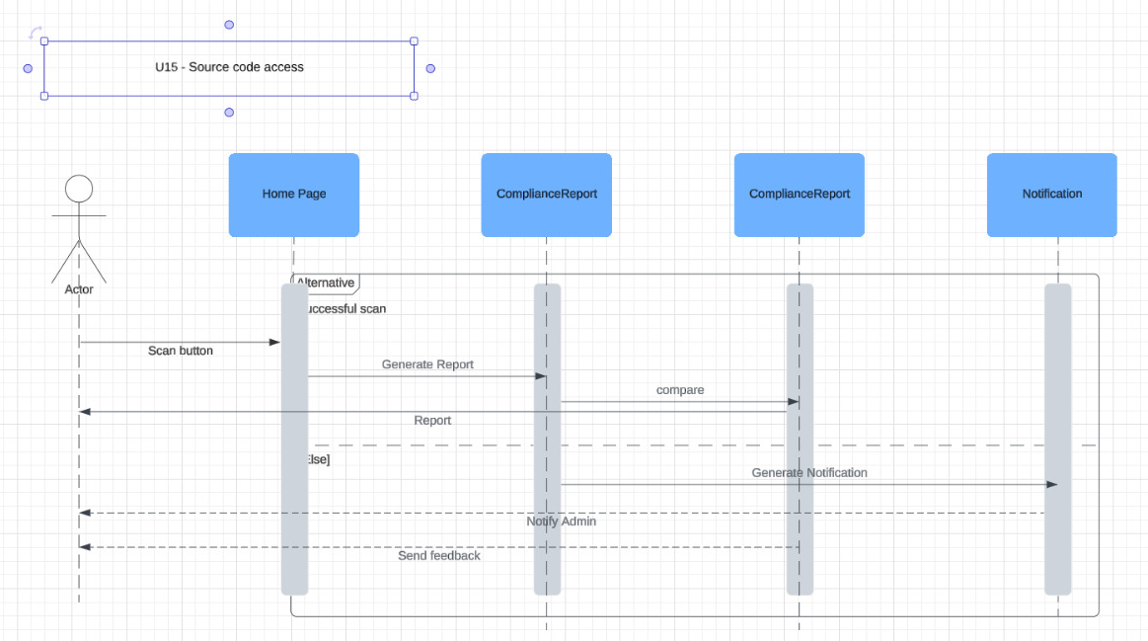

UC – 16: Information Classification Compliance Audit

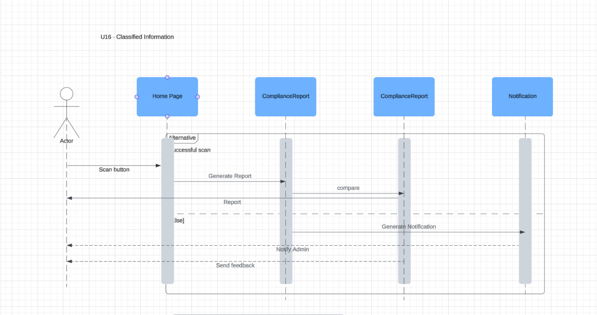

UC – 17: Cloud Service Usage Compliance Check

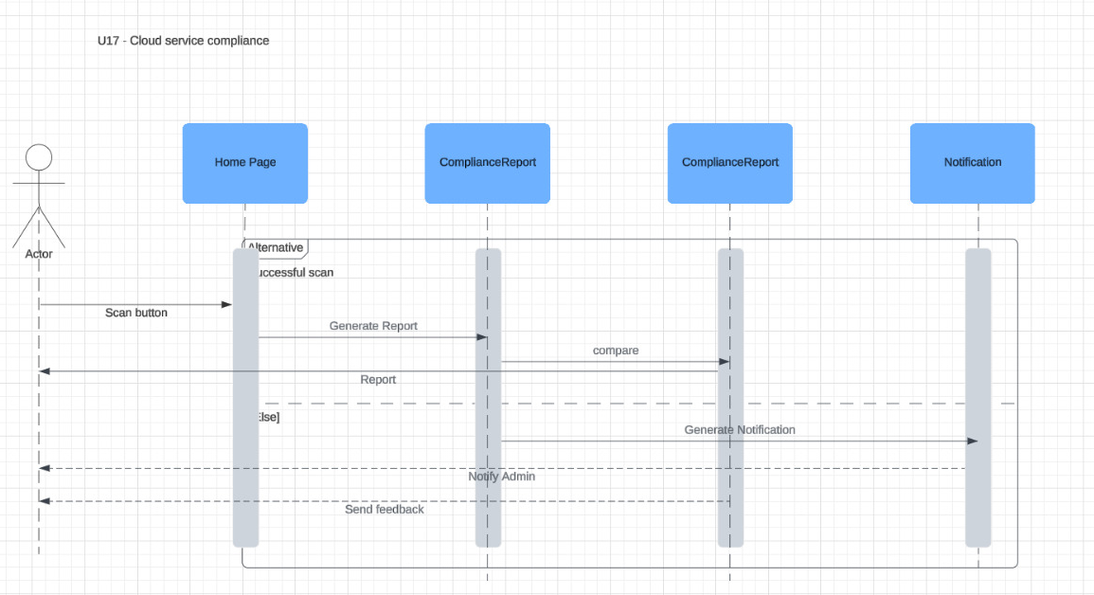

UC – 18: Terms of Employment Compliance Check

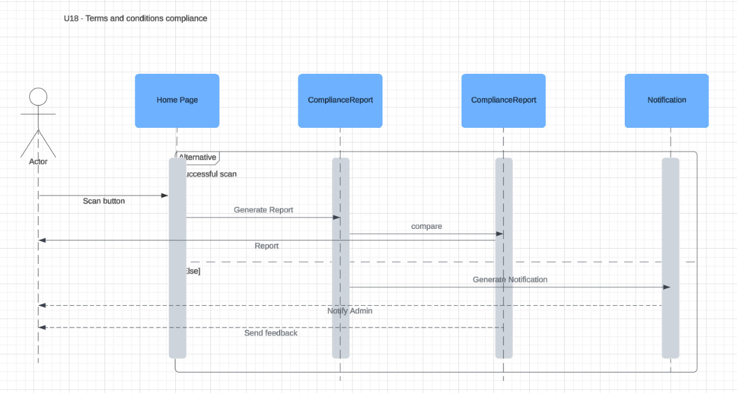

UC – 19: Confidentiality Agreement Compliance Audit

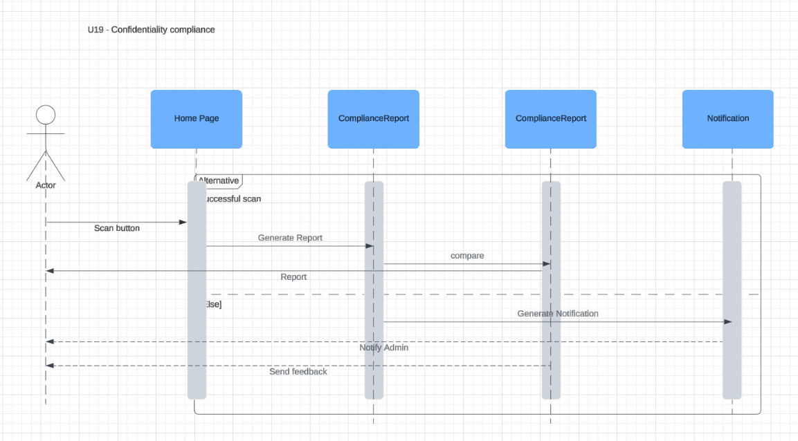

UC – 20: Data Protection Impact Assessment Audit

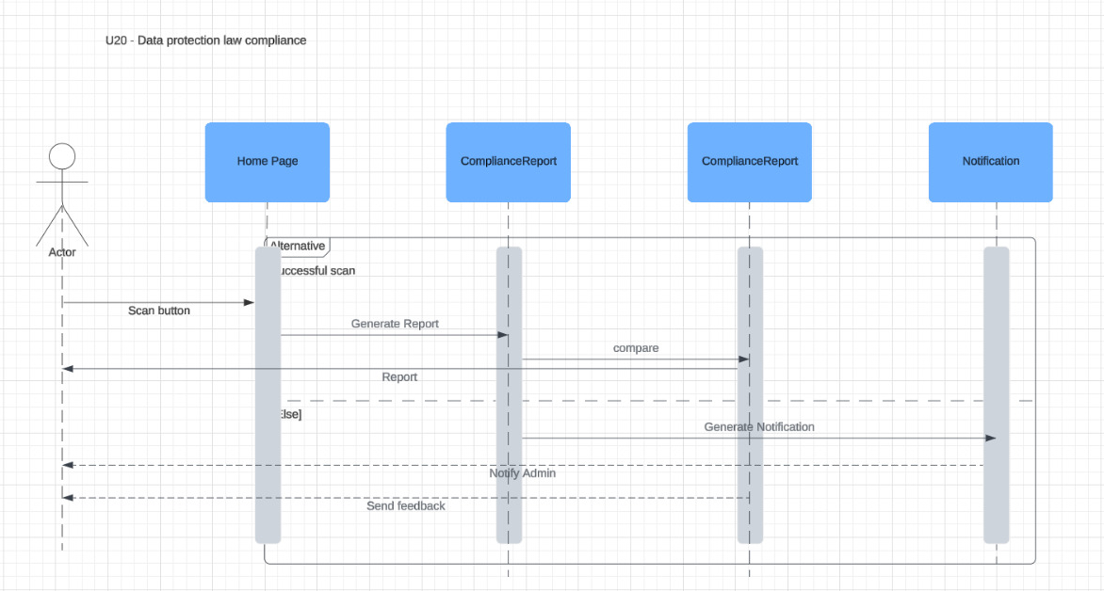

State Diagrams

<Repeat the following if you need to draw state diagrams of multiple objects>

Diagram details

<Name of the object whose state is being shown along with details of states and messages.>

Login State:
Messages:

- System starts with `[*] --> Login`.
- On valid credentials, `Login --> LoginSuccess`.
- On invalid credentials, `Login --> LoginFailed`.
- User can retry login after a failure.
- When successful, login transitions to the idle state (`LoginSuccess --> Idle`).
- User logs out, which returns to the login state (`Logout --> Login`).

Details: Manages user authentication, including successful login, failed attempts, and retry behavior.

Idle State:
Messages:

- After a successful login (`LoginSuccess --> Idle`), the system enters the idle state, where the user can upload a document.
- Transition to document uploading (`Idle --> Uploading: Upload document`).

Details: The user is idle after logging in, awaiting action.

Document Handling (DocHandling):
Messages:

- The user uploads a document, and the system attempts the upload (`Idle --> Uploading`).
- If the upload is successful (`Uploading --> UploadSuccess`), it transitions to the compliance check.
- If the upload fails (`Uploading --> UploadFailed`), the user retries the process.

Details: Manages the document uploading process and its success or failure.

Compliance Check (Compliance):
Messages:

- After successful upload, the compliance check is initiated (`UploadSuccess --> Checking`).
- If compliance passes (`Checking --> ComplianceSuccess`), the system proceeds to generate a report.
- If compliance fails (`Checking --> ComplianceFailed`), the user is notified of failure (`ComplianceFailed --> NotifyFailure`).

Details: Runs compliance checks on uploaded documents and handles outcomes (success/failure).

Report Generation (ReportGen):
Messages:

- If compliance passes, the system generates a report (`ComplianceSuccess --> Generating`).
- If report generation is successful, the user is notified (`Generating --> ReportSuccess`).
- If report generation fails, the system retries the process (`Generating --> ReportFailed`, then `Retry --> Generating`).

Details: Handles generating reports based on compliance check results and manages retries on failure.

Notification Handling (Notification):
Messages:

- Notifications are sent to users after report generation (`ReportAvailable --> Sending: Notify user`).
- Notifications are also sent on compliance failure (`NotifyFailure --> Sending: Notify failure`).
- Notifications either succeed (`Sending --> NotificationSuccess`) or fail (`Sending --> NotificationFailure`).

Details: Manages user notifications for both success and failure events.

Audit Logging (AuditLog):
Messages:

Logs every important system action, including:

- Successful login (`LoginSuccess --> Logging`).
- Logout (`Logout --> Logging`).
- Report generation success (`ReportSuccess --> Logging`).
- Compliance check actions (`Checking --> Logging`).
- Notification status (`NotificationSuccess --> Logging`).

Details: Provides an audit trail of system activity, including logins, compliance checks, report generation, and notifications.

Diagram
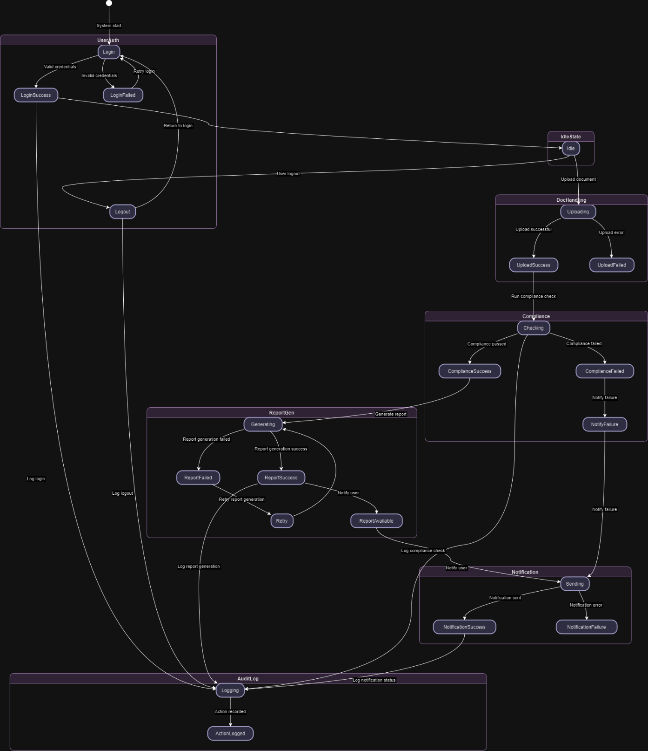

Non-functional Requirements / Quality Attributes

<Requirements must be testable>

Sr# | Requirements
1 | The system should maintain memory usage below 2 GB during typical operations and should not exceed 3 GB during peak loads, ensuring efficient performance without crashing.
2 | The system should restore normal operations within 5 minutes in the event of a failure.
3 | The system must load the web dashboard and other critical functionalities like audit logs within 7 seconds to provide a seamless user experience.
4 | The software should be capable of handling up to 10-15 concurrent users without a degradation in performance.
5 | The system should maintain a 99.9% uptime excluding planned maintenance windows, ensuring high availability for users.

Who Did What?

Name of the Team Member | Tasks done
Shabbir Kamal | Drafted Use Cases
Ammad Akram | Created Sequence Diagrams
Rida Bilgrami | Created Class Diagram
S. M. Aqdas Rizvi | Created State Diagram & Drafted Non Functional Req.

Review checklist

Before submission of this deliverable, the team must perform an internal review. Each team member will review one or more sections of the deliverable.

Section Title | Reviewer Name(s)
Use Cases | Ammad Akram
Sequence Diagrams | Rida Bilgrami
Class Diagram | S. M. Aqdas Rizvi
State Diagram & Non Functional Req. | Shabbir Kamal

