Czech University of Life Sciences Prague

Faculty of Economics and Management

Department of Informatics



Project Management Method

Opening New restaurant

Made By: Sadman Amir

Ilkhomjon Khasanov

Table of Contents

1.0 Introduction 3

2.0 Project Description 3

3.0 Project analysis 4

3.1 Resources 5

4.0 Tasks 7

4.1 Cost analysis 8

5.0 Gantt chart 9

6.0 conclusion 10

# 1.0 Introduction

Open the new restaurant is a complicated process that requires much advanced planning and the necessary project management. We need to do more work such as choosing the right location, market analysis, cost management overview which includes all the furniture, cooking material and start-up capital to get the restaurant on going.

As everyone knows that the restaurant is a place where people will go to enjoy and relax with the taste of tasty food. Everyone loves tasty food with affordable price and comfortable place for relaxing so that’s the reason we have decided to develop a project management plan for opening a restaurant and we will be going to use all the method and technique that we learned through our class.

# 2.0 Project Description

Opening a restaurant is a straightforward process. For that we need to have a good planning and the process to execute the plan. About project we are going to evaluate a real-world idea from a different point of view. We all have a different idea from different nations. We are going to use different kind of strategy from a different point of view.

Established a new restaurant involve so many different tasks which we are going to present in our project. This project will have divided into three different team they are director, management, and labour work force. The director has a main responsibility for the project he is finalizing the estimate time and budget for the project second the management team who will responsible for the managing the whole project, including the architect of hotel room managing staff and their salary mange the working hours of staff cost management of the restaurant even management team responsible for the HR department of the restaurant. The third team is short term labour staff. They are not going to be for permanent for us. They include carpenter, electrician, painter etc.

The project duration to finish is for three months and we have a work schedule from 7:00 am to 12:00 am and 12:30 pm to 17:30 pm. We have planed all the work task will be done on time, except the planning and strategic management will be done by the management team. All the temporary worker will get their salary on an hourly basis, but management team will get their salary monthly basis.

Management team (project manager) decides the work will begin 1st of June and it goes up to 15th of July. 1st of August the restaurant will open for the public.

# 3.0 Project analysis

Our project has 30 estimated days for the finished. And we have a plan that we have a 5 days’ work in the week. So, its mean we have 10 hrs work every day, which means 300 hours to finish the work, and our estimated budget for the project is $65000. All the cost and work detail are show below table.

Table No.1

**Work Duration and cost analysis**

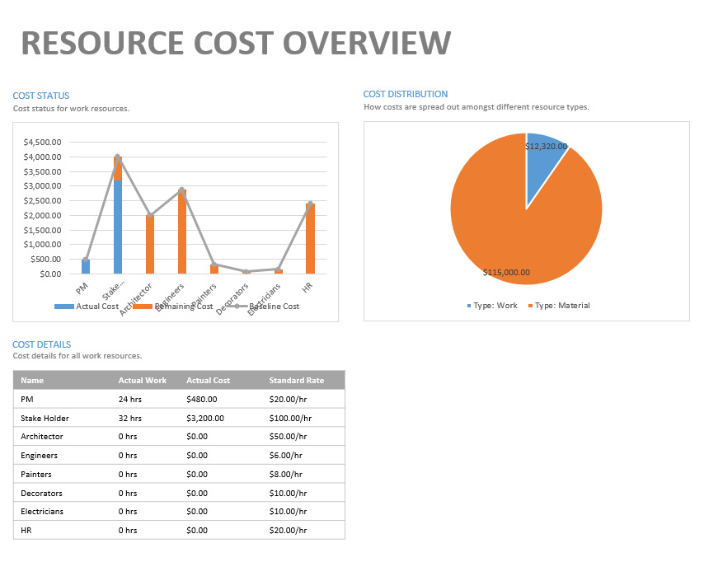

# 3.1 Resources

For every project, there are many resources that are needed to make the project complete. Our team classified them to the two-different way. They are work and material resources.

As for work resources (employees) we need Decorator, electrician, painters, janitors, project manager and assistant project manager, carpenter.

For the material resources, we need furniture such as table, chair, kitchen equipment like gas stove fridge, microwave and many more, menus, banner, hooding board, bar equipment includes alcohol juice and cola, shishas terrace, electrical sockets, staff room equipment, delivery motorcycle, TV, and paint for painting.

Those are the main need resources for our project the project manager and the assistant project manager is us who are creating this project, but we need to ask for the director who supply the budget for this project.

**Table of work resources**

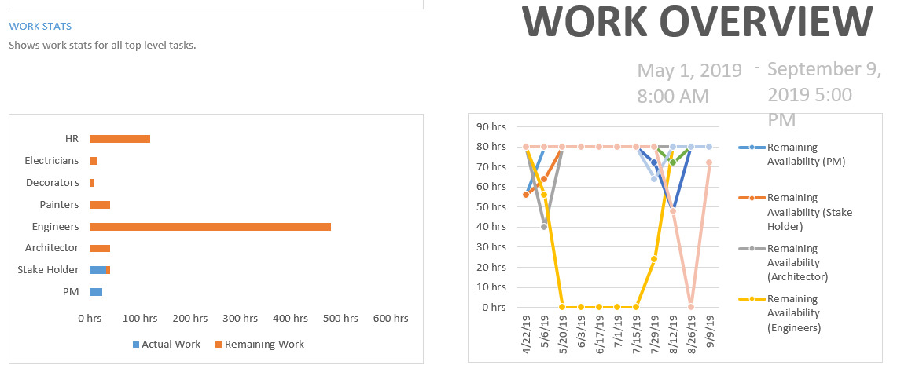

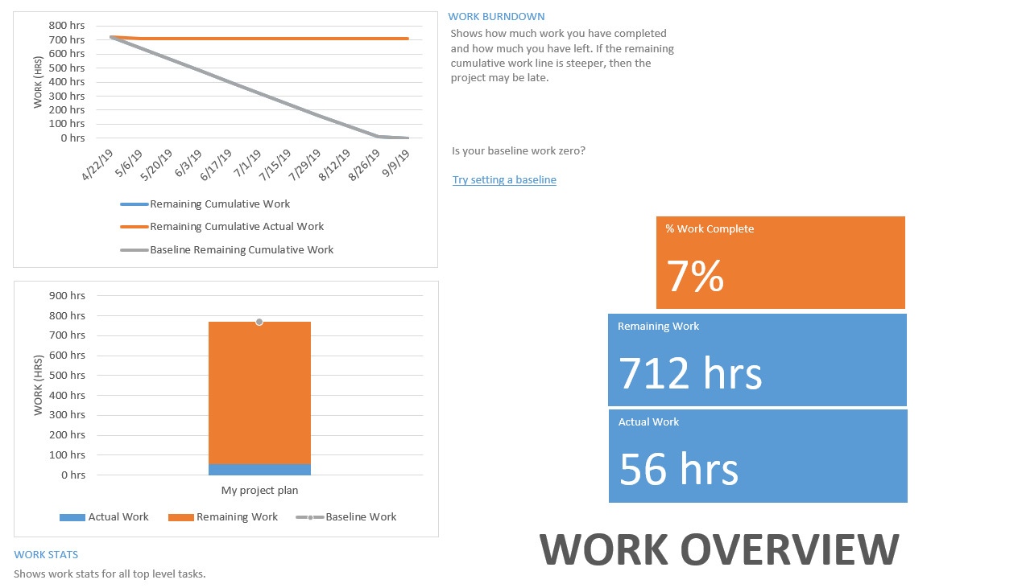



# 4.0 Tasks

After classification of the resources we must separation them to the different tasks. Cause every team has different task and different time duration for the finished the task.

Regarding opening the new restaurant our project duration is 6 weeks which mean 300 hrs in total (5 day’s work the week and 10 hours a day). As we defined our team is split in 3 major categories, so we define our task like in 3 part which is given below.

Director = Give order to PM/ management team and flow the budget for our project

Management team (US) = our main task is here, here we split the task for the different resources according its time line.

Labour work force = here is basically include cleaning and helper for the project According to our project we have different task with different time bound which is given below on the table.

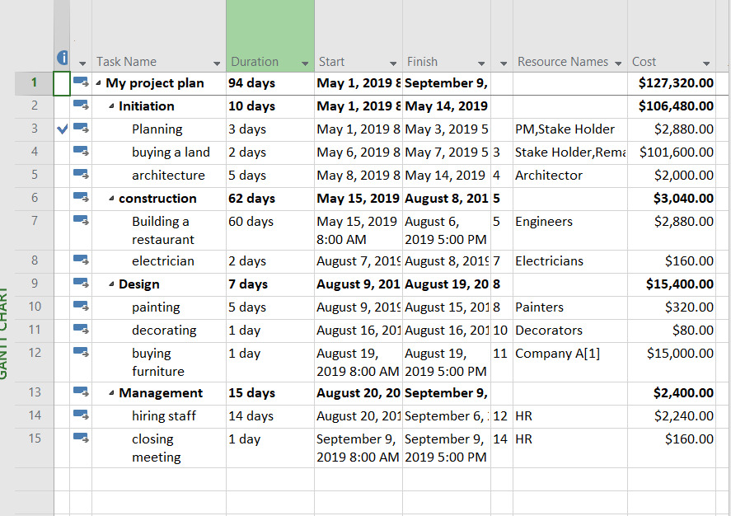

# 4.1 Cost analysis

While open the restaurant cost management play the very big roll because the all business stay with cost and the profit maximization. So there for our project management team also have some record about cost analysis. In the table given below they will show the how the budget is divided to the different activities.

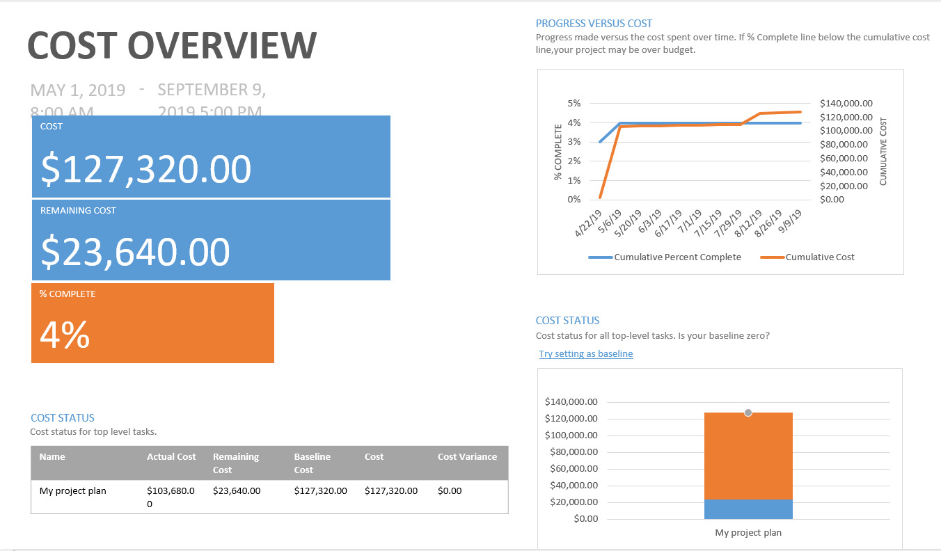

# 5.0 Gantt chart

A chart that describe about activities about project. It is a commonly used in project management. Its shows the task or events against the time duration.

According to our project on the left-hand side it’s listed the activities and along the top is its shows start date and finished date of the task and bottom the chart its shows day of complete of one task

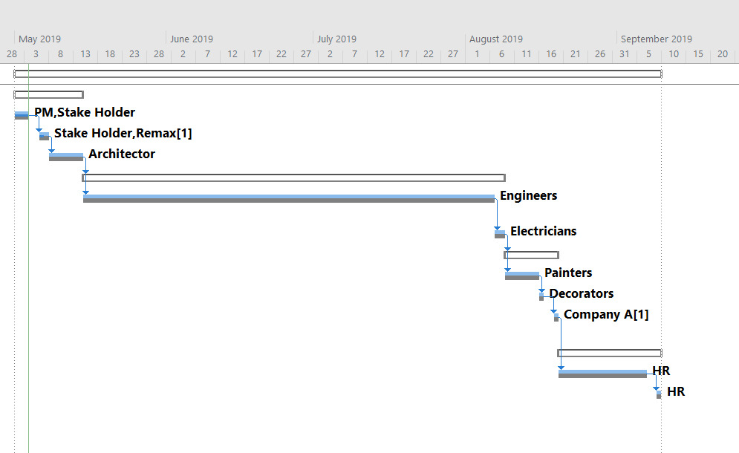

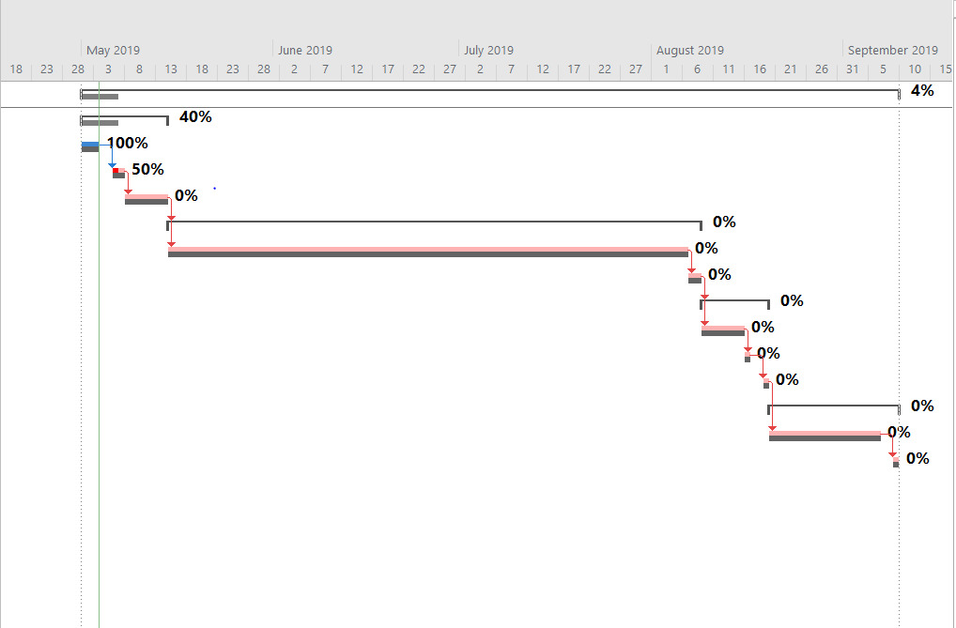

# 6.0 conclusion

From my point of view, Microsoft project is one of the best tools for managing the project. It’s offers the powerful reporting utilities. If every project manager will use the Microsoft project for any kind of project it will prove that this software is very useful for the difficult situation while assigning the resources, tracking progress, budget managing and analysis workload.