**Czech University of Life Science Prague**

**Faculty of Economics and Management**

**Department of Information Engineering**



Software Engineering project

University library system

Authors: Sadman Amir

# **Table of content**

Table of Contents

**Table of content** 1

**Introduction** 2

**Methodology** 3

**Representation of external entities** 3

**Data Model** 4

Relationship Diagram 4

**Data Dictionary** 5

**Behaviour model** 6

**Context diagram** 6

**Event list** 7

Functional model 8

Data Flow Diagram 8

**DFD 0** 8

**DFD 1** 9

**DFD 2** 10

**Conclusion** 10

# **Introduction**

Software engineering is a process of making or developed a software application that can work without any bugs. Its include research, design, coding and testing. So, in other word it is a research of one software engineer who design or create the format of the software in discipline order as user requirement and a programmer will implement that.

In this development project, the process of software development is presented with an example of the **library system** in University. The university library system will have presented with ER diagram and data dictionary including data flow diagram context diagram. While we are making the project, we will talk about problem that one software engineer will face while developing the software.

This project will represent a part of library system where students can barrow books and return them to the university library, the system will be collecting all that data and it will be represented on the Entity relationship diagram and Data flow diagram

# **Methodology**

In this project we are making explaining the process of a library system in a university by describing the internal processes using an online diagram creating service which is called draw.io

Then by creating an Entity relationship diagram which shows the relationships of entity sets stored in a database

Context diagram which is a diagram that defines the boundary between the system, or part of a system, and its environment, showing the entities that interact with it.

Also we used Data flow diagram is a graphical representation of the "flow" of data through an information system, modelling its process aspects.

Finally, we use decomposition to get more details out of the system model not just the over view

# **Representation of external entities**

This project contains those external entities (terminators):

Students: in this entity the student can either use their student ID to borrow books or buy them then the system adds the book to the list of books on the student name and the period of borrowing (if it was borrowed) or just an invoice if it was bought

Library (system) this entity is the system that registers the borrowed books and the sold books also has all the connection between the students and books

Book this entity has all the information about the books that will be sold or borrowed

# **Data Model**

Data Models are fundamental entities to introduce abstraction in a DBMS. Data models define how data is connected to each other and how they are processed and stored inside the system.

## Relationship Diagram

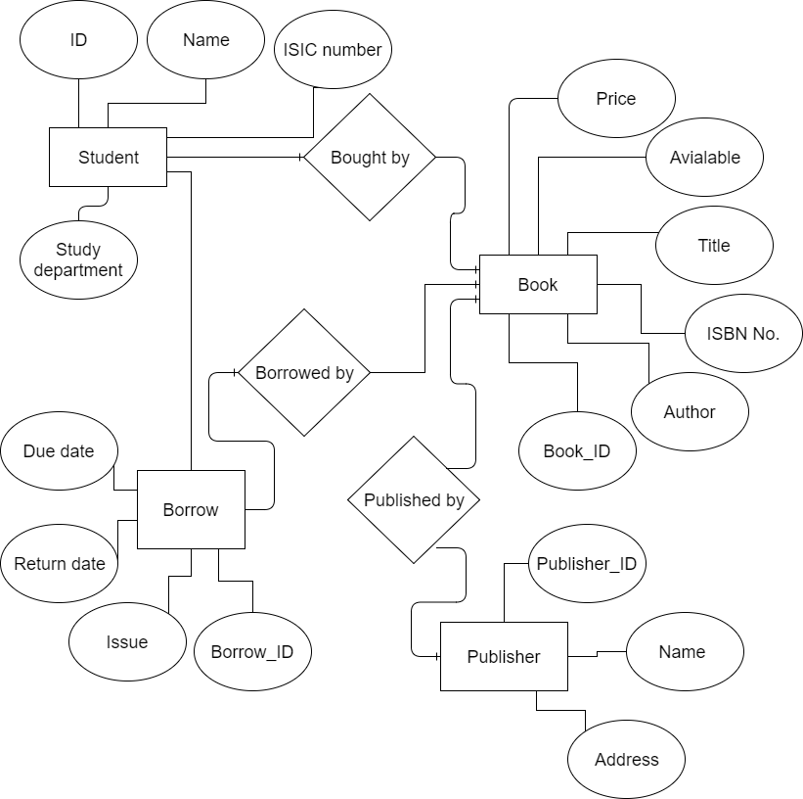

Picture 1. Entity Relationship Diagram

## **Data Dictionary**

|  |  |  |
| --- | --- | --- |
| **Entity** | **Attributes** | **Data type** |
| **Student** | Student_ID | NUMBER |
| Name | CHAR |
| ISIC_number | NUMBER |
| Study_department | CHAR |
| **Book** | Book_ID | NUMBER |
| Available | CHAR |
| Title | CHAR |
| ISBN_NO | NUMBER |
| Author | CHAR |
| Price | NUMBER |
| **Publisher** | Publisher_ID | NUMBER |
| Name | CHAR |
| Address | CHAR |
| **Borrow** | Borrow_ID | NUMBER |
| Due_date | Date |
| Return_date | Date |
| Issue | Date |

# **Behaviour model**

In behaviour modelling we use available and relevant consumer and business spending data to estimate future behaviour.

## **Context diagram**

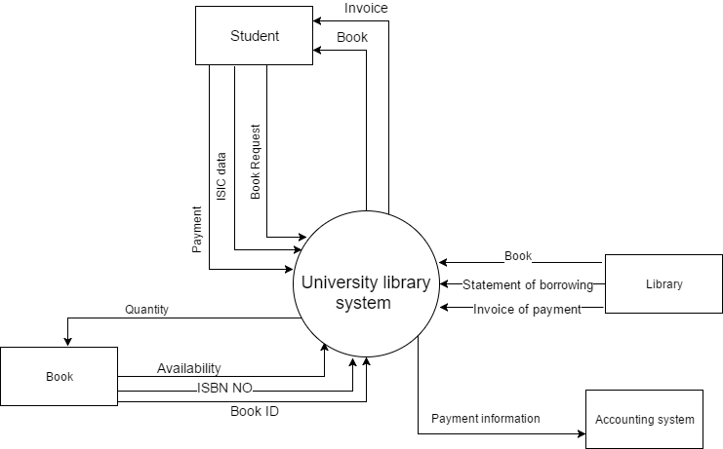

Picture 2. Context diagram

## **Event list**

|  |  |  |
| --- | --- | --- |
|  | **Process** | **Description of the process** |
| **1** | **Selecting a book (making a buy or borrow request)** | The student select a book from the library |
| **2** | **Showing availability** | The library system will check if the selected book is available or not |
| **3** | **Students personal information** | The student needs to give their data to the system |
| **4** | **Giving ISIC card** | The student should give an ISIC card in order for the system to recognize it. So it can process the payment and give a discount if it’s possible |
| **5** | **Student choice whether to buy or borrow** | The student here choose to buy or borrow a book and the system will decide whether to issue and invoice or statement of payment |
| **6** | **Purchasing (buying) or Borrowing a book** | The system issues an invoice with the price and marks the book as sold if a book was bought but if a book was borrowed The system will give a paper statement with due date and return date and it will also be marked on the system by the same ISIC card used |
| **7** | **Student payment** | The system takes the payment from the student ISIC card |
| **8** | **The system edits the database** | When book is borrowed or sold the university library system edits the books data base |
| **9** | **The publisher gets notified** | If the book of a certain publisher are sold and they are need the library system immediately report that to the publisher via email |
| **10** | **The cycle repeats** | When a book is requested from a student the same cycle repeats |

# Functional model

Functional model is a structured representation of the functions (activities, actions, processes, operations) within the modelled system or subject area.

## Data Flow Diagram

This is a data flow for a part of the process (after decomposition)

### **DFD 0**

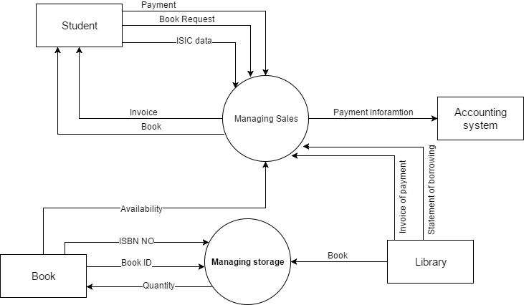

Picture 3. Data flow diagram

### **DFD 1**

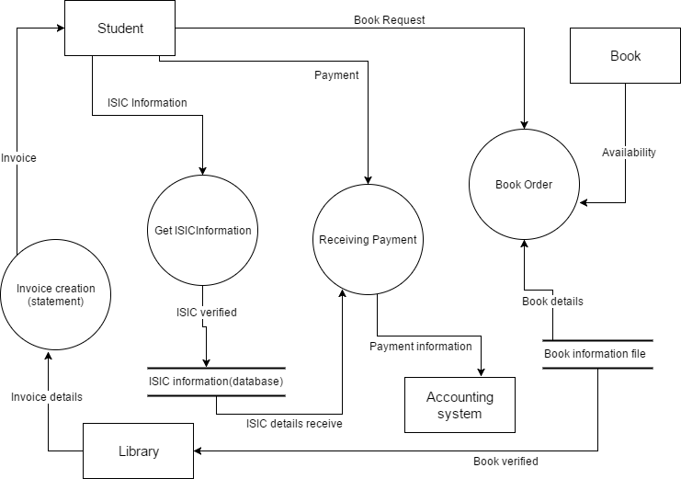

Picture 4. Managing sales decomposition

### **DFD 2**

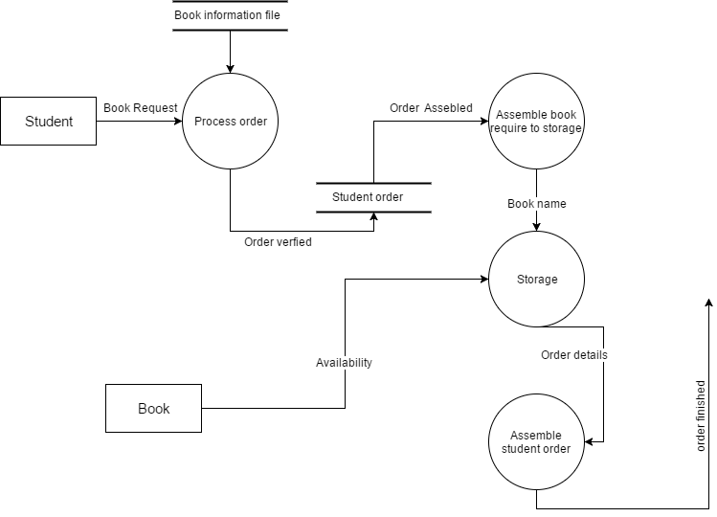

Picture 4. Book order decomposition

# **Conclusion**

In this project we demonstrated how a student can use the library system in the university in very fast and reliable way which will help the whole university in better performance and it will save a lot of time for students.