SOC Home Lab
Attack Simulation & Detection Engineering Report
Prepared by: Mohamed Saad
Environment: Windows 11 Pro (host) + Kali Linux (VirtualBox, host-only network)
SIEM: Splunk Enterprise + Universal Forwarder
July 2026

1. Executive Summary
This report documents a self-directed home lab exercise simulating a credential-based compromise of a Windows 11 Pro host from an isolated Kali Linux attack machine, with detection and log analysis performed in Splunk Enterprise. The exercise covered the full attack lifecycle: reconnaissance, credential attack, initial access, lateral movement, credential access, and persistence, mapped against real defensive controls encountered along the way.
The lab demonstrates not only successful attack execution but, more importantly, several genuine Windows security controls actively holding under test: UAC Remote Restriction, Windows Defender real-time protection, and LSA Protection (Credential Guard-adjacent). Each of these blocked a specific attack technique despite the attacker already holding valid, compromised credentials — illustrating defense-in-depth in practice rather than a single point of failure.
One limitation is noted transparently: Sysmon-to-Splunk log forwarding could not be resolved despite extensive troubleshooting (ACL modification, service account correction, full system reboot). All findings in this report are therefore drawn from Windows Security, System, and Application event logs, which fully captured the relevant authentication and defensive-control events.

2. Lab Environment

2.1 Topology
- Target host: Windows 11 Pro, hostname <TARGET-HOST>, physical laptop (not virtualized)
- Attacker: Kali Linux, VirtualBox VM, host-only adapter (private lab subnet)
- Kali host-only IP: <ATTACKER-IP> (DHCP-assigned)
- Windows host-only IP: <TARGET-IP> (VirtualBox Host-Only Ethernet Adapter)
- A second bridged adapter was added to Kali for out-of-band administration via SSH (Termius, iOS)

2.2 Toolchain
- Endpoint telemetry: Sysmon (SwiftOnSecurity configuration)
- Log shipping: Splunk Universal Forwarder 10.4.1
- SIEM: Splunk Enterprise 10.4.1 (manual start, index=main)
- Attack tooling: Nmap, Hydra, NetExec (CrackMapExec successor), Impacket (psexec.py), Mimikatz, smbclient, native Windows schtasks

3. Environment Setup — Evidence
Sysmon was installed using the official Sysinternals release with the community-maintained SwiftOnSecurity configuration, providing high-signal process, network, and file-event logging.
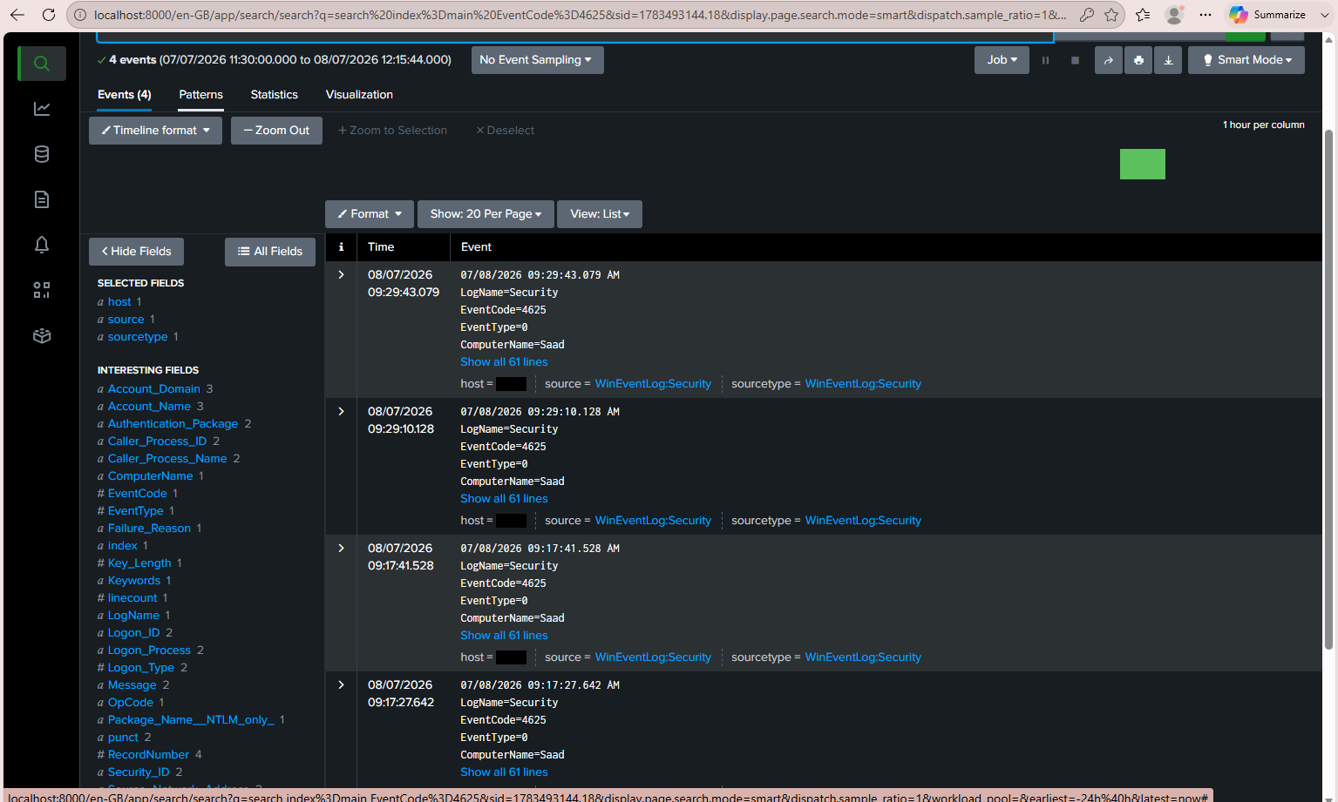
Figure 1 — Sysmon download page (Microsoft Sysinternals)
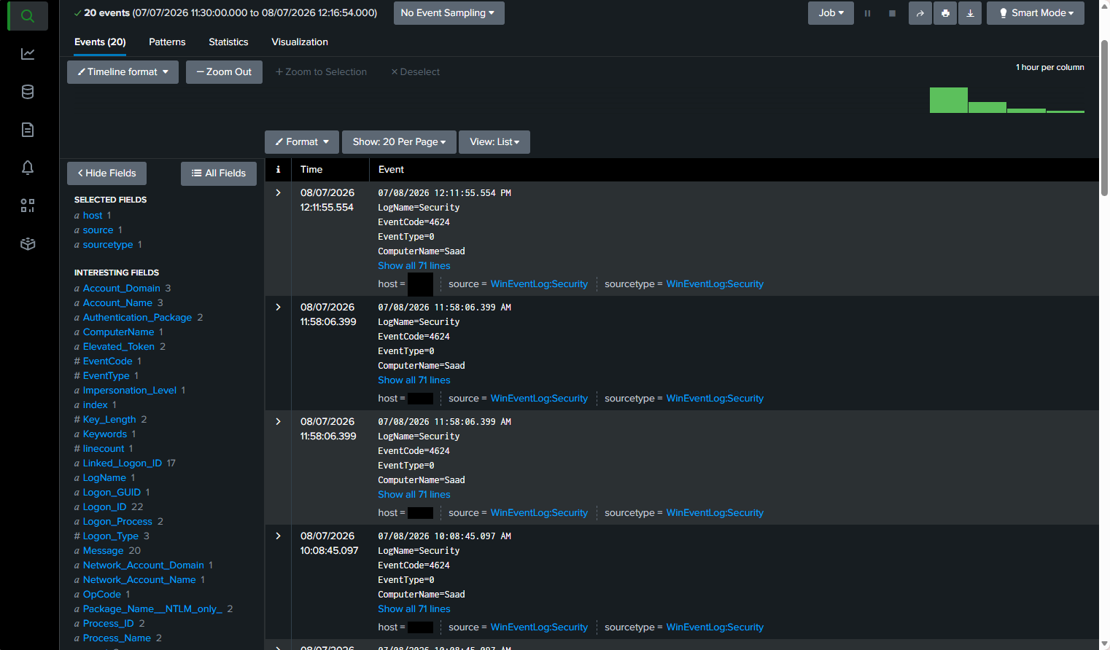
Figure 2 — SwiftOnSecurity sysmon-config reference configuration
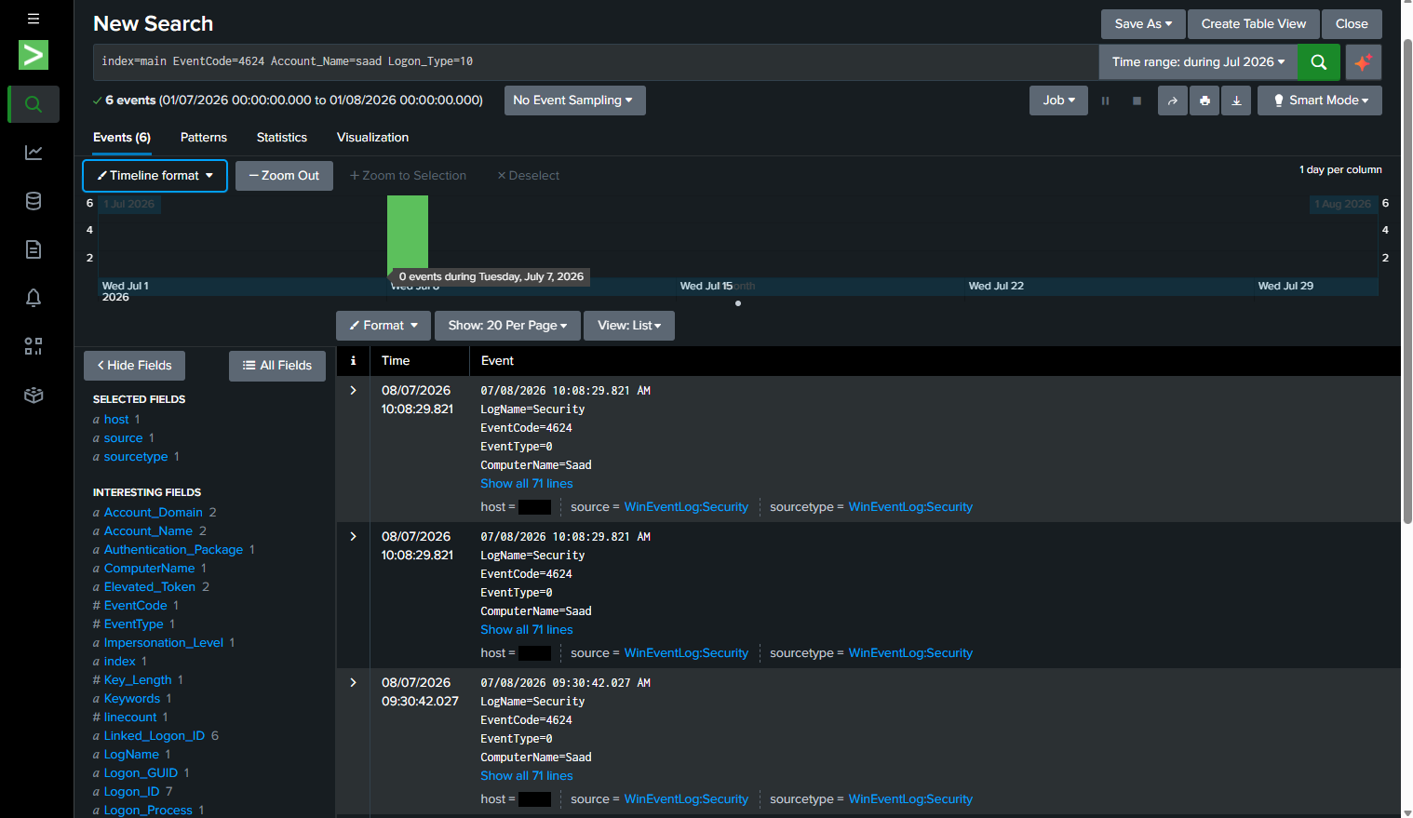
Figure 3 — Sysmon service installed and running (sc query Sysmon64)
Splunk Enterprise and the Universal Forwarder were installed on the Windows host itself. The forwarder was configured to ship Security, System, Application, and (intended) Sysmon event data to the local indexer on port 9997.
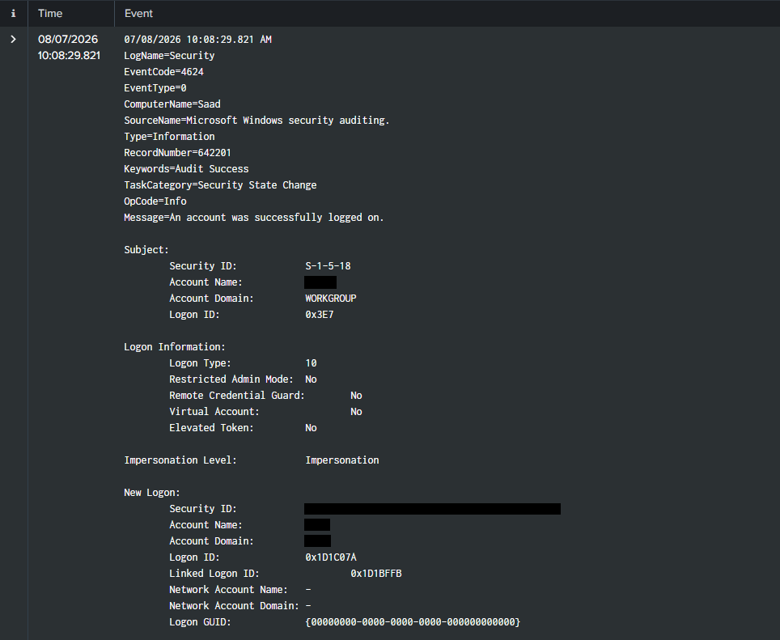
Figure 4 — Splunk Universal Forwarder service confirmed running
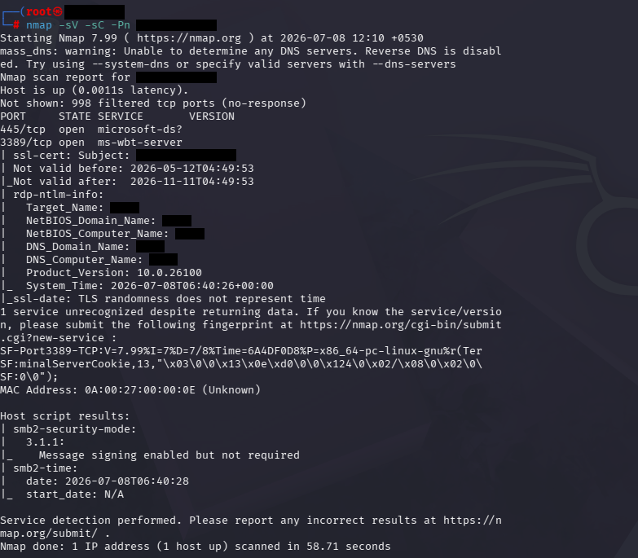
Figure 5 — Splunk Enterprise web interface, initial search view
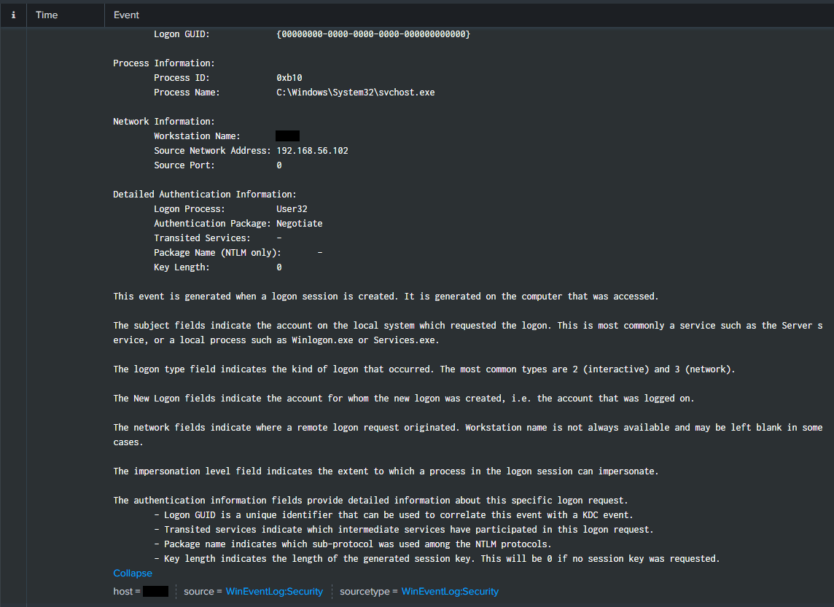
Figure 6 — Forwarder confirmed actively connected to receiving indexer (127.0.0.1:9997)
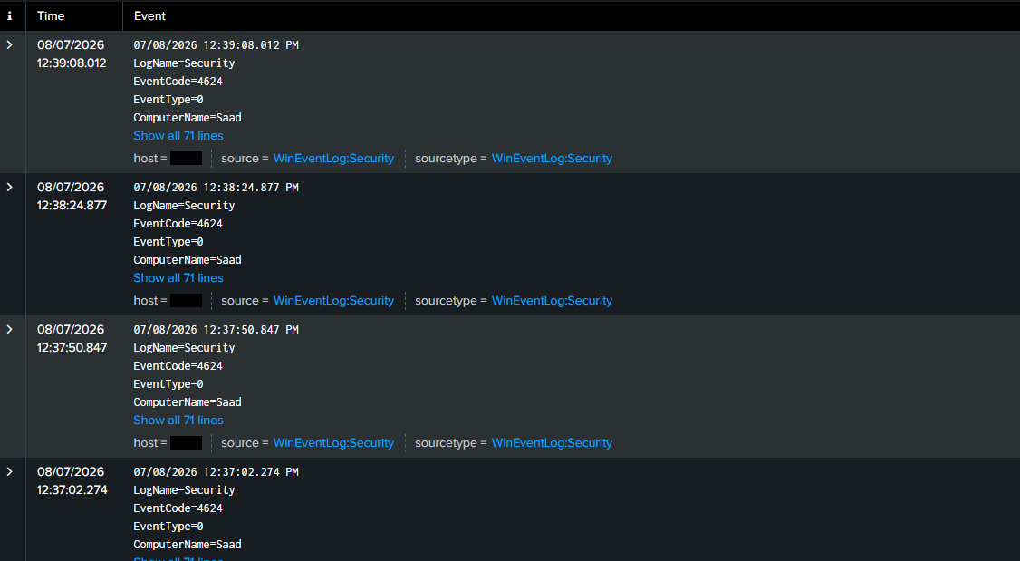
Figure 7 — VirtualBox Host-Only Ethernet Adapter configuration on the Windows host
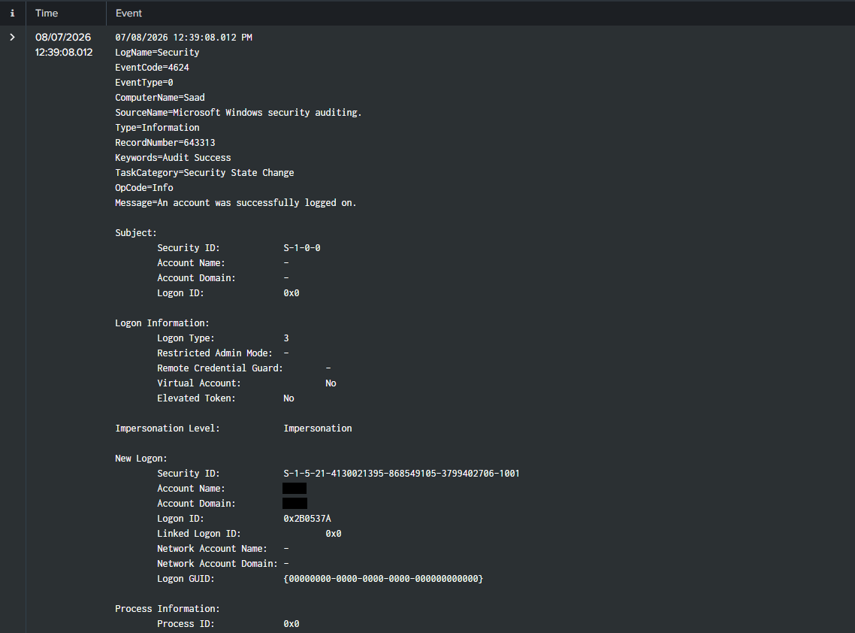
Figure 8 — Remote Desktop unavailable on Windows 11 Home; upgraded to Pro to enable RDP hosting

4. Attack Narrative & Findings

4.1 Reconnaissance
An Nmap scan against the Windows host (<TARGET-IP>) identified two exposed services of interest:
nmap -sV -sC -Pn <TARGET-IP>
445/tcp open microsoft-ds
3389/tcp open ms-wbt-server (after RDP + firewall rules enabled)
Initial ICMP probes were filtered by the Windows Firewall (default behavior); service scanning with -Pn confirmed both SMB and RDP were reachable once inbound firewall rules were added for testing purposes.

4.2 Credential Attack — RDP Brute Force
Hydra was used to brute-force RDP credentials for the local account. A successful crack was confirmed:
hydra -l <local-admin> -P wordlist.txt rdp://<TARGET-IP> -t 1
[3389][rdp] host: <TARGET-IP> login: <local-admin> password: <cracked>
1 of 1 target successfully completed, 1 valid password found
Note: Hydra's RDP module requires Network Level Authentication (NLA) to be disabled and the target account to be a member of Remote Desktop Users (or Administrators) to complete a full authentication check.

4.3 Detection — RDP Logon Events in Splunk
The brute-force attempt and subsequent successful authentication were both captured in the Windows Security event log and indexed by Splunk:
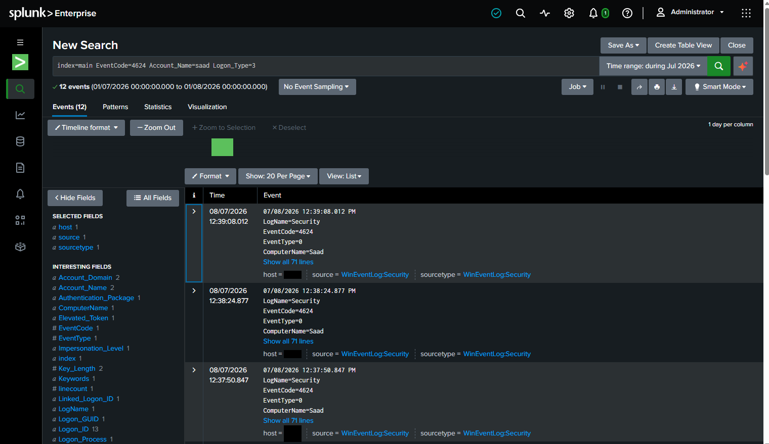
Figure 9 — EventCode 4625 (failed logon): four brute-force attempts recorded against the target host
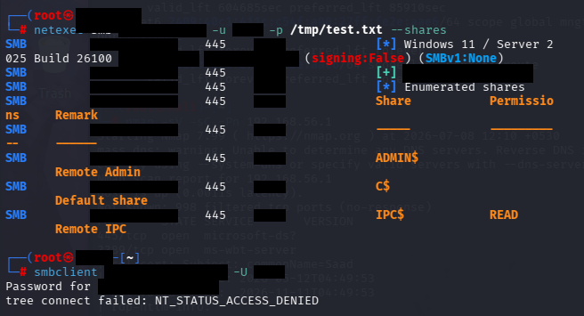
Figure 10 — EventCode 4624 (successful logon): 20 successful logons recorded over the observation window
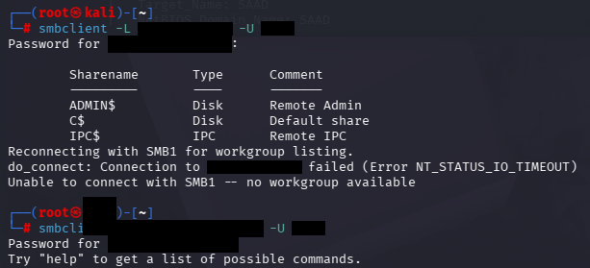
Figure 11 — Search results filtered to the compromised account
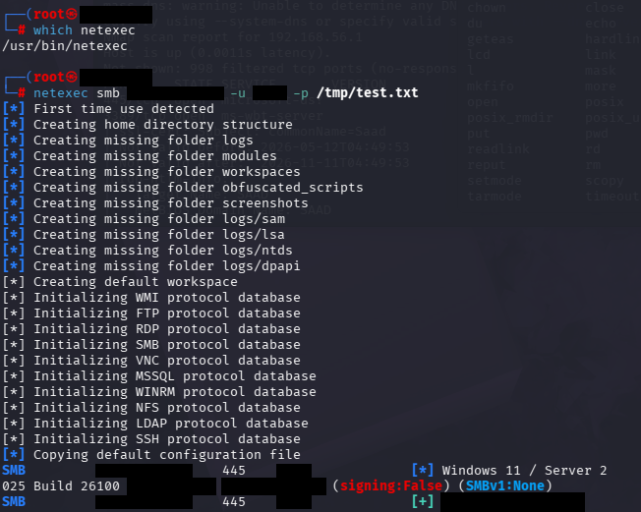
Figure 12 — Filtered search (Logon_Type=10) isolating RemoteInteractive (RDP) logons: 6 matching events
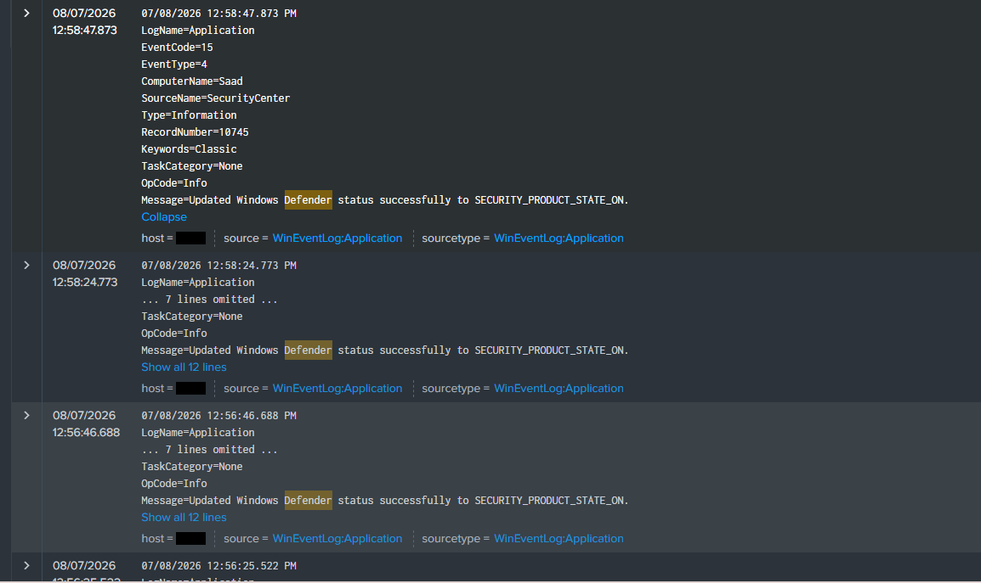
Figure 13 — Expanded event detail: Logon Type 10, Account Name <local-admin>, Domain <TARGET-HOST>
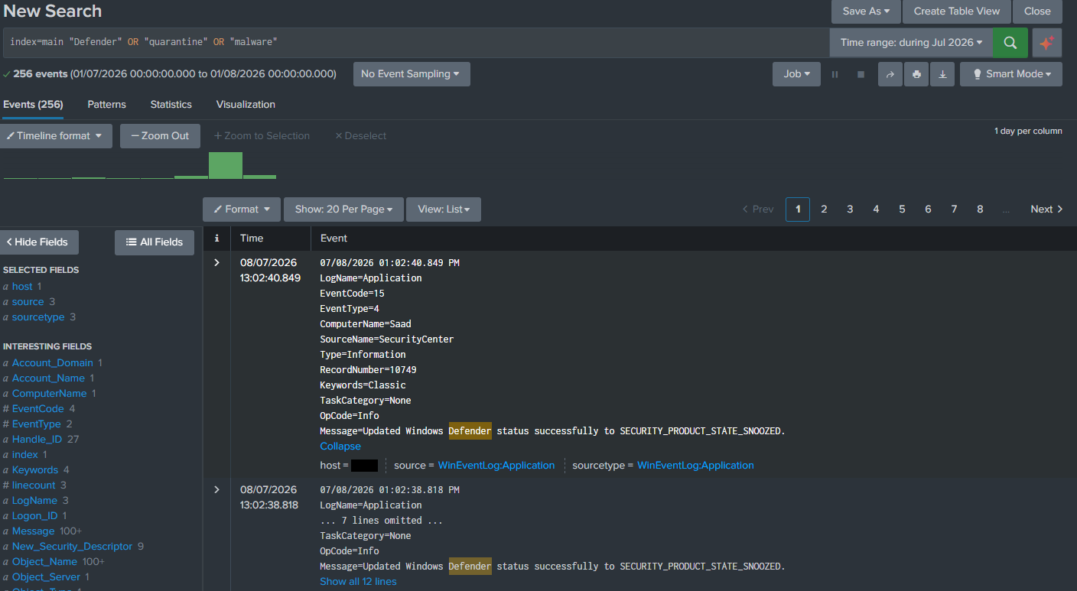
Figure 14 — Network Information fields: Source Network Address <ATTACKER-IP> (Kali), confirming the logon originated from the attack host
This pairing — a cluster of EventCode 4625 failures immediately followed by an EventCode 4624 success from the same source address, with Logon Type 10 — is a textbook brute-force detection signature.

4.4 SMB Enumeration & Credential Validation
Default administrative shares were enumerated using smbclient, and the recovered credential was validated against SMB using NetExec:
smbclient -L <TARGET-IP> -U <local-admin>
ADMIN$ Disk Remote Admin
C$ Disk Default share
IPC$ IPC Remote IPC
netexec smb <TARGET-IP> -u <local-admin> -p <password>
[*] Windows 11 / Server 2025 Build 26100 (name:<TARGET-HOST>) (signing:False)
[+] <TARGET-HOST>\<local-admin>:<password>
Notable secondary finding: SMB signing is disabled on the target (signing:False), which independently increases exposure to SMB relay attacks — a configuration weakness worth remediating regardless of the credential-brute-force outcome.

4.5 Access Control Finding — UAC Remote Restriction
Despite valid administrator-level credentials, an attempt to browse the C$ administrative share was denied:
smbclient //<TARGET-IP>/C$ -U <local-admin>
tree connect failed: NT_STATUS_ACCESS_DENIED
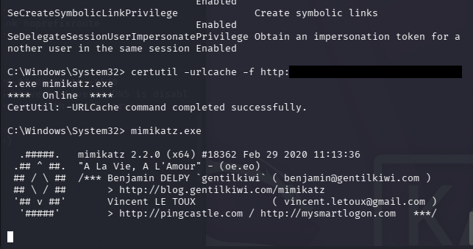
Figure 15 — net localgroup Administrators confirming the compromised account holds local Administrator rights
The account's Administrators-group membership was confirmed directly on the host, ruling out a simple permissions gap. The denial is attributable to Windows' UAC Remote Restriction (LocalAccountTokenFilterPolicy), which strips the elevated token from local accounts authenticating over the network by default — a real, working control that limited the practical impact of the compromised credential.
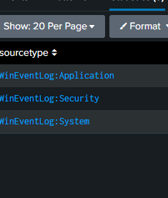
Figure 16 — Splunk: 12 Logon Type 3 (Network) events recorded for the SMB connection attempts, distinct from the Type 10 RDP logons

4.6 Lateral Movement — PsExec (Impacket)
To continue testing under a simulated misconfiguration, the UAC Remote Restriction was deliberately disabled via registry edit (documented as an intentional control bypass, not a discovered flaw):
New-ItemProperty -Path HKLM:\SOFTWARE\Microsoft\Windows\CurrentVersion\Policies\System `
-Name LocalAccountTokenFilterPolicy -Value 1 -PropertyType DWord -Force
With the restriction lifted, Impacket's psexec.py successfully uploaded a service executable to ADMIN$ and created/started a remote service — the classic PsExec lateral-movement technique.

4.7 Endpoint Defense — Windows Defender
Windows Defender quarantined the PsExec payload on three consecutive attempts before a fourth attempt succeeded, coinciding with Defender's protection state being observed in a snoozed condition.
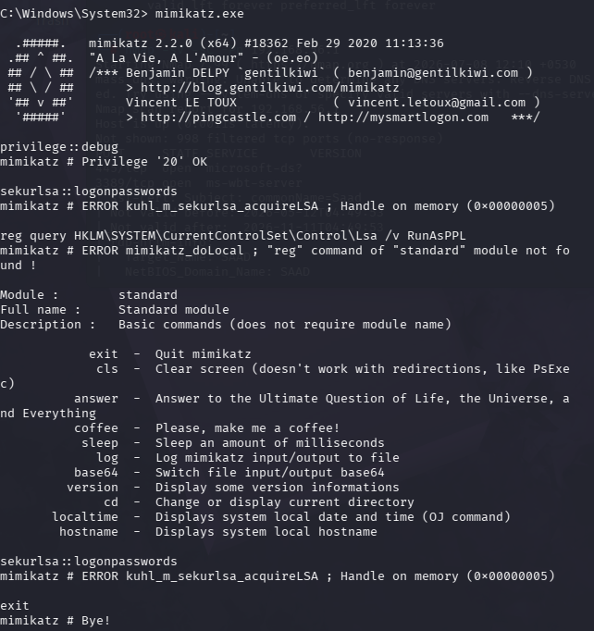
Figure 17 — Windows Defender status change events: SECURITY_PRODUCT_STATE_SNOOZED recorded in the Application log
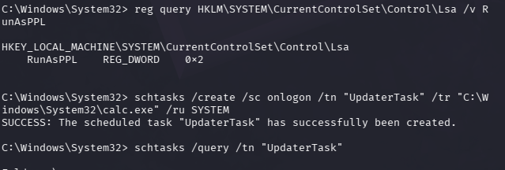
Figure 18 — Broader Splunk search across Defender/quarantine/malware-related events (256 matches during the session)
This is treated as a positive finding: real-time protection actively blocked unsigned, remotely-deployed executable payloads on three separate occasions, consistent with expected antivirus behavior against a known attack pattern.

4.8 Credential Access Attempt — Mimikatz vs. LSA Protection
Once a SYSTEM-level shell was obtained via psexec.py, Mimikatz was transferred to the target and executed to attempt LSASS credential extraction:
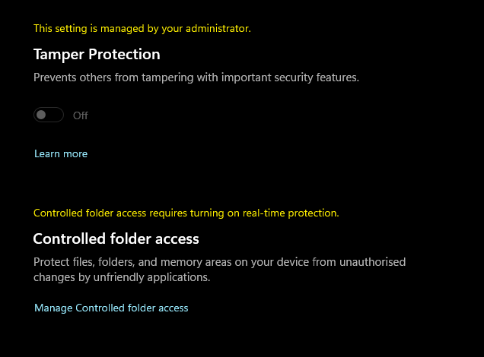
Figure 19 — Mimikatz retrieved via certutil and launched from the PsExec SYSTEM shell
mimikatz # privilege::debug
Privilege '20' OK
mimikatz # sekurlsa::logonpasswords
ERROR mimikatz_doLocal ; Handle on memory (0x00000005)
The 0x00000005 (ACCESS_DENIED) error was traced to LSA Protection being enforced at its strongest level:
reg query HKLM\SYSTEM\CurrentControlSet\Control\Lsa /v RunAsPPL
RunAsPPL REG_DWORD 0x2
RunAsPPL=2 runs LSASS as a UEFI/Secure-Boot-backed protected process, which prevents even SYSTEM-level processes from opening a handle to its memory. This blocked one of the most historically effective post-exploitation techniques, despite full SYSTEM code execution having already been achieved.

4.9 Persistence — Scheduled Task
A logon-triggered scheduled task was created from the SYSTEM shell to simulate a common persistence technique:
schtasks /create /sc onlogon /tn "UpdaterTask" /tr "C:\Windows\System32\calc.exe" /ru SYSTEM
The task was created and executed successfully with no blocking control observed. Detection via EventCode 4698 (scheduled task creation) was attempted but returned no results, as the corresponding advanced audit subcategory (Other Object Access Events) was not enabled by default on this host — noted below as a detection gap rather than a tooling failure.

4.10 Known Limitation — Sysmon-to-Splunk Forwarding
Sysmon was confirmed installed and actively logging locally throughout the exercise (verified in Windows Event Viewer), but the Universal Forwarder consistently failed to subscribe to the Sysmon Operational channel:
WinEventLogChannel::init: Init failed, unable to subscribe to Windows Event Log channel
'Microsoft-Windows-Sysmon/Operational': errorCode=5
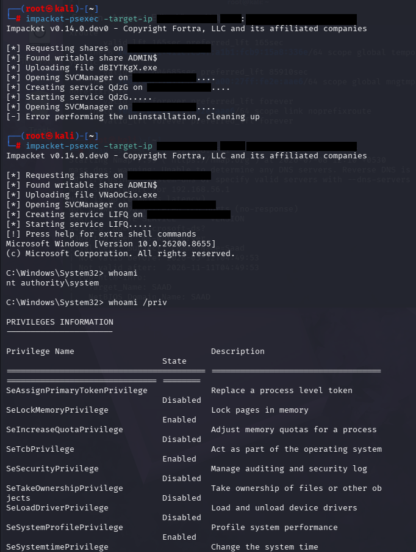
Figure 20 — Confirmed indexed sourcetypes limited to WinEventLog:Application, :Security, and :System
Troubleshooting performed: identified the forwarder's exact virtual service account (NT SERVICE\SplunkForwarder) via its SID, modified the Sysmon channel's security descriptor (SDDL) to explicitly grant that SID read access, attempted a broader permission set, and performed a full system reboot. The subscription error persisted in all cases. As a result, Sysmon-specific process and network telemetry (e.g., detailed process-creation chains for psexec/mimikatz) was not available in Splunk for this exercise; all findings above rely on native Windows Security/System/Application logging, which proved sufficient to detect and correlate every attack stage performed.

5. Summary of Findings
# | Finding | Result
1 | RDP exposed with weak/guessable credentials | Exploited — Hydra recovered valid password
2 | SMB admin shares (C$, ADMIN$) reachable | Enumerated — credentials validated via NetExec
3 | UAC Remote Restriction on local accounts | Held — blocked interactive C$ browsing despite valid admin credentials
4 | Windows Defender real-time protection | Held — quarantined PsExec payload on 3 consecutive attempts
5 | LSA Protection (RunAsPPL = 2) | Held — blocked Mimikatz LSASS memory access (Error 5, Access Denied)
6 | Scheduled task persistence | Successful — task created and executable via schtasks with no alerting observed
7 | Sysmon-to-Splunk log forwarding | Not resolved — forwarder blocked by channel ACL (Error 5); Security/System/Application logs unaffected

6. MITRE ATT&CK Mapping
Tactic | Technique | ID | Observed In Lab
Reconnaissance | Active Scanning: Vulnerability/Service Scanning | T1595 | Nmap service/version scan against target host
Credential Access | Brute Force: Password Guessing | T1110.001 | Hydra brute force against RDP; NetExec credential validation against SMB
Initial Access / Lateral Movement | Remote Services: RDP | T1021.001 | Successful RDP authentication using cracked credentials
Initial Access / Lateral Movement | Remote Services: SMB/Windows Admin Shares | T1021.002 | SMB share enumeration and PsExec-based remote execution
Execution | System Services: Service Execution | T1569.002 | Impacket psexec.py remote service creation and execution
Credential Access | OS Credential Dumping: LSASS Memory | T1003.001 | Mimikatz sekurlsa::logonpasswords attempt (blocked)
Persistence | Scheduled Task/Job | T1053.005 | schtasks creation of logon-triggered task
Defense Evasion | Impair Defenses: Disable/Modify Tools | T1562.001 | Deliberate registry change (LocalAccountTokenFilterPolicy) to test control bypass

7. Recommendations
- Enforce account lockout policy after a small number of failed logon attempts to blunt online brute-force attacks against RDP and SMB.
- Require multi-factor authentication for RDP access (e.g., via Windows Hello for Business, RD Gateway with MFA, or a third-party MFA proxy).
- Enable SMB signing to mitigate SMB relay risk (currently disabled on the target).
- Retain UAC Remote Restriction (LocalAccountTokenFilterPolicy) at its default value in production; do not disable it for administrative convenience, as this exercise showed it is an effective control.
- Keep LSA Protection (RunAsPPL) enabled at level 2 and consider enabling Credential Guard where hardware supports it.
- Enable the 'Other Object Access Events' audit subcategory to capture EventCode 4698 for scheduled-task-based persistence detection.
- Resolve the Sysmon channel ACL issue (or run the forwarder as LocalSystem in a lab context) to restore full process/network telemetry fidelity.

8. Conclusion
This exercise successfully demonstrated an end-to-end attack chain — reconnaissance, credential compromise, initial access, attempted lateral movement, attempted credential dumping, and persistence — against a Windows 11 Pro host, with every stage correlated to corresponding Splunk detections. Equally important, three independent Windows security controls (UAC Remote Restriction, Windows Defender, LSA Protection) were each observed actively blocking a specific attack technique, illustrating that layered defenses meaningfully reduced the practical impact of a fully compromised credential. The one unresolved item — Sysmon log forwarding — is documented transparently with the troubleshooting steps attempted, consistent with how a real detection-engineering gap would be reported and tracked.

Appendix A — Additional Evidence Captures
The following captures were collected during the exercise and are retained here for completeness.
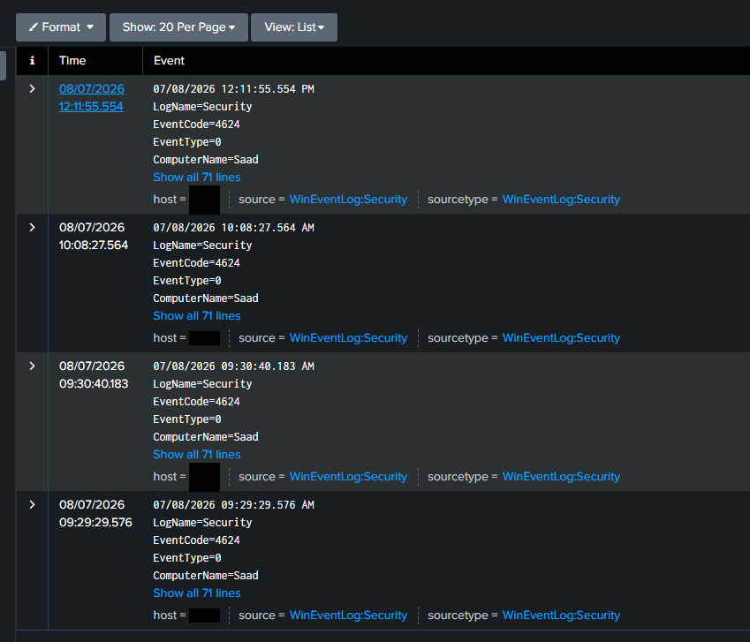
Figure A1 — Raw SwiftOnSecurity Sysmon configuration source (GitHub raw content)
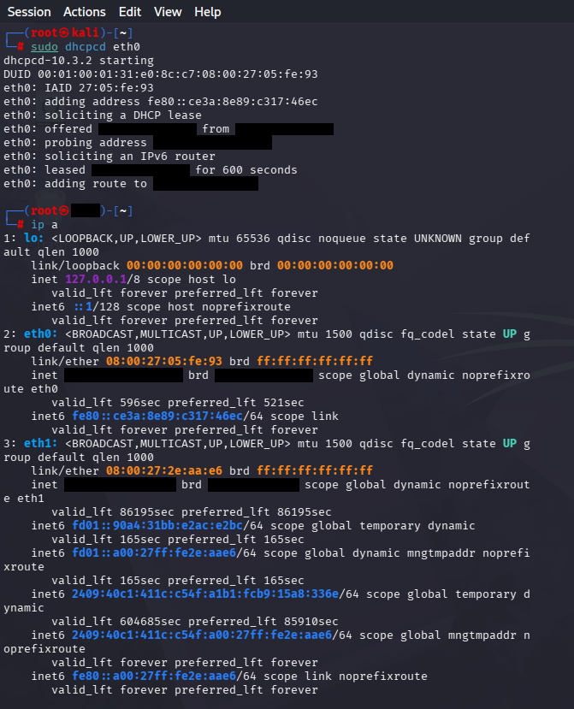
Figure A2 — Splunk Universal Forwarder download package selection
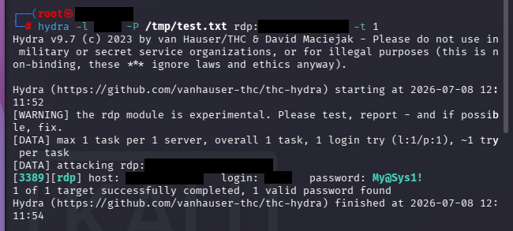
Figure A3 — Sign-in options screen (PIN/Windows Hello) prior to local-account migration
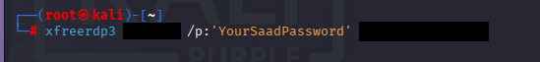
Figure A4 — Local account migration notice (BitLocker recovery key advisory)
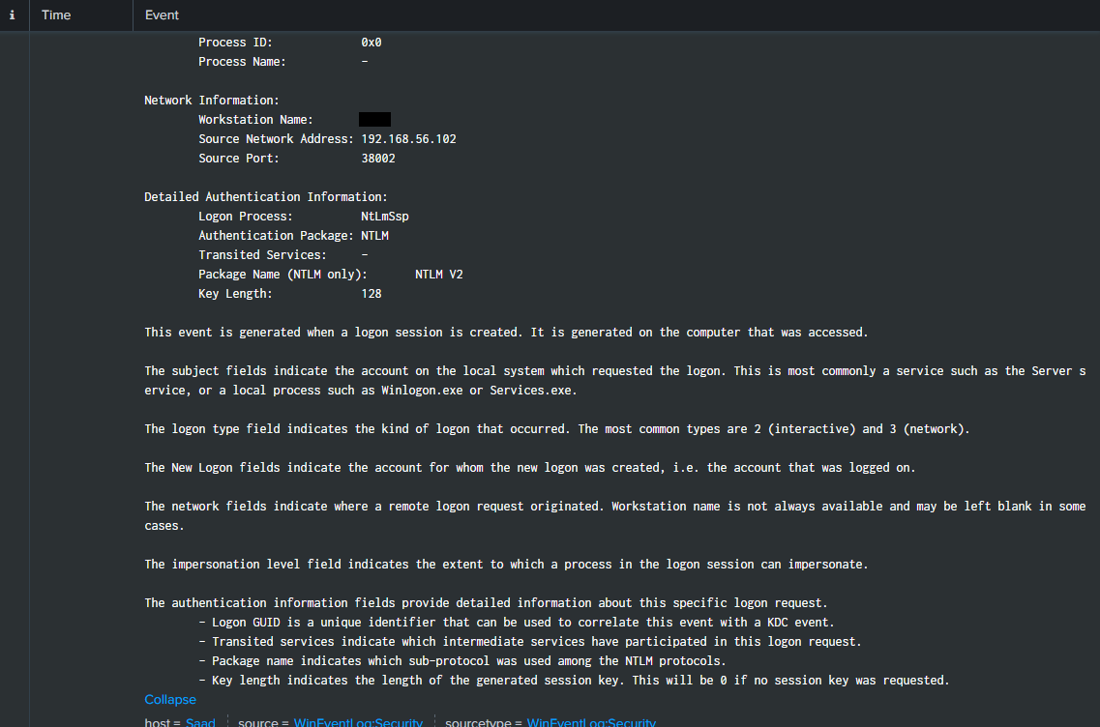
Figure A5 — Additional successful logon (4624) event listing
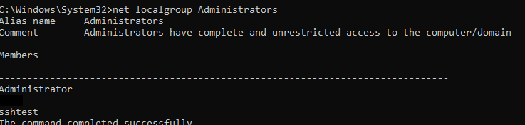
Figure A6 — Search bar detail during logon-event investigation
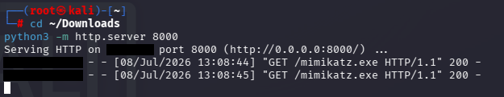
Figure A7 — Splunk search bar: Sysmon-scoped query returning no indexed events

