

INFORMATIC INSTITUTE OF TECHNOLOGY
UNIVERSITY OF WESTMINSTER
Object Oriented Programming
5COSC019C.1

Name: Muhammed Saad Mazhar
Uow Number: W2053223
IIT Number: 20221804

Test case scenarios

No. | Test Case | Expected Result | Actual Result | Pass / Fail
1 | Menu Navigation | The menu should display the available options again | The menu displayed options correctly | Pass
2 | Invalid Input for Menu | The system should prompt: ">> Enter a Valid Option number!" | The system prompted for a valid option | Pass
3 | Register Vendor | The system should display "Vendor registration successful!" | "Vendor registration successful!" displayed | Pass
4 | Vendor Registration with Invalid Name | The system should prompt to enter a name between 3 and 100 characters. | System prompted for a valid name | Pass
5 | Vendor Registration with Invalid Username | The system should prompt to enter a username between 5 and 30 characters. | System prompted for a valid username | Pass
6 | Vendor Registration with Invalid Password | The system should prompt to enter a password with at least 8 characters. | System prompted for a valid password | Pass
7 | Setup Configuration with Valid Inputs | Configuration setup successful! | Configuration setup was successful | Pass
8 | Setup Configuration with Total Tickets Exceeding Max Capacity | The system should prompt to re-enter total tickets, ensuring they do not exceed max capacity. | System correctly prompted for re-entry | Pass
9 | Simulation with Valid Configuration | The system should start the simulation and show "Simulation started..." | "Simulation started..." displayed | Pass
10 | Setup Configuration with Invalid Ticket Release Rate | The system should prompt to re-enter the valid release rate. | System prompted for valid rate | Pass
11 | Setup Configuration with Invalid Customer Retrieval Rate | The system should prompt to re-enter the valid customer retrieval rate. | System prompted for valid rate | Pass
12 | Exit the Application | The program should exit successfully without errors. | The program exited successfully | Pass
13 | Invalid Option for Registration (Less than 3 characters for name) | The system should prompt for a valid name. | System prompted for a valid name | Pass
14 | Invalid Option for Registration (More than 30 characters for username) | The system should prompt for a valid username. | System prompted for a valid username | Pass

GUI

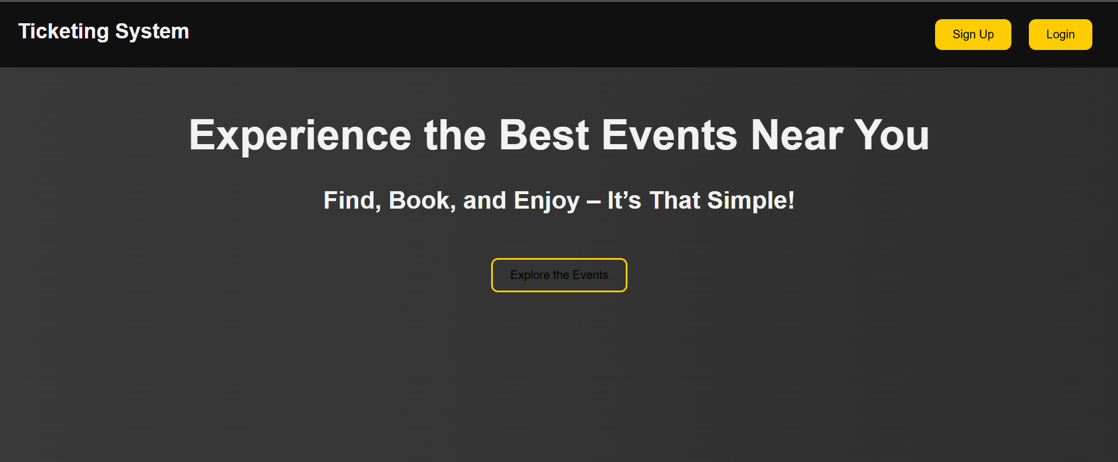

Class Diagrams

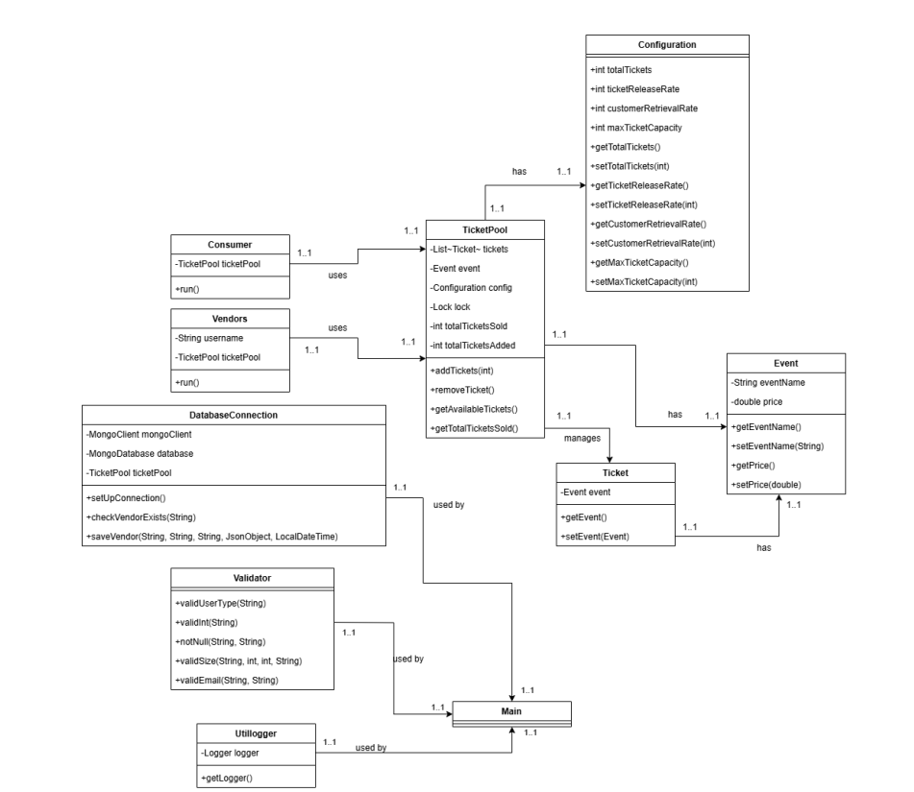

Sequence Diagram

