# **Medical Store Inventory System**

### **Deliverable 1**

### **Team: IntelliWare**

### **Team Members:**

* Amaar Khan 22i-0759– Scrum Master
* Saad Nadeem – 22i-1030 Developer
* Mustafa Iqbal – 22i-1139 Team Lead

### **Submission Date: 28 February**

## Module for Sprint 1

The first module to be developed in Sprint 1 is the **Inventory Management Module**. This module will allow the medical store to add, update, delete, and view stock levels of medicines.

## User Stories for Sprint 1

### User Story 1: Add New Medicine

As a **pharmacist**, I want to **add new medicines to the inventory**, so that I can **keep track of available stock and update prices accordingly**.

#### Sub User Stories:

- As a pharmacist, I want to enter medicine details (name, category, price, expiry date) when adding new stock.

- As a pharmacist, I want the system to validate input fields before saving.

- As a pharmacist, I want to receive a confirmation message after successfully adding a new medicine.

### User Story 2: Update Medicine Information

As a **pharmacist**, I want to **update existing medicine details**, so that I can **keep the stock information accurate and up to date**.

### User Story 3: Delete Expired Medicines

As a **store manager**, I want to **remove expired medicines from the system**, so that I can **ensure no expired products are sold to customers**.

## Structured Specifications for User Story: Add New Medicine

**Precondition:** The user must be logged in as a pharmacist.

**Trigger:** The pharmacist selects 'Add Medicine' from the inventory management menu.

**Normal Flow:** 1. The system displays an input form.  
2. The pharmacist enters medicine details.  
3. The system validates the input.  
4. If valid, the system adds the medicine and displays a success message.

**Postcondition:** The medicine is added to the inventory database and is available for stock tracking.

## Scrum Board Snapshots

The Trello board will be used to track the Sprint 1 backlog. Below are the required three snapshots:

- **Snapshot 1**: Initial backlog uploaded.

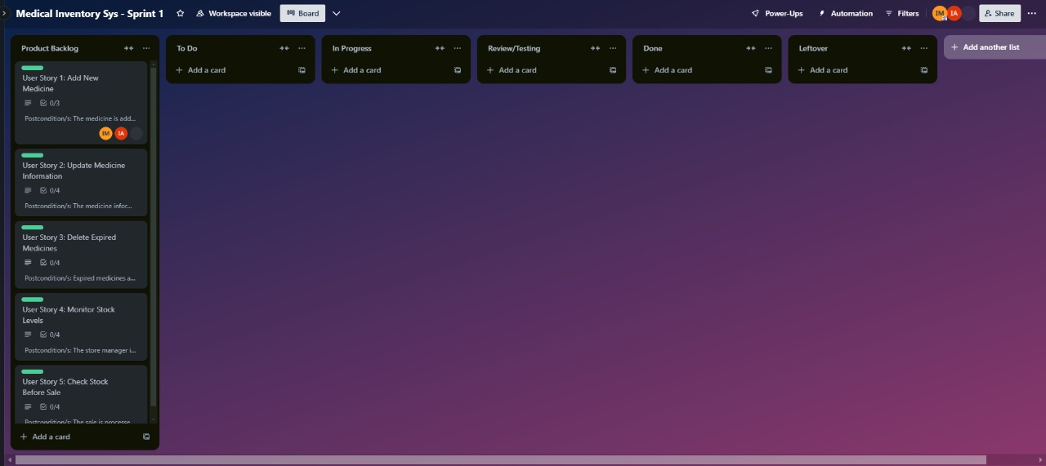

- **Snapshot 2**: Mid-sprint progress with half of the tasks completed.

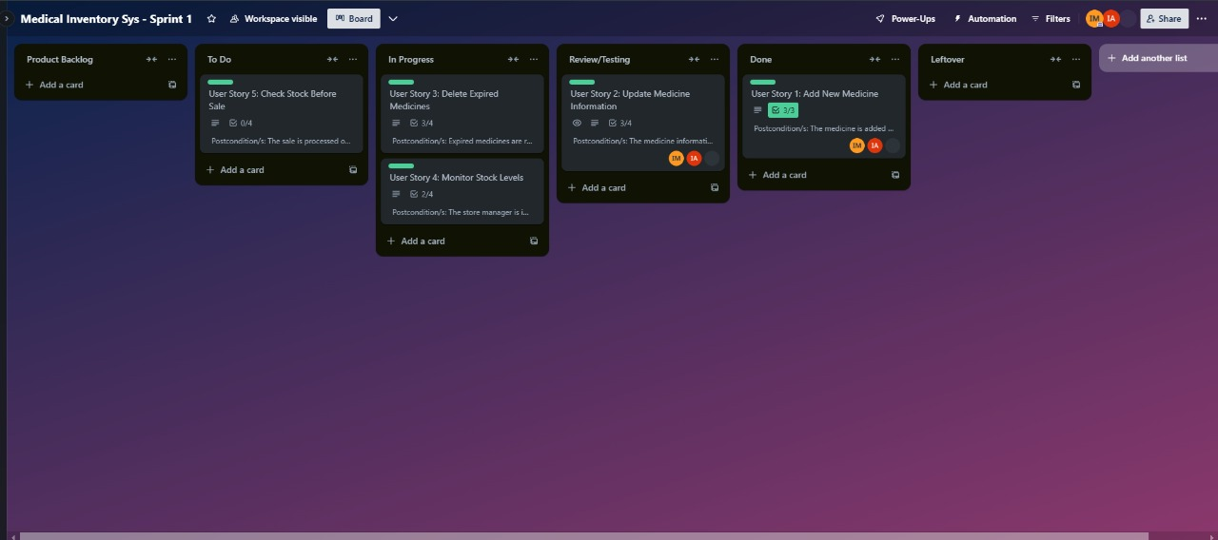

- **Snapshot 3**: End of sprint showing completed and leftover tasks.

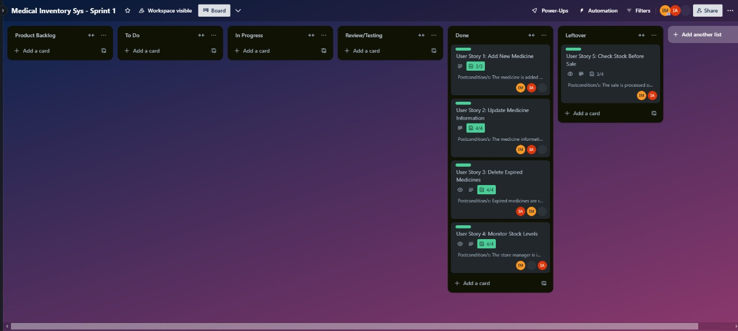Card Example

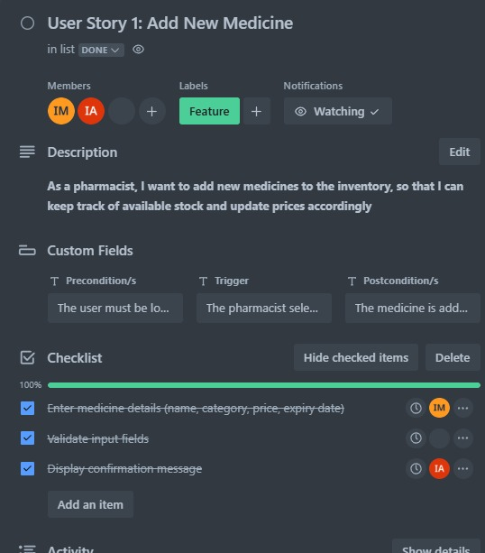

## Sprint 1 Product Burndown Chart

The burndown chart below shows the planned versus completed tasks over the 10-day sprint duration.

