**Software Project Plan**

**Project: Medical Store Inventory System**

**Team: IntelliWare  
Team Members:**

* **Mustafa Iqbal – Team Lead**
* **Amaar Khan – Scrum Master**
* **Saad Nadeem – Developer**

**Project Timeline**

* **Deliverable 1: Feb 13 – Feb 28**
* **Deliverable 2: Mar 6 – Mar 23**

**Work Breakdown Structure (WBS)**

**Level 1: Project**

* **1. Medical Store Inventory System**

**Level 2: Deliverables**

* **1.1 Project Planning**
* **1.2 Deliverable 1 – Basic System**
* **1.3 Deliverable 2 – Advanced System**

**Level 3: Components**

**1.1 Project Planning**

* **1.1.1 Requirement Gathering**
* **1.1.2 Team & Tool Setup**

**1.2 Deliverable 1 – Basic System**

* **1.2.1 SRS & UI Mockups**
* **1.2.2 Flask App Initialization**
* **1.2.3 Inventory Module**
* **1.2.4 Testing & Documentation**

**1.3 Deliverable 2 – Advanced System**

* **1.3.1 Reporting Module**
* **1.3.2 Sales & Stock Validation**
* **1.3.3 UI Enhancements**
* **1.3.4 Final Testing & Submission**

**Level 4: Activities (Work Packages)**

**1.1.1 Requirement Gathering**

* **Interview stakeholders**
* **Document requirements**
* **Review & get approval**

**1.1.2 Team & Tool Setup**

* **Set up GitHub repo**
* **Configure Trello board**
* **Install and configure development tools**

**1.2.1 SRS & UI Mockups**

* **Create Software Requirements Specification**
* **Design UI mockups in Figma**
* **Review and finalize**

**1.2.2 Flask App Initialization**

* **Create Flask project structure**
* **Set up routing**
* **Integrate SQLite**

**1.2.3 Inventory Module**

* **Add Medicine feature**
* **Update Medicine feature**
* **Delete Medicine feature**
* **Input validation**

**1.2.4 Testing & Documentation**

* **Write unit tests with Pytest**
* **Create user documentation**
* **Peer review**

**1.3.1 Reporting Module**

* **Design report layout**
* **Implement filter logic**
* **Display with Chart.js**

**1.3.2 Sales & Stock Validation**

* **Implement sales entry logic**
* **Realtime validation logic**
* **Integrate with stock records**

**1.3.3 UI Enhancements**

* **Add error handling**
* **Implement dark mode**
* **Improve UI responsiveness**

**1.3.4 Final Testing & Submission**

* **Conduct peer testing**
* **Fix reported bugs**
* **Prepare final submission package**

**Level 5: Task Assignments**

**Mustafa Iqbal**

* **Interview stakeholders**
* **Write SRS**
* **Design UI mockups**
* **Implement UI enhancements**

**Amaar Khan**

* **Configure Trello**
* **Write documentation**
* **Perform final testing**

**Saad Nadeem**

* **Set up Flask project**
* **Build inventory module**
* **Develop reporting & validation modules**

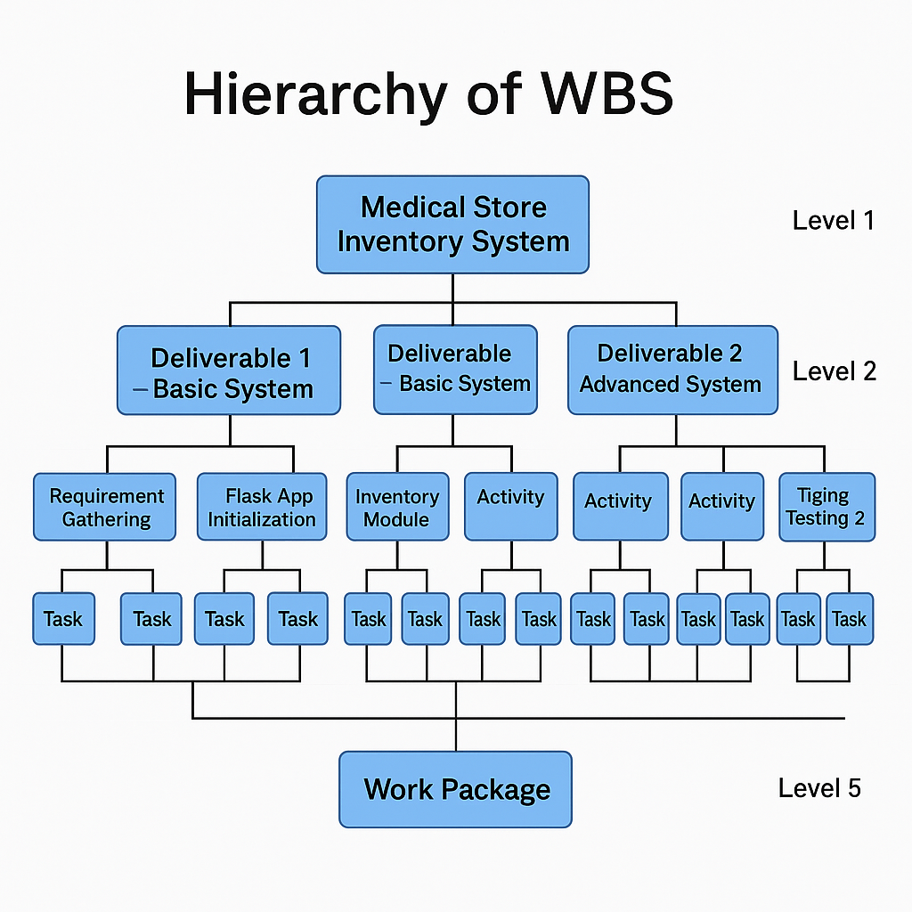

## Project Gantt Chart

The Gantt chart below shows the timeline of tasks for Deliverables 1 and 2:

