Name: amaar khan 22i-0759

Saad nadeem 22i-1030

Mustafa iqbal 22i-1139

cs k

terllo board

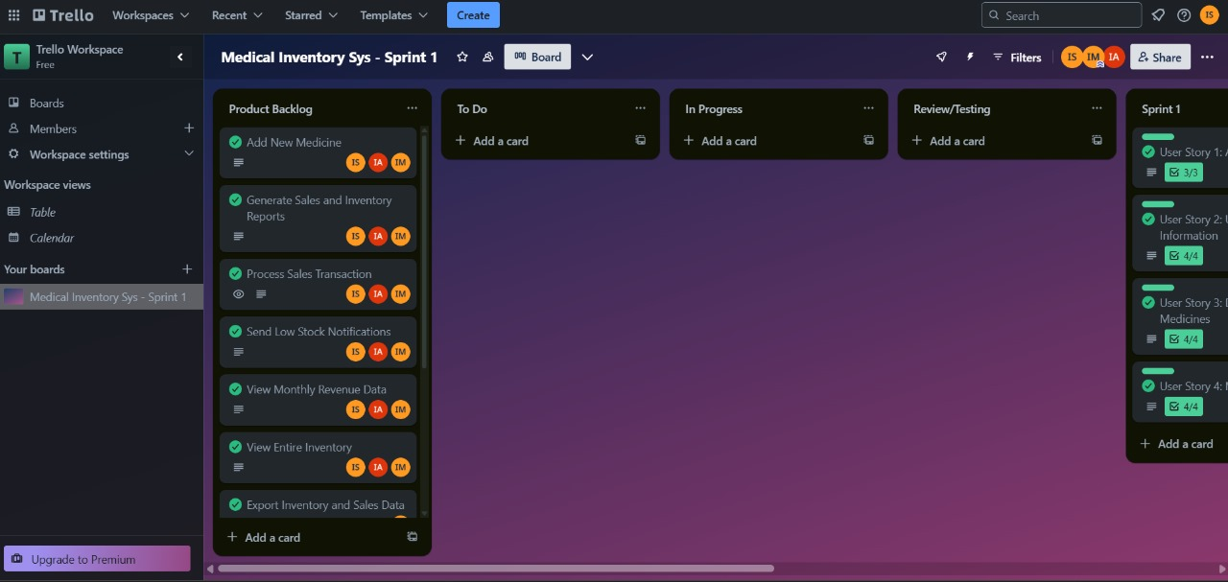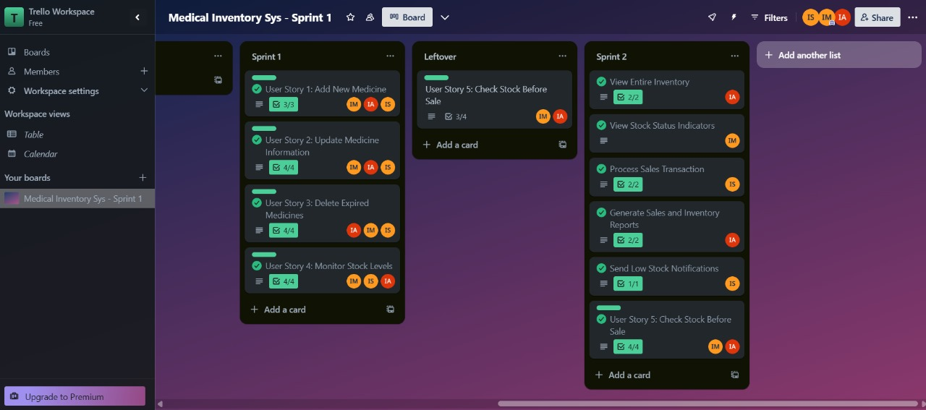

Github link:

<https://github.com/saadnadeem554/SE-Project>

Github screenshots

