LAB – 6 Asp.net and Webforms

**ASP.Net**

ASP.Net is a web development platform, which provides a programming model, a comprehensive software infrastructure and various services required to build up robust web application for PC, as well as mobile devices.

ASP.Net works on top of the HTTP protocol and uses the HTTP commands and policies to set a browser-to-server two-way communication and cooperation.

ASP.Net is a part of Microsoft .Net platform. ASP.Net applications are compiled codes, written using the extensible and reusable components or objects present in .Net framework. These codes can use the entire hierarchy of classes in .Net framework.

The ASP.Net application codes could be written in either of the following languages:

• C#

• Visual Basic

• Jscript

• J#

ASP.Net is used to produce interactive, data-driven web applications over the internet. It consists of a large number of controls like text boxes, buttons and labels for assembling, configuring and manipulating code to create HTML pages.

**Web Forms**

ASP.NET Web Forms is a part of the ASP.NET web application framework and is included with Visual Studio. It is one of the four programming models you can use to create ASP.NET web applications, the others are ASP.NET MVC, ASP.NET Web Pages, and ASP.NET Single Page Applications.

Web Forms are pages that your users request using their browser. These pages can be written using a combination of HTML, client-script, server controls, and server code. When users request a page, it is compiled and executed on the server by the framework, and then the framework generates the HTML markup that the browser can render. An ASP.NET Web Forms page presents information to the user in any browser or client device.

Using Visual Studio, you can create ASP.NET Web Forms. The Visual Studio Integrated Development Environment (IDE) lets you drag and drop server controls to lay out your Web Forms page. You can then easily set properties, methods, and events for controls on the page or for the page itself. These properties, methods, and events are used to define the web page's behavior, look and feel, and so on. To write server code to handle the logic for the page, you can use a .NET language like Visual Basic or C#.

**Get start with Asp.Net web Forms**

**Step 1:** Select the project or website

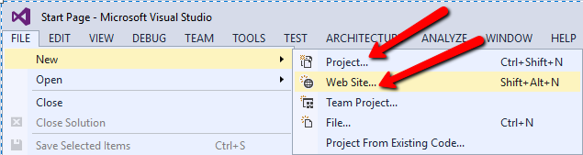

**Step 2:** Select the development language, framework and appropriate application to create.

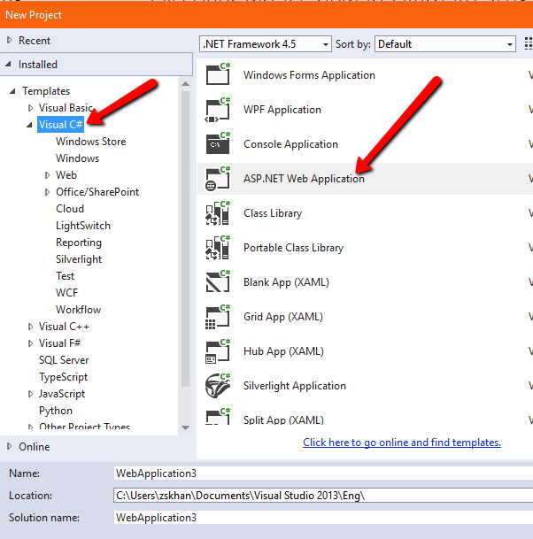

**Step 3:** Select template, folders and core references

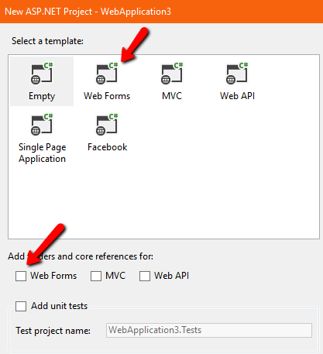

**Step 4: Add new web Form**

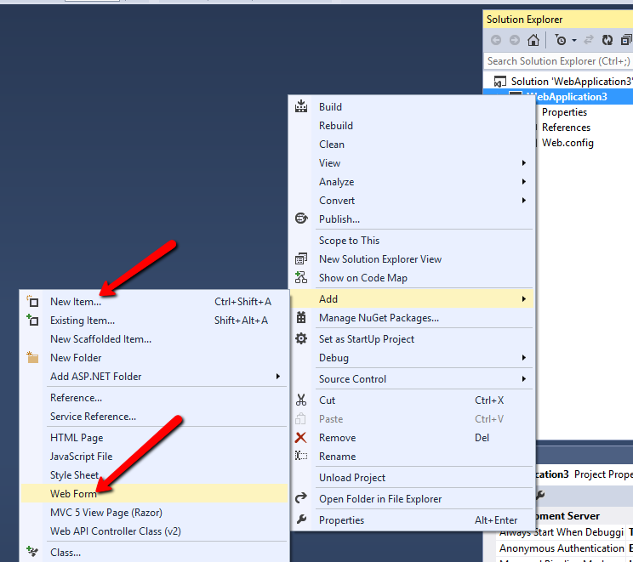

**How to code in ASP.NET**

**<asp: ---------- represents the asp tag [The tag must be ended]**

**Example 1**

<body>

<form id="form1" runat="server">

<div>

<asp:Label runat="server" id="HelloWorldLabel"></asp:Label>

</div>

</form>

</body>

</html>

**Example 2**

**using System**; // namespace contains fundamental classes and base classes that define commonly-used value and reference data types, events and event handlers, interfaces, attributes, and processing exceptions.

**using System.Data**; // namespace provides access to classes that represent the ADO.NET architecture.

**using System.Configuration**; // namespace contains the types that provide the programming model for handling configuration data.

**using System.Web**; // namespaces contain types that enable browser/server communication.

**using System.Web.Security**; // namespace contains classes that are used to implement ASP.NET security in Web server applications.

**using System.Web.UI**; // namespace provides classes and interfaces that enable you to create ASP.NET server controls and ASP.NET Web pages for the user interface of your ASP.NET Web applications.

**using System.Web.UI.WebControls**; // namespace contains classes that allow you to create Web server controls on a Web page. Web server controls run on the server and include form controls such as buttons and text boxes.

**using System.Web.UI.WebControls.WebParts**;// namespace contains classes and interfaces known collectively as the Web Parts control set. You can use these classes to create Web pages whose appearance and behavior can be modified (personalized) by end users. Each user's personalized settings for a page are saved for future browser sessions.

**using System.Web.UI.HtmlControls**;

Page class is used in the code-behind page model. Note that the code-behind source file declares a partial class that inherits from a base page class. The base page class can be Page, or it can be another class that derives from Page. Furthermore, note that the partial class allows the code-behind file to use controls defined on the page without the need to define them as field members.

public partial class _Default : System.Web.UI.Page

{

protected void Page_Load(object sender, EventArgs e)

{

}

}

HelloWorldLabel.Text = "Hello, world!";

**Example 3**

<form id="form1" runat="server">

<div>

<asp:Label runat="server" id="HelloWorldLabel"></asp:Label>

<br /><br />

<asp:TextBox runat="server" id="TextInput" />

<asp:Button runat="server" id="GreetButton" text="Say Hello!" />

</div>

</form>

Write this code under button event

HelloWorldLabel.Text = "Hello, " + TextInput.Text;

**Example 4**

<asp:DropDownList runat="server" id="GreetList" autopostback="true">

<asp:ListItem value="no one">No one</asp:ListItem>

<asp:ListItem value="world">World</asp:ListItem>

<asp:ListItem value="universe">Universe</asp:ListItem>

</asp:DropDownList>

<asp:DropDownList runat="server" id="GreetList" autopostback="true" onselectedindexchanged="GreetList_SelectedIndexChanged">

protected void GreetList_SelectedIndexChanged(object sender, EventArgs e)

{

HelloWorldLabel.Text = "Hello, " + GreetList.SelectedValue;

}

**Example 5**

<form id="form1" runat="server">

Your name:<br />

<asp:TextBox runat="server" id="txtName" />

<asp:Button runat="server" id="btnSubmitForm" text="Ok" onclick="btnSubmitForm_Click" />

protected void btnSubmitForm_Click(object sender, EventArgs e)

{

btnSubmitForm.Text = "My form is valid!";

}

**Example 6: Parameters Interchange Transfer**

protected void Button3_Click(object sender, EventArgs e)

{

string MyOccupation = "SoftwareDeveloper";

string url = "WebForm2.aspx?occupation=" + MyOccupation;

Response.Redirect(url);

}

**Receive**

protected void Page_Load(object sender, EventArgs e)

{

//Label1.Text = "hello world";

string value1 = Request["occupation"];

Label1.Text = value1;

}

**Example 1: Database insertion**

protected void Button1_Click(object sender, EventArgs e)

{

string conn;

conn = "Provider=Microsoft.Jet.OLEDB.4.0;" + "Data Source=" +

Server.MapPath("Database3.mdb");

OleDbConnection connect = new OleDbConnection(conn);

connect.Open();

string sql = "insert into EP (Name) values('" + TextBox1.Text + "')";

OleDbCommand cmd = new OleDbCommand();

cmd.CommandText = sql;

cmd.Connection = connect;

cmd.ExecuteNonQuery();

connect.Close();

Label1.Visible = true;

Label1.Text = "Thanx! " + TextBox1.Text + " now you are a member of CSI. ";

//LinkButton1.Enabled = false;

}

**Example 2: Database Retrieval**

protected void Button3_Click(object sender, EventArgs e)

{

conn = "Provider=Microsoft.Jet.OLEDB.4.0;" + "Data Source=" +

Server.MapPath("App_Data\\db1.mdb");

OleDbConnection connect = new OleDbConnection(conn);

connect.Open();

int user_id;

user_id = Convert.ToInt16(TextBox3.Text);

string sql = "select * from Table1 where [ID] ="+user_id+" and [FirstName] like '"+TextBox2.Text+"' and [LastName] like '"+TextBox1.Text+"';";

OleDbCommand cmd = new OleDbCommand();

cmd.CommandText = sql;

cmd.Connection = connect;

OleDbDataReader dr=cmd.ExecuteReader();

if (dr.HasRows)

{

dr.Read();

Label2.Visible = true;

}

**Tasks**

1. Design SignIn/SignUp page by using webforms.

There are 4 webforms

**1st Web Form**

using System;

using System.Collections.Generic;

using System.Linq;

using System.Web;

using System.Web.UI;

using System.Web.UI.WebControls;

public partial class Default2 : System.Web.UI.Page

{

protected void Page_Load(object sender, EventArgs e)

{

}

protected void Button1_Click(object sender, EventArgs e)

{

Response.Redirect("Default3.aspx");

}

protected void Button2_Click(object sender, EventArgs e)

{

Response.Redirect("Default.aspx");

}

}

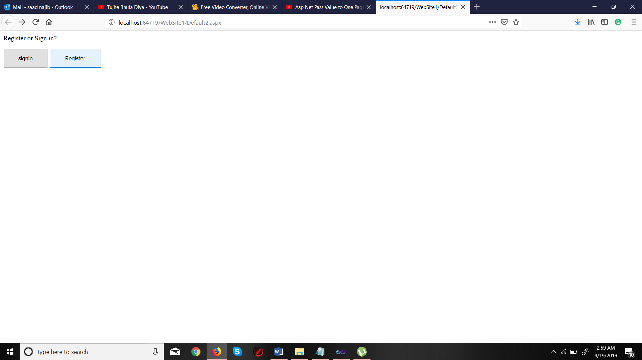

**2nd Web Form**

using System;

using System.Collections.Generic;

using System.Linq;

using System.Web;

using System.Web.UI;

using System.Web.UI.WebControls;

using System.Data.OleDb;

public partial class _Default : System.Web.UI.Page

{

protected void Page_Load(object sender, EventArgs e)

{

}

protected void Button1_Click(object sender, EventArgs e)

{

string conn;

conn = "Provider=Microsoft.Jet.OLEDB.4.0;" + "Data Source=" +

Server.MapPath("dblab1.mdb");

OleDbConnection connect = new OleDbConnection(conn);

connect.Open();

string sql = "insert into saadtb (email,pass,fnam,lnam) values('" + TextBox1.Text + "','" + TextBox2.Text + "','" + TextBox3.Text + "','" + TextBox4.Text + "')";

OleDbCommand cmd = new OleDbCommand();

cmd.CommandText = sql;

cmd.Connection = connect;

cmd.ExecuteNonQuery();

connect.Close();

Label1.Visible = true;

Label1.Text = "Thanx! " + TextBox3.Text + " now you are Registered. ";

}

}

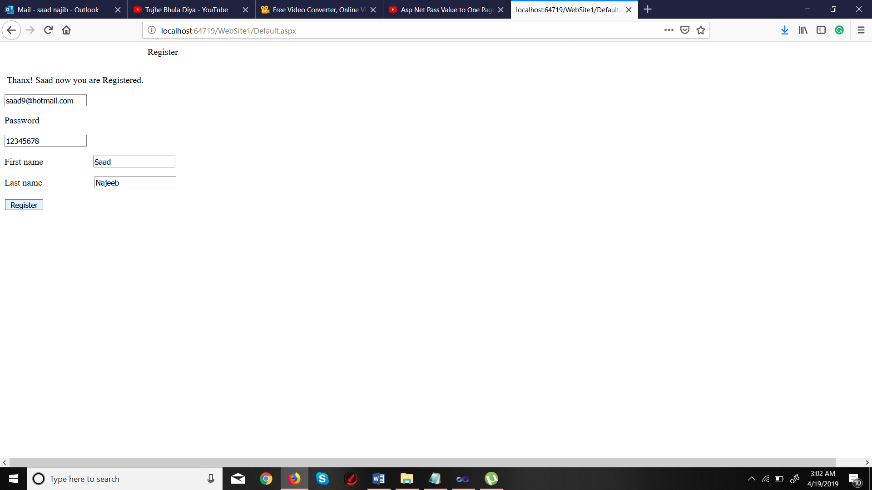

**3rd Web Form**

using System;

using System.Collections.Generic;

using System.Linq;

using System.Web;

using System.Web.UI;

using System.Web.UI.WebControls;

using System.Data.OleDb;

public partial class Default3 : System.Web.UI.Page

{

protected void Page_Load(object sender, EventArgs e)

{

}

protected void Button1_Click(object sender, EventArgs e)

{

string conn = "Provider=Microsoft.Jet.OLEDB.4.0;" + "Data Source=" +

Server.MapPath("dblab1.mdb");

OleDbConnection connect = new OleDbConnection(conn);

connect.Open();

string sql = "select * from saadtb where [email] ='" + TextBox1.Text + "' and [pass] = '" + TextBox2.Text + "';";

OleDbCommand cmd = new OleDbCommand();

cmd.CommandText = sql;

cmd.Connection = connect;

OleDbDataReader dr = cmd.ExecuteReader();

if (dr.HasRows)

{

dr.Read();

string fname = (dr["fnam"].ToString());

string lname = (dr["lnam"].ToString());

Session["value"] = fname;

Session["fnam"] = lname;

Response.Redirect("Default4.aspx");

}

}

}

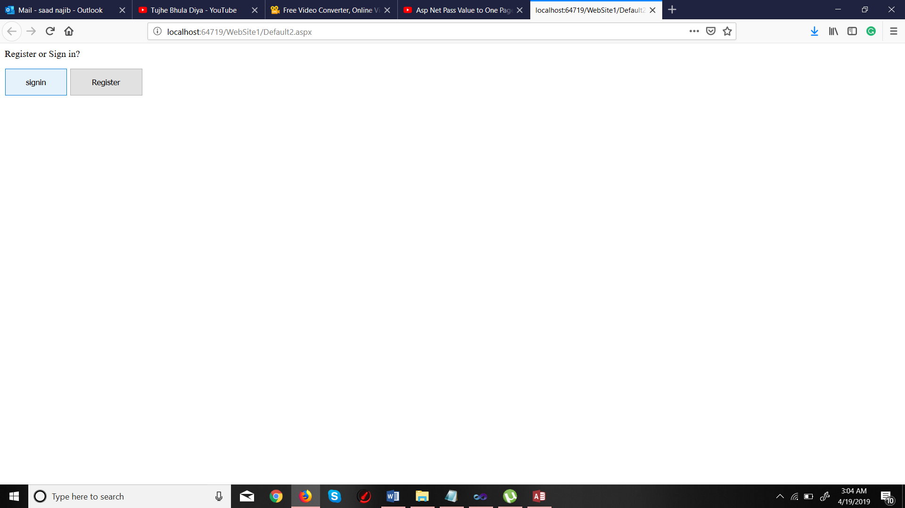

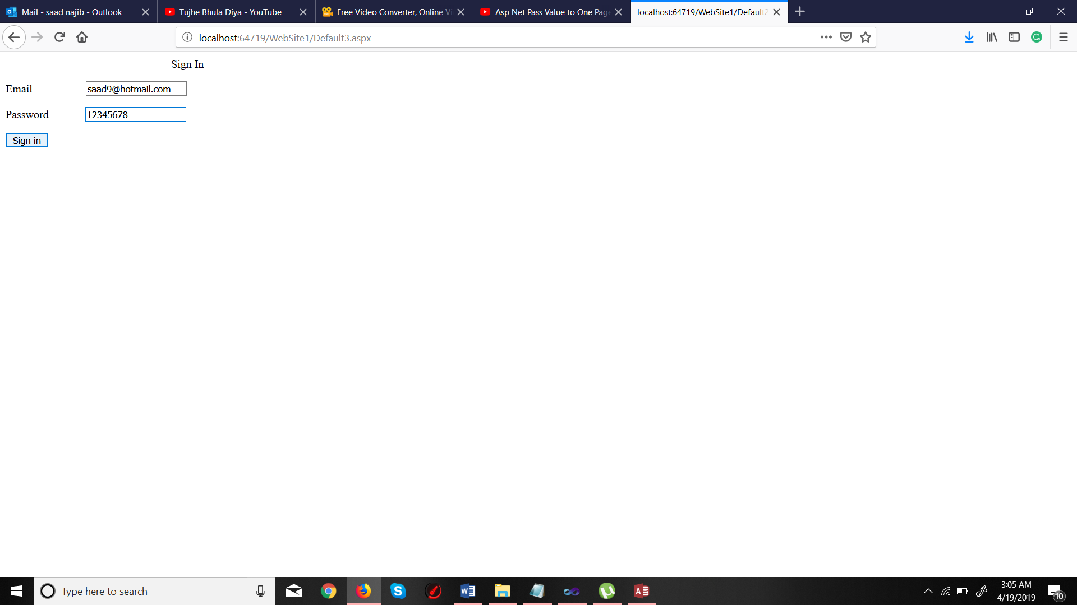

**4th Web Form**

using System;

using System.Collections.Generic;

using System.Linq;

using System.Web;

using System.Web.UI;

using System.Web.UI.WebControls;

public partial class Default4 : System.Web.UI.Page

{

protected void Page_Load(object sender, EventArgs e)

{

Label2.Text = Session["value"].ToString();

Label3.Text = Session["fnam"].ToString();

}

}

