**Trello Board:**

<https://trello.com/invite/b/67c16b7b6df863855867cffc/ATTI05ce8b56f130ae8ba080ccd2fbd78316ED45F659/library>  
  
**Product Backlog**

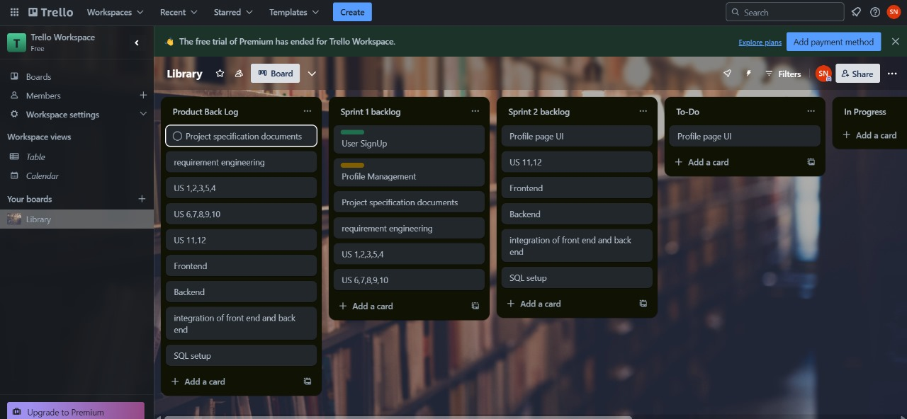

**Sprint 1 Backlog**

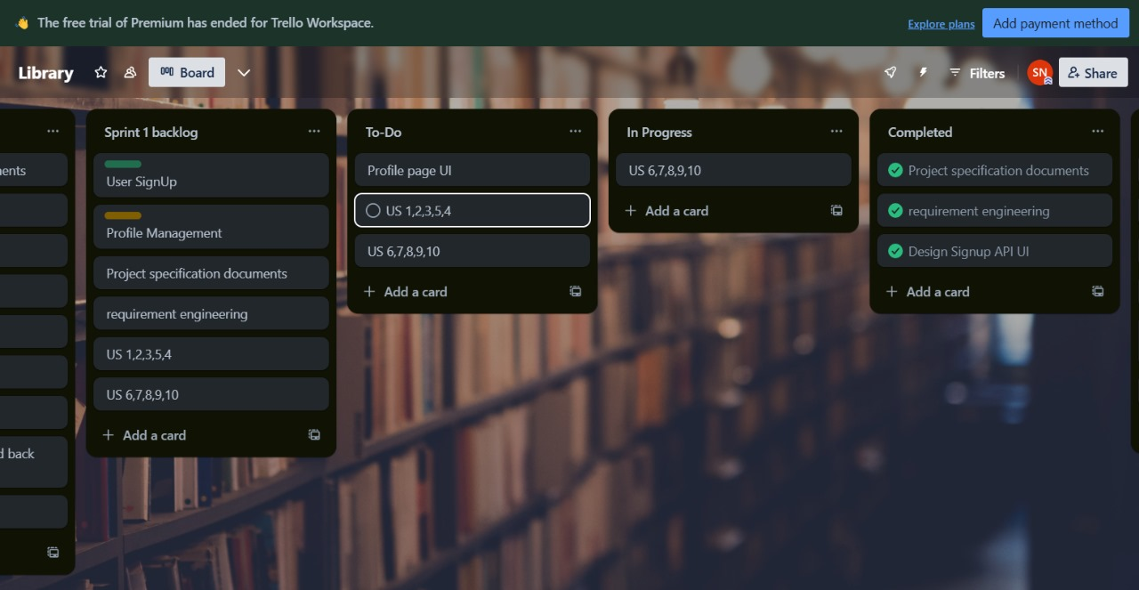

**Sprint 2 Backlog**

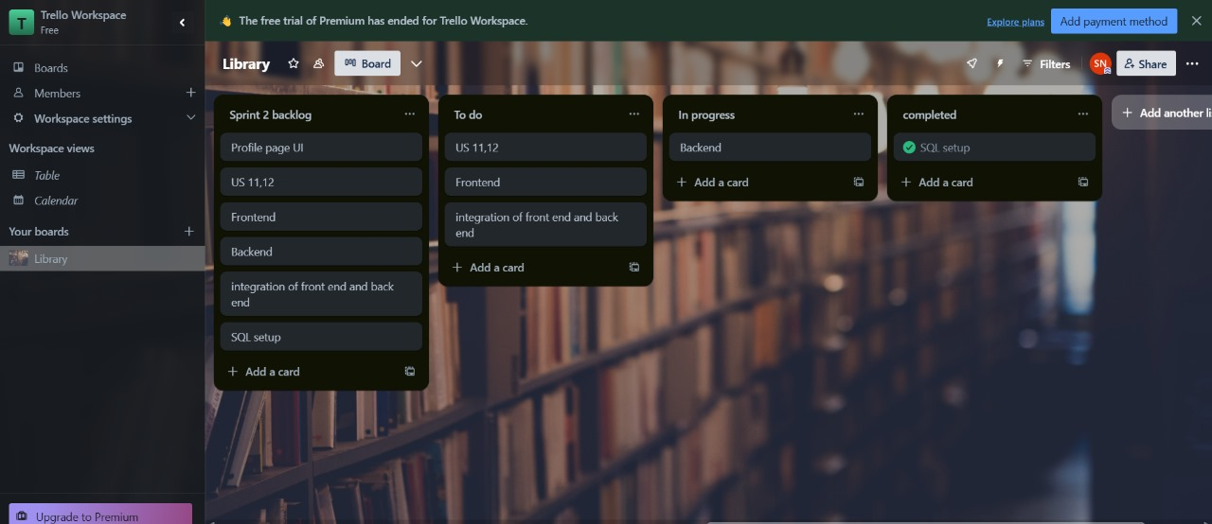

**Conversion Control:**