# 

EBS Integration Kit 2.2.0.12

Pre-requisites Guide

Version 1.1



Table of Contents

Introduction 4

Purpose 4

Scope 4

Pre-requisites for EBS Integration Kit 5

Preparing Binaries with Licenses 5

Preparing PingFederate & Active Directory Environments 5

Preparing Oracle EBS Application for Single Sign-On 6

Server Communications, Firewall Requirements & VLAN Design 7

Change Log

|  |  |  |
| --- | --- | --- |
| **Date** | **Type** | **Description** |
| 13/04/2022 | Networking | Root domains of EBS application and EIK nodes should be identical |
| 13/04/2022 | EIK Version | EIK 2.2.0.12 |

# **Introduction**

Delivering the Single Sign-On Experience for Oracle EBS application with LikeMinds EBS Integration Kit with PingFederate as the Identity Provider.

# **Purpose**

Purpose of this document is to provide pre-requisites to install the EBS Integration Kit in a standalone or Clustered Instance of PingFederate.

# **Scope**

The latest EIK 2.2.0.x versions up to 2.2.0.12 with their pre-requisites are tested & certified against the following versions of the products.

|  |  |  |  |  |
| --- | --- | --- | --- | --- |
| EBS Integration Kit | Oracle E-Business Suite | Oracle Database | PingFederate | PingAccess (optional) |
| 2.2.0.12 | Releases with update packs  12.0.x to 12.1.x  &  12.2.0 to 12.2.10 | 11g release – 11.2.x  &  19c release | 8.x to 11.0.2 | 4.x to 7.x |

# **Pre-requisites for EBS Integration Kit**

The following are the pre-requisites for installing the EBS integration kit in PingFederate & EBS application for enabling secure SSO with additional capabilities for Oracle EBS application.

**Teams involved for EIK Implementation Oracle EBS SSO**

* Oracle EBS Application & EBS Database Administrators
* Active Directory Administrator
* PingIdentity Solution Implementation partner

## Preparing Binaries with Licenses

* Prepare/Download the EBS Integration kit binaries with Eval/Prod license copy
* Download the PingFederate-10.x installation binary from the PingIdentity website and be prepared with the Eval/Prod license copy (PingFederate Eval license including the enablement of OAuth/OIDC protocols)
* Openjdk-11 (or) Oracle Java SE Development Kit

## Preparing PingFederate & Active Directory Environments

The following are the pre-requisites for PingFederate installation & connecting with Microsoft Active Directory for User authentication.

* **System Requirements for PingFederate Installation**
  + UNIX/Linux virtual machine with 2 CPU cores / 8Gig Memory / 100GB Space (for optimal performance)
  + PingFederate machine to be installed on the Internal network zone (application layer) of the Organization’s Infra
  + Have the PingFederate-10.x, EBS Integration Kit & JDK binaries in the PingFederate server as part of the implementation’s first phase
* **Active Directory Requirements**
  + Active Directory SSL/non-SSL port to be opened with the PingFederate server
  + Active Directory Service Account to be configured with PingFederate for authentication
  + Active Directory FQDN with its port
  + DN and Password of the AD Service Account
  + Test User in Active Directory for testing SSO to Oracle EBS

## Preparing Oracle EBS Application for Single Sign-On

The following are the pre-requisites to be done or kept ready on the Oracle EBS side for SSO with PingFederate & EBS Integration Kit

* Oracle EBS ‘APPS’ user credentials for registering a custom user to create authentication sessions in EBS
* Create a new user in EBS Application FND_USER table with the following details:
  + Username - EIKUSER
  + Role - UMX|APPS_SCHEMA_CONNECT
* Oracle EBS Database – JDBC url, Oracle JDBC drive details, Cookie domain value of EBS application
* Oracle EBS System Profile parameter changes to enable SSO. Following are the EBS system profiles that will needs to be modified for EBS SSO:
  + Application SSO type
  + Application Authenticate Agent
  + Application SSO Login types
  + Application SSO LDAP Synchronization
* Test User to be present in the Oracle EBS Application with proper roles and active account. The USER_NAME of this test user should match with the sAMAccountName or any other authentication attribute in the Active Directory

## Server Communications, Firewall Requirements & VLAN Design

The following are the firewall requirements and designs for EBS SSO with PingFederate & EBS Integration Kit.

**Server Communications between Oracle EBS/Database & PingFederate/EIK**

* The EBS application server will be communicating with EBS Integration Kit(PingFederate server) for authentication
* EBS Integration Kit will communicate with Oracle EBS Database server for account validation and EBS session creation.
* EBS Integration Kit will also communicate with EBS application server for redirecting the User to EBS application homepage post authentication & user session creation.

**Port Requirements**

* EBS Integration Kit will be installed on the PingFederate server itself, and therefore it uses the PingFederate runtime port for communication.

By default, PingFederate runtime port is 9031.

Note: There is no specific firewall requirement to be enable for EBS Integration Kit.

* The firewall should be opened between EBS application server and PingFederate Runtime port/Load Balancer ports during a cluster-based configuration.
* The EBS Database should be reachable through EBS Integration Kit for session creation, and therefore, the firewall should be opened between EBS Integration Kit & EBS Database (Two-way communication mode)

**DNS Changes**

* The root domains that point to the EBS Application and the PingFederate nodes hosting the EIK should be identical.

For example: Domain name for EBS- ebs.company.com

Domain name for EIK- pingfederate.company.com



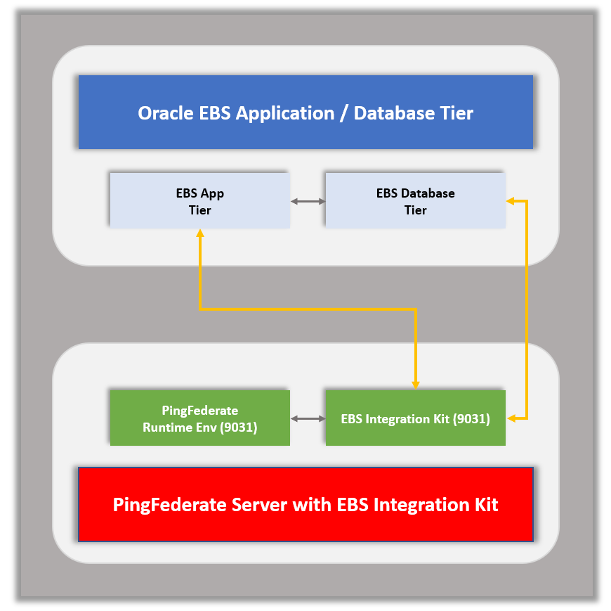**VLAN Design**

**About LikeMinds Consulting Inc**

LikeMinds consulting is a leading provider of consulting, systems integration and managed services and focuses on Identity Management, Application Security, Governance, Risk and Compliance solutions. We have focused on providing our customers with a full range of services which span through our core beliefs of Advising, Integrating, Maintaining and Accelerating the Complete Identity and Security Solution.

For more information, contact us toll-free 1-888-562-3528, email [info@likemindsconsulting.com](mailto:info@likemindsconsulting.com) or visit [likemindsconsulting.com](http://www.likemindsconsulting.com) © 2020 Like Minds Consulting. All rights reserved