EIK Support Lifecycle

& Customer Manual



LikeMinds Consulting

Table of Contents

**1.** **LikeMinds EIK Support Policy** 3

**1.1** **Severity Levels** 3

**2.** **EIK Support Ticket Management** 5

**2.1** **Steps to create a New Support Ticket** 5

## **LikeMinds EIK Support Policy**

LikeMinds EIK Support policy helps drive your business success. Our support policy covers the entire EIK technology-based criteria. Our flexible support policy stages make it easier for you to plan for upgrades.

With LikeMinds EIK support, you know up front and with certainly how the policy provides access to technical experts for as long as you license your LikeMinds EIK product.

### **Severity Levels**

* Severity 1 (Urgent) - Production Down & critical impact on Business
* Severity 2 (High) - Production Up with minimal impact but require resolution
* Severity 3 (Medium) - Non-Production systems with least or no impact
* Severity 4 (Low) - Customer request on any enhancements requests

**Severity 1 (Urgent) Escalation Process**

Description:

The Error results in complete interruption of a production system that impacts all users and no viable workaround exists. Customer must raise a ticket in LikeMinds helpdesk portal to report a Severity Level 1 Error.

Response Time:

LikeMinds shall acknowledge receipt within one (1) hour of Customer’s submission of a Support Request. LikeMinds shall provide hourly updates via email.

Resolution Time:

LikeMinds shall Resolve the Support Request as soon as practicable and no later than twenty-four (24) hours after LikeMinds receipt of the Support Request.

**Severity 2 (High) Escalation Process**

Description:

The Error has a (i) severe impact on performance, important services/components are not functioning, or a subset of users cannot access necessary functionality in a production system; or (ii) critical business impact and deployment is delayed with a hard deadline approaching in a non-production environment.

Response Time:

During Support Hours, LikeMinds shall acknowledge receipt within two (2) hours of Customer’s submission of a Support Request. LikeMinds and Customer will mutually agree on a schedule for ongoing updates.

Resolution Time:

LikeMinds shall Resolve the Support Request as soon as practicable and no later than forty-eight (48) hours after LikeMinds receipt of the Support Request.

**Severity 3 (Medium) Escalation Process**

Description:

The Error has a low impact on (i) a small number of users in a production environment; or (ii) development or quality assurance in a non-production environment.

Response Time:

During Support Hours, LikeMinds shall acknowledge receipt within two (2) hours of Customer’s submission of a Support Request. LikeMinds and Customer will mutually agree on a schedule for ongoing updates.

Resolution Time:

LikeMinds shall Resolve the Support Request as soon as practicable and no later than ten (10) days after LikeMinds receipt of the Support Request.

**Severity 4 (Low) Escalation Process**

Description:

Customer is letting LikeMinds know about a minor problem or enhancement request for which feedback is not required.

Response Time:

During Support Hours, LikeMinds shall acknowledgement receipt within three (3) Business Days of Customer’s submission of a Support Request.

Resolution Time:

Not applicable.

**Out-of-Scope Services**

This means any of the following: (a) any services requested by Customer for Products for which Customer has not purchased or paid for Support Services; (b) any services requested by Customer in connection with any apparent Error that LikeMinds determines in its reasonable discretion to have been caused by a Customer Cause; or (c) any other services that Customer and LikeMinds may from time to time agree in writing are not included in the Support Services; (d) any configurations involving only PingIdentity related use cases (i.e., PingIdentity product recommendations or changes without EIK consideration).

## **EIK Support Ticket Management**

This section shows how an EIK support ticket can be created/managed. As a LikeMinds customer, you can access LikeMinds helpdesk portal which will allow you to create a new support ticket or report an incident or outage with respect to EIK features.

Helpdesk Portal - <support.likemindsconsulting.com>

Helpdesk Contact - +1 (732)-374-9158

### **2.1 Steps to create a New Support Ticket**

1. To avail the LikeMinds helpdesk portal credentials, please follow the below process.

LikeMinds helpdesk portal Credentials:

1. One account will be created in LikeMinds helpdesk portal for the Client to manage their support tickets.
2. As part of this process, an email address should be provided from the Client team (Engineer/Consultant Company email address from concerned Client team to work on the EIK)
3. The login ID will be the company email address provided in the previous step.
4. An email will be sent to your company email address at the time of your user account setup and the user will be allowed to reset their password with the one-time link provided in it.
5. After a successful User registration, you can access the LikeMinds helpdesk portal using the following link:

<support.likemindsconsulting.com>

Please refer the screenshot in-line.

1. After you login, the LikeMinds helpdesk homepage will be displayed. In the homepage, you can find options to create ‘New Support Ticket’ | ‘Check Ticket Status’ | ‘Knowledge Base’ and ‘Community Forums’.

1. Click ‘New Support Ticket’ to create a new related to any EIK issues or to report an incident.

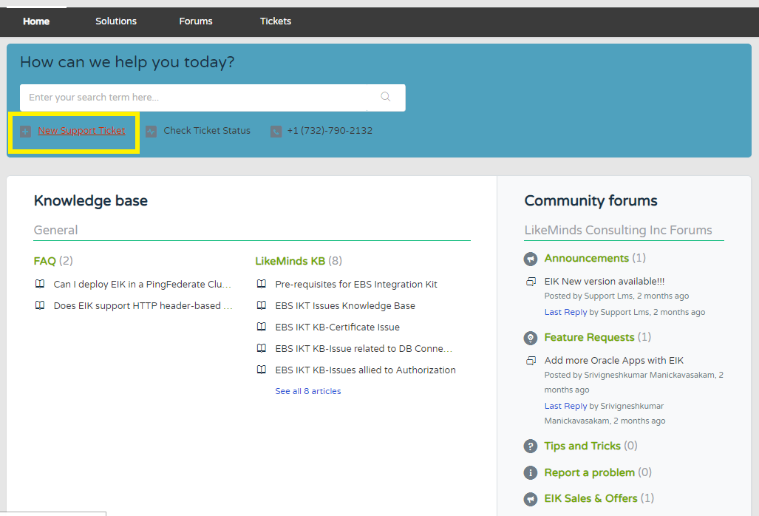

1. In the ‘Submit a ticket’ page, you will find fields for ‘Requester (auto-filled with your email address)’, ‘Subject’ & ‘Environment’, ‘Severity’, & ‘Description’. Please enter the details with respect to the EIK issue you’re facing and click ‘Submit’.

Note: Please attach the relevant log files to expedite the troubleshooting process.

1. Upon clicking Submit, the ticket will be created, and you will be redirected to the ‘Tickets’ page where you can see the acknowledgement message – ‘Your ticket has been created’ & ticket details on the right side.
2. A notification email will be sent to the registered email address.
3. You can manage your ticket by requesting for an update in the same Tickets list page. The assigned engineer will update with resolution if any and based on the EIK Support SLA with you.
4. You will also be notified via email if there is any update done to your ticket by the support engineer.
5. The ticket will be closed by the support engineer once the issue is resolved and with a confirmation from your side that EIK is working as expected in your system. You will also receive an email on the closure of your ticket. The ticket can’t be re-opened for any reasons. In case if you face any issues later, please submit a new ticket to assist you in a better way.

Notification Email on Ticket Closure

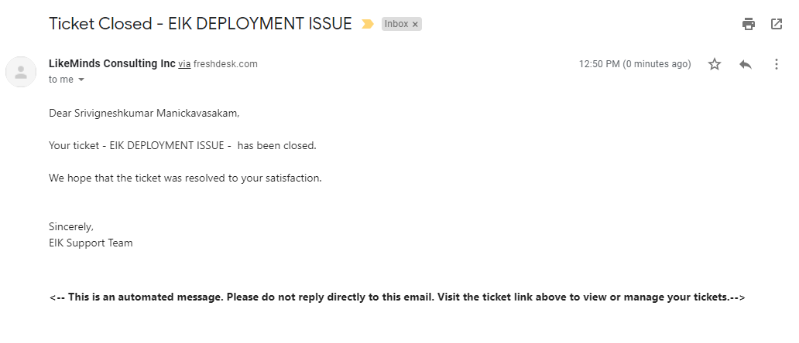

*Kindly reach out to* [*eiksupport@likemindsconsulting.com*](mailto:eiksupport@likemindsconsulting.com) *for any queries / concerns with this document.*

**Thank You!**