[Hamza Asaad](https://devpost.com/hamzaasaad15" \t "_blank)**,** [Shehreyar Kitchlew](https://devpost.com/Shryr), [Haziq Ahmed](https://devpost.com/231452941), [Ahmad Saad](https://devpost.com/231461463)

https://github.com/saadpocalypse/Stanford\_Data\_Project

**Using Data Reflection to provide recommendations on the education system**

**Post-pandemic** ­­

**Abstract:**

This paper is a data driven effort to provide valuable insights to the stake-holders of Forman Christian College about the validity, sustainability and ethicality of distance learning. The pandemic of 2019 has fostered a dystopian society and has propelled educational institutions into unforeseen circumstances. The two year continuation of Covid-19 has separated prepared institutions from the unprepared. As the world looks to reinstate a semblance of normalcy, this paper institutes a reflective eye and recognizes that basing predictions on information acquired during this transitional phase will ultimately increase effectiveness in the plausible future. Considerations ranging from surveys to sentimental analysis of tweets to the history and adoption of online learning have been reflected on to conclude on the central research question. The findings from this data have included the overall perceptions regarding online learning by students. Moreover, the tweets garnered reflected the sentiments surrounding distance learning on a global level. Tertiarily the rate of adoption of online learning has been considered to show the inevitability in the future of this new mode of teaching. Finally multifaceted data has been gathered, assessed and inferred upon to give a substantial recommendation on the future of distance learning. **Introduction:**

The year 2020 had brought significant changes in the world of education. E-learning replaced in-person interaction to continue academic programs, circumventing the spread of Covid-19.  From the very start, enough grievances were raised to warrant dialogue into this matter. Many students and teachers realized that they were ill-equipped to transition into online frameworks. The sudden impetus for change had uncovered a plethora of foundational problems in Pakistan’s education system. Unlike institutions in developed nations, that had been adopting contemporary teaching methodologies, for many years, Pakistan lacked the environment to implement a comparable framework. Pakistani education has historically struggled to keep up with top tier institutions; the new circumstances have only exasperated the disparity.[7]

This situation pushed Pakistan to build its e-learning framework from scratch. Several other countries were just as inexperienced in this challenge [1]. E-learning has many aspects that conventional learning doesn’t deeply involve. Thus, it requires careful execution and intense scrutiny. It mutates typical methods and curriculum like exams quizzes, assignments and. Hence it is a polarizing prospect that has led to a variety of perceptions from satisfaction to dissatisfaction. This research is thus a data driven effort to  analyze the overall opinions of the affectees, understand the grievances, and inform the way forward for distance learning in a third world country like Pakistan.

The first stage of the study dives in for a granular look at a major section of direct affectees in Pakistan, i.e. the student body. Data was obtained via a survey to capture the breadth of student satisfaction and overall sentiment towards distance learning. The survey was modeled on a similar study[1]  in Jordan, with objectives that intersected with our own, modifying questions in the direction of our research yet keeping enough similarity for comparison. The survey was shared, via social media forums, throughout the student body of Forman Christian College (FCC). The outcomes were compared with those of the Jordanian study to assess the resounding trends beyond national borders. The second stage expands to a broader perspective of public opinion. 200,000 tweets, on e-learning, were analyzed to garner a source of general sentiment. In the third stage, to assess the pre-existing demand for online learning, we consider the growth and trajectory of online learning by analyzing a dataset which is related to its adoption before the pandemic. The overall objective of this paper is to consider all these aspects of online learning as a whole; its inception, growth and, particularly, its current status as an emergency mode of learning during the pandemic. The paper will combine the insights from all analyses to comment on student and teacher satisfaction, identify the related grievances and appealing factors, comment on the sustainability and ethicality of e-learning, and to explore how it can become a permanent option in a post-pandemic Pakistan. The paper is an effort to provide valuable recommendations to the stakeholders of Forman Christian College to build the College in the image of data sculpted efficacy, improving the e-learning experience and outcomes moving forward.

**Literature Review:**

A pertinent argument is raised when the system of online education depends on how smoothly it runs; can a flawed system be turned around to satisfy teachers and students alike, surviving in a post pandemic, third world Pakistan?

A study was done in Jordan University (2020) after the pandemic had caused a country-wide closure of universities. It looked at how over 200,000 students adapted to the new system of online learning, overcoming environmental, electronic, and mental struggles of the pandemic. A survey was conducted which boiled down to a better understanding of student perception towards online learning. While the paper did not interpret its data to reflect on the implications for current and future online learning, this survey served as a suitable basis for our own collection methodology of dataset 1 from FCC. Another global study explored the effect of diminished physical contact, negative emotions and reduced social interaction, during the pandemic, on students’ academic performance. It found a decline in students’ cognitive engagement, motivation, and efficacy after the transition to e-learning, validating the findings with simple statistics e.g. t-test, rs coefficient, and p-value.

On the contrary, a study in Saudi Arabia (2020) presented an antagonistic conclusion to what we’ve seen already. It states that students in KSA are highly satisfied with the effectiveness of e-learning during the pandemic, especially the modes of assessment such as open book exams and self-assessments. The differences in the conclusions can be reconciled by considering academic integrity, which is one of the primary concerns in relation to teacher satisfaction with e-learning. In his article “Cheating on Online Exams”, renowned sociologist and physicist, Prof. Hoodbhoy highlights some of the problems students face while learning remotely, and how a lack of effective methods employed by their institutions forced them to turn to cheating. He sheds light on how students are in WhatsApp groups dedicated towards doing assignments together, and online resources such as Chegg, willing to complete course questions for a price. He claims that the only way the students can truly be tested is through live vivas over video conferencing. The article concludes by showing the inverse relationship between e-learning and academic integrity in Pakistan. Hoodbhoy claims, students are taught to value grades over learning. He went on to resign from a university, citing his disappointment with the way the institute implemented e-learning. This is a prime example of teacher’s dissatisfaction with the rushed system of e-learning in Pakistan.

Note that all the studies examined were conducted around mid-2020 latest. They explore a world still new to COVID. As of Q2 2021, students have spent more time acclimatizing to the new normal. Teachers have had time to adapt their methods. Considering the Technology Adoption Lifecycle Model [8], a study of today’s world would explore a user base at a different point in their journey of accepting e-learning. The implications of this may or may not result in a varied snapshot of performance, sentiments, and perceptions.

**Methodology:**

The paper analyzes multiple datasets:

*Dataset-1* was a survey conducted by the authors on the student-body of FCC. An online survey was formulated based on the Jordanian study. The survey was specifically designed to follow standard practices. Questions where bias could be an issue were repeated so that a steady trend could be seen. The survey was intentionally provided keeping demographics such as gender and field of study balanced. 140 students responded over 2 days. There were no missing values recorded in the dataset used. 9 explanatory variables were selected (Table 1). These represented demographics, environment, and academic performance. These factors could possibly affect student perceptions of e-learning. 7 response variables were chosen as indicators of satisfaction and demand for e-learning. (See Table 2)

|  |  |
| --- | --- |
| **Label** | **Attribute** |
| E1 | Gender |
| E2 | Age |
| E3 | Level of education |
| E4 | Field of Study |
| E5 | Used E learning prior to the pandemic |
| E6 | My Relatives think I should adopt e learning |
| E7 | People who influence my behavior think I should adopt e learning |
| E8 | Has your GPA increased or decreased with remote learning? |
| E9 | How likely do you think it is that remote learning will become a permanent option in post pandemic Pakistan? |

**Table 1: Explanatory Variables**

|  |  |  |
| --- | --- | --- |
| **Label** | **Attribute** | **Indicator** |
| O1 | How likely are your friends to take the semester remotely | Demand |
| O2 | Remote learning increases my academic efficiency | Satisfaction |
| O3 | Remote learning saves me time | Satisfaction |
| O4 | Remote learning is easy to adapt to | Satisfaction |
| O5 | if given the option I would opt for e learning during pandemic | Demand |
| O6 | if given the option I would opt for e learning post pandemic | Demand |
| O7 | Online learning should be a permanent option post pandemic | Demand |

**Table 2: Response Variables**

The analysis section shows the use of statistics to see whether each of the explanatory factor is significantly tied to the demand for e-learning and student satisfaction (i.e. response variables)

*Dataset-2* was a pool of global 200,000+ tweets about e-learning. The dataset and much of the processing source code was acquired from *“kaggle.com”*. The code was tuned to be made relevant to the study. The code removes unnecessary characters from the tweets and isolates their polarity and subjectivity. Sentiment analysis is used to categorize data. The tweets are then categorized as positive, negative, or neutral and the relation between them is observed and visualized. Finally, 2 word-clouds are made (positive, negative) showing recurring words and ideas that people present while praising e-learning or sharing their frustration over it. Noting the most relevant words from the word cloud, we revisit the pools of positive and negative tweets and observe a sample of the tweets with the relevant words. Negative tweets are used to inform our recommendations on challenges and areas of improvement. Positive tweets are used to assess what people already like about e-learning, so that its strengths can be capitalized on

*Dataset-3* was provided by the Stanford Open Datathon Project team. The Dataset was based on the number of students who enrolled in university courses and were distinguished by mode of learning and education level. This was pre-pandemic data. The data provided was already processed. The processed data-points were used to plot the market trend over a 5-year span. The questions of interest here were about user acceptance and sustainability of e-learning observed in the pre-pandemic era.

**Analysis:**

In Dataset 1, E6, E7, E9 and all Response variables were rated on a scale of 1-5 whereas the remaining attributes were categorical. As the data was limited, the ratings were grouped in categories 1, 2-3 and 4-5 to mitigate the unreliability that would have resulted from a disproportional dataset. As all attributes could be represented as categorical data, the categorical Chi-square test was used to find p-values of each pair of explanatory and response variable to assess any significant correlation between them. If the pair had a p- value below 0.05, the explanatory value was not a good predictor for the response variable. Figure 1 shows a heat map of p-values of explanatory and response variable pairs. The significance of each p-value is visualized as a color intensity, with the most significant p-value depicted by the darkest shade of green and least significant by the lightest as shown in the key. The smaller the p-value, the more it is likely that the distribution of data between two variables is a result of factors other than mere chance. E4, Field of study (STEM, non-STEM) has no significant p-values, as indicated by the completely white row i.e. the STEM vs Non-STEM field distinction does not seem to provide us any distinct information when we observe them in correlation with indicators of satisfaction (O2,O3,O4) or demand (O1,O5, O6,O7). With the same rationale, different gender groups – E1 – (Male or Female) do not provide vastly different feedback on satisfaction or demand either. E2 (age) shows significant correlation with all 3 indicators of satisfaction (0.00076 <= p values <= 0.017661) and 3/4 demand indicators (0.000150 <= p values <= 0.016848). The correlations are present but they are weak, with most of the p value cells shown in lighter shades of green. E3 (education) similarly shows sparse significant values. E5 (Use of e-learning before pandemic) shows significant correlations with 2/3 satisfaction indicators (0.000993 <= p values <= 0.014777) and 3/4 indicators of demand (0.000037 <= p values <= 0.004734).

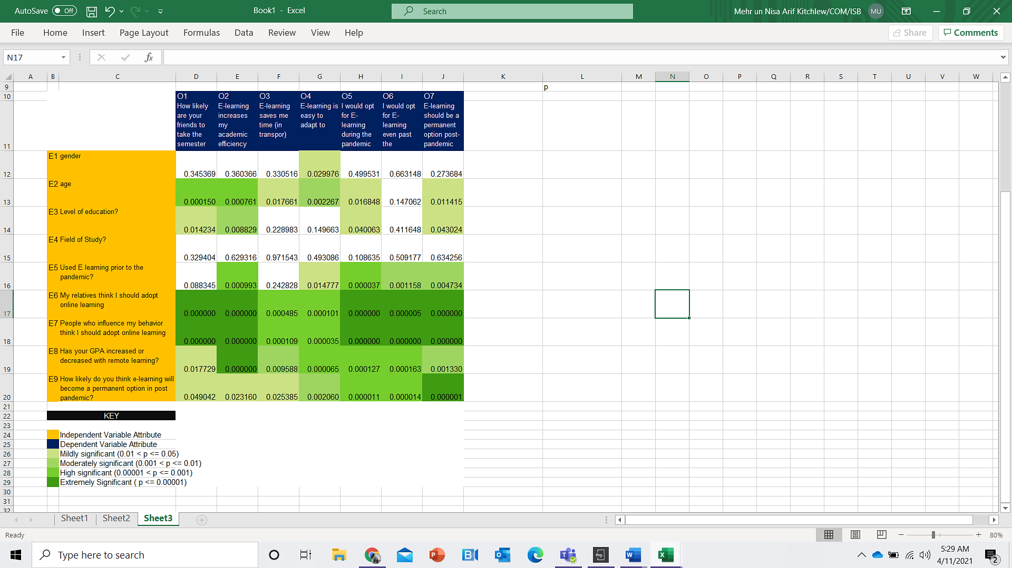

**Figure 1: P-Value Heat-map**

E6-E9 show no white cells i.e. each of these variables (perceptions of relatives, perceptions of influencers, increase/ decrease in GPA post pandemic and perspective on whether e-learning is here to stay) is significantly related to all 3 indicators of satisfaction and all 4 indicators of demand. The rows for E6 and E7 show the most significant p-values indicating that the perception of influencers and relatives has a significant correlation with indicators of satisfaction and demand. All indicators show very significant values (p value <= 0.001) for E7 and E6.

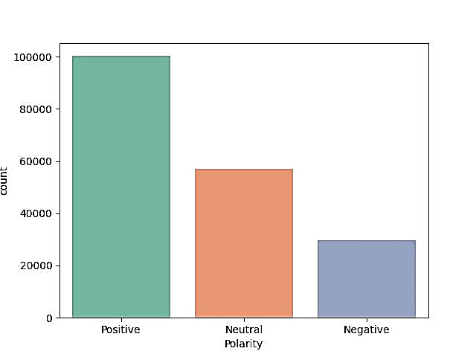

**Figure 2: Sentiment Analysis Bar Chart - Distribution of tweets by polarity**

Dataset 2 was first processed through a Natural Language Processing algorithm for Sentiment analysis. The tweets were segmented into ones with positive, negative and neutral sentiment. Figure 2, shows a bar chart distribution of the overall polarity, charting positive, neutral, and negative tweets respectively. We can observe 100,000 positive, 60,000 neutral and 20,000 negative tweets.Figure 3 shows a scatter plot of all tweets by polarity and subjectivity. The high density of green points (positive), as compared to blue (negative) supports the bar graph evidence that there are far more positive tweets than negative. As we move outward from the vertical center of the scatter plot, we see that population of points decreases, showing that most tweets gravitate towards a more neutral stance. Polarizing/extreme tweets are comparatively sparse. The green points cover the area distant from the vertical center more densely than blue points. Thus, the positive tweets are more polarized/ expressive, than negative tweets. The scatter of the positive and negative tweets roughly forms a “V” shape, with the population of points thinning as we travel down the y axis (subjectivity), indicating that the most objective tweets tend to be closer to neutral whereas subjective tweets occur on a spectrum covering neutral as well as highly polar (positive/ negative) sentiments. Hence, we are more likely to find polarized opinions in subjective rather than objective tweets.

**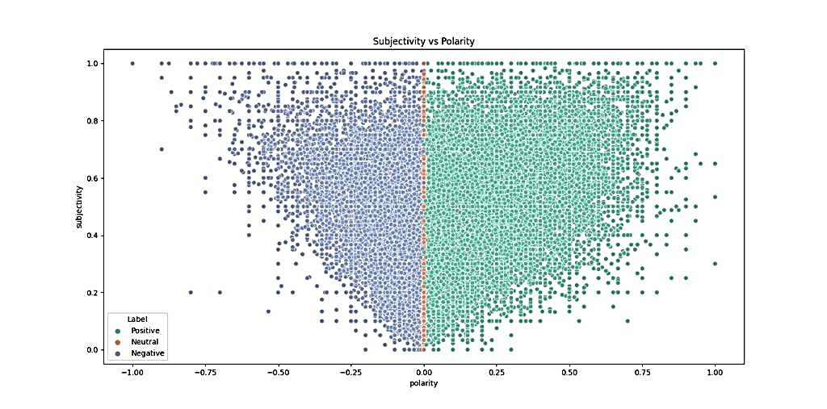**

**Figure 3: Sentiment Scatter Plot – Subjectivity vs Polarity**

The positive and negative tweets were plotted on separate word clouds as shown in Figures 4. By zooming into different sections of the negative cloud we found a set of keywords: [Saynotofees, Fee, Fund, Money, Duty, Cheat, Unfair, Administration, Administrators, Transparency, Process, Politics, Policy, Onlineclasses, Zoom, Mic, Screen, Support, Slides, Classmates, Inperson, Mean, Boring, Hours, Lab, Productivity, Remembering, Examining, Exams, Attention, Graded, Completing, Deadlines, Anxiety, Geographical, Parenting, Parent, Child, Bully, Abuse, Vulnerable, Unethical, Dishonest, … ].

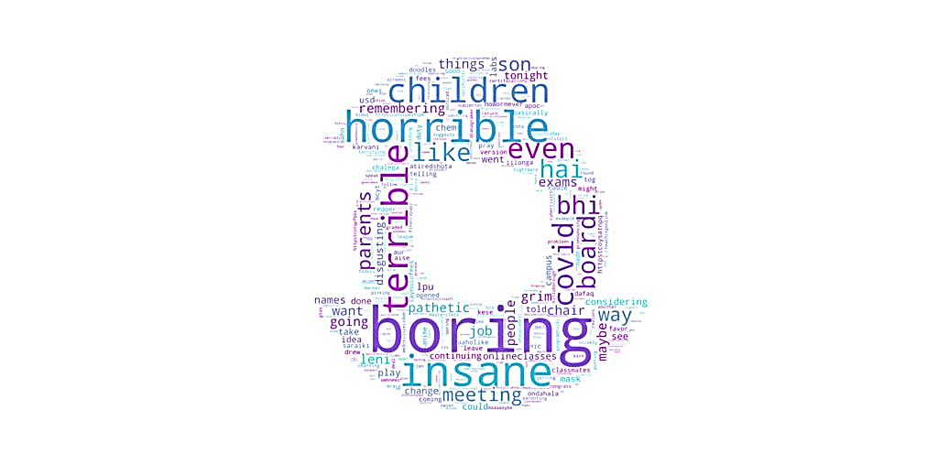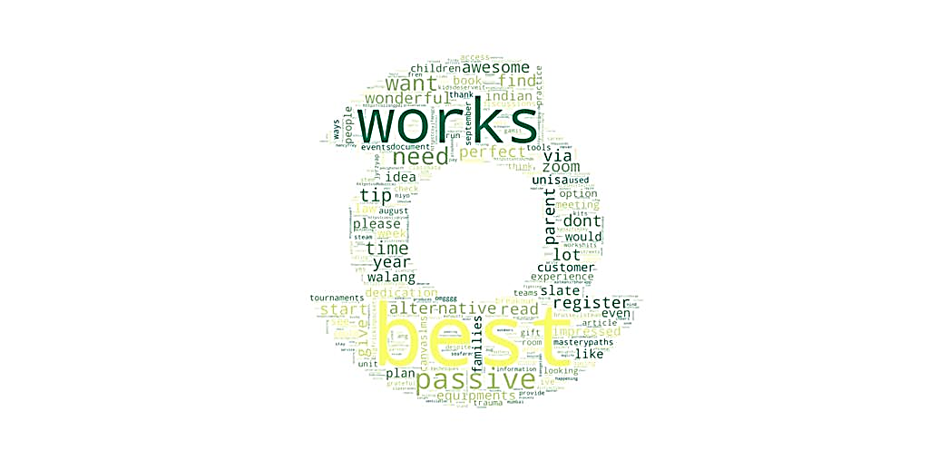

**Figure 4: Word Cloud –**

**Left: Negative Tweets, Right: Positive Tweets**

These words commonly occurred within the tweets and appeared relevant to our pursuit to understand users’ grievances of diagnosing the causes of doubt or dissatisfaction with e-learning. The same was done for positive tweets to discover what works well and draws people to e-learning so that related areas can be capitalized upon in our pursuit of improving e-learning frameworks. The list of key words from positive tweets include [Zoom, Information, Discuss, Techniques, Interaction, Experience, Schedule, Time, Option, Platform, Access, Repurpose, Career, Afford, Chance, Google, Candid, Openaccess, Alternative, Breakout, Parent, Need, Opportunity, opportunities, Partner, Contradict, Examination, Tool, … ] Example of user feedback (relevant tweets) and their implications are highlighted in the discussion section

**Figure 5: Percentage of people who enroll in online courses each year**

From Dataset-3, we used data from 2015-20 to derive a market trend for e-learning demand. We found that students from title IV institutions who enrolled online entirely or partially comprised 36.6% of the e-learning market share, 2019-20. The annual shares are shown in Figure 5. A linear trend is seen for market growth this indicates the market to be maturing. Over the five years there was an average growth rate of 1.46%.

**Discussion**

Our findings from dataset 3 validate that there was an increasing place for online learning in US institutions in the pre covid era. The pandemic became a great opportunity to catalyze this growth and to market online learning, but online learning was already taking over the education ecosystem slowly but surely. Pakistani universities like FCC model much of their curriculum and methodologies after these US universities.[9] Even the Pakistani government had been taking interest in e-learning before the pandemic, with the introduction of digital programs like PIAIC to teach the general population about AI, Blockchain and Cloud Computing with the support of online resources. Due to the unnatural saturation of distance learning in the COVID era, it would not be surprising if its growth slows down or market share starts declining as the natural order is restored. However, this would not necessarily indicate a lack of interest in e-learning. The sentiment analysis of dataset 2 yielded a much higher proportion of positive responses than negative ones. One user quotes:” *I missed so much school as a kid due to* ***social anxiety****, I bet I would’ve thrived with distance learning tbh*” Another user explains their experience with teaching online, stating: ”*What I had good luck with in my summer online class, which was a combo of synchronous and asynchronous, was putting the students in breakout groups on synchronous days and giving them a task to work on together. They really* ***enjoyed*** *this as well.”* Teachers are progressively finding ways to effectively engage students with innovative use of technology. An observant user stated: *“****Academic honesty*** *during distance learning is causing our #math teachers’ anxiety. My tech int. instincts and PLN counsel that most (all?) assessments should now be considered open book and so designed.”* Teachers faced many challenges getting started with a new mode of learning. A user recognizes the difficulty and addresses it*: “Distance learning is not* ***ideal,*** *but I am more hopeful about this semester and my anxiety has lessened a little bit. thank you, teachers, for working so hard to adapt. Teachers have already learned a lot since last semester.”* Having said that, negative sentiments were abundant in our data as well. We used the word-cloud for negative tweets, similarly, to identify keywords and diagnose grievances. Consistent with Hoodbhoy’s claim, academic dishonesty was a recurring pain point with 400+ tweets dedicated to the keywords [dishonest, unfair, cheat, unethical. One user asks: *“What student wants to go to class? OFCOURSE they want distance* ***cheating*** *I mean learning”*, Another points out: *“The kids* ***cheat****/look up answers and* ***learn NOTHING****. This isn’t educating my kids!”*, In certain instances, parents collaborate with students in academic dishonesty, as one user points out: *“Second day of distance learning, I’m already helping my kids* ***cheat****.”*, Academic dishonesty puts hardworking students at a disadvantage when the grading is relative and students obtain high marks from collaborating on individual assignments, thus raising the class mean. Sub-standard teaching adds to the distress as one user recounts: *“I need Pass/NC policy this semester! I‘ve used it last semester owing to* ***terrible online instruction*** *and* ***high means****.“*, While efficient management leads to a good experience and garners praise from the public, as highlighted earlier, poor management leads to dissatisfaction and stress. A neutral tweet points out: *“it possible to bring learning home literally. But schools need to be* ***flexible*** *with* ***schedules and deadlines”***, A lack of practical understanding and compassion in policies translates into distress for students. One user shares their grievance:*“ Currently in* ***exam stress****... my uni had no clue about* ***online lectures****, the semester was a mess but we have to write the exams. They are even more* ***complicated*** *bc we "****had more time*** *bc you all were at home"*, Students are additionally unhappy with institutions charging exorbitant fees despite the fact that they are no longer incur the running costs involved in operating in person from a physical premises. Students feel that they are not being offered value for money, despite having to struggle with added issues. One user notes: *“we're* ***paying the same*** *amount of fee as before for a* ***third-class online education****, not to mention that half of us don't even have the* ***internet connectivity*** *required (which is also really expensive).”*, While some previous sources of anxiety were mitigated by e-learning, new ones have cropped up. A user mentions: *“ I don't want to be seen on camera by professors…* ***Social anxiety*** *really is destroying my life”*, Another points out: *“I have a crisis of* ***anxiety,*** *I am afraid of falling or getting a* ***bad grade****”*, A new challenge has immerged for teachers in the form of cyber-bullying: *“Though school teachers and college professors have adapted to the system of #onlineclasses and #webinars, many of them are troubled with* ***#bullying*** *and online trolling.* ***#teacher #trol****l”.* Distance learning may not be practical or even possible for everyone. Blue collar workers often do not have access to the sort of privilege that makes online learning convenient for most of its advocates: One twitter user implores us to reflect on this: *“what about kids who have two* ***essential workers*** *as parents? What if both of those parents are grocery store workers or UPS drivers? How are those parents going to manage a full day of distance learning? They* ***don't have the option*** *to work from home, and many can't afford childcare”* Economic privilege is of high concern, especially in developing countries like Pakistan. Taking a deeper look within the Pakistani demographic, particularly FCC, Dataset1 unraveled further determinants of public sentiments towards e-learning. Prior experience with e-Learning influences student adaptability to online learning, academic efficiency, desire to opt for it during and after the pandemic and desire to keep it as an option past the pandemic. This suggests that experience is one of the keys to student satisfaction with e-Learning. Many students subjectively link their GPA fluctuation during e-Learning with the same issues as mentioned before namely adaptability, efficiency and preferences surrounding online learning holistically. One of the biggest drivers of student satisfaction with online learning is their social structure driving largely their opinions about the overall system. This be an exasperation of similar issues surrounding online learning faced by peers in the community. All these findings for students at FCC maintain an aligned view with the research and the perception the data model made in the Jordanian research concluded. Behavioral intention, perceived ease of use, perceived influence and social influence were all major factors seen in this survey conducted by the team in a Pakistani setting. Finally taking this into consideration and using findings made by the research conducted in KSA which showed the positive perceptions of students on a “well-made” online system we can theorize that once the system becomes accessible and polished the overall communal sentiment will subsequently be raised and student perceptions surrounding it should promote the use of e-learning during and after the pandemic.

**Recommendations and Conclusion:**

Looking at the information in the paper, we can make an educated estimate that there will be considerable demand for online education. Collectively looking at the findings we see consistent trends based on which we put forward our recommendations. *Target trust building at parental level:* Repeated use of the lexicon in dataset-2 postures towards a uniform notion that criticism and praise of e-learning stems from how well it caters to vulnerabilities of the systems and individuals involved. We found in dataset-1 that much of student satisfaction, at university level, depended on either social or performance-based factors. At a parallel , when we looked at the word-cloud we found keywords like parents, children, boards, and anxiety. We can derive a predicate based on the negative externalities derived through these factors. They indicate that if parents have a negative perception of the system, children are also likely to. This is supported by our analysis of attribute E7 that deals with relative’s perceptions. Involving parents’ feedback in improving e-learning could help gain their trust in the system, thus positively influencing students’ perceptions. *Adopt Compassionate Examination Practices:* Having anxiety may justify why children have a negative perception. As inferred from the tweets, that anxiety may be based on factors like board examinations or discomfort with social interactions. Policies like asking students to attempt exams with the camera on or minimizing the time may create unnecessary stress in an already stressful environment. Exams that constitute major grade components should be taken in a relaxed environment, with extra time being given to accommodate power failures, connectivity issues etc. *Prioritize Collaborative Assessments:* Lack of social interaction is a recurring concern in the tweets. The constant indication, that the people involved want social influence, suggests that isolation tactics like individual examinations, if partially exchanged with group assessments could mitigate negative externalities to some extent. Social tactics like group projects may cause positive externalities. If we were to institute online education, it could be an opportunity to integrate effective learning in the system. A major grievance of teachers and parents alike happens to be academic dishonesty as students collaborate on individual assignments. If students are given assessments that are designed, instead, for groups, in which peer teaching is encouraged, this will mitigate the problem. The focus should be on learning conceptually rather than learning conventionally. *Adopt Innovative, Open Book Assessments:* Assessment materials should be designed to stimulate student’s minds. Again, the idea of testing concepts rather than rote learning is important here. Design challenging problems for students to solve. Let students use online resources to work through it. This would be better than making assessment materials by copy-pasting textbook questions for which the answers can also be copy pasted. Plagiarism should be discouraged at both the student and teacher level. *Make Vivas Mainstream:* A major concern with group projects is that some students tend to contribute less than others and benefit off others’ efforts. Well-structured, open book vivas assessments can give the teachers a great idea of students’ standing and provide mitigation of the academic dishonesty challenge. *Create content repositories for accountable teaching:* As recommended by Hoodbhoy, lectures should be recorded and all teaching material should be saved to a university repository, regularly audited, and scrutinized for quality control. The outcry behind online education be a microcosm that magnifies the problems which are already present in in-person education because most of the problems in theory have the distinct duality also occurring in in-person education. With the practices recommended above, the major challenges can be addressed for a sustainable, ethical and experience centric future of e-learning that any institution that capitalizes on.

***References:***

1. Al-Okaily, M., Alqudah, H., Matar, A., Lutfi, A., & Taamneh, A. (2020, August 18). Dataset on the acceptance of e-learning system among Universities Students' under the Covid-19 PANDEMIC CONDITIONS. Retrieved from <https://www.sciencedirect.com/science/article/pii/S2352340920310702>
2. Almusharraf, N. (2020, November 16). *Students Satisfaction with Online Learning Experiences during the COVID-19 Pandemic | Almusharraf | International Journal of Emerging Technologies in Learning (iJET)*. Online-Journals. <https://online-journals.org/index.php/i-jet/article/view/15647/8179>
3. Patricia, A. (2020, January 1). *College students’ use and acceptance of emergency online learning due to COVID-19*. ScienceDirect. <https://www.sciencedirect.com/science/article/pii/S266637402030011X>
4. Hoodbhoy, P. (2021, January 23). *Cheating on online exams*. DAWN.COM. https://www.dawn.com/news/1603040

5. jdipino. (2020, October 24). Social\_Analytics\_Notebook. Retrieved April 11, 2021, from Kaggle.com website: https://www.kaggle.com/jdipino/social-analytics-notebook

6. The Integrated Postsecondary Education Data System. (2019). Retrieved April 11, 2021, from Ed.gov website: https://nces.ed.gov/ipeds/Search?query=distance%20learning&query2=distance%20learning&resultType=table&page=1&sortBy=date\_desc&overlayTableId=28442

7. Human Development Report 2013 The Rise of the South: Human Progress in a Diverse World Pakistan HDI values and rank changes in the 2013 Human Development Report. (2013). Retrieved from <http://hdr.undp.org/sites/default/files/Country-Profiles/PAK.pdf>

8. Liao, C., Palvia, P., & Chen, J.-L. (2009). Information technology adoption behavior life cycle: Toward a Technology Continuance Theory (TCT). *International Journal of Information Management*, *29*(4), 309–320. <https://doi.org/10.1016/j.ijinfomgt.2009.03.004>

9. Medium. (2019). Retrieved April 11, 2021, from Medium website: https://medium.com/@tosifjamil/a-comparison-between-higher-education-in-pakistan-and-united-states-482d3f50dae7

‌

‌