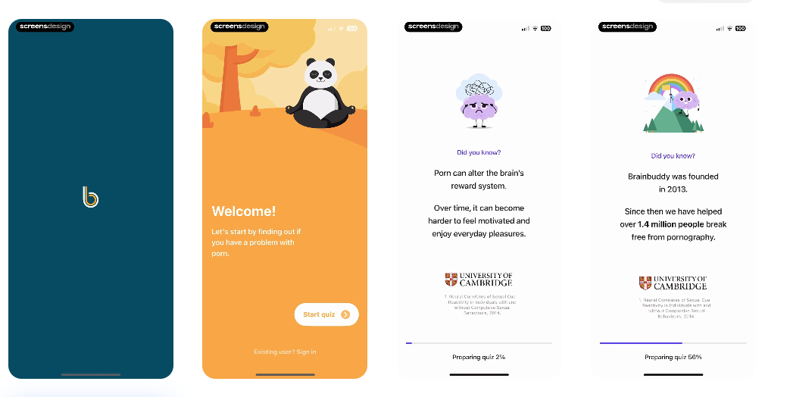
Screen design.
I will explain the onboarding flow as I paste the screenshots.
This is from another app. Take inspiration from all these screenshots and how the onboarding flow works. First screen is a logo. Second screen is a welcome screen. Third and 4th screen is a simple 'facts' screen about our app while 'preparing for quiz' is displayed at the bottom.
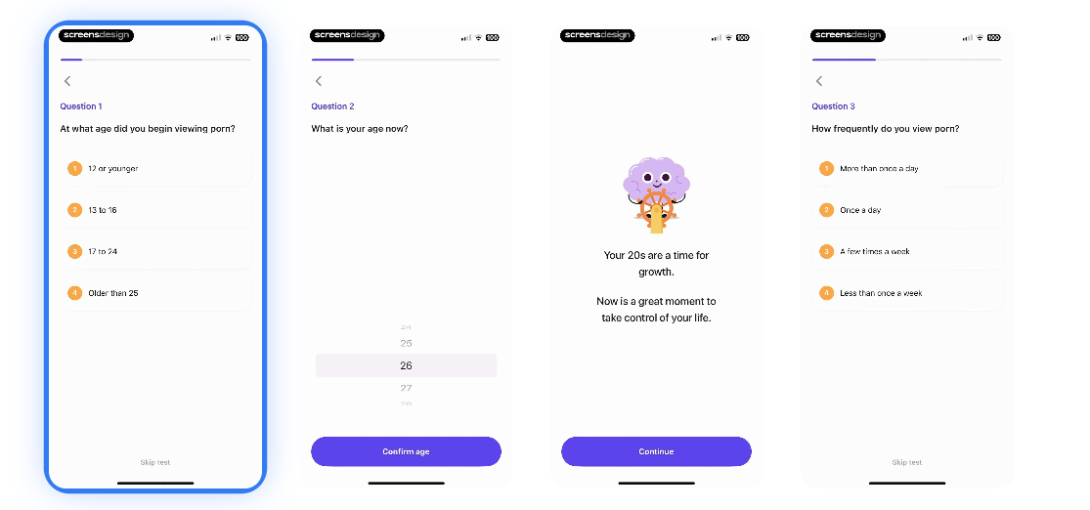

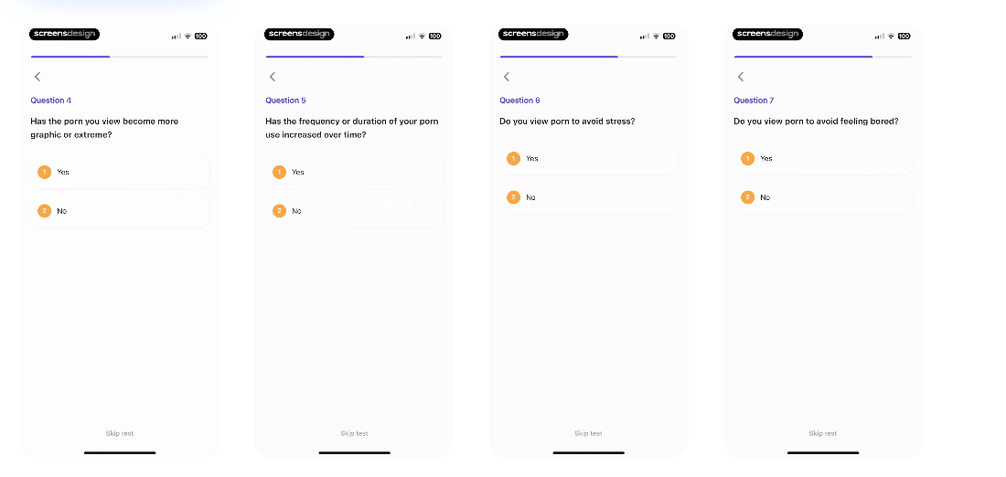

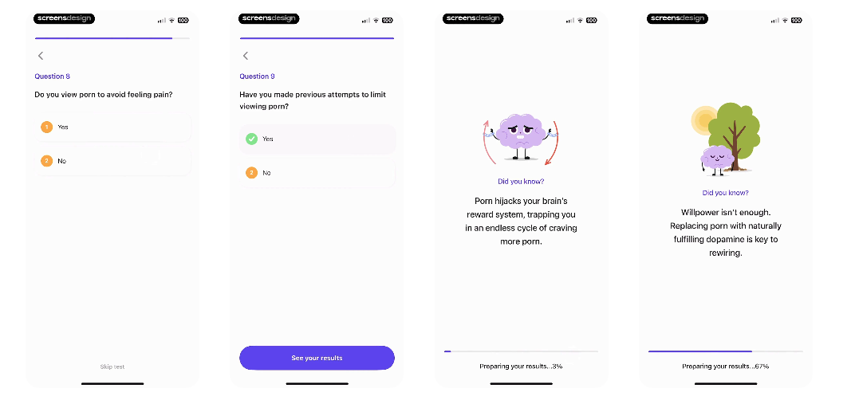

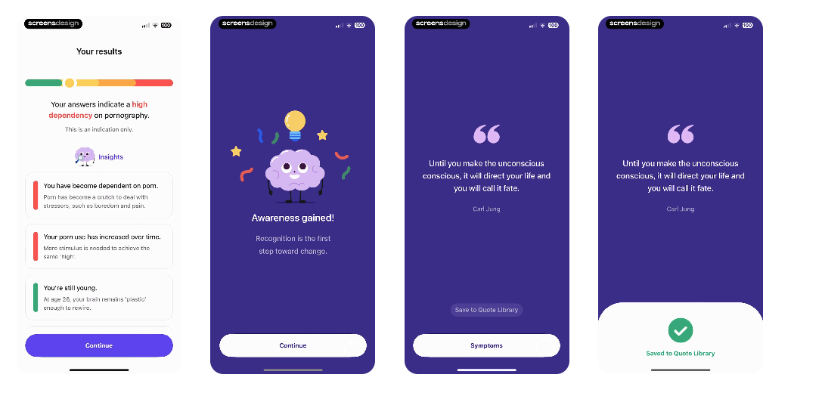
Then there is a quiz with 9 to 10 questions, each in 1 screen. Do the same for our app. Questions pertaining to our app.
1. How much do you spend on delivery per week ( with multiple options ).
2. How many times do you order in a week ( scrollable creative ui wheel ).
3. Main reason for ordering delivery
4. Age
5. Would you say the food you order is healthy, unhealthy, or a mix of both.
6 to 9 - add 4 more questions to make the person dive deep into their habits and understand how much money and health they are wasting.

After the quiz there are 2 screens with fun facts about something to do w our app ( preparing your results ) in the bottom.
Then the results screen.
Then 2 screens acknowledging the fact that the user has taken their first steps.

Then a screen asking user to select symptoms like above ( first screen in above screenshot )

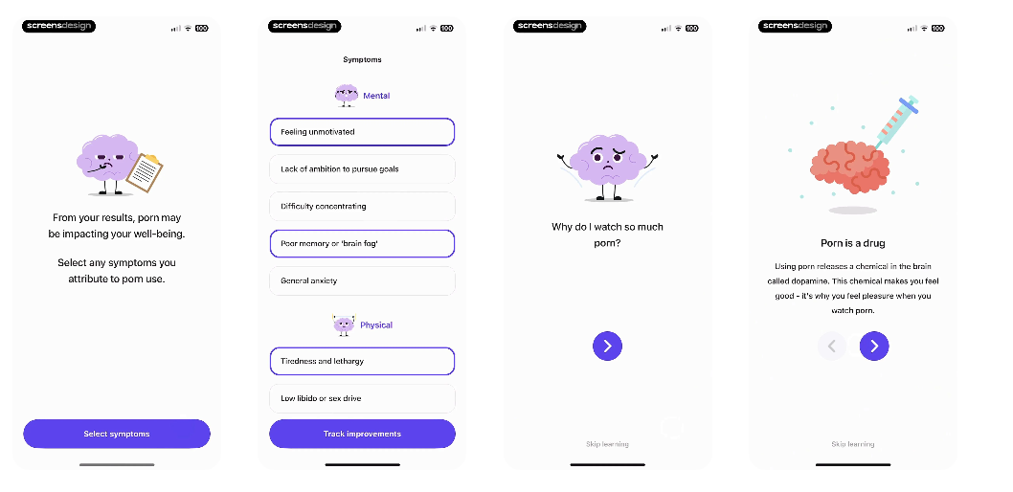
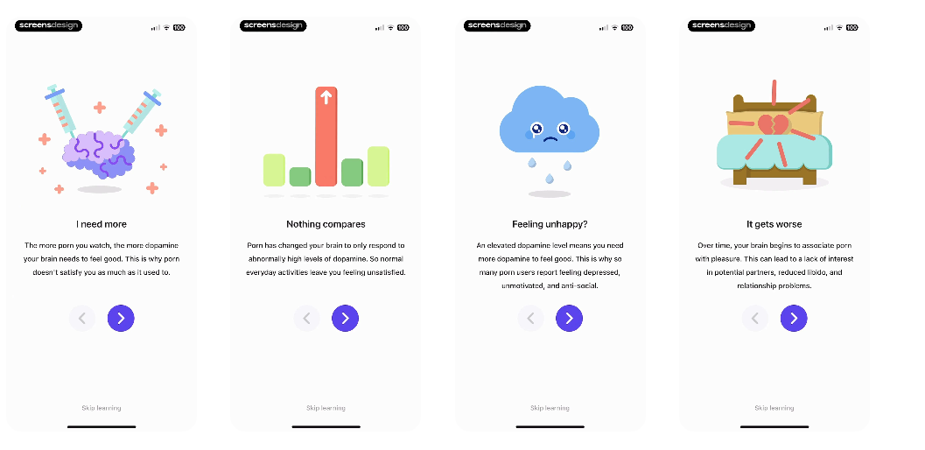
Then a screen where user selects symptoms ( take inspiration from second screen in above screenshot ).
then 4 screens, each with one consequences of ordering food and spending money ordering food a lot ( like above take inspiration ).

then a screen asking us what we should call the user with continue button.
Then a screen asking user to enter their weekly / monthly budget.
then 3 screens talking about how our app helps with their problem ( ordering too much delivery food )
then a screen that asks permission to allow app blocking
Then a screen that asks users if they want to enable notifications for - daily budget reminders, cooking ideas before meal times.

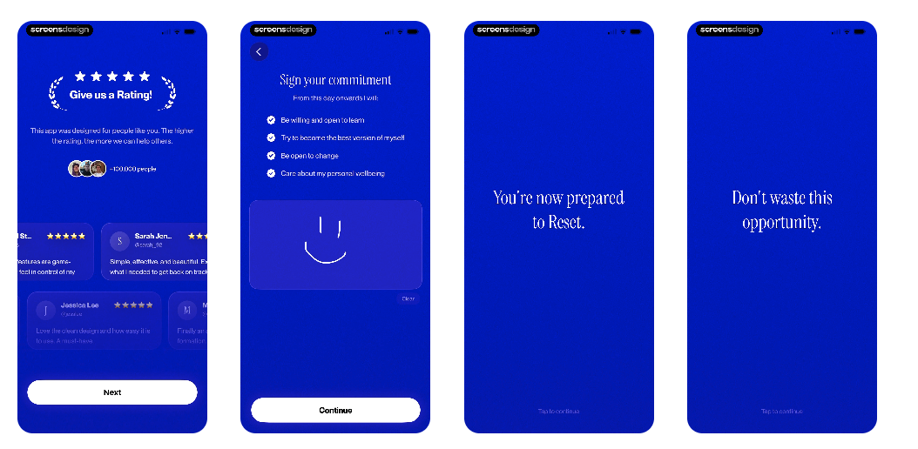
then a screen asking for rating / review (first pic above )

Then a screen asking for sign your commitment ( like 2nd pic above )

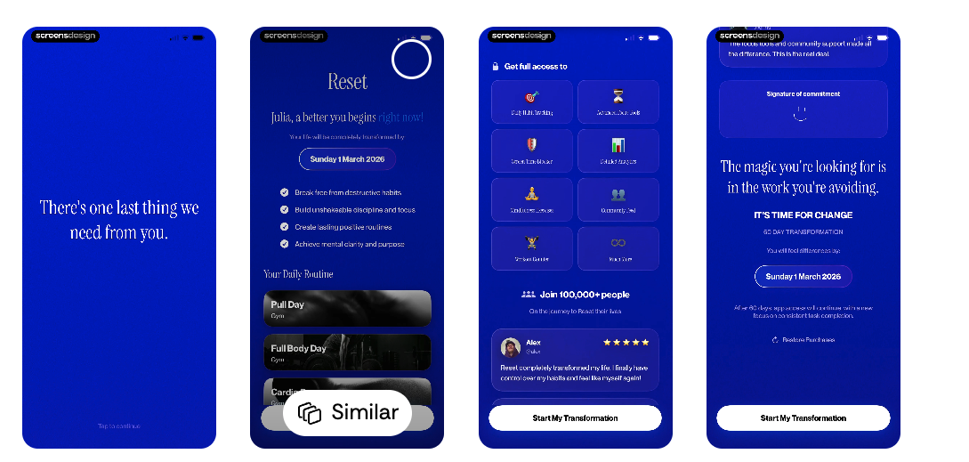
Then 2 screens saying motivational stuff ( like last 2 pics in above sc)

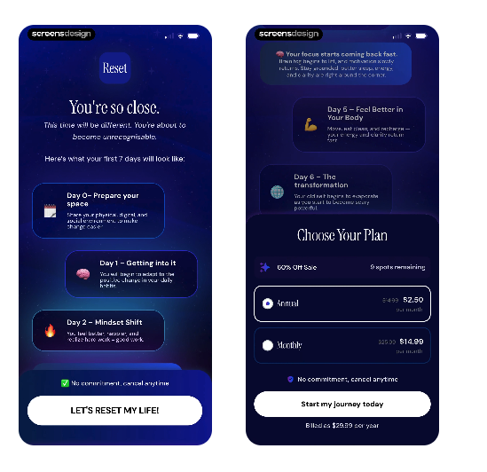
Then a screen saying we need one last thing from you ( like above sc )
then 2 screens similar to last 2 pics in above sc

Then 1 last screen that reveals the paywall ( like last pic in above sc ).

