# 

**Career Guidance**

# Session 2023 –2027

# Submitted by:

Saad Qaiser 2023-CS-37

# Supervised by:

Sir Nazeef-ul-Haq

# Course:

CSC200 – Data Structure & Algorithms

Department of Computer Science

# University of Engineering and Technology

# Lahore Pakistan

## Contents

1. **Project Overview**  
   1.1 Summary  
   1.2 Motivation  
   1.3 Objectives  
   1.4 Target Audience  
   1.5 Stakeholders  
   1.6 Operational Details
2. **Use Cases**  
   2.1 User Registration and Login  
   2.2 Career Assessment Questions  
   2.3 Career Recommendation  
   2.4 View Career Details  
   2.5 Restart Assessment
3. **Wireframes**  
   3.1 Home Screen  
   3.2 Questionnaires Screen  
   3.3 Recommendation Screen
4. **Database Details**  
   4.1 Data Handling Strategy
5. **Implementation**  
   5.1 Languages Used  
   5.2 Project Features
6. **Project Details**

## 1. Project Overview

### 1.1 Summary

The Career Guidance System aims to assist individuals in choosing a suitable career path by answering a series of questions. Leveraging decision tree logic, this system evaluates user responses to provide accurate career recommendations based on their interests and preferences.

### 1.2 Motivation

Choosing a career can be a daunting task for students and professionals. This project is designed to bridge the gap between an individual’s preferences and their career options. The motivation behind this project is to simplify decision-making by utilizing core concepts of data structures and algorithms.

### 1.3 Objectives

* Implement a decision tree-based career recommendation system.
* Provide a user-friendly interface to guide users through career assessment questions.
* Use data structures like graphs, trees, stacks, and queues to process user responses efficiently.

### 1.4 Target Audience

The target audience includes:

* High school and college students seeking career guidance.
* Professionals exploring new career opportunities.
* Career counselors and advisors.

### 1.5 Stakeholders

Key stakeholders in this project include:

* End users (students, professionals)
* Educational institutions and career counseling firms
* Developers and project managers overseeing implementation

### 1.6 Operational Details

The application operates through a structured process:

1. Users register or log in to the system.
2. Users answer a series of career assessment questions.
3. Based on responses, the system uses decision tree logic to recommend a career.
4. Users can view career details and restart the assessment if needed.

## 2. Use Cases

### 2.1 User Registration and Login

Users need to register by providing basic details like name. Upon registration, they can log in to access the system.

### 2.2 Career Assessment Questions

Users are presented with a predefined set of questions covering various aspects of their skills and interests. The questions are structured hierarchically to ensure accurate recommendations.

### 2.3 Career Recommendation

After completing all the questions, the system processes the responses to generate career recommendations. These recommendations are displayed along with a brief description of the suggested career.

### 2.4 View Career Details

Users can click on any recommended career to view detailed information, including required skills, educational paths, and job prospects.

### 2.5 Restart Assessment

If users are unsatisfied with the recommendation, they can restart the assessment to provide new answers.

## 3. Wireframes

### 3.1 Home Screen

The home screen displays options to register or log in. Users are greeted with an overview of the system and its benefits.



### 3.2 Questionnaires Screen

The questionnaire screen presents the assessment questions one by one. Users can select their answers from predefined options (e.g., Yes/No, Multiple Choice).

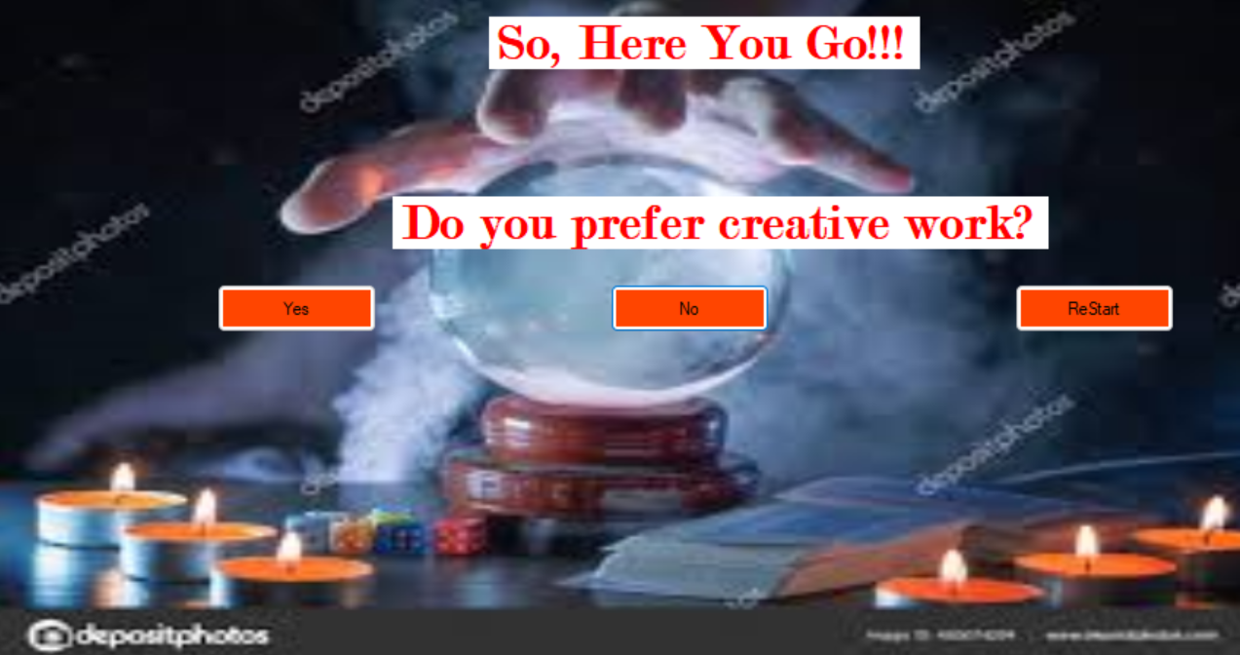

### 3.3 Recommendation Screen

The recommendation screen displays the top career recommendations based on user responses. It includes an option to view more details or restart the assessment.



## 4. Database Details

### 4.1 Data Handling Strategy

Since no external databases are allowed, user data and question responses are stored in runtime memory (e.g., lists or dictionaries). This ensures that data resets every time the application is restarted, maintaining simplicity and compliance with project constraints.

## 5. Implementation

### 5.1 Languages Used

* **C# with .NET Framework**: For building the application’s interface and implementing backend logic.

### 5.2 Project Features

* **Dynamic Questionnaires**: Questions are displayed dynamically based on user inputs.
* **Decision Tree Logic**: Efficiently processes responses to suggest relevant careers.
* **User-Friendly Interface**: Simple and intuitive design for seamless navigation.
* **Graphical Representation**: Clear graphs showing user progress and recommendation paths.
* **Reset Functionality**: Users can restart the assessment at any point.

## 6. Project Details

### 6.1 Languages Used

* **C# with .NET Framework**: Combines robust development tools and a rich ecosystem for desktop application development.

### 6.2 Concepts Implemented

* **Trees**: Hierarchical structure for decision-making.
* **Graphs**: Displaying relationships and progress.
* **Stacks & Queues**: Managing user inputs and question flow.
* **Linked Lists**: For dynamic data storage during runtime.