

**Name: Saad Rehman Section: 6E**

**Student I’d: 21F-9640 Lab: 05**

**Subject: Web Programming Topic: jQuery**

**Department of Computer Science**

|  |  |
| --- | --- |
| **Semester** | **Spring 2024** |

GitHub Repository:

[Click here](https://github.com/saadrehman171000/21F-9640_Web-Programming_University-Assessments/tree/main/Assignments/Lab5Tasks)

**Task 1**

**HTML Comments:**

* HTML comments are used to add notes or explanations within the HTML code that are not visible to the user in the browser.
* They are written between **<!--** and **-->**.

**Example:**

<!-- This is an HTML comment. It will not be displayed in the browser -->

<p>This is a paragraph.</p>

**CSS Comments:**

* CSS comments are used to provide explanations or to temporarily disable certain styles in a stylesheet.
* They are written between **/\*** and **\*/**.

**Example:**

/* This is a CSS comment. It will not affect the styling */

p {

    color: blue;

  }

**JavaScript Comments:**

* JavaScript comments are used to add explanations, notes, or to temporarily remove code from execution.
* Single-line comments start with **//**, while multi-line comments are enclosed between **/\*** and **\*/**.

**Example:**

// This is a single-line JavaScript comment

/*

   This is a multi line JavaScript comment.

   It can span across multiple lines.

*/

**Task 2**

<!DOCTYPE html>

<html lang="en">

<head>

<meta charset="UTF-8">

<meta name="viewport" content="width=device-width, initial-scale=1.0">

<title>Task 2</title>

<script src="https://ajax.googleapis.com/ajax/libs/jquery/3.5.1/jquery.min.js"></script>

<script>

$(document).ready(function() {

  alert("Welcome to jQuery");

});

</script>

</head>

<body>

<h1>JQuery Installed</h1>

</body>

</html>

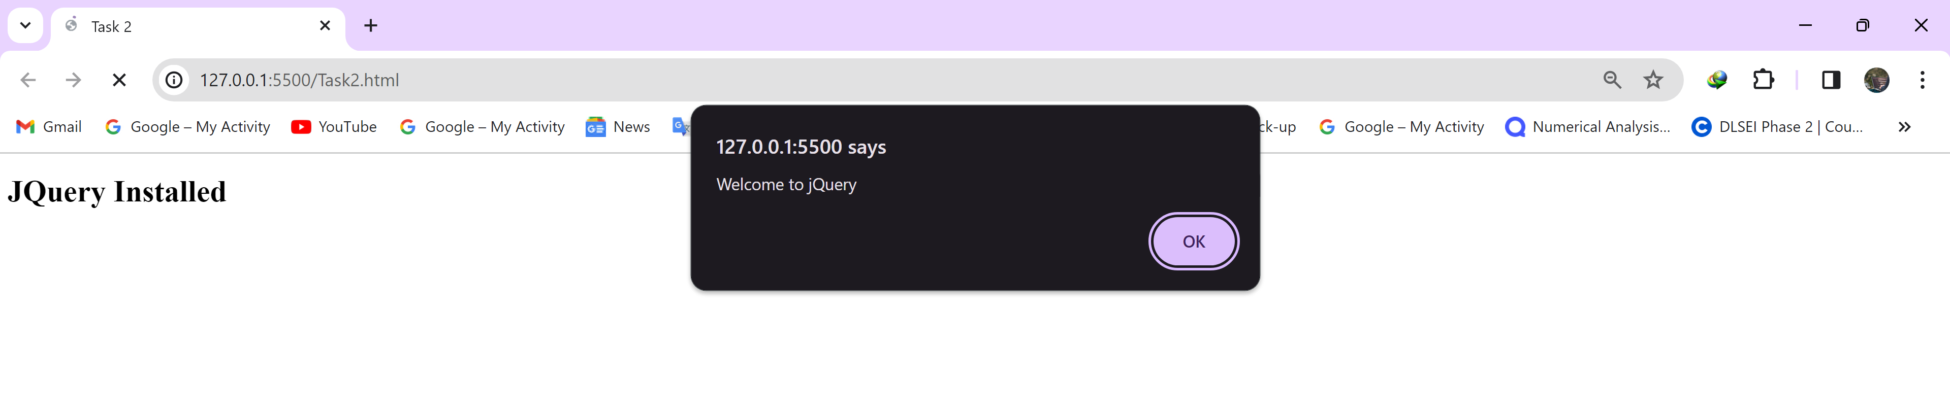

**Task 3**

<!DOCTYPE html>

<html lang="en">

<head>

<title>Task 3</title>

<style>

#toggleButton {

  padding: 10px 20px;

  font-size: 16px;

}

</style>

<script src="https://ajax.googleapis.com/ajax/libs/jquery/3.5.1/jquery.min.js"></script>

<script>

$(document).ready(function() {

  $("#toggleButton").click(function() {

    $("#toggleImage").toggle();

    var buttonText = $(this).text();

    $(this).text(buttonText === "Hide" ? "Show" : "Hide");

  });

});

</script>

</head>

<body>

<img src="image.png" id="toggleImage" style="display: none;">

<button id="toggleButton">Show Image</button>

</body>

</html>

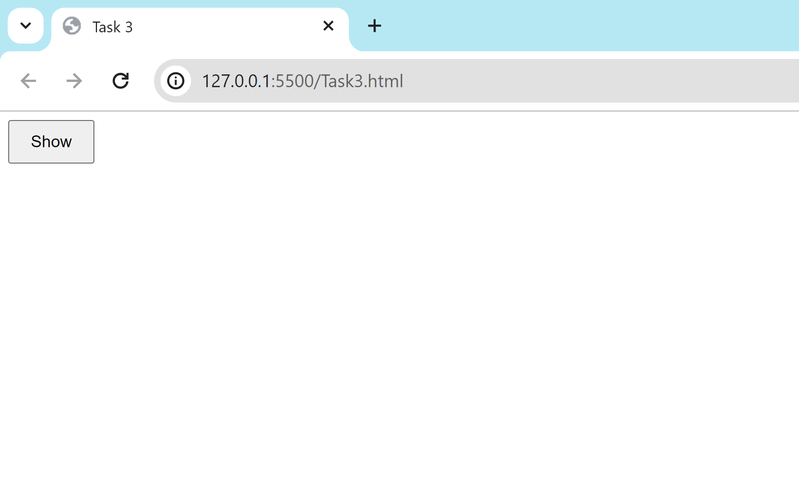

**Task 4**

<!DOCTYPE html>

<html lang="en">

<head>

<title>Task 4</title>

<script src="https://ajax.googleapis.com/ajax/libs/jquery/3.5.1/jquery.min.js"></script>

<script>

$(document).ready(function() {

  $(".removeButton").click(function() {

    $(this).closest("tr").remove();

  });

});

</script>

</head>

<body>

<table border="1" cellspacing="0" width="30%">

  <thead>

    <tr>

      <th>Name</th>

      <th>Age</th>

      <th>Action</th>

    </tr>

  </thead>

  <tbody>

    <tr>

      <td>Saad Rehman</td>

      <td>23</td>

      <td><button class="removeButton">Remove</button></td>

    </tr>

    <tr>

      <td>Ali Shaikh</td>

      <td>22</td>

      <td><button class="removeButton">Remove</button></td>

    </tr>

    <tr>

      <td>Talib Hussain</td>

      <td>22</td>

      <td><button class="removeButton">Remove</button></td>

    </tr>

  </tbody>

</table>

</body>

</html>

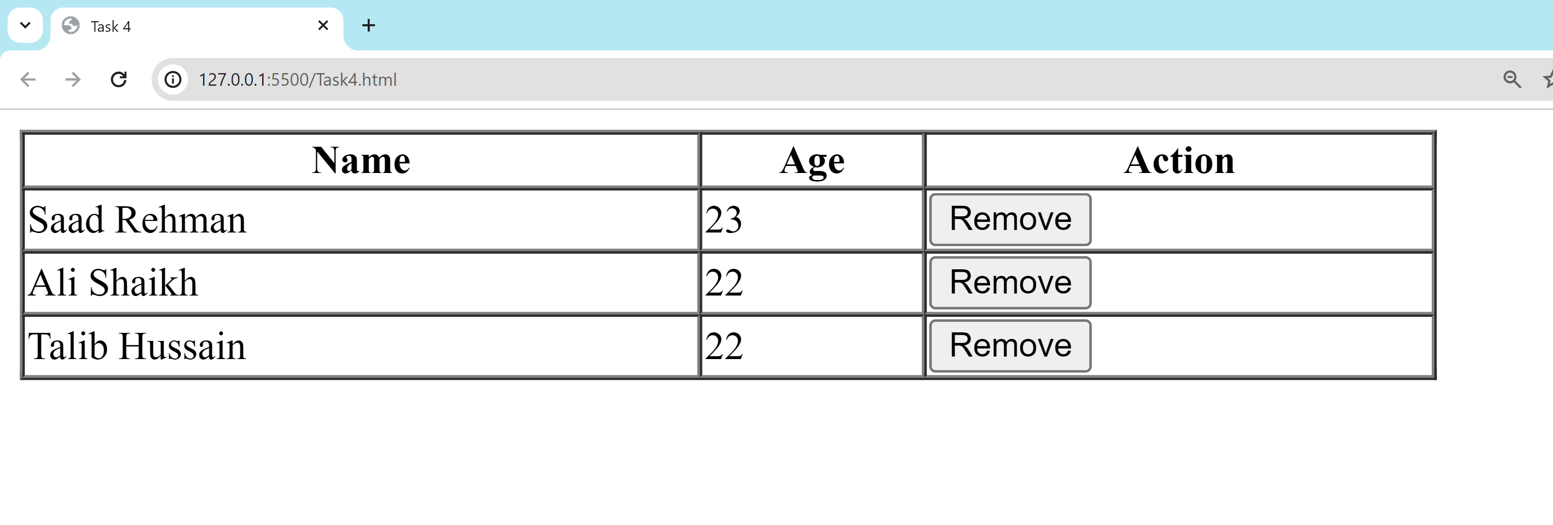

**Task 5**

<!DOCTYPE html>

<html lang="en">

<head>

<title>Task 5</title>

<script src="https://ajax.googleapis.com/ajax/libs/jquery/3.5.1/jquery.min.js"></script>

<script>

$(document).ready(function() {

  $(".clickable").click(function() {

    var elementClass = $(this).attr("class");

    var elementId = $(this).attr("id");

    alert("Class: " + elementClass + "\nID: " + elementId);

  });

});

</script>

</head>

<body>

<p id="paragraph1" class="clickable paragraph Class">Click me</p>

<div id="Div 1" class="clickable div Class">Click me too</div>

</body>

</html>

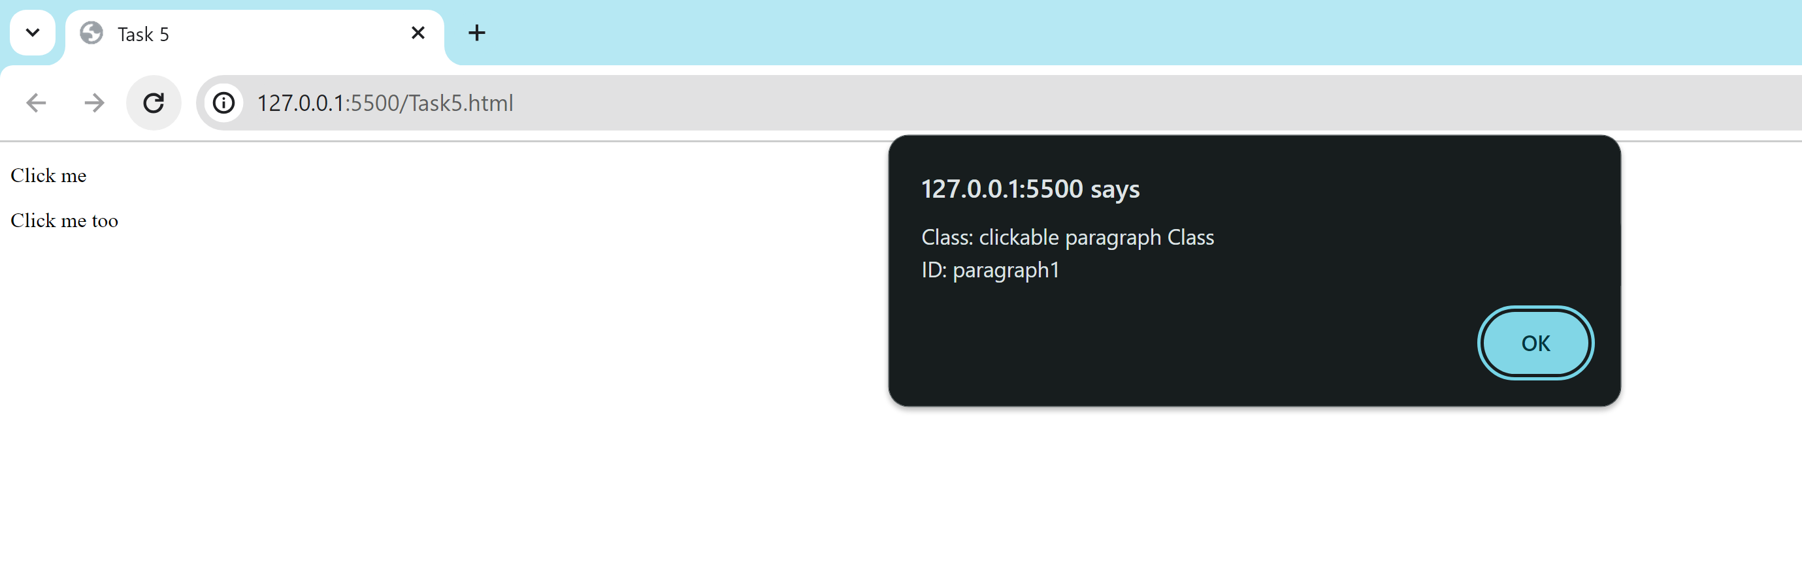

**Task 6**

<!DOCTYPE html>

<html>

<head>

    <script src="https://code.jquery.com/jquery-git.js"></script>

    <meta charset="utf-8">

    <meta name="viewport" content="width=device-width">

    <title>Find total width of an element (including width, padding and border) in jQuery.</title>

</head>

<body>

    <p id="myText">jQuery Exercises, Practice, Solution</p>

    <script>

        $(document).ready(function () {

            var totalWidth = $("#myText").outerWidth(true);

            alert("Total Width of Element (including width, padding, and border): " + totalWidth + " pixels");

        });

    </script>

</body>

</html>

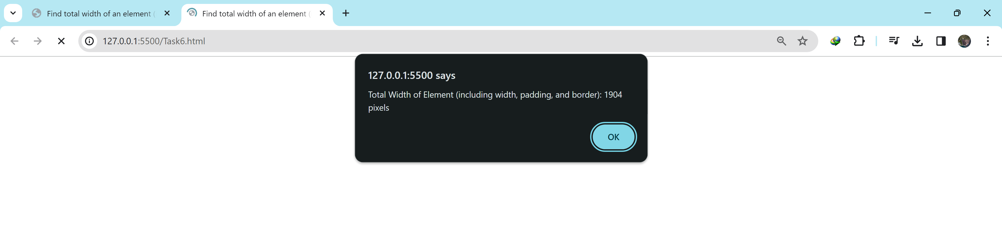

**Task 7**

<!DOCTYPE html>

<html>

<head>

    <script src="https://code.jquery.com/jquery-git.js"></script>

    <meta charset="utf-8">

    <meta name="viewport" content="width=device-width">

    <title>Count child elements using jQuery. </title>

</head>

<body>

    <div id="selected">

        <p>Red</p>

        <p>White</p>

        <p>Green</p>

        <p>Black</p>

        <p>Blue</p>

        <p>Orange</p>

    </div>

    <script>

        $(document).ready(function () {

            var numberOfPElements = $("#selected").find("p").length;

            alert("Number of 'p' elements: " + numberOfPElements);

        });

    </script>

</body>

</html>

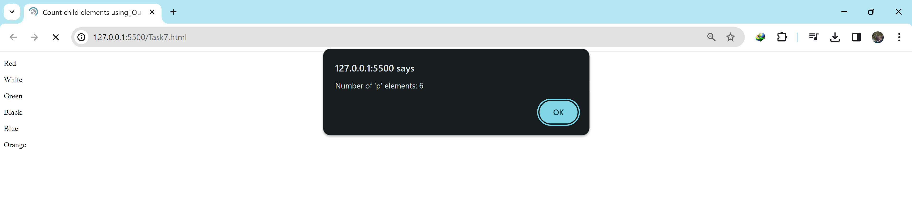

**Task 8**

<!DOCTYPE html>

<html>

<head>

<script src="https://code.jquery.com/jquery-git.js"></script>

<title>Task 8</title>

<style>

#animatedDiv {

  width: 100px;

  height: 100px;

  background-color: blue;

  position: relative;

}

</style>

</head>

<body>

<div id="animatedDiv"></div>

<script>

$(document).ready(function() {

  $("#animatedDiv").animate({

    left: "500px"

  }, 8000);

});

</script>

</body>

</html>



