**(1)**

% Simulation Exercise of Power Transformer Electrical Tests

% Define transformer parameters

R1 = 0.01; % Resistance of primary winding (ohms)

L1 = 0.1; % Inductance of primary winding (H)

R2 = 0.02; % Resistance of secondary winding (ohms)

L2 = 0.15; % Inductance of secondary winding (H)

M = 0.05; % Mutual inductance (H)

C = 1e-6; % Capacitance (F)

% Define transformer specifications

nominal_voltage = 110; % Nominal voltage (kV)

nominal_power = 50; % Nominal power (MVA)

frequency = 50; % Frequency (Hz)

% Simulation parameters

timestep = 1e-5; % Simulation time step

total_time = 0.1; % Total simulation time

% Create a time vector

t = 0:timestep:total_time;

% Define input voltage (can be modified based on your scenario)

V_in = sin(2*pi*frequency*t); % Sine wave input voltage

% Initialize matrices to store simulation results

I1 = zeros(size(t));

I2 = zeros(size(t));

% Initialize derivatives

dI1 = 0;

dI2 = 0;

% Simulation loop

for i = 2:length(t)

% Calculate voltages and currents using differential equations

dI1 = (V_in(i-1) - R1 * I1(i-1) - M * dI2) / L1;

dI2 = (M * dI1 - R2 * I2(i-1)) / L2;

I1(i) = I1(i-1) + dI1 * timestep;

I2(i) = I2(i-1) + dI2 * timestep;

end

% Plot the results

figure;

subplot(2, 1, 1);

plot(t, I1, 'r', 'LineWidth', 2);

title('Current in Primary Winding');

xlabel('Time (s)');

ylabel('Current (A)');

subplot(2, 1, 2);

plot(t, I2, 'b', 'LineWidth', 2);

title('Current in Secondary Winding');

xlabel('Time (s)');

ylabel('Current (A)');

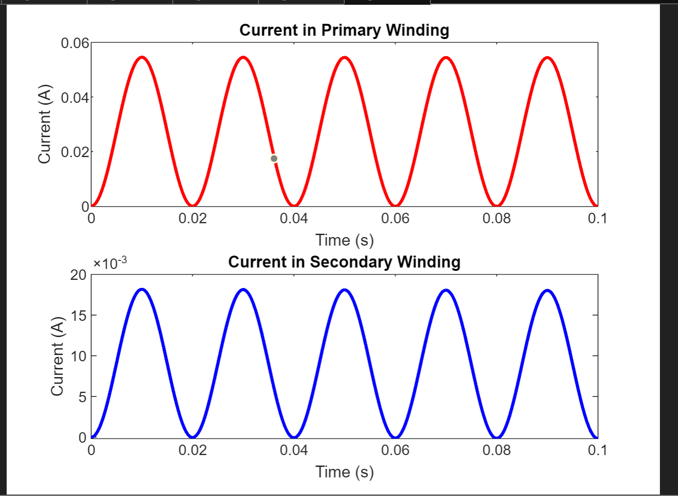

**(2)**

% 6. Develop Case Scenarios:

% Scenario 1: No Faults (Normal Operation)

I1_scenario1 = zeros(size(t));

I2_scenario1 = zeros(size(t));

for i = 2:length(t)

dI1 = (V_in(i-1) - R1 * I1_scenario1(i-1) - M * dI2) / L1;

dI2 = (M * dI1 - R2 * I2_scenario1(i-1)) / L2;

I1_scenario1(i) = I1_scenario1(i-1) + dI1 * timestep;

I2_scenario1(i) = I2_scenario1(i-1) + dI2 * timestep;

end

% Plot Scenario 1

figure;

subplot(2, 1, 1);

plot(t, I1_scenario1, 'r', 'LineWidth', 2);

title('Scenario 1: No Faults (Normal Operation)');

xlabel('Time (s)');

ylabel('Current (A)');

subplot(2, 1, 2);

plot(t, I2_scenario1, 'b', 'LineWidth', 2);

xlabel('Time (s)');

ylabel('Current (A)');

% Scenario 2: Winding Fault in Primary Winding

I1_scenario2 = zeros(size(t));

I2_scenario2 = zeros(size(t));

for i = 2:length(t)

% Introduce winding fault in primary winding

if t(i) > 0.02 && t(i) < 0.03

V_in(i) = 0; % Simulate a short circuit in the primary winding

end

dI1 = (V_in(i-1) - R1 * I1_scenario2(i-1) - M * dI2) / L1;

dI2 = (M * dI1 - R2 * I2_scenario2(i-1)) / L2;

I1_scenario2(i) = I1_scenario2(i-1) + dI1 * timestep;

I2_scenario2(i) = I2_scenario2(i-1) + dI2 * timestep;

end

% Plot Scenario 2

figure;

subplot(2, 1, 1);

plot(t, I1_scenario2, 'r', 'LineWidth', 2);

title('Scenario 2: Winding Fault in Primary Winding');

xlabel('Time (s)');

ylabel('Current (A)');

subplot(2, 1, 2);

plot(t, I2_scenario2, 'b', 'LineWidth', 2);

xlabel('Time (s)');

ylabel('Current (A)');

% Scenario 3: Core Fault

I1_scenario3 = zeros(size(t));

I2_scenario3 = zeros(size(t));

for i = 2:length(t)

% Introduce core fault

if t(i) > 0.05 && t(i) < 0.06

M = 0; % Simulate a breakdown in the core

end

dI1 = (V_in(i-1) - R1 * I1_scenario3(i-1) - M * dI2) / L1;

dI2 = (M * dI1 - R2 * I2_scenario3(i-1)) / L2;

I1_scenario3(i) = I1_scenario3(i-1) + dI1 * timestep;

I2_scenario3(i) = I2_scenario3(i-1) + dI2 * timestep;

end

% Plot Scenario 3

figure;

subplot(2, 1, 1);

plot(t, I1_scenario3, 'r', 'LineWidth', 2);

title('Scenario 3: Core Fault');

xlabel('Time (s)');

ylabel('Current (A)');

subplot(2, 1, 2);

plot(t, I2_scenario3, 'b', 'LineWidth', 2);

xlabel('Time (s)');

ylabel('Current (A)');

**(3)**

% 7. Execute Simulations:

% Execute and Save Simulation for Scenario 1

figure;

subplot(2, 1, 1);

plot(t, I1_scenario1, 'r', 'LineWidth', 2);

title('Scenario 1: No Faults (Normal Operation)');

xlabel('Time (s)');

ylabel('Current (A)');

subplot(2, 1, 2);

plot(t, I2_scenario1, 'b', 'LineWidth', 2);

xlabel('Time (s)');

ylabel('Current (A)');

saveas(gcf, 'Scenario1.png');

% Execute and Save Simulation for Scenario 2

figure;

subplot(2, 1, 1);

plot(t, I1_scenario2, 'r', 'LineWidth', 2);

title('Scenario 2: Winding Fault in Primary Winding');

xlabel('Time (s)');

ylabel('Current (A)');

subplot(2, 1, 2);

plot(t, I2_scenario2, 'b', 'LineWidth', 2);

xlabel('Time (s)');

ylabel('Current (A)');

saveas(gcf, 'Scenario2.png');

% Execute and Save Simulation for Scenario 3

figure;

subplot(2, 1, 1);

plot(t, I1_scenario3, 'r', 'LineWidth', 2);

title('Scenario 3: Core Fault');

xlabel('Time (s)');

ylabel('Current (A)');

subplot(2, 1, 2);

plot(t, I2_scenario3, 'b', 'LineWidth', 2);

xlabel('Time (s)');

ylabel('Current (A)');

saveas(gcf, 'Scenario3.png');