Software Engineering Course Project Report​
Project Name: Taylor Clinic Health Portal System Prototype Design​
Group Number:​ No.1
Submission Date:​ March 13, 2026
1. Prototype Development Process
This project followed agile development principles, refining a prototype for a three-party medical service platform (students, doctors, administrators) through iterative “design-test-revise” cycles. Figma was used as the primary design tool, with two major development iterations.
1.1 Initial Prototype (Low-Fidelity Wireframes)
Objective:​ To quickly validate the core workflow and information architecture.
Design Overview:
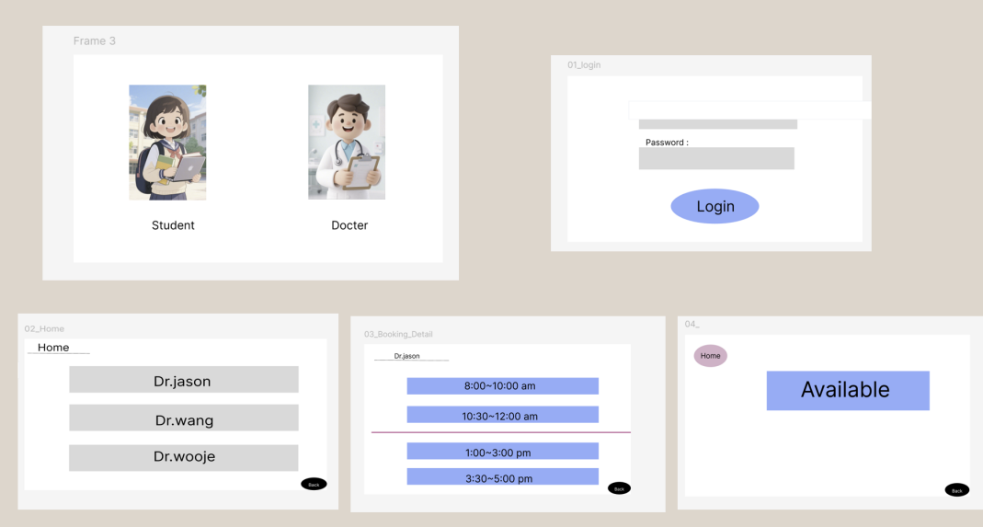
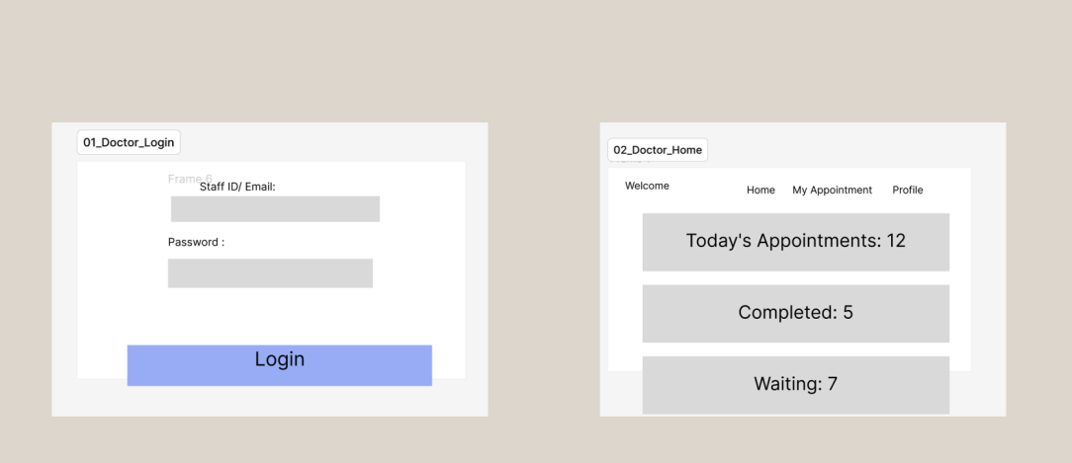
Figure 1:​ Demonstrates the initial flow: role selection (student/doctor), basic login, and the student appointment process (doctor list → time slot selection → confirmation).
Figure 2:​ Shows the early concept for the doctor's homepage, presenting a daily appointment overview using data cards.
Design Characteristics:​ Pure black-and-white wireframes focused on functional layout and user task flows, avoiding visual details to ensure the core interaction logic was quickly understandable to the team and stakeholders.
1.2 Final Prototype (High-Fidelity Interactive Prototype)
Basis for Iteration:​ Building on internal reviews and preliminary user feedback of the initial prototype, the information architecture, interaction details, and visual system were comprehensively enhanced and expanded.
Key Improvements & New Modules​ :
(login)
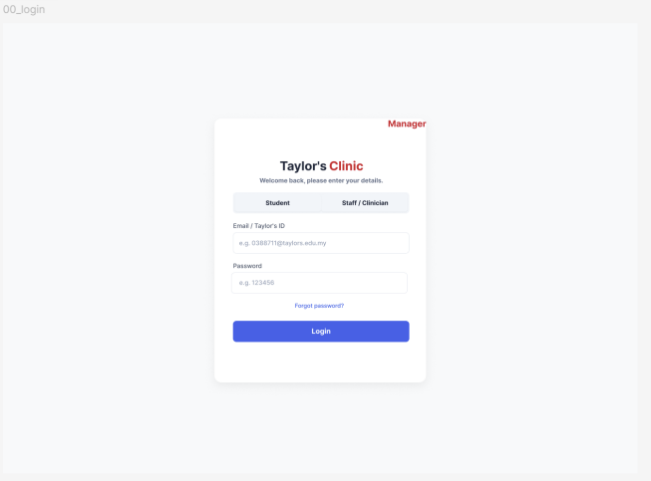
(student)
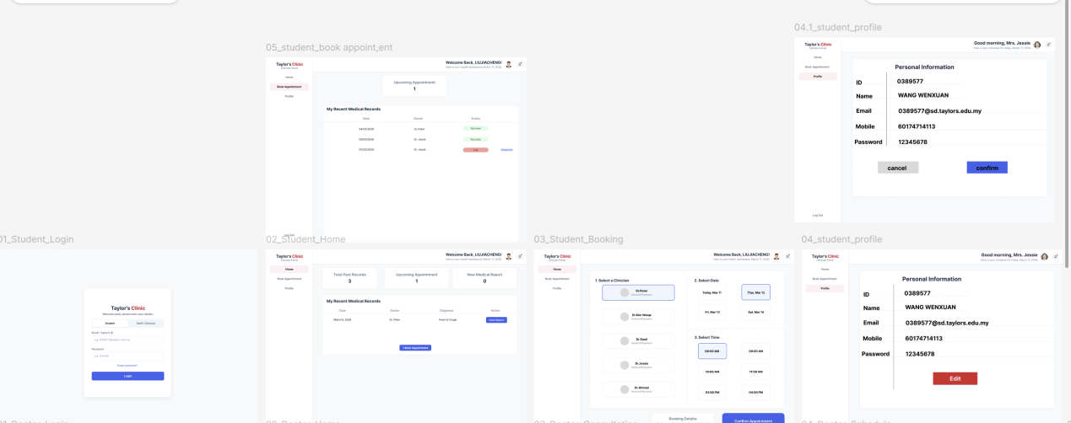
(doctor)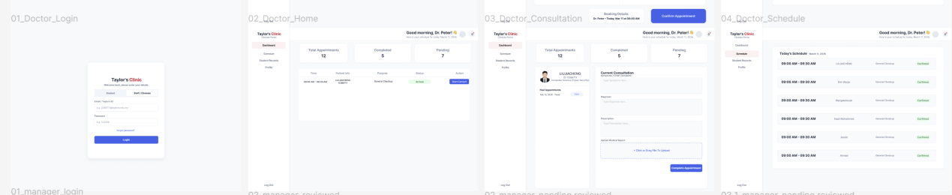
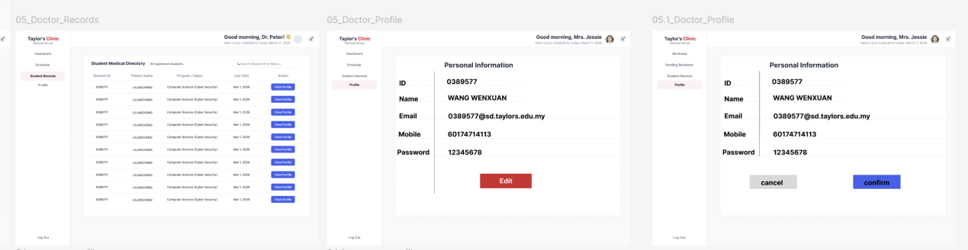
(manager)
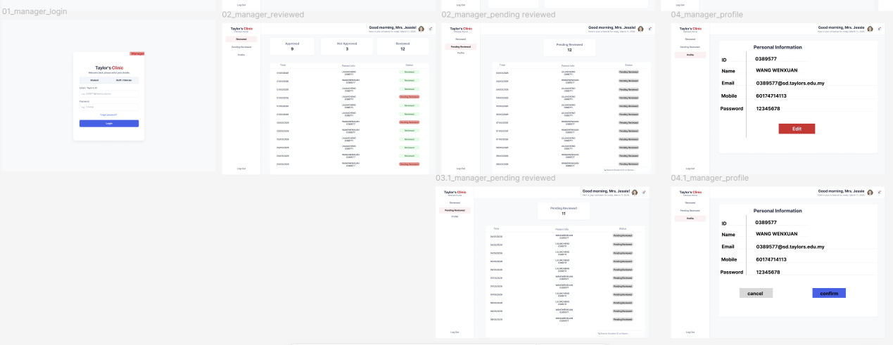
Role & Process Enhancement:​ Added an "Administrator" role to the initial "Student" and "Doctor" roles, completing the three-party system.
Student Side :​ Evolved into a personal health dashboard integrating "Appointment Management," "Medical History," and "Report Viewing." The booking process was refined into three clear steps: "Select Doctor → Select Date → Select Time."
Doctor Side:
Consultation Page:​ Designed as the core workstation. The left panel shows the daily schedule, while the right panel integrates student health records and a drag-and-drop report upload function, optimizing the diagnostic workflow.
Medical Directory:​ A new page allowing doctors to query students' historical medical records.
Administrator Side :
Unified Login Page: Integrates entry points for all three roles.
Review Management: Divided into "Reviewed" and "Pending Review" panels. In our system, this function allows administrators to verify and approve medical certificates (MCs) or consultation reports issued by doctors, ensuring that students' medical leaves are officially validated for university records.
Personal Profile:​ Supports information management.
Design Characteristics:​ Applied a brand color scheme, a complete design system, realistic data, and interactive components to deliver a high-fidelity, interactive prototype closely resembling the final product experience.
2.Testing and Evaluation
2.1 Test Objectives & Methodology
To test our Figma prototype, we created a Google Form and invited 14 students from Taylor's University to try our clinic booking system. Our main goal was to see if the booking process is easy to understand and if the UI design is user-friendly. We sent them the prototype link and asked them to complete a booking task, then fill out the survey.
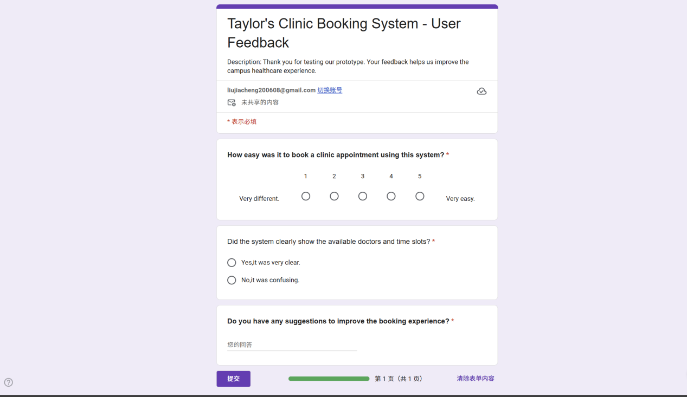
2.2 Quantitative Results
After collecting the data, the results are very positive. For the question "How easy was it to book a clinic appointment using this system?", 9 out of 14 students gave 5 points (Very Easy), and 4 students gave 4 points (Easy). This means around 92% of the users think our system is smooth to use. Also, 13 out of 14 users said the doctors and time slots are displayed very clearly on the screen.
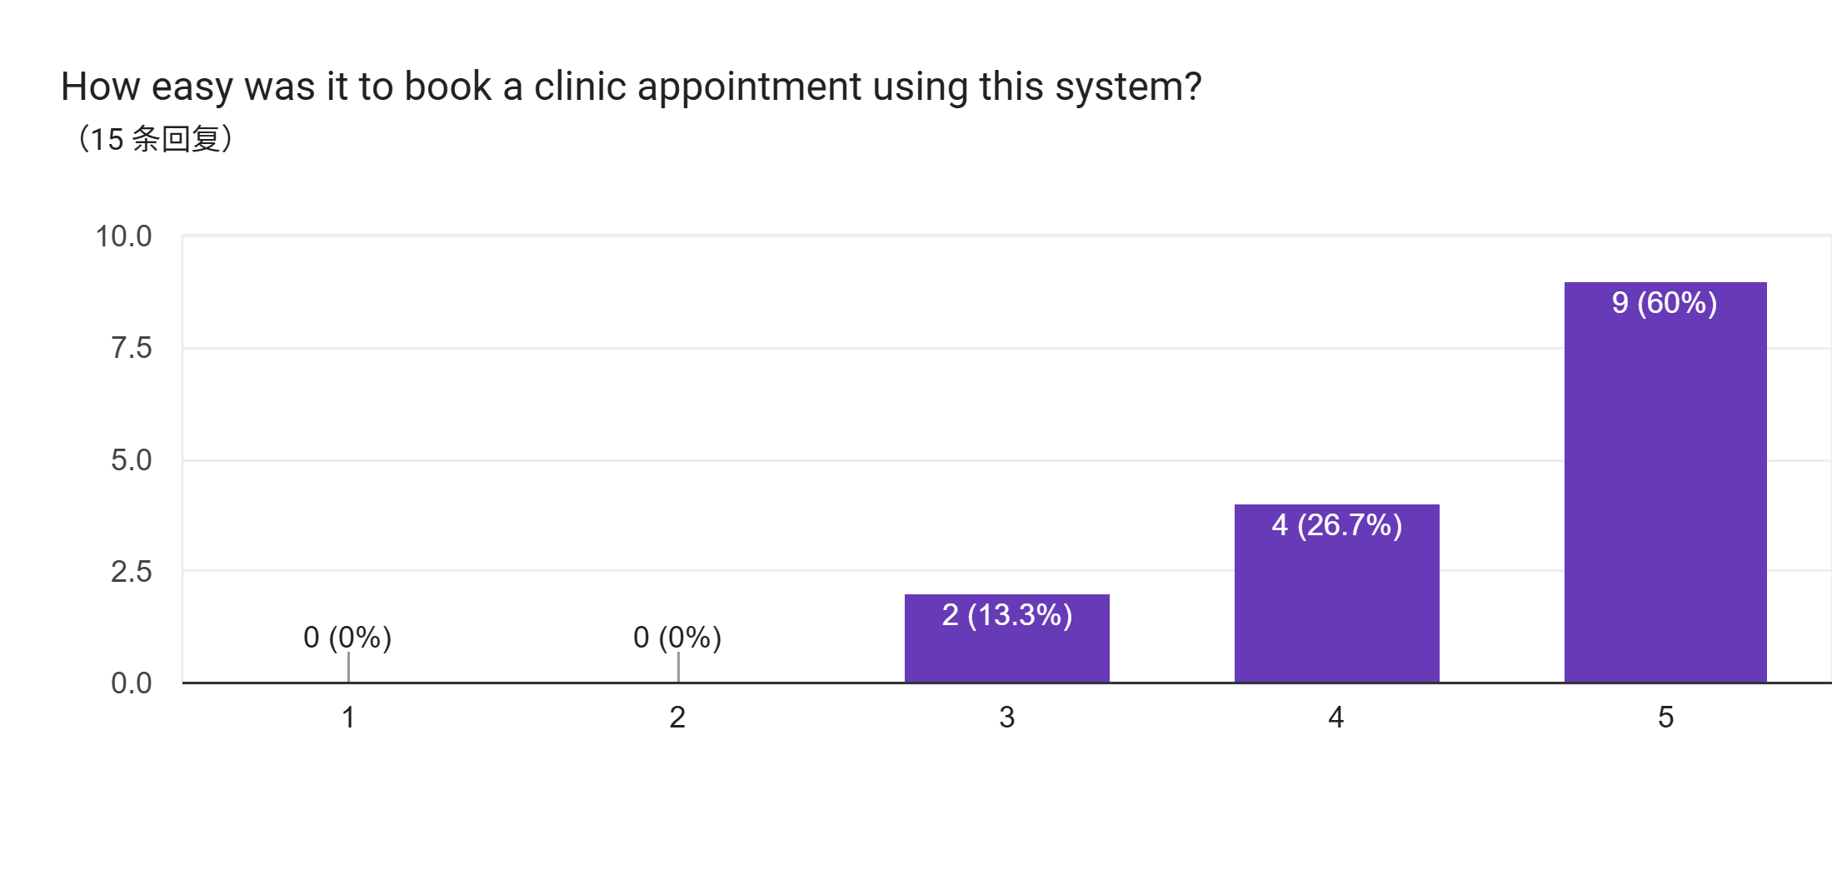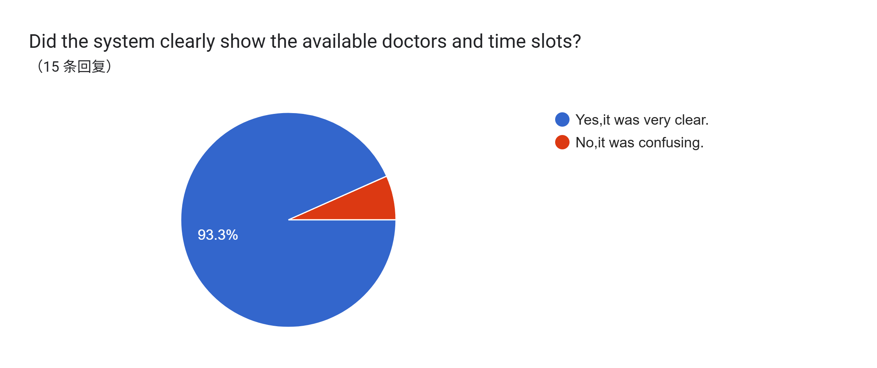
2.3 Qualitative Feedback
In the short answer section, users left some great comments. Many students mentioned that they like the "Unified Login" because they don't need to find different links for students and staff. They also praised the "Split-pane" layout on the booking page.
Here are some positive comments from the testers:
（1）"The split-pane layout for picking time slots is super clear. Great job!"
（2）"The green success pop-up after booking gave me peace of mind."
（3）"Very smooth interface. Much better than waiting in line at the campus clinic."
2.4 Improvements Based on Findings
However, user testing also helped us find some missing features. According to the Agile process, we analyzed the constructive feedback and planned to make two main improvements in our future Sprints:
1. Add a "Cancel Appointment" Button: Some users noticed that there is no obvious way to cancel a booking if they are suddenly busy. Action plan: We will add a clear "Cancel" or "Reschedule" button in the "My Records" page so students can manage their time better.
2. Google Calendar Integration: One tester suggested that it would be very helpful to receive a reminder. Action plan: We plan to put an "Add to Google Calendar" button directly on the success pop-up window.
These suggestions are very valuable. They show why continuous user testing is very important in software engineering to improve the prototype.

3. Prototype Showcase
The interactive high-fidelity prototype can be accessed via the following link:
https://www.figma.com/proto/AeGFMlUgQ6DarhA4BeQ05V/Untitled?node-id=1-2&t=hpRrb11VdiHfZDj9-1
Key interfaces are statically showcased below:
Student Homepage​ – Health dashboard and integrated booking flow.
Doctor Consultation Page​ – Integrated diagnostic workstation.
Doctor Side – Student Medical Directory​ – Historical record query.
Unified Login Portal​ – Three-role entry points.
Administrator Review Panels​ – Data dashboard and list management.
Administrator Personal Profile Page.
4. Agile Development Practice & Project Reflection
4.1 Application of Agile Methodology
- Iterative Development:​ Clearly divided into two main sprints: "Low-Fidelity Validation" and "High-Fidelity Enhancement," each resulting in a demonstrable outcome.
- User Story Driven:​ All designed features originated from user stories ("As a student, I want to…", "As a doctor, I need to…"), ensuring a user-centered design approach.
- Continuous Integration & Review:​ Utilized Figma's collaboration features for daily design syncs and held regular design review meetings to ensure consistency and gather team feedback rapidly.
4.2 Reflection & Lessons Learned
- Value of Early Validation:​ Low-fidelity prototypes were crucial for quickly exposing logical flaws in workflows, preventing deep investment in visual design for misguided concepts.
- Timeliness of Testing:​ User experience testing should be conducted early and frequently. In this project, the innovative layout of the doctor's workstation stemmed from the pain point of "frequent interface switching" identified in early testing.
- Importance of a Design System:​ As prototype complexity grew, establishing and strictly adhering to design standards for colors, typography, spacing, and component libraries was key to enhancing team collaboration efficiency and maintaining product consistency.
- Communication & Documentation:​ Clear prototype annotations, update logs, and records of design decisions effectively reduced communication overhead and ensured the continuity of project knowledge.

