LIBRARY MANAGEMENT SYSTEM
Name: SAHIL AWASTHI
Enrollment number: 161B185
Batch:: B6(BY)

FIRST WINDOW:
USERNAME: admin PASSWORD: secret
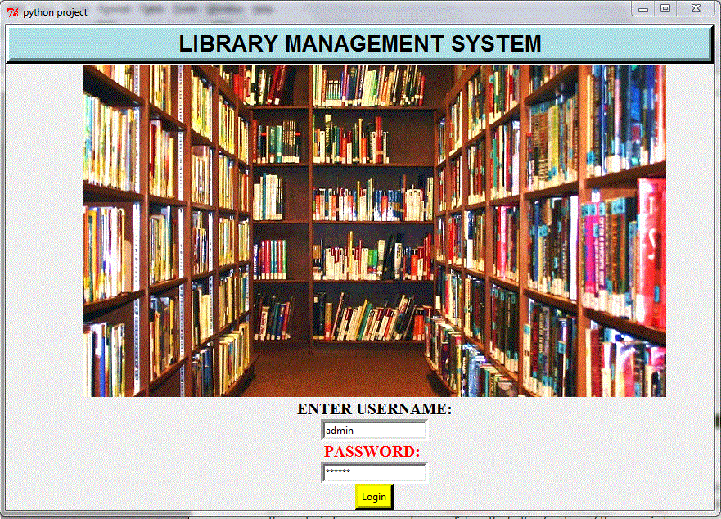
First window asks the user to enter the username and password (here username=admin and password=secret). As you enter the username and password and click on the ‘login’ button the button to the next window appears and as you click on the button ‘next page’ the new window appears.
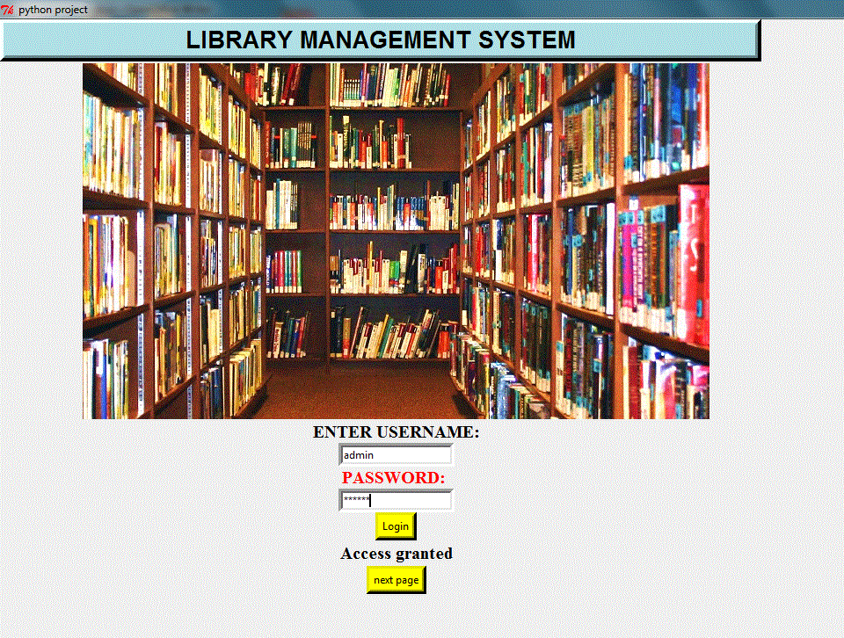
LOGIN BUTTON:
As the user enter the correct username and password and click on the login button the user is given access and then a new button appears NEXT PAGE which when clicked opens a new window as shown below.

SECOND WINDOW:
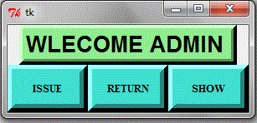
The second window has three buttons 'ISSUE', 'SHOW',”RETURN”.
A. ISSUE BUTTON:
The issue button when pressed makes the user to the next window.
As the user click on the ‘issue’ button a new window opens where the user is asked to select the subject of which the user wants to issue the book.
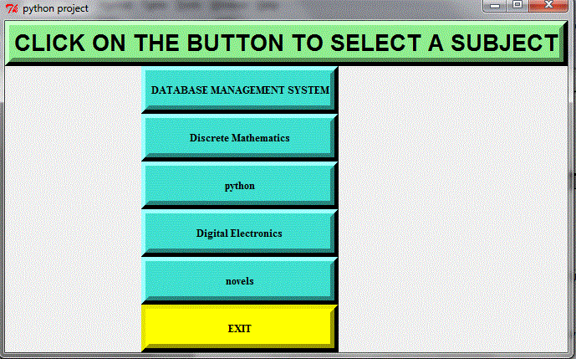
In the above window shown the user is provided with the 6 buttons.

1. DATABASE MANAGEMENT SYSTEM BUTTON:
When pressed opens a new window that asks the user to select a database book which he wants to issue.
Here the user is provided with the various checkbuttons which when selected and clicked on the issue buttons stores the data of the book issued.
Exit Button:
when clicked on the exit button the window gets destroyed.
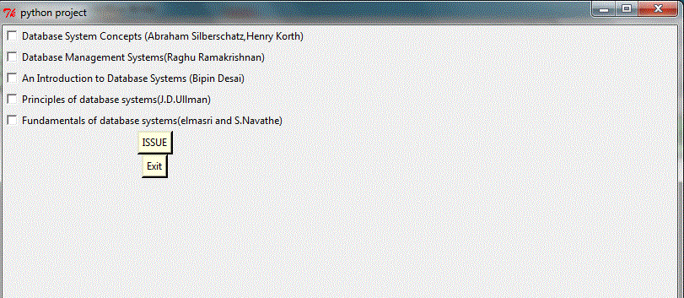

- DISCRETE MATHEMATICS:
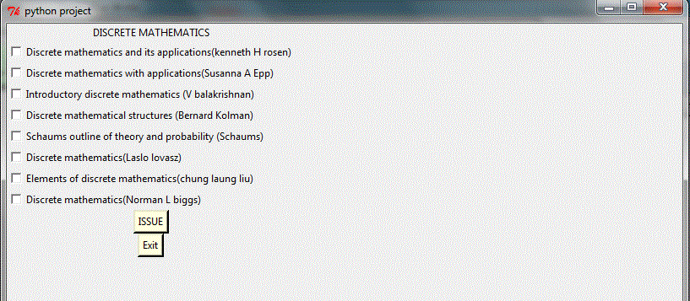
similarily it is for all the subjects. At last there is an exit button that makes the window to get destroyed
.
B. SHOW BUTTON:
It helps the user to see the information of the Books which have been issued by the user.

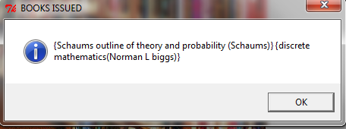

C.RETURN BUTTON:
Return button asks the user to enter the book title and author name of the book and click on the return button gives a message of successful return.
If the user enter a wrong entry the message of error is shown.

